Batch: ML1
Roll No.: 1911004

Experiment / Assignment / Tutorial No. 4

Title: Implementation of Decision Tree Classification algorithm.

Aim: To understand & implement decision tree using python.

Expected Outcome of Experiment:

CO2: Describe and apply supervised learning methods.

Theory of Decision Tree ID3 Algorithm:
Decision tree algorithm falls under the category of supervised learning. They can be used to solve both regression and classification problems. Decision tree uses the tree representation to solve the problem in which each leaf node corresponds to a class label and attributes are represented on the internal node of the tree. We can represent any boolean function on discrete attributes using the decision tree.
Below are some assumptions that we made while using decision tree: At the beginning, we consider the whole training set as the root. Feature values are preferred to be categorical. If the values are continuous then they are discretized prior to building the model.
On the basis of attribute values records are distributed recursively. We use statistical methods for ordering attributes as root or the internal node. As you can see from the above image that Decision Tree works on the Sum of Product form which is also known as Disjunctive Normal Form. In the above image, we are predicting the use of computer in the daily life of the people.
In Decision Tree the major challenge is to identification of the attribute for the root node in each level. This process is known as attribute selection. We have two popular attribute selection measures: Information Gain Gini Index
- Information Gain When we use a node in a decision tree to partition the training instances into smaller subsets the entropy changes. Information gain is a measure of this change in entropy. Definition: Suppose S is a set of instances, A is an attribute, Sv is the subset of S with A = v, and Values (A) is the set of all possible values of A, then
- Gini Index Gini Index is a metric to measure how often a randomly chosen element would be incorrectly identified. It means an attribute with lower Gini index should be preferred. Sklearn supports “Gini” criteria for Gini Index and by default, it takes “gini” value.

Problem Definition:

To analyze, model, and predict the quality of wine (low, medium, or high) using physicochemical attributes (fixed acidity, volatile acidity, citric acid, residual sugar, chlorides, free sulfur dioxide, total sulfur dioxide, density, pH, sulphates, alcohol, quality, wine_type & quality_label).
Dataset: https://archive.ics.uci.edu/ml/datasets/wine+quality
Perform the following tasks:
1. Exploratory Data Analysis & Visualizations
• Descriptive analysis
• Univariate analysis
• Multivariate analysis
2. Train, Predict & Evaluate Model using Decision Tree
3. View Feature Importance from Decision Tree Model
4. Visualize the Decision Tree
5. Train, Predict & Evaluate Model using Random Forests
6. Compare the performance
Implementation:

NoteBook - https://colab.research.google.com/drive/1vkDN1mAgl4mRYcCaV1jxO6ZHGiU2m5l2
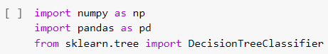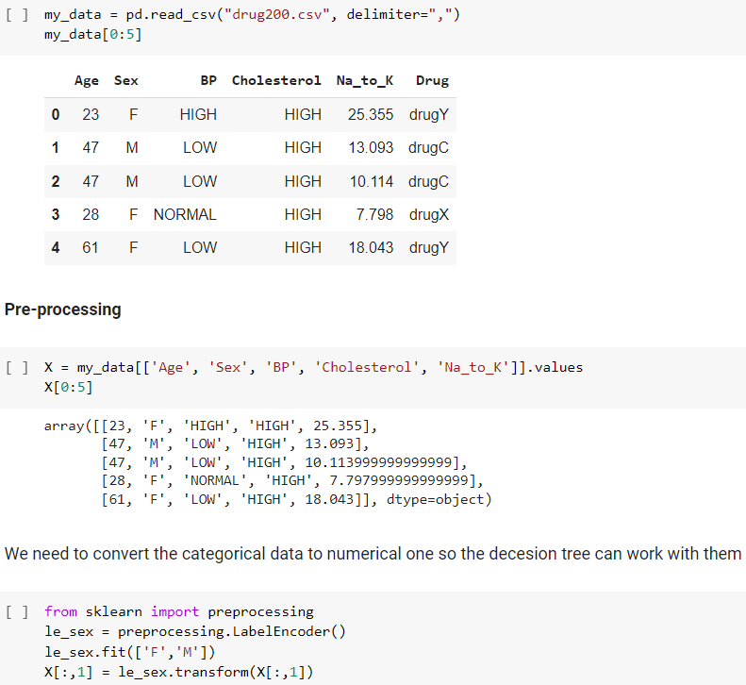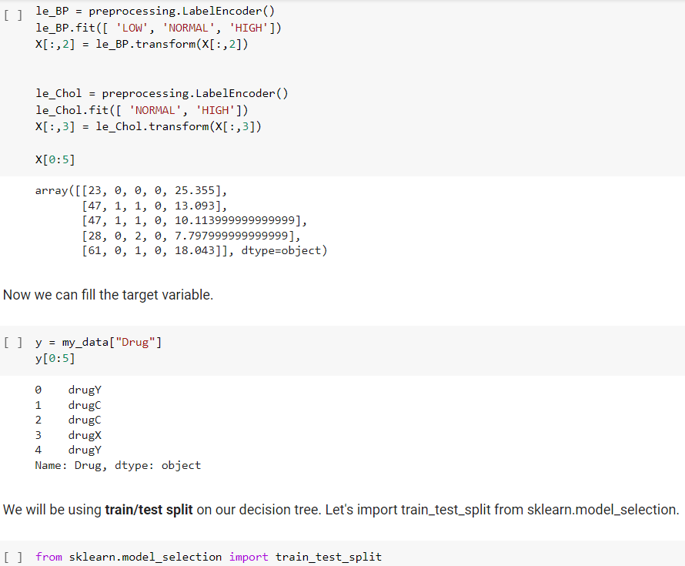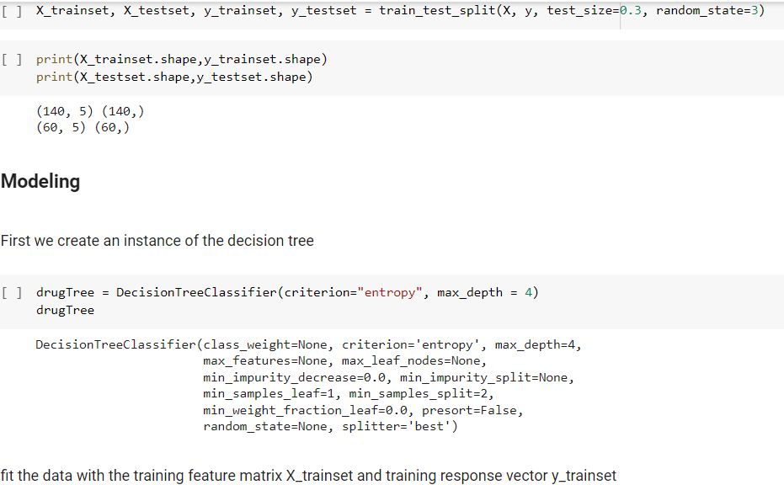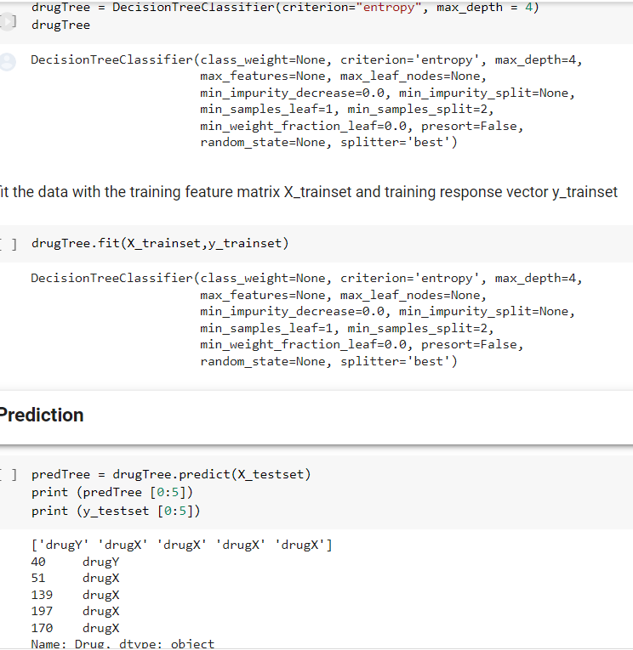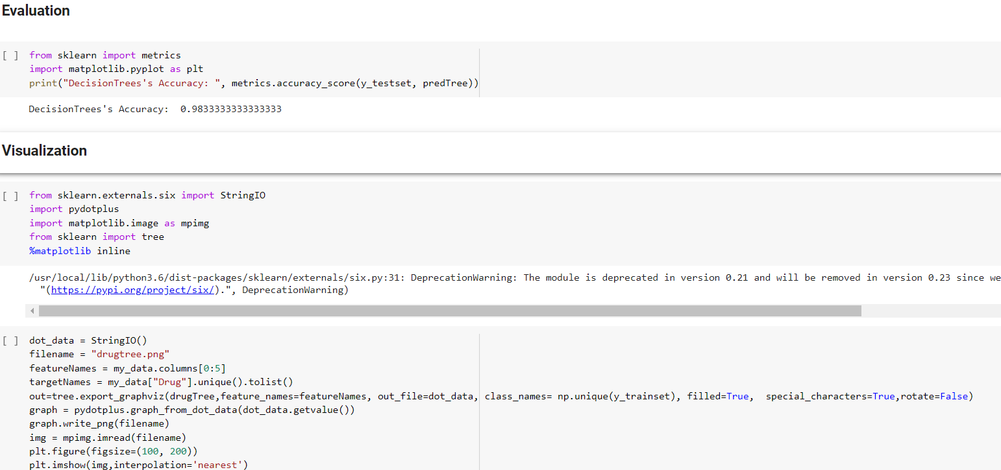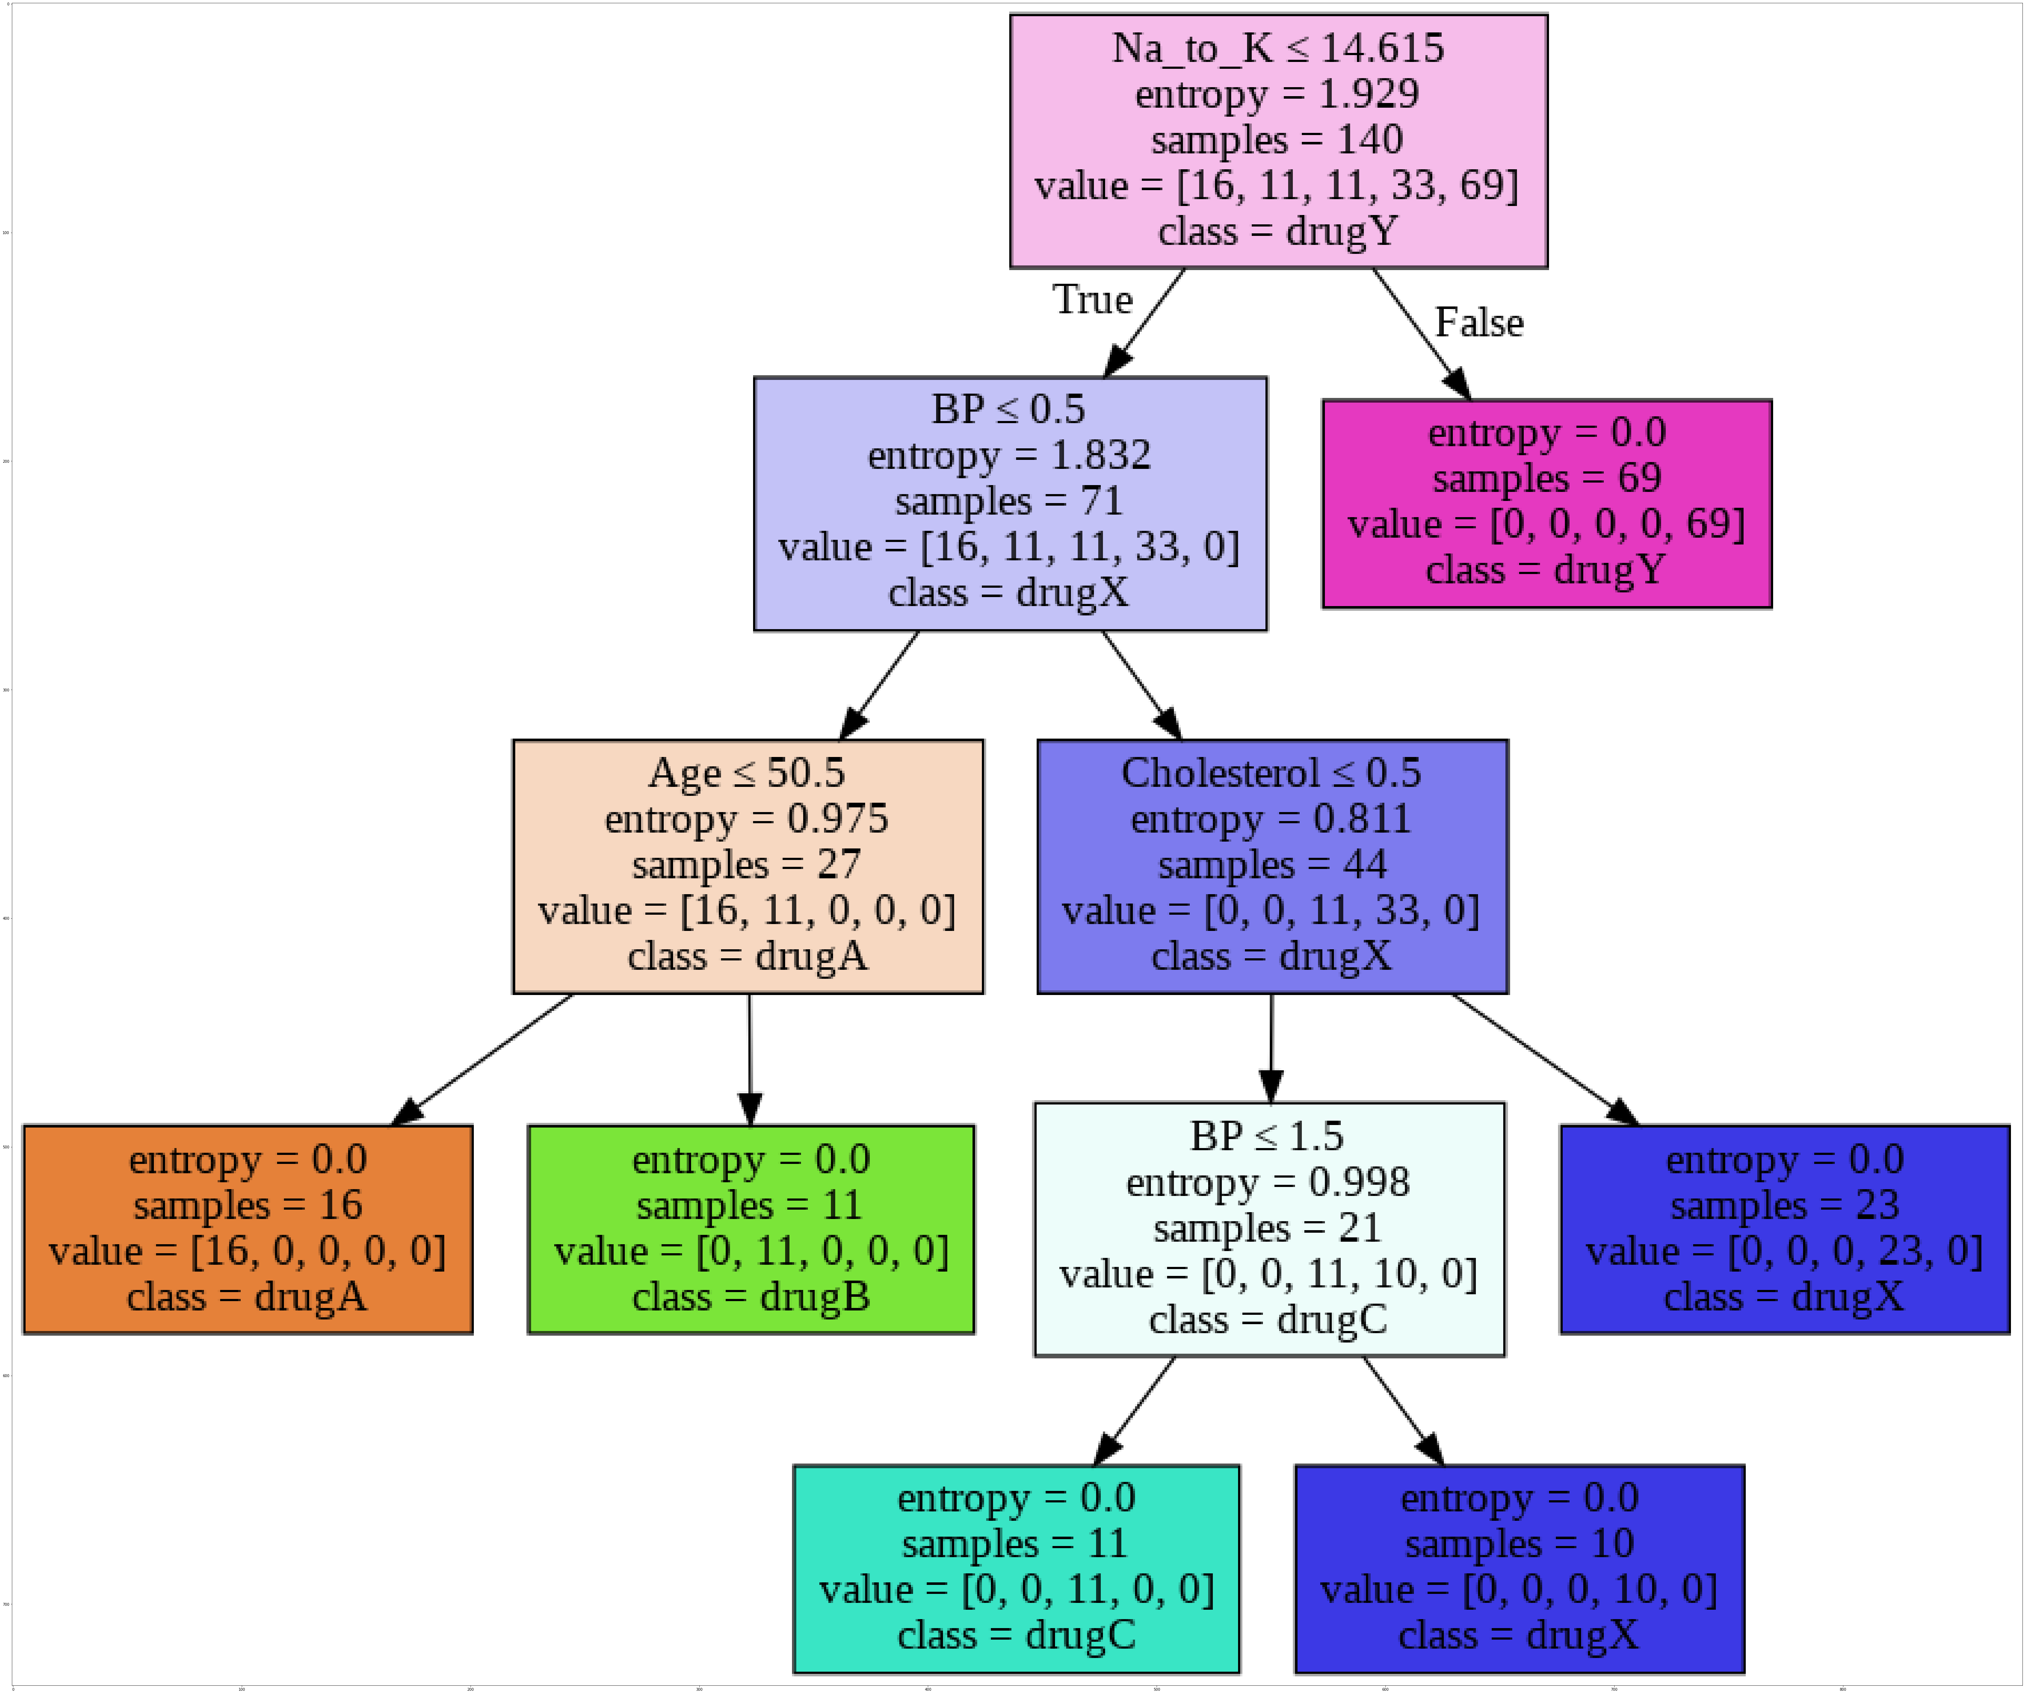
API/Function/Libraries used:
- numpy
- pandas
- skleran
- matplotlib

Conclusion:
We successfully understood and implemented the concept of decision tree Algorithm in jupyter NB.

