Batch: A1 Roll No.: 1911004

Experiment / assignment / tutorial No 1

Grade: AA / AB / BB / BC / CC / CD /DD

TITLE: : Shareholder portfolio data calculation.

AIM: Implement a program for Shareholder portfolio data calculation.
______________________________________________________________________
Expected OUTCOME of Experiment:
CO 1- Describe the Numbers, Math functions, Strings, List, Tuples and Dictionaries in Python
CO 2 - Interpret Different Decision Making statements, Functions, Object oriented programming in Python
_____________________________________________________________________
Books/ Journals/ Websites referred:
- Classroom Notes
_____________________________________________________________________
Pre Lab/ Prior Concepts:
Data structures are a way of organizing and storing data so that they can be accessed and worked with efficiently. They define the relationship between the data, and the operations that can be performed on the data. There are many various kinds of data structures defined that make it easier for the data scientists and the computer engineers, alike to concentrate on the main picture of solving larger problems rather than getting lost in the details of data description and access.
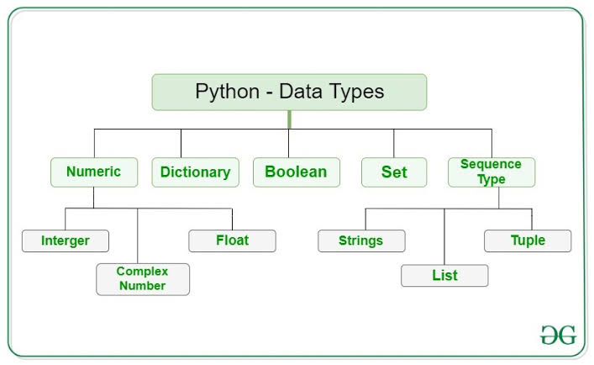
There are quite a few data structures available. The built-ins data structures are: lists, tuples, dictionaries, strings, sets and frozen sets.

Theory for Functions used to implement the given problem statement
- input("String ")
- input function is used to take input from user. The default data type of input value is string .Thus when we need to have integer or float datatypes value we type cast using int(input("Enter no")) or float(input("Enter no")).we can also take list as input & the split it.
- input("Enter list of no separated by ,").split(",")
- split(‘’) function is use to split the string into list of string when inputted string is split using mention character/string in parameters of split() . Here list of no is separated using the ‘,’ so that we get our list as input using single line without using for loop & append() on list variable. This helps to save & reduces our run time & space complexity
- print(p)
- print() function is used to print the variables/string/etc on the screen which are mention in paramters of print statement. It helps us to obtain output on screen. It has default end parameter as ‘\n’ thus every time out put is obtained on new line using print. We can change end as per our needs.
- shares.append(share)
- to append any variable/list/string/number etc we use append() to add the mentioned element in parameter to the given List. It increases the length of List.
- range(num)
- It helps us by giving range of number bu giving the Range of Numbers where starting default number is 0 & default increment value is 1. We can change it range(start,end,increament) here according to our need we can just change start,end,increament and thus get needed Range.

Problem Statement: Store the data about shares held by a user as tuples containing the following information about shares: Share name Date of purchase Cost price Number of Shares Selling price .Write a program to determine:
- Total cost of the portfolio
- Total amount gained or lost
- Percentage profit made or loss incurred.

Program: Notebook Link
ppl = []
noOfUser = int(input("Enter no of User "))
for user in range(noOfUser):
num = int(input("Enter num of different shares "));name = input("Enter ShareHolder Name ")
shares = []
for i in range(num):
share = input("Enter Share Name,Date Of Purchase,Cost Price,No of Shares,Selling Price ").split(",")
share[2],share[3],share[4] = int(share[2]),int(share[3]),int(share[4])
share = tuple(share)
shares.append(share)
ppl.append(tuple([name,shares]))
for p in ppl: print(p)
i = 1
for shares in ppl:
print("User no",i,"Name",shares[0])
TotCP = TotSP = TotalValue = TotalVP = 0
for share in shares[1]:
TotCP+=(share[2]*share[3])
TotSP+=(share[4]*share[3])
TotalValue = TotSP-TotCP
TotalVP = (TotalValue/TotCP)*100
if (TotalValue>0):
print("Total Cost of Portfolio Rs",TotSP,'\tProfit of Rs',TotalValue,"\tProfit% =","%.3f"%TotalVP)
elif (TotalValue<0):
print("Total Cost of Portfolio Rs",TotSP,'\tLoss of Rs',(-1*TotalValue),"\tLoss % =","%.3f"%(-1*TotalVP))
else:
print("Total Cost of Portfolio",TotSP,'\tNo Profit/Loss',"\tNo Profit/Loss %")
i+=1

Output:
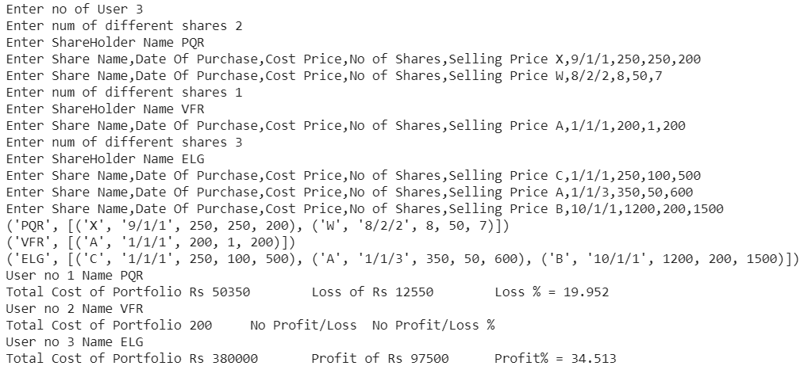

Conclusion: We successfully implemented the given problem statement in python using concepts of List, string, control, looping statements for it.
Post Lab Descriptive Questions
- Python supports multiprocessing that is executing more than one process of a program simultaneously.
- float() converts an integer to floating point number.
- To find XY , you will use * operator
- Explain use of ’'’
They are used as multiline string, however Python ignores string literals that are not assigned to a variable, so we can use these to add a multiline string (triple quotes) in our code, and hence, they can be used to add comments over multiple lines. We have to place them at the start and end of the comment content.
- Evaluate following expressions :
  - True and False
- False
  - (100<0) and (100>20)
- False
  - True or False
- True
  - Not True and False or True
- True

Date: 02-02-2021 Signature of faculty in-charge

