Batch: A1 Roll No.: 1911004

Experiment No. 2

Grade: AA / AB / BB / BC / CC / CD /DD

Signature of the Staff In-charge with date

TITLE: Implement the program for validating username and password.

AIM: Implement the program for validating username and password.
______________________________________________________________________
Expected OUTCOME of Experiment:

CO 1- Describe the Numbers, Math functions, Strings, List, Tuples and Dictionaries in
Python
CO 2 - Interpret Different Decision Making statements, Functions, Object oriented programming in Python
_____________________________________________________________________
Books/ Journals/ Websites referred:

- Core Python Applications Programming by Wesley J Chun
- https://www.tutorialspoint.com/python/index.htm

_____________________________________________________________________
Pre Lab/ Prior Concepts: Data structures are a way of organizing and storing data so that they can be accessed and worked with efficiently. They define the relationship between the data, and the operations that can be performed on the data. There are many various kinds of data structures defined that make it easier for the data scientists and the computer engineers, alike to concentrate on the main picture of solving larger problems rather than getting lost in the details of data description and access.
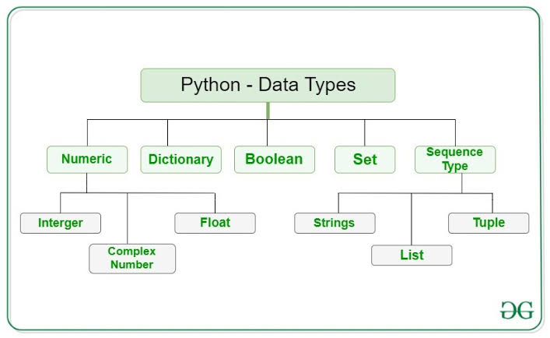
There are quite a few data structures available. The built-ins data structures are: lists, tuples, dictionaries, strings, sets and frozen sets.

Theory for Functions used to implement the given problem statement
- input("String ")
- input function is used to take input from user. The default data type of input value is string .Thus when we need to have integer or float datatypes value we type cast using int(input("Enter no")) or float(input("Enter no")).we can also take list as input & the split it.
- input("Enter list of no separated by ,").split(",")
- split(‘’) function is use to split the string into list of string when inputted string is split using mention character/string in parameters of split() . Here list of no is separated using the ‘,’ so that we get our list as input using single line without using for loop & append() on list variable. This helps to save & reduces our run time & space complexity
- print(p)
- print() function is used to print the variables/string/etc on the screen which are mention in paramters of print statement. It helps us to obtain output on screen. It has default end parameter as ‘\n’ thus every time out put is obtained on new line using print. We can change end as per our needs.
- len(l)
- It gives us the Length of mention List/String/Dict/Tuple mention in its parameters.It helps us when we want to iterate using loops through the Sequence & Mapping Datatypes.

Problem Statement: Write a program to accept the users input for username and password to register. Write a program to check the validity of Username and password input by users. Following are the criteria for checking the password:
1. At least 1 letter between [a-z]
2. At least 1 number between [0-9]
1. At least 1 letter between [A-Z]
3. At least 1 character from [$#@]
4. Minimum length of transaction password: 8
5. Maximum length of transaction password: 15
Your program should accept a sequence of comma separated passwords and will check them according to the above criteria. Passwords that match the criteria are to be printed, each separated by a comma.
Note: Unique username, valid password based on rules.
signup and then go for sign in checking with 2 or 3 attempts.
Program: Link of Notebook
part1
Credentials = {'username':'pAs$1234'}
i = -1
while (i!=0):
i = int(input("Enter 1.SignUp 2.LogIn 0.Exit "))
if i==1:
un = input("Enter a username ")
if un not in Credentials:
passW = (input("Enter password "))
flag = False
if (len(passW)>=8 and len(passW)<=15):
for ch in passW:
if ch in 'abcdefghijklmnopqrstuvwxyz':
flag = True
continue
elif ch in 'ABCDEFGHIJKLMNOPQRSTUVWXYZ':
flag = True
continue
elif ch in '0123456789':
flag = True
continue
elif ch in '$#@':
flag = True
continue
else:
flag = False
print("Your Password is Invalid ")
else :
print("Invalid Length") #pass

if (flag==True): #print(l,end=' , ')
Credentials[un]=passW
print("Sign up Successful")
else: print(un,"Already Exists Login")
elif i == 2:
un = input("Enter username ")
if un in Credentials:
passW =(input("Enter password "))
if passW == Credentials[un]: print("Login Successful")
else: print("Wrong Password")
else: print("Please Sign up")
elif i == 0: break
else: continue
print(Credentials)
part2
L = input("Enter list of password separated by , ").split(",")
print("Valid Passwords are :")
for l in L:
flag = False
if (len(l)>=8 and len(l)<=15):
for ch in l:
if ch in 'abcdefghijklmnopqrstuvwxyz':
flag = True
continue
elif ch in 'ABCDEFGHIJKLMNOPQRSTUVWXYZ':
flag = True
continue
elif ch in '0123456789':
flag = True
continue
elif ch in '$#@':
flag = True
continue
else:
flag = False #print("Your Password is Invalid ")
else :
pass #print("Invalid Length")
if (flag==True):
print(l,end = ' , ')
print('\b\b') #remove extra ,

Output: (Screenshot of Sample Output)
part1
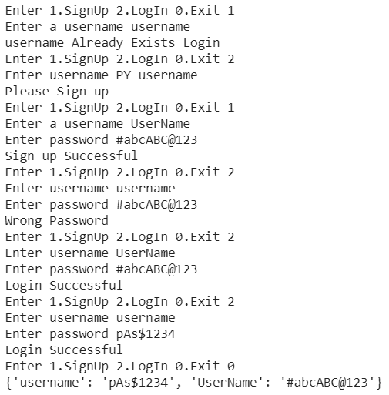
part2
Conclusion: We successfully implemented the given problem statement in python using concepts of dictionary, List, string, control, looping statements for it.
Post Lab Descriptive Questions
What will be the output of the following statements?
- str='python'
print (str.center(15,'*'))
Output *****python****
- str='abbabadaadbbaccabc'
print(str.count('ab',2))
Output 2
- str='PYTHON\nString\nConcepts'
print (str.splitlines())
Output ['PYTHON', 'String', 'Concepts']
- print ('+55'.zfill(5))
Output +0055
- str='abcdefcdyzcd'
print (str.split('cd',2))
Output ['ab', 'ef', 'yzcd']
- str='abcdefcdyz'
print (str.partition('cd'))
Output ('ab', 'cd', 'efcdyz')

Date: 02-02-2021 Signature of faculty in-charge

