Batch: A1 Roll No.: 1911004
Experiment / assignment / tutorial No. 04

Grade: AA / AB / BB / BC / CC / CD /DD

Signature of the Staff In-charge with date

Title: Implement a simple Lexical analyser for C language and Construct Symbol Table, Function Table, Operator Table, Keyword Table

AIM : To understand the implementation of Lexical analyser using the concept of regular expression and files
______________________________________________________________________
Expected OUTCOME of Experiment:

CO3: Understand and summarize different file handling operations
________________________________________________________________
Books/ Journals/ Websites referred:

1.“Compilers Principles, Techniques, and tools” by Aho, Sethi, Ulman Pearson publication.
_____________________________________________________________________
Pre Lab/ Prior Concepts:

Lexical analysis is the process of converting a sequence of characters into a sequence of tokens. Programs performing lexical analysis are called lexical analyzers or lexers. The specification of a programming language will include a set of rules, often expressed syntactically, specifying the set of possible character sequences that can form a token or lexeme. The whitespace characters are often ignored during lexical analysis.
A token can look like anything; it just needs to be a useful part of the structured text. Consider this expression in the C programming language:
newval:=oldval+12;

Tokenized in the following table:

Lexeme | Token type
newval | IDENT
:= | ASSIGN_OP
oldval | IDENT
+ | ADD_OP
12 | NUMBER
; | SEMICOLON

Tokens are frequently defined by regular expressions, which are understood by a lexical analyser generator such as lex. The lexical analyser (either generated automatically by a tool like lex, or hand-crafted) reads in a stream of characters, identifies the lexemes in the stream, and categorizes them into tokens. This is called "tokenizing." If the lexer finds an invalid token, it will report an error.

Following tokenizing is parsing. From there, the interpreted data may be loaded into data structures, for general use, interpretation, or compiling.

Stepwise-Procedure:
- Read a ’C’ file as input.
- Display a token for every lex unit
- Write into specified table/file (eg: keywords table/file, symbol table/file, keyword etc)

Implementation details:
Code:
import re
keyWords = ['auto', 'break', 'case', 'char', 'const', 'continue', 'default', 'do', 'double', 'else', 'enum', 'extern', 'float', 'for', 'goto', 'if', 'int', 'long', 'register', 'return', 'short', 'signed', 'sizeof', 'static', 'struct', 'switch', 'typedef', 'union', 'unsigned', 'void', 'volatile', 'while']
delim=['\t','\n',',',';','(',')','{','}','[',']','#','<','>']
operator=['+','-','*','/','%','=','!','~','^','&&','||','&','|',"<<",'>>','.','new',',']
predirect=["#include","#define"]
header=["<stdio.h>","<conio.h>","<malloc.h>","<process.h>","<string.h>","<ctype.h>"]
pattern = '([a-zA-Z_{1}][a-zA-Z0-9_]+)(?=\()'
k_ = [];i_= [];o_ = [];d_ = [];p_ = [];h_ = [];f_ = [];s_ = [];l_ = []
def isDelim(x):
if x in delim:
return True
return False
def isKeyWord(x):
if x in keyWords:
return True
return False
def isOperator(x):
if x in operator:
return True
return False
def isPreDirect(x):
if x in predirect:
return True
return False
def isHeader(x):
if x in header:
return True
return False
def isFunc(x):
if re.search(pattern,x):
return True
return False
def display(t,l):
print(t,'Table for given C code')
for i in set(l): print(i)
print()
try:
file = open(input('Enter the file name '))
f_ = re.findall(pattern,file.read())
file = open('file.c')
for line in file:
for token in line.split():
if isDelim(token):
d_.append(token)
elif isKeyWord(token):
k_.append(token)
elif isHeader(token):
h_.append(token)
elif isPreDirect(token):
p_.append(token)
elif isOperator(token):
o_.append(token)
elif isFunc(token):
pass#f_.append(token)
else:
if token.isdigit():
l_.append(token)
else:
s_.append(token)
except Exception as e: print(e)
finally: file.close()
print()
display('Symbol',s_);display('Keyword',k_);display('Operator',o_);display('Function',f_);display('Literal',l_)

Input C program:
#include <stdio.h>
int main() {
int sum = 5 + 10 ;
print( "%d" , sum ) ;
return 0 ;
}

Output: (Identified table/symbol table)
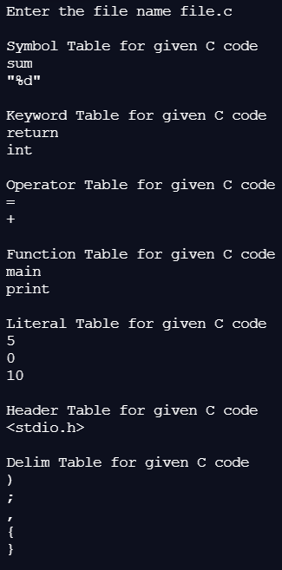
Post lab questions:
- What will be the output of the following Python code?
- f = None
- for i in range (5):
- with open("data.txt", "w") as f:
- if i > 2:
- break
- print(f.closed)
- True ANS a
- False
- None
- Error
2. The readlines() method returns ____________
a) str
b) a list of lines ANS b
c) a list of single characters
d) a list of integers
3. To open a file c:\scores.txt for reading, we use _____________
a) infile = open(“c:\scores.txt”, “r”)
b) infile = open(“c:\\scores.txt”, “r”) ANS b
c) infile = open(file = “c:\scores.txt”, “r”)
d) infile = open(file = “c:\\scores.txt”, “r”)
4. if a file opened in “w” mode does not exist, then
a) nothing will happen
b) file will be created
c) error will be generated ANS c
d) data will be written to a file that has a name a similar to the specified name
5. To open a file c:\scores.txt for reading, we use _____________
a) infile = open(“c:\scores.txt”, “r”)
b) infile = open(“c:\\scores.txt”, “r”) ANS b
c) infile = open(file = “c:\scores.txt”, “r”)
d) infile = open(file = “c:\\scores.txt”, “r”)

Conclusion:
We successfully understood & implemented concept of File Handling with Regex to code Lexical Analyser in Python for C thus obtaining correct necessary tokens’ tables as output.
Date: 06-04-2021 Signature of faculty in-charge

