Batch: A1 Roll No.: 1911004

Experiment / assignment / tutorial No.: 5

Grade: AA / AB / BB / BC / CC / CD /DD

Signature of the Staff In-charge with date

TITLE: User Defined Exception

AIM: Implement an user-defined exception using the Error class and implementing exception handling using try-except block
______________________________________________________________________
Expected OUTCOME of Experiment:

CO 2- Interpret different Decision Making statements, Functions, Object oriented programming in Python
_____________________________________________________________________
Books/ Journals/ Websites referred:
- Notes ppt
_____________________________________________________________________
Pre Lab/ Prior Concepts:

ERRORS: We can make certain mistakes while writing a program that lead to errors when we try to run it. A python program terminates as soon as it encounters an unhandled error.
These errors can be broadly classified into two classes:
- Syntax Errors
- Logical Errors (Exceptions)
Syntax Errors: Error caused by not following the proper structure (syntax) of the language is called syntax error or parsing error.
- Syntax error usually appear at compile time
- reported by the Interpreter & code doesn’t compile

Logical errors: Errors that occur at runtime (after passing the syntax test) are called exceptions or logical errors.
For instance, they occur when we :
- try to open a file(for reading) that does not exist (FileNotFoundError)
- try to divide a number by zero (ZeroDivisionError),
- try to import a module that does not exist (ImportError).
When these runtime errors occur, Python creates an exception object.

Exceptions : An exception is an event, which occurs during the execution of a program that disrupts the normal flow of the program's instructions. An exception is a Python object that represents an error.
When a Python script raises an exception, it must either handle the exception immediately otherwise it terminates and quits.

User Defined Exception:
We can further customize this class to accept other arguments as per our needs as shown below
Example:
#User Defined Exceptions
class Error(Exception): #Base class for other exceptions
pass
class ValueTooSmallError(Error): #Raised when the input value is too small
pass
number = 10 # Driver main program
while True:
try:
i_num = int(input("Enter a number: "))
if i_num < number:
raise ValueTooSmallError
break
except ValueTooSmallError:
print("This value is too small, try again!")

Problem statement: Write a Program that implements a Queue data structure of specified size.if the queue becomes full and we still try to add an element to it then a user-defined QueueError exception should be raised. Similarly, if the queue is empty and we try to delete an element from it then a QueueError exception should be raised.
Program (with comments)
queue = []
size=int(input("Enter size of the queue "))
class QueueError(Exception):
def __init__(self,arg):
self.msg=arg
def enqueue(queue, e):
if len(queue)==size:
raise QueueError("Queue Overflow Exception")
else:
queue.append(e)
def dequeue(queue):
if len(queue) < 1:
raise QueueError("Queue Underflow Exception")
else:
return queue.pop(0)
while(True):
op=int(input("Choose one:\n1)Enqueue queue\n2)Dequeue queue\n0)Quit\n"))
if op==1:
try:
e=int(input("Enter element to be added "))
enqueue(queue,e)
print("After adding: ",queue)
except QueueError as error:
print(error)
elif op==2:
try:
print(dequeue(queue)," has been removed\nAfter deleting ",queue)
except QueueError as error:
print(error)
elif op==0:
break
else:
print("Invalid choice")
Output:
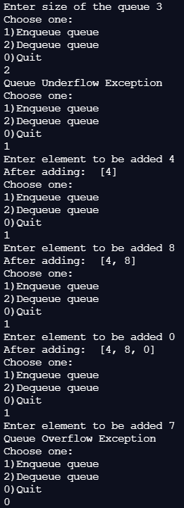
Post Lab Questions:
- What will be the output of the following Python code?
def foo():
try:
return 1
finally:
return 2
k = foo()
print(k)
- 1
- 2 ANS b
- 3
- error, there is more than one return statement in a single try-finally block
- Can one block of except statements handle multiple exception?
a) yes, like except TypeError, SyntaxError
b) yes, like except [TypeError, SyntaxError] ANS b
c) no
d) none of the mentioned
- What is the output of the following code ?
a = 20
b = 30
assert b - a , 'a is smaller than b'
print(b)
- 20
- 30 ANS b
- AssertionError: a is smaller than b
- 10
4. Which type of error specifies all those type of errors in which the program executes but gives incorrect results?
a) syntax
b) logic ANS b
c) exception
d) none of these
5. Which block acts as a wildcard block to handle all exceptions ?
a) try
b) except Exceptionclass
c) except: ANS c
d) catch

Conclusion:
We successfully understood & implemented the concept of Exception Handling in Python by defining user defined QueueError Exception & thus obtaining correct necessary output.

Date: 04-04-2021 Signature of faculty in-charge

