Batch: A1 Roll No.: 1911004

Experiment / assignment / tutorial No. 7

Grade: AA / AB / BB / BC / CC / CD /DD

Signature of the Staff In-charge with date

TITLE: Validity and class of IP address using Regular Expression

AIM: Implementation of validity and class of IP address using f Regular Expression.
______________________________________________________________________
Expected OUTCOME of the experiment:

CO2- Interpret different decision making statements, functions, object oriented programming in python
_____________________________________________________________________
Books/ Journals/ Websites referred:

- ppt notes
_____________________________________________________________________
Pre Lab/ Prior Concepts:

Regular expression:
Regular Expressions are sequence of characters which form a powerful tool for searching & matching pattern. It can detect the presence or absence of a text by matching with a particular pattern, and also can split a pattern into one or more sub-patterns. Thus, to find a pattern in a string it is used.

Python packages to support regular expression
Python has a built-in package called re, which can be used to work with Regular Expressions.

Import the regex module re:
import re

Regex methods
Function | Explanation
search | Returns a Match object if there is a match anywhere in the string
findall | Returns a list containing all matches
split | Returns a list where the string has been split at each match
sub | Replaces one or many matches with a string

Metacharacters
[] A set of characters "[a-m]"
. Any character (except newline character) "p...on"
^ Starts with "^py"
| Either or "are|is"
$ Ends with "prog$"
* Zero or more occurrences "str*"
\ Signals a special sequence "\d"
+ One or more occurrences "str+"
{} Exactly the specified number of occurrences "th{2}"
() Capture and group

Example of regular expression
import re
s = "the python program"
print(re.findall("th",s))
# output ➔ ['th', 'th']

IP address & classes of IP address in IPV4 :
Class | Leading  bits | Size of network  no bit field | Size of rest  bit field | No  of networks | Addresses  per network | Start address | End address
Class A | 0 | 8 | 24 | 128 (2⁷) | 16,777,216 (2²⁴) | 0.0.0.0 | 127.255.255.255
Class B | 10 | 16 | 16 | 16,384 (2¹⁴) | 65,536 (2¹⁶) | 128.0.0.0 | 191.255.255.255
Class C | 110 | 24 | 8 | (2²¹) | 256 (2⁸) | 192.0.0.0 | 223.255.255.255
Class D (multicast) | 1110 | not defined | not defined | not defined | not defined | 224.0.0.0 | 239.255.255.255
Class E (reserved) | 1111 | not defined | not defined | not defined | not defined | 240.0.0.0 | 255.255.255.255

Program:
import re
IP=input("Enter an IP address: ")
ans=re.findall(r'^([0-9]|[1-9][0-9]|1[0-9][0-9]|2[0-4][0-9]|25[0-5])\.([0-9]|[1-9][0-9]|1[0-9][0-9]|2[0-4][0-9]|25[0-5])\.([0-9]|[1-9][0-9]|1[0-9][0-9]|2[0-4][0-9]|25[0-5])\.([0-9]|[1-9][0-9]|1[0-9][0-9]|2[0-4][0-9]|25[0-5])$',IP)
if(ans):
print("Valid IP Address")
if (re.search(r'^([0-9]?[0-9]|[1][0-2][0-7])\.',IP)):
print("Class A")
elif (re.search(r'^([1][2][8-9]|[1][3-8][0-9]|19[0-1])\.',IP)):
print("Class B")
elif (re.search(r'^(19[2-9]|2[0-1][0-9]|22[0-3])\.',IP)):
print("Class C")
elif (re.search(r'^(22[4-9]|23[0-9])\.',IP)):
print("Class D")
elif (re.search(r'^(24[0-9]|25[0-5])\.',IP)):
print("Class E")
else:
print("Invalid IP Address")

Output:
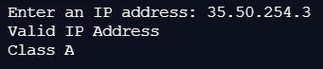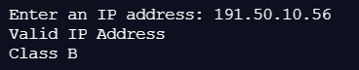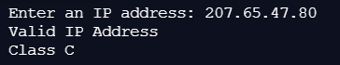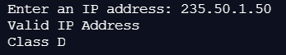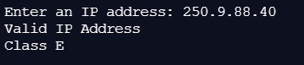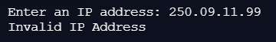
Post lab questions: Select the right choice/s
- The character Dot (that is, ‘.’) in the default mode, matches any character other than _____________
a) caret
b) ampersand
c) percentage symbol
d) newline ANS D

- What will be the output of the following Python code?

re.split('\W+', 'Hello, hello, hello.')
a) [‘Hello’, ‘hello’, ‘hello.’]
b) [‘Hello, ‘hello’, ‘hello’]
c) [‘Hello’, ‘hello’, ‘hello’, ‘.’]
d) [‘Hello’, ‘hello’, ‘hello’, ”] ANS D

- Which of the following functions results in case insensitive matching?
a) re.A
b) re.U
c) re.I ANS C
d) re.X

- What will be the output of the following Python function?

re.findall("hello world", "hello", 1)
a) [“hello”]
b) [ ] ANS B
c) hello
d) hello world

- The expression a{5} will match _____________ characters with the previous regular expression.
a) 5 or less
b) exactly 5 ANS B
c) 5 or more
d) exactly 4

Conclusion:
Regular Expressions in python were studied & implemented to verify valid & class of IP Addresses with correct necessary output.

Date: 29/03/2021 Signature of faculty in-charge

