Batch: A1 Roll No.: 1911004

Experiment No. 01

Grade: AA / AB / BB / BC / CC / CD /DD

Signature of the Staff In-charge with date

Title: Activation functions.
___________________________________________________________________________________
Objective: To implement activation functions of Neural Network.
___________________________________________________________________________________
Expected Outcome of Experiment:

CO1 : Identify and describe soft computing techniques and their roles ____________________________________________________________________________________
Books/ Journals/ Websites referred:
- J.S.R.Jang, C.T.Sun and E.Mizutani, “Neuro-Fuzzy & Soft Computing”, PHI, 2004, Pearson Education 2004.
- Davis E.Goldberg, “Genetic Algorithms: Search, Optimization and Machine Learning”, Addison Wesley, N.Y., 1989.
- S. Rajasekaran and G.A.V.Pai, “Neural Networks, Fuzzy Logic and Genetic Algorithms”, PHI, 2003.
- http://library.thinkquest.org/C007395/tqweb/history.html
____________________________________________________________________________________
Pre Lab/ Prior Concepts:
Neural networks, sometimes referred to as connectionist models, are parallel-distributed models that have several distinguishing features-
1) A set of processing units;
2) An activation state for each unit, which is equivalent to the output of the unit;
3) Connections between the units. Generally each connection is defined by a weight w_{jk} that
determines the effect that the signal of unit j has on unit k;
4) A propagation rule, which determines the effective input of the unit from its external inputs;
5) An activation function, which determines the new level of activation based on the effective
input and the current activation;
6) An external input (bias, offset) for each unit;
7) A method for information gathering (learning rule);
8) An environment within which the system can operate, provide input signals and, if necessary,
error signals.
____________________________________________________________________________________
Implementation Details:
Most units in neural network transform their net inputs by using a scalar-to-scalar function called an activation function, yielding a value called the unit's activation. Except possibly for output units, the activation value is fed to one or more other units. Activation functions with a bounded range are often called squashing functions. Some of the most commonly used activation functions are :
- Identity function
- The identity function is a function which returns the same value, which was used as its argument. It is also called an identity relation or identity map or identity transformation.
- If f is a function, then identity relation for argument x is represented as
f(x) = x ; for all values of x
Graph:
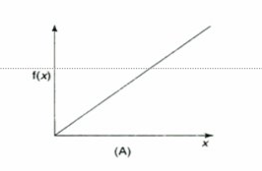
- Binary step function
- A binary step function is a threshold-based activation function. If the input value is above or below a certain threshold, the neuron is activated and sends exactly the same signal to the next layer.
- It is defined as
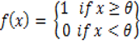
[ θ represents the threshold value]
- It is used in single layer nets to convert the net input to an output that binary(0 or 1).
Graph:
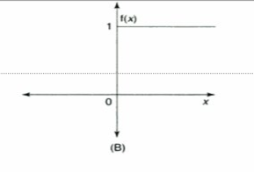
3) Sigmoid function
There are two types :
- Binary Sigmoid function
- It is logistic function or unipolar sigmoid function
- It is defined as :
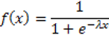
where λ = steepness parameter
- The derivative of this function is :
f’(x) = λ1 f(x)[1-f(x)]
- Graph:
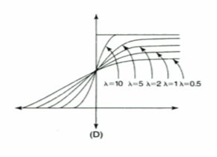

- Bipolar Sigmoid function
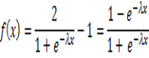
- Where λ is the steepness parameter and the sigmoid range is between -1 and +1.
- The derivative of this function can be
f’(x) = λ /2 ([1+f(x)][1-f(x)])
- It is closely related to hyperbolic tangent function, which is written as 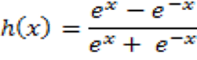
- Graph:
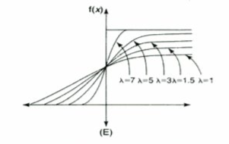

Code :
import java.util.*;
class Main {
public static void main(String[] args) {
Scanner ob = new Scanner(System.in);
System.out.print("Enter no of i/p = ");
int n=ob.nextInt(),i=0;
System.out.print("Enter Inputs = ");
int a[]= new int[n];
for(i=0;i<n;i++){
a[i]=ob.nextInt();
}
System.out.print("Enter Threshold = ");
int t = ob.nextInt();
System.out.print("Enter Steepness parameter = ");
int s = ob.nextInt();
System.out.print("Identity : ");
for(i=0;i<n;i++){
System.out.print(a[i]+" ");
} System.out.println("");
System.out.print("Binary : ");
for(i=0;i<n;i++){
if(a[i]<t)
System.out.print("0 ");
else
System.out.print("1 ");
} System.out.println("");
System.out.print("Bipolar : ");
for(i=0;i<n;i++){
if(a[i]<t)
System.out.print("-1 ");
else
System.out.print("1 ");
} System.out.println("");
System.out.print("Binary Sigmoidal : ");
for(i=0;i<n;i++){
System.out.print((1/(1+Math.exp(-s*a[i])))+" ");
} System.out.println("");
System.out.print("Bipolar Sigmoidal : ");
for(i=0;i<n;i++){
System.out.print(((2/(1+Math.exp(-s*a[i])))-1)+" ");
} System.out.println("");
System.out.print("Ramp Function : ");
for(i=0;i<n;i++){
if(a[i]>1)
System.out.print("1 ");
else if(a[i]<0)
System.out.print("0 ");
else
System.out.print(a[i]+" ");
} System.out.println("");
}
}

Output:

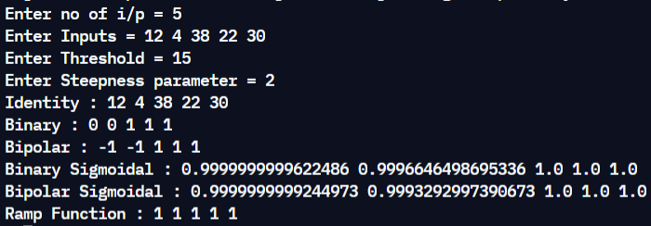
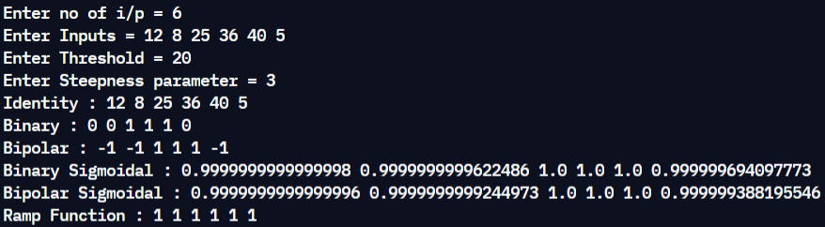

Conclusion: Thus, we have successfully implemented 4 Activation Functions of Neural Network.

Post Lab Descriptive Questions :

- Explain the concept behind using Activation function.
- An Activation function is biologically inspired by activities inside our brain wherein different neurons get activated by different stimulus. For instance, if we smell something delicious, certain neurons gets fired or activated which helps us to sense the smell or taste. On the contrary, if we smell something awful or unpleasant, the same neurons do not get activated, instead another set of neurons do. So briefly, “getting activated” can be represented as 1 and “not getting activated” can be represented as 0.
Activation function decides, whether a neuron should be activated or not by calculating weighted sum and further adding bias with it. The purpose of the activation function is to introduce non-linearity into the output of a neuron. We know, neural network has neurons that work in correspondence of weight, bias and their respective activation function. In a neural network, we would update the weights and biases of the neurons on the basis of the error at the output. This process is known as back-propagation. Activation functions make the back-propagation possible since the gradients are supplied along with the error to update the weights and biases.

- Explain different types of neural network.
- Perceptron (P):
The perceptron model is also known as a single-layer neural network. This neural net contains only two layers:
- Input Layer
- Output Layer
In this type of neural network, there are no hidden layers. It takes an input and calculates the weighted input for each node. Afterward, it uses an activation function (mostly a sigmoid function) for classification purposes.
Applications:
- Classification.
- Encode Database (Multilayer Perceptron).
- Monitor Access Data (Multilayer Perceptron).
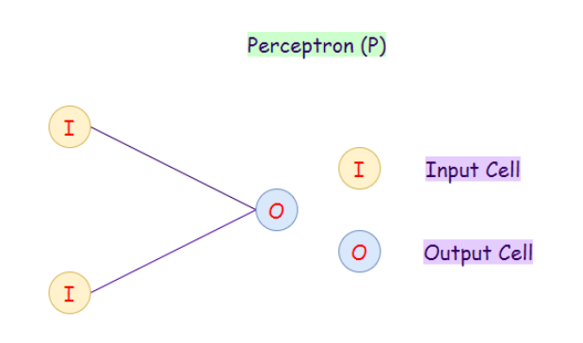
- Feed Forward (FF):
A feed-forward neural network is an artificial neural network in which the nodes do not ever form a cycle. In this neural network, all of the perceptrons are arranged in layers where the input layer takes in input, and the output layer generates output.
Applications:
- Data Compression.
- Pattern Recognition.
- Computer Vision.
- Sonar Target Recognition.
- Speech Recognition.
- Handwritten Characters Recognition.
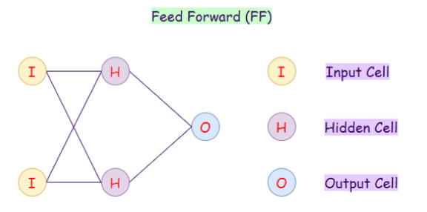
- Radial Basis Network (RBN):
Radial basis function networks are generally used for function approximation problems. They can be distinguished from other neural networks because of their faster learning rate and universal approximation. The main difference between Radial Basis Networks and Feed-forward networks is that RBNs use a Radial Basis Function as an activation function. A logistic function (sigmoid function) gives an output between 0 and 1, to find whether the answer is yes or no. The problem with this is that if we have continuous values, then an RBN can’t be used. RBIs determines how far is our generated output from the target output. These can be very useful in case of continuous values. In summary, RBIs behave as FF networks using different activation functions.
Applications:
- Function Approximation.
- Timeseries Prediction.
- Classification.
- System Control.
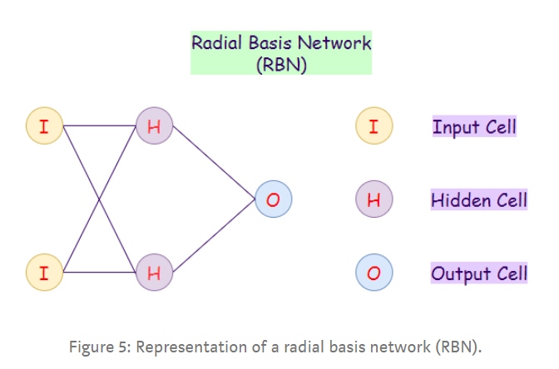
- Deep Feed-forward (DFF):
A deep feed-forward network is a feed-forward network that uses more than one hidden layer. The main problem with using only one hidden layer is the one of overfitting, therefore by adding more hidden layers, we may achieve (not in all cases) reduced overfitting and improved generalization.
Applications:
- Data Compression.
- Pattern Recognition.
- Computer Vision.
- ECG Noise Filtering.
- Financial Prediction.
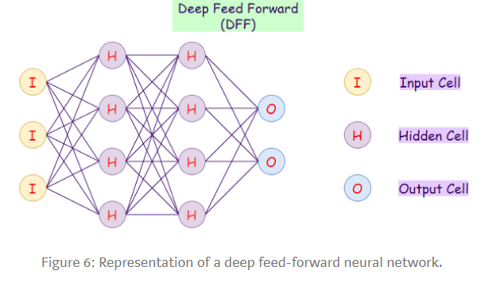
- Recurrent Neural Network (RNN):
Recurrent neural networks (RNNs) are a variation to feed-forward (FF) networks. In this type, each of the neurons in hidden layers receives an input with a specific delay in time. We use this type of neural network where we need to access previous information in current iterations. For example, when we are trying to predict the next word in a sentence, we need to know the previously used words first. RNNs can process inputs and share any lengths and weights across time. The model size does not increase with the size of the input, and the computations in this model take into account the historical information. However, the problem with this neural network is the slow computational speed. Moreover, it cannot consider any future input for the current state. It cannot remember info from a long time ago.
Applications:
- Machine Translation.
- Robot Control.
- Time Series Prediction.
- Speech Recognition.
- Speech Synthesis.
- Time Series Anomaly Detection.
- Rhythm Learning.
- Music Composition.
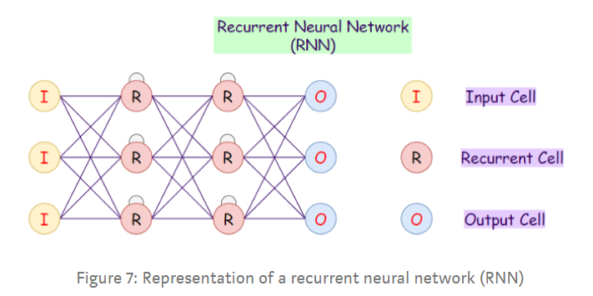
- Long / Short Term Memory (LSTM):
LSTM networks introduce a memory cell. They can process data with memory gaps. Above, we can notice that we can consider time delay in RNNs, but if our RNN fails when we have a large number of relevant data, and we want to find relevant data from it, then LSTMs is the way to go. Also, RNNs cannot remember data from a long time ago, in contrast to LSTMs.
Applications:
- Speech Recognition.
- Writing Recognition.
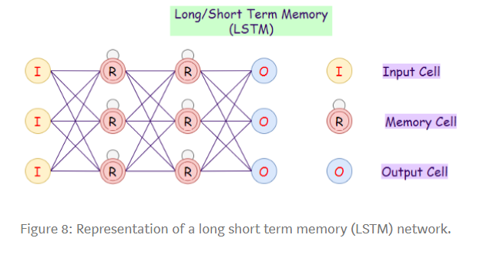

Date: 28-08-2021 Signature of faculty in-charge

