Batch: A1 Roll No.: 1911004

Experiment No. 10

Grade: AA / AB / BB / BC / CC / CD /DD

Signature of the Staff In-charge with date

Title: Case study on Fuzzy systems
__________________________________________________________________________________
Objective: To gain a greater understanding of Fuzzy Systems and its applications
__________________________________________________________________________________
Expected Outcome of Experiment:
CO2 : Apply basics of fuzzy logic.
___________________________________________________________________________________
Books/ Journals/ Websites referred:
- http://www.arpnjournals.org/jeas/research_papers/rp_2016/jeas_0316_3756.pdf
- Abul-Haggag O. Y. and Barakat W. 2013. Application of Fuzzy Logic for Risk Assessment using Risk Matrix. International Journal of Emerging Technology and Advanced Engineering, p. 3.
- Altenbach T. J. 1995. A comparison of risk assessment techniques from qualitative to quantitative. Lawrence Livermore National Lab., CA (United States).
- Arunraj N. and Maiti J. 2007. Risk-based maintenanceTechniques and applications. Journal of Hazardous Materials. 142, 653-661.
- Chan H. K. and Wang, X. 2013. Fuzzy Hierarchical Model for Risk Assessment. London: Springer London. Doi. 10, 978-1.
- Hellmann M. 2001. Fuzzy logic introduction. Université de Rennes, 1.
- Klir G. and Yuan, B. 1995. Fuzzy sets and fuzzy logic, Prentice Hall New Jersey. Lee C. C. 1990. Fuzzy logic in control systems: fuzzy logic controller. II. Systems, Man and Cybernetics, IEEE Transactions on. 20, 419-435.
- Markowski A. S. and Mannan M. S. 2008. Fuzzy risk matrix. Journal of hazardous materials. 159, 152-157.
- Pokoradi L. 2002. Fuzzy logic-based risk assessment. AARMS, Academic and Applied Research in Military Science, 1, 63-73. Radu L.-D. 2009.
___________________________________________________________________________________

Pre Lab/ Prior Concepts:
Risk assessment is a process of categorizing and measurement of risk related outcomes from a specific incident and in a particular scenario. While risk itself is considered as the combination of likelihood and severity of the consequences of hazards. Typically, the qualitative approach of risk based inspection (RBI) is applied in oil and gas industries to measure the risk levels of hazards. But with this qualitative approach sometime the risk ranking ties among the different factors can lead to problem in selecting the most critical factor. To address the problem, this study aims to develop a fuzzy logic-base risk assessment model using a quantitative approach of RBI that will assist to mitigate the risk ties in risk ranking process of hazard. In this proposed model, fuzzy membership functions and ranges have been assigned for likelihood, severity of consequences and for total risk levels. A case study on ammonia hazard is presented to demonstrate the vitality of the proposed fuzzy risk assessment model with samples of four categories (people, environment, asset and reputation) from an oil and gas industry. The outcomes of this study indicate that the developed model has a strong potential application in oil and gas industry in assessing the severity levels of risk, and resolving risk ranking ties.
___________________________________________________________________________________
Implementation Details:

FUZZY LOGIC-BASED RISK ASSESSMENT IN OIL AND GAS INDUSTRY:

INTRODUCTION

It has been observed from recent literature that risk assessment has been considered as a critical factor in oil and gas industries, the investigation of risk assessment factors assists the oil and gas industry to minimize the risk related issues. Additionally, it can cause personal injuries of workers, environmental damages, degradation and destruction of the assets, strategically these factors have high effects on the reputation of the industry. It has been established from past studies that the risk assessment process is a combination of likelihood and consequence of the hazard. The literature suggested that generally there are three approaches to calculate the risk level; qualitative approaches, semi-quantitative approaches and quantitative approaches (Pokoradi, 2002, Radu, 2009, Arunraj and Maiti, 2007). Basically, the qualitative risk assessment is a complete process of hazard analysis, this process, identify and provide comprehensive information with some relative decisions in order to categorize the probable hazards and risks. The common use of this approach is to investigate the compliance assessment. While the semiquantitative approach is applied to categorizing the equipment/components, whereas to conclude final risk scores are achieved by using different methods. The quantitative approach applied to measure the risk, in this approach the numerical values being used for any specific hazard (Ramona, 2011; Altenbach, 1995). Considering the above arguments some objectives have been set to develop a model and validation of that model with some set of data taken from oil and gas industry. To fulfill the aims, this study incorporated the quantitative risk assessment approach with fuzzy logic to evaluate the risk and reduce the risk ranking ties involved with four categories of hazard (people, environment, asset and reputation).

FUZZY LOGIC IN RISK ASSESSMENT

Fuzzy logic (FL) has been formulated by Zadeh in 1965 (Zadeh, 1965). It is based on the set of mathematical principals to represent knowledge based on degrees of membership and degrees of truth. It reflects towards the thinking and intellectual capabilities of people in giving models and different circumstances. The use of FL approach in risk assessment has been covered a range of application such as; assessing of earthquake risk, assessing of environmental risk, assessing of project risk, safety risk assessment and supply chain risk assessment (Chan and Wang, 2013). The advantages of fuzzy logic are to be modelling the complex problem where linguistic variables are used to express the specific logic rules.
The basic structure of a fuzzy inference system is based on these processes; fuzzification, inference engine and defuzzification. The detail fuzzy inference system is shown in Figure-1. In terms of risk assessment, FL has been virtuous approach in dealing with operational risk, where the assessment is often based on the expert opinion (Hellmann, 2001, Markowski and Mannan, 2008). Moreover; during the fuzzification process, the membership functions are defined as “the input variables which have been applied to their actual values”.
In inference process the truth-value for the foundation of each rule is computed, and it will apply to the concluding part of each rule. These sets of rules are generated from engineering knowledge with the collection of IF-THEN statement. IF the severity of people is catastrophic AND the likelihood of people is Unlikely, THEN the risk will be high (Wang, 1999). The catastrophic, unlikely and high are characterized by the membership functions. In the process of defuzzification the values are estimated for weighting and averaging from the dependent variables which based on a single output fuzzy crisp number after applying the fuzzy inference rule.
Also, in defuzzification process the aggregated membership functions can simply represent the value of the overall risk as a fuzzy system (Klir and Yuan, 1995; Lee, 1990; Ross, 2009; Sii et al., 2001).

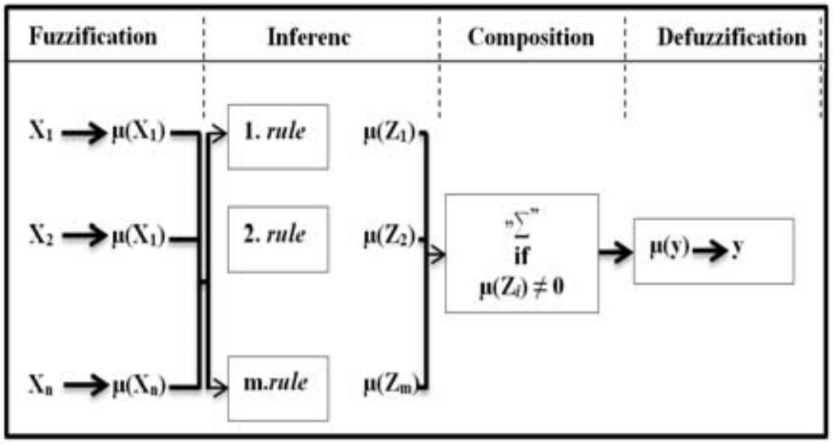

In this study a risk assessment of ammonia hazard in oil and gas industry is used as a case study. The Ammonia hazard has been categorized under four categories (people, environment, asset and reputation) and it is based on the qualitative approach. The fuzzy logic approach has been adopted to the transformation of qualitative risk evaluation data set into fuzzy value.

METHODOLOGY
The methodology used for developing of the fuzzy risk assessment model is shown in Figure-2.
Step 1
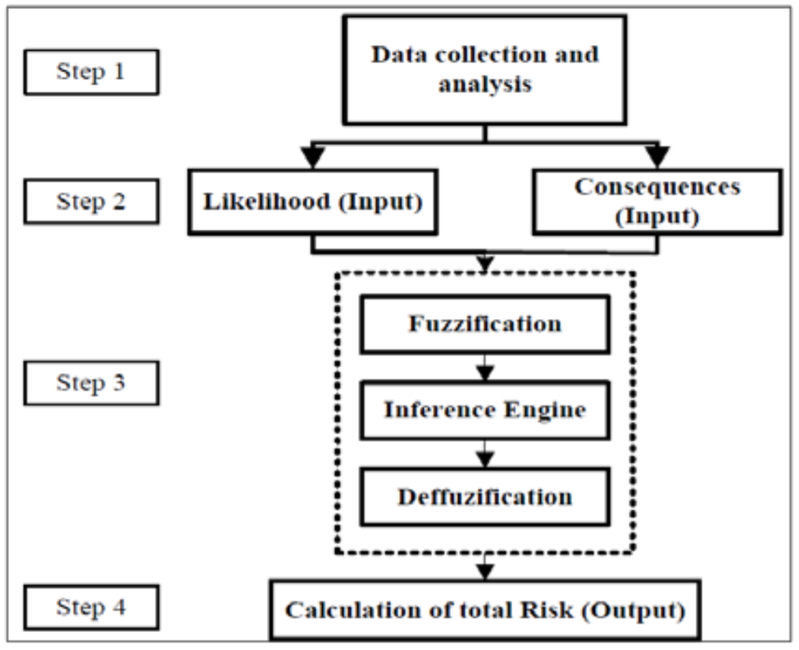

This step is based on data collected, and a set of data is required to validate the proposed model. An excel based template has been created to assist data collection and later it was sent to responded to assess the risk of hazard through likelihood and consequence with their existing method. The received data were qualitative and based on ammonia hazard which comprises these four categories; people, environment, asset, and reputation. Further, the data has been transferred in fuzzy value and used in the proposed model to evaluate the total risk which will assist to reduce the risk ranking ties among four categories.

Step 2
The Matlab was used to apply fuzzy logic Toolbox to develop a fuzzy risk assessment model. The model has been assigned the input (likelihood and consequence) and output (Risk) variables and selection of a ‘‘membership function’’ for input and output variables. In this fuzzy risk assessment model the Gaussian type of membership function has been used to derive the fuzzy values for the input quantitative data, as it has been quite proven that this type of membership function is the most natural and popular choice for risk assessment (AbulHaggag and Barakat, 2013). A membership function is a curve and it defines how the values of a fuzzy input and output variables are represented in degrees of membership or degrees of truth between 0 and 1 (Simoes, 2010). In place of risk assessment, Table-1 and Table-2 has been used to determine the likelihood and consequence for four categories (people, environment, asset and reputation). The risk matrix shows in Figure-3 has been used to generate the inputs (likelihood and consequence) and output (Risk) in the model. The risk matrix has been applied by oil and gas industry to evaluate the overall risk of hazard by qualitatively.
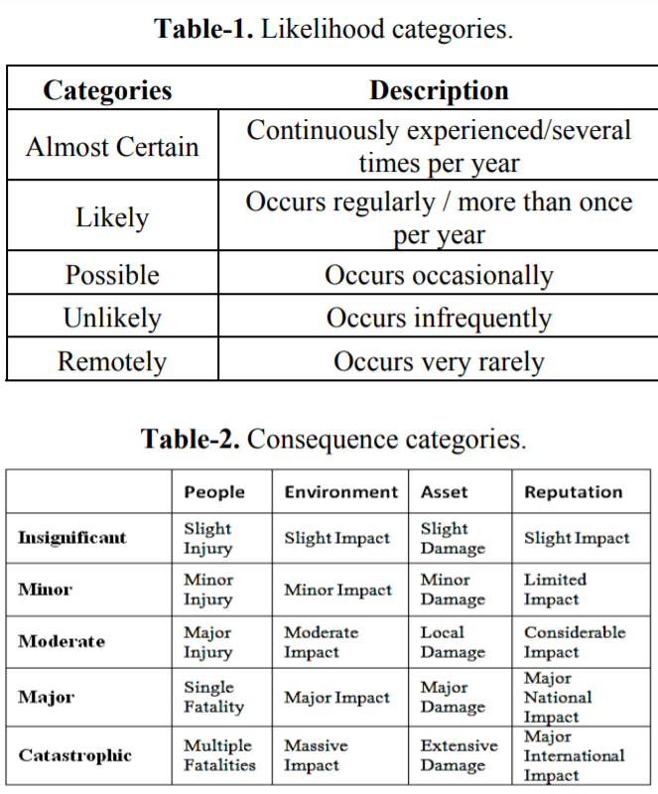

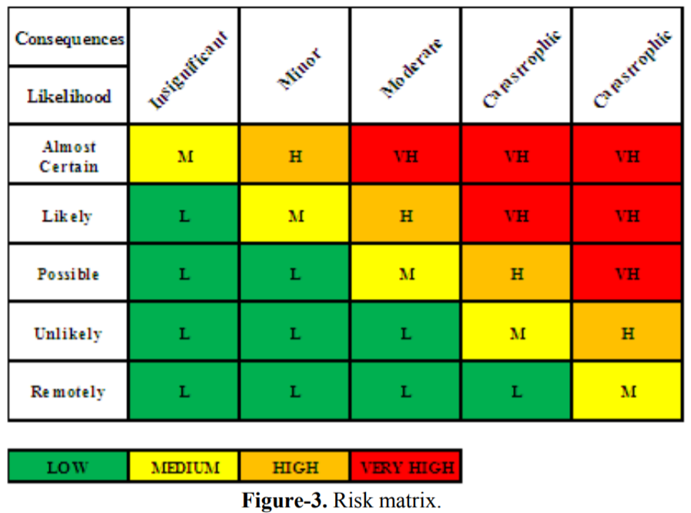

Step 3
The qualitative data were transferred in fuzzy set values in the risk matrix to evaluate the overall risk as shown in Table-3. The input membership functions of likelihood categories such as; Remote, unlikely, possible, likely and almost certain with assigned ranges from 0 to 10 shows in Figure-4. Figure-5 shows the input membership functions for consequence categories (people, environment, asset and reputation) have been categorized in five membership functions such as: Insignificant, minor, moderate, major and catastrophic with assigned ranges from 0 to 10.
The total risk has been categorized into four membership functions; Low, medium, high and very high. Ranges have been assigned from 1 to 100 as shown in Figure-6
In this research, we have proposed fuzzy risk assessment model rules which contain linguistic variables related to the risk ranking. The OR, AND logical operation has been used in rule base for fuzzy inference system. We have implemented with 2 inputs with 1 output. A set of twenty-five aggregation rules have been settled and determine that how the risk level change under the different scenarios. The rules in the rule base are the combination of likelihood, consequences and total risk which are based on the risk matrix shown in Figure-3.

Step 4 Calculation of risk level is done by interpreting the final output risk score. However, the fuzzy rules and risk rating can be modifiable according to company’s own risk criteria.

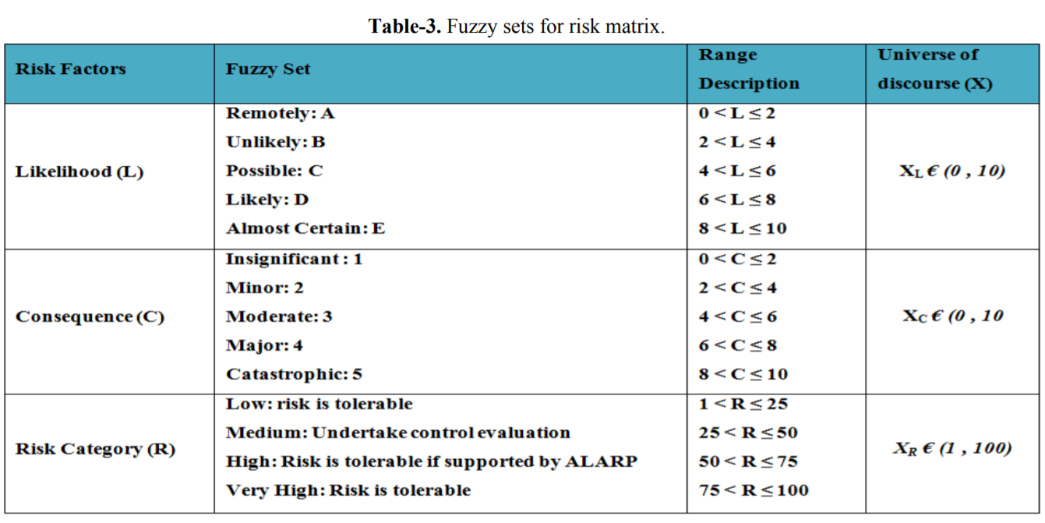
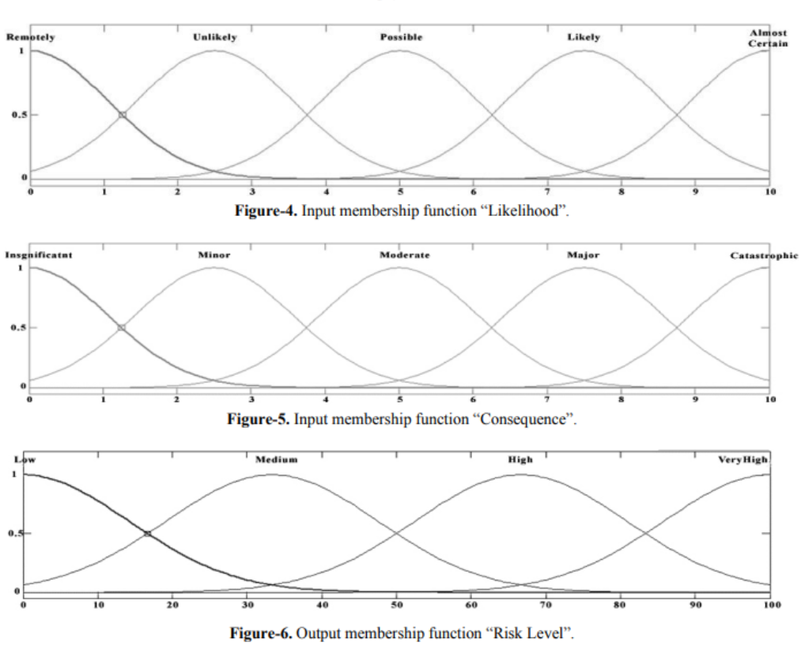
RESULTS AND DISCUSSIONS
Ammonia hazard in oil and gas industry has been used as a case study. For validation of proposed fuzzy risk assessment model, the hazard data set has been evaluated under four categories; people, environment, asset and reputation. The process of risk assessment for qualitative and proposed fuzzy risk assessment model for these categories are shown in Tables 4-7. Additionally; simulation was performed to compare the calculation results of qualitative risk assessment and the proposed fuzzy risk assessment model.
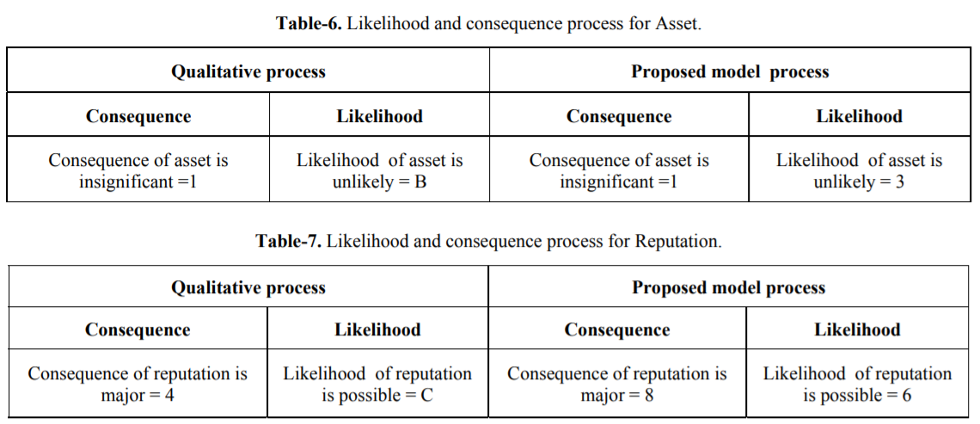

Figure-7 shows how aggregating membership functions (input and output) indicate the risk level in a fuzzy risk assessment method. It illustrates one of the test category “people” for its likelihood and consequences when calculating risk.
It shows that if Likelihood of people is 9 AND consequences of people is 3 THEN the risk will be 54.2. The relationship between likelihood, consequence and risk are shown as a graphically surface is shown in Figure-8. It shows the three dimensional plot of two inputs and one output that indicating the risk matrix. The plot shows that when likelihood and consequence increases, the risk will be higher.

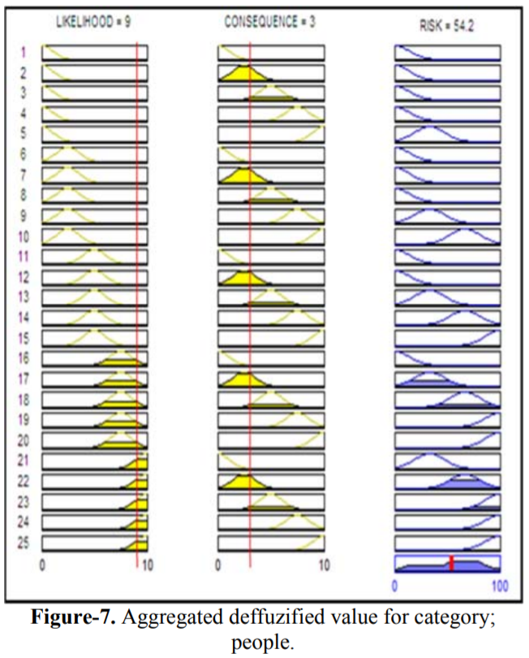

Table-8 shows the comparison results of qualitative risk assessment and proposed fuzzy risk assessment model of four categories; people, environment, asset and reputation. In qualitative the risk assessment result of category people “5B” and category reputation “4C” both are indicating the “High” risk level, and it is difficult to decide the most critical factor from both people and reputation. The results from proposed fuzzy risk assessment model are indicating the “High” risk level of category people with “54.2” and category reputation with “67.9” output risk level score.
It is found that the risk result of both methods is “High”, but the results from proposed fuzzy risk assessment model are more precise and defined in details with their final risk score. It shows that the reputation is more crucial than people; therefore “reputation” should be given more importance than the “people”. Through this way the proposed fuzzy risk assessment model will assist RBI engineers to categorize the risk levels comfortably.

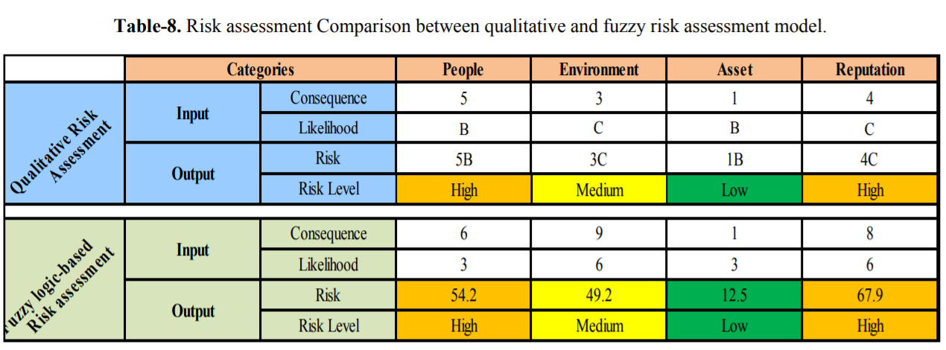

CONCLUSIONS

In this paper, a fuzzy logic-based risk assessment model has been proposed for oil and gas industries to categorize the risk level and assist to mitigate the risk ranking ties of hazard. The input parameters under consideration were likelihood and severity of consequence of four different categories; people, environment, asset and reputation. The model can be used to rank the categories with their output risk level score. The case study data indicate that the final risk result has been achieved due to the proposed model is more detailed and decisive. As compared with the existing risk ranking method, our proposed model is able to provide the risk level score more precisely and accurately and will also assist to reduce the risk ranking ties wherever possible and it can integrate the opinions of experts in a more accurate way and can rank the risk levels quantitatively.

Date: 02-12-2021 Signature of faculty in-charge

