Batch: A1 Roll No.: 1911004
Experiment No : 02
Grade: AA / AB / BB / BC / CC / CD /DD

Signature of the Staff In-charge with date

Title: Perceptron learning algorithm.
____________________________________________________________________________________
Objective: To write a program to implement Logic gate using perceptron network.
____________________________________________________________________________________
Expected Outcome of Experiment:

CO1 : Identify and describe soft computing techniques and their roles

____________________________________________________________________________________
Books/ Journals/ Websites referred:

- J.S.R.Jang, C.T.Sun and E.Mizutani, “Neuro-Fuzzy and Soft Computing”, PHI, 2004, Pearson Education 2004.
- Davis E.Goldberg, “Genetic Algorithms: Search, Optimization and Machine Learning”, Addison Wesley, N.Y., 1989.
- S. Rajasekaran and G.A.V.Pai, “Neural Networks, Fuzzy Logic and Genetic Algorithms”, PHI, 2003.
- http://library.thinkquest.org/C007395/tqweb/history.html
____________________________________________________________________________________
Pre Lab/ Prior Concepts:
Neural networks, sometimes referred to as connectionist models, are parallel-distributed models that have several distinguishing features-
1) A set of processing units;
2) An activation state for each unit, which is equivalent to the output of the unit;
3) Connections between the units. Generally each connection is defined by a weight w_{jk} that
determines the effect that the signal of unit j has on unit k;
4) A propagation rule, which determines the effective input of the unit from its external inputs;
5) An activation function, which determines the new level of activation based on the effective
input and the current activation;
6) An external input (bias, offset) for each unit;
7) A method for information gathering (learning rule);
8) An environment within which the system can operate, provide input signals and, if necessary,
error signals.
____________________________________________________________________________________
Implementation Details:

Perceptron learning concept :
Perceptron Learning Rule states that the algorithm would automatically learn the optimal weight coefficients. The input features are then multiplied with these weights to determine if a neuron fires or not.
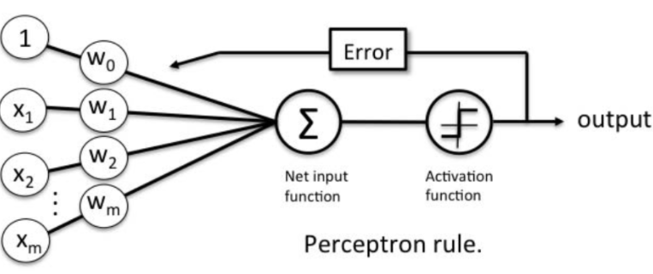
The Perceptron receives multiple input signals, and if the sum of the input signals exceeds a certain threshold, it either outputs a signal or does not return an output. In the context of supervised learning and classification, this can then be used to predict the class of a sample.
Consider a finite "n" number of input training vectors, with their associated target(desired) values x(n) and t(n), where "n" ranges from 1 to N.The target is either +1 or -1. The output ''y" is obtained on the basis of the net input calculated and activation function being applied over the net input.
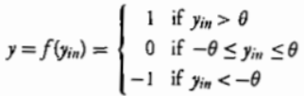
The weight updation in case of perceptron learning is as shown : 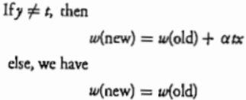
α: learning rate
The weights can be initialized at any values in this method. The perceptron rule convergence theorem states that “If there is weight vector w such that f(x(n).W) = t(n), for all n, then for any starting vector w1, the perceptron learning rule will converge to weight veactor that gives response for all training patterns and this learning takes place within a finite number of steps provide that the solution exists. ”

AND Function :
The output state of a AND gate only returns “LOW” again when ANY of its inputs are at a logic level “0”. In other words for a logic AND gate, any LOW input will give a LOW output.
2-input: (Using 1 and 0)
X1 | X2 | Y
0 | 0 | 0
0 | 1 | 0
1 | 0 | 0
1 | 1 | 1

Algorithm:
- Initialize the weights and the bias (for easy calculation they can be set to zero). Also initialize the learning rate α (0< α <= 1). For simplicity α is set to 1.
- Perform Steps 2-6 until the final stopping condition is false.
- Perform Steps 3-5 for each training pair indicated by s : t.
- The input layer containing input units is applied with identity activation functions: x_{i} = s_{i}
- Calculate the output of the network. To do so, first obtain the net input:
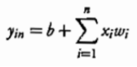
where "n" is the number of input neurons in the input layer. Then apply activations over the net input calculated to obtain the output:
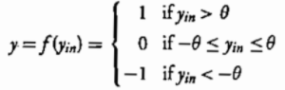
- Weight and bias adjustment: Compare the value of the actual (calculated) output and desired (target) output.
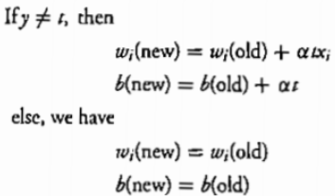
- Train the network until there is no weight change. This is the stopping condition for the network. If this condition is not met, then start again from Step 2.
Code :
def prt(w1,w2):
i1= float(input("Enter Input 1 "))
i2= float(input("Enter Input 2 "))
print(" y = x1*w1 + x2*w2 =",str(i1*w1+i2*w2))
if and_perceptron(i1,i2): print("Neuron will fire")
else: print("Neuron will not fire")
def and_perceptron(x1,x2):
t1=x1*w1+x2*w2
if(t1>=threshold): return 1
else: return 0
w1 = float(input("Enter Wt 1 "))
w2 = float(input("Enter Wt 2 "))
threshold=w1+w2
print("Threshold =",threshold,"\n\n\t\t\t --- AND FUNCTION ---")
x1=[0,0,1,1]
x2=[0,1,0,1]
x=zip(x1,x2)
output=[]
print("\t | x1 | x2 | Output | Neuron |\n\t ------------------------------------")
for i,j in x:
op=and_perceptron(i,j)
if (op!=0):
print("\t |", i, " | ", j, "| ",op, " | Fired |")
else:
print("\t |", i, " | ", j, "| ",op, " | Not Fired |")
output.append(op)
print("\nOutput =",output)
prt(w1,w2)

Output:
- 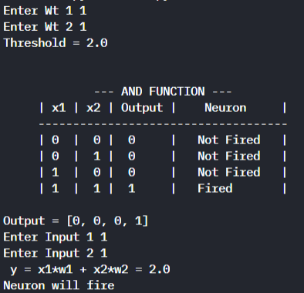
- 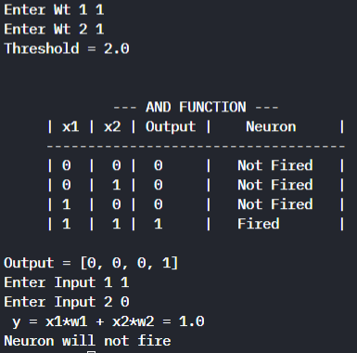
Conclusion:
Thus, we have successfully implemented perceptron training algorithm for AND function.

Post Lab Descriptive Questions :

- Explain Linear Separability.
- Consider two-input patterns (x1, x2) being classified into two classes as shown in figure A.Each point with either symbol of or represents a pattern with a set of values (x1, x2). Each pattern is classified into one of two classes. Notice that these classes can be separated with a single line L. They are known as linearly separable patterns. Linear separability refers to the fact that classes of patterns with -dimensional vector x = (x1, x2,….,xn) can be separated with a single decision surface.
In two-dimensional space, it means that there is a line, which separates points of one class from points of the other class.In three dimensions, it means that there is a plane that separates points of one class from points of the other class.
In the case above, the line L represents the decision surface.
The processing unit of a single-layer perceptron network is able to categorize a set of patterns into two classes as the linear threshold function defines their linear separability. Conversely, the two classes must be linearly separable in order for the perceptron network to function correctly. Indeed, this is the main limitation of a single-layer perceptron network.
- Explain MLP
- A multi-layered perceptron (MLP) is one of the most common neural network models used in the field of deep learning. Often referred to as a “vanilla” neural network, an MLP is simpler than the complex models of today’s era. However, the techniques it introduced have paved the way for further advanced neural networks.
The Basic Structure:
A multi-layered perceptron consists of interconnected neurons transferring information to each other, much like the human brain. Each neuron is assigned a value. The network can be divided into three main layers.
Input Layer
This is the initial layer of the network which takes in an input which will be used to produce an output.
Hidden Layer(s)
The network needs to have at least one hidden layer. The hidden layer(s) perform computations and operations on the input data to produce something meaningful.
Output Layer
The neurons in this layer display a meaningful output.
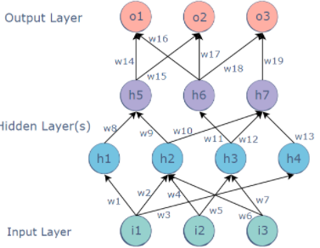
Connections
The MLP is a feedforward neural network, which means that the data is transmitted from the input layer to the output layer in the forward direction.
The connections between the layers are assigned weights. The weight of a connection specifies its importance. This concept is the backbone of an MLP’s learning process. While the inputs take their values from the surroundings, the values of all the other neurons are calculated through a mathematical function involving the weights and values of the layer before it.
For example, the value of the h5 node could be:
h5 = h1.w8 + h2.w9
Backpropagation
Backpropagation is a technique used to optimize the weights of an MLP using the outputs as inputs.
In a conventional MLP, random weights are assigned to all the connections. These random weights propagate values through the network to produce the actual output. Naturally, this output would differ from the expected output. The difference between the two values is called the error.
Backpropagation refers to the process of sending this error back through the network, readjusting the weights automatically so that eventually, the error between the actual and expected output is minimized.
In this way, the output of the current iteration becomes the input and affects the next output. This is repeated until the correct output is produced. The weights at the end of the process would be the ones on which the neural network works correctly.
Applications:
The multilayer perceptron (MLP) is used for a variety of tasks, such as stock analysis, image identification, spam detection, and election voting predictions.

Date: 03-09-2021 Signature of faculty in-charge

