Batch: A1 Roll No.: 1911004
Experiment No : 03
Grade: AA / AB / BB / BC / CC / CD /DD

Signature of the Staff In-charge with date

Title: Logic gates with multilayer neural network.
____________________________________________________________________________________
Objective: To Solve logic gates with two nodes in the hidden layer.
____________________________________________________________________________________
Expected Outcome of Experiment:
CO1 : Identify and describe soft computing techniques and their roles
____________________________________________________________________________________
Books/ Journals/ Websites referred:

- J.S.R.Jang, C.T.Sun and E.Mizutani, “Neuro-Fuzzy and Soft Computing”, PHI, 2004, Pearson Education 2004.
- Davis E.Goldberg, “Genetic Algorithms: Search, Optimization and Machine Learning”, Addison Wesley, N.Y., 1989.
- S. Rajasekaran and G.A.V.Pai, “Neural Networks, Fuzzy Logic and Genetic Algorithms”, PHI, 2003.
- http://library.thinkquest.org/C007395/tqweb/history.html.
____________________________________________________________________________________
Pre Lab/ Prior Concepts:
Neural networks, sometimes referred to as connectionist models, are parallel-distributed models that have several distinguishing features-
1) A set of processing units;
2) An activation state for each unit, which is equivalent to the output of the unit;
3) Connections between the units. Generally each connection is defined by a weight w_{jk} that
determines the effect that the signal of unit j has on unit k;
4) A propagation rule, which determines the effective input of the unit from its external inputs;
5) An activation function, which determines the new level of activation based on the effective
input and the current activation;
6) An external input (bias, offset) for each unit;
7) A method for information gathering (learning rule);
8) An environment within which the system can operate, provide input signals and, if necessary,
error signals.
____________________________________________________________________________________
Implementation Details:

XOR problem :
Consider two-input patterns (x1, x2) being classified into two classes as shown in figure A.Each point with either symbol of x or o represents a pattern with a set of values (x1, x2). Each pattern is classified into one of two classes. Notice that these classes can be separated with a single line L. They are known as linearly separable patterns. Linear separability refers to the fact that classes of patterns with n-dimensional vector x = (x1, x2,….,xn) can be separated with a single decision surface.
In two-dimensional space, it means that there is a line, which separates points of one class from points of the other class.
In three dimensions, it means that there is a plane that separates points of one class from points of the other class.
In the case above, the line L represents the decision surface.
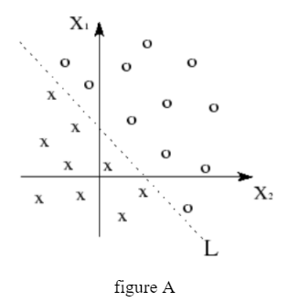
The most classic example of linearly inseparable pattern is a logical exclusive-OR (XOR) function. Shown in figure B is the illustration of XOR function that two classes, 0 for black dot and 1 for white dot, cannot be separated with a single line. The solution seems that patterns of (x1, x2) can be logically classified with two lines L1 and L2
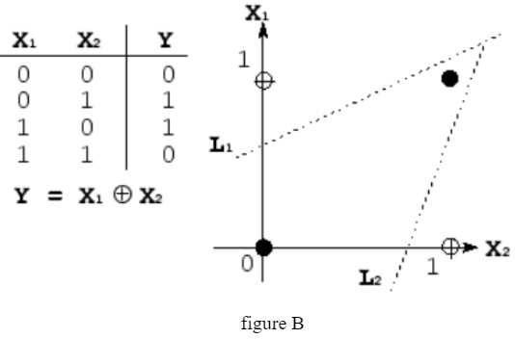
Algorithm :
McCulloch-Pitts
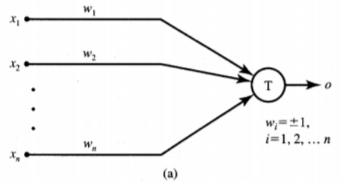
The McCulloch-Pitts model of the neuron is shown in Figure a. The inputs xi, for i = 1, 2, . . . , n, are 0 or 1, depending on the absence or presence of the input impulse at instant k. The neuron's output signal is denoted as o. The firing rule for this model is defined as follows
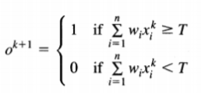
Code:
import java.util.*;
class Main {
static int lc;
static int act1(int val){ //activation for hidden layer
if (val>=2) //threshold
return 1;
else
return -1;
}
static int act2(int val){ //activation for output layer
if (val>=1) //threshold
return 1;
else
return -1;
}
static int[] perceptron(int x1[],int x2[], int t[], int act,int tableType,int z1[],int z2[]){
int w1[]= {-1,-1,1,1};
int w2[]= {-1,1,-1,1};
int wt[]= new int[2];
int actV[]=new int[4];
if(tableType==1)
System.out.println(" X1 \t X2 \t Y \t Z1 \t W1 \t W2 ");
else if(tableType==2)
System.out.println(" X1 \t X2 \t Y \t Z2 \t W1 \t W2 ");
else
System.out.println(" X1 \t X2 \t Y \t Z1 \t Z2 \t W1 \t W2 ");
for(int i=0; i<4 ;i++){ //for each combination of weight
wt[0]=w1[i];
wt[1]=w2[i];
for(int j=0; j<4; j++){
int val= (x1[j]*w1[i])+(x2[j]*w2[i]);
if(act==1)
actV[j]= act1(val);
else
actV[j]= act2(val);
String ptr = "";
if(tableType==1 || tableType==2)
ptr = "\t"+format(x1[j])+" \t "+format(x2[j])+" \t "+format(actV[j])+" \t "+format(t[j])+" \t "+format(w1[j])+" \t "+format(w2[j]);
else
ptr = "\t"+format(x1[j])+" \t "+format(x2[j])+" \t "+format(t[j])+" \t "+format(z1[j])+" \t "+format(z2[j])+" \t "+format(w1[j])+" \t "+format(w2[j]);
System.out.println(ptr);
}
int k=0;
while(k<4){
if(actV[k]!=t[k]){
wt[0]=w1[i]+lc*act*x1[i];wt[1]=w2[i]+lc*act*x2[i];
}
k++;
}
if(k==4)
return wt;
}
return wt;
}
public static void main(String[] args) {
Scanner ob = new Scanner(System.in);
System.out.println("");
int x1[] = {-1,-1,1,1};//X1
int x2[] = {-1,1,-1,1};//X2
int z1T[] = {-1,-1,1,-1};//target for Training z1
int z2T[] = {-1,1,-1,-1};//target for Training z2
int y[] = {-1,1,1,-1};//target
int w1[] = new int[2],w2[] = new int[2];//hidden layer weight
int v[] = new int[2];//output layer weights
int wt[] = new int[2];
System.out.print("Considering learning Constant = 1"); lc= 1;
System.out.println("\nInput: ");
System.out.println("x1 = "+java.util.Arrays.toString(x1));
System.out.println("x2 = "+java.util.Arrays.toString(x2));
System.out.print("\nOutput: y = "+java.util.Arrays.toString(y));
System.out.println("Training Z1");
w1= perceptron(x1,x2,z1T,1,1,new int[4],new int[4]);
System.out.println("Training Z2");
w2= perceptron(x1,x2,z2T,1,2,new int[4],new int[4]);
System.out.println("Training Z");
v= perceptron(z1T,z2T,y,2,3,z1T,z2T);
System.out.println("\nWeights : ");
System.out.println("w[1][1] = "+w1[0]);
System.out.println("w[2][1] = "+w1[1]);
System.out.println("w[1][2] = "+w2[0]);
System.out.println("w[2][2] = "+w2[1]);
System.out.println("v1 = "+v[0]);
System.out.println("v2 = "+v[1]);
}
static String format(int a){
if(a==1)
return " 1";
return "-1";
}
}
Output:
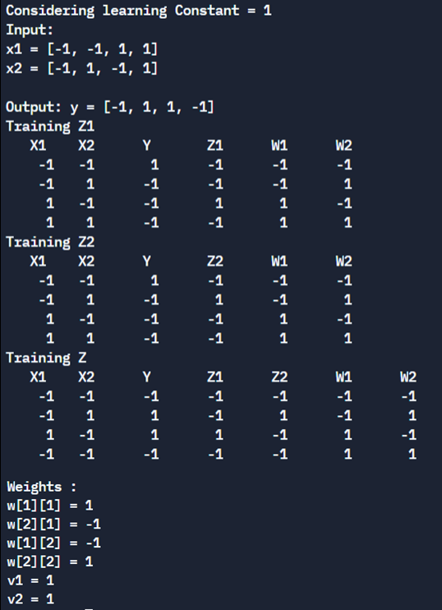
Conclusion: Thus, we have successfully implemented 4 Activation Functions of Neural Network.

Post Lab Descriptive Questions :

- Explain MLP.
- A multi-layered perceptron (MLP) is one of the most common neural network models used in the field of deep learning. Often referred to as a “vanilla” neural network, an MLP is simpler than the complex models of today’s era. However, the techniques it introduced have paved the way for further advanced neural networks.
The Basic Structure:
A multi-layered perceptron consists of interconnected neurons transferring information to each other, much like the human brain. Each neuron is assigned a value. The network can be divided into three main layers.
Input Layer
This is the initial layer of the network which takes in an input which will be used to produce an output.
Hidden Layer(s)
The network needs to have at least one hidden layer. The hidden layer(s) perform computations and operations on the input data to produce something meaningful.
Output Layer
The neurons in this layer display a meaningful output.
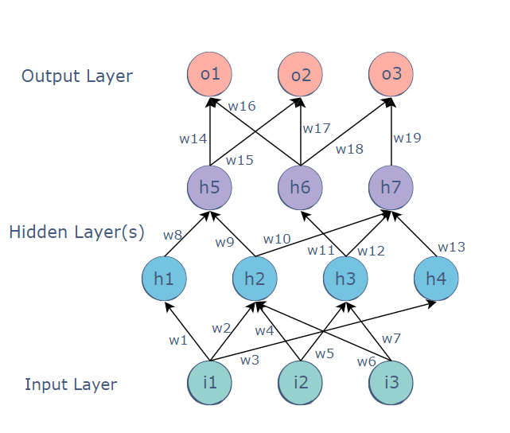

Connections
The MLP is a feedforward neural network, which means that the data is transmitted from the input layer to the output layer in the forward direction.
The connections between the layers are assigned weights. The weight of a connection specifies its importance. This concept is the backbone of an MLP’s learning process.
While the inputs take their values from the surroundings, the values of all the other neurons are calculated through a mathematical function involving the weights and values of the layer before it.
For example, the value of the h5 node could be:
h5 = h1.w8 + h2.w9
Backpropagation
Backpropagation is a technique used to optimize the weights of an MLP using the outputs as inputs.
In a conventional MLP, random weights are assigned to all the connections. These random weights propagate values through the network to produce the actual output. Naturally, this output would differ from the expected output. The difference between the two values is called the error.
Backpropagation refers to the process of sending this error back through the network, readjusting the weights automatically so that eventually, the error between the actual and expected output is minimized.
In this way, the output of the current iteration becomes the input and affects the next output. This is repeated until the correct output is produced. The weights at the end of the process would be the ones on which the neural network works correctly.
Applications:
The multilayer perceptron (MLP) is used for a variety of tasks, such as stock analysis, image identification, spam detection, and election voting predictions.

- State any other linear inseparable problem.
- Just like XOR the XNOR is another example of linearly inseperable problem.
- XOR is one where if one is 1 and other is 0 but not both same.
Table for XNOR
W1 | W2 | Y
0 | 0 | 1
0 | 1 | 0
1 | 0 | 0
1 | 1 | 1
- We Need:
1.w1 + 0.w2 not cause a fire, i.e. < t
0.w1 + 1.w2 < t
0.w1 + 0.w2 cause a fire, i.e. >= t
1.w1 + 1.w2 also cause a fire, >= t

- Form the equations:
w1 < t
w2 < t
0 > t
w1+w2 > t
This will create contradiction.
Hence it is linearly inseparable as a single boundary cannot be created.

- Explain why multilayer neural network is needed for linear inseparable problems.
- Let us consider the example of XOR.
XOR is one where if one is 1 and other is 0 but not both same.
Look at the table
W1 | W2 | Y
0 | 0 | 0
0 | 1 | 1
1 | 0 | 1
1 | 1 | 0

- We Need:
1.w1 + 0.w2 cause a fire, i.e. >= t
0.w1 + 1.w2 >= t
0.w1 + 0.w2 doesn't fire, i.e. < t
1.w1 + 1.w2 also doesn't fire, < t

- Form the equations:
w1 >= t
w2 >= t
0 < t
w1+w2 < t
This will create contradiction.
- We need all 4 inequalities for the contradiction. If weights negative, e.g. weights = -4 and t = -5, then weights can be greater than t yet adding them is less than t, but t > 0 stops this.
A "single-layer" perceptron can't implement XOR. The reason is because the classes in XOR are not linearly separable. You cannot draw a straight line to separate the points (0,0),(1,1) from the points (0,1),(1,0).
Hence, we will require a multilayer perceptron to solve XOR, as it is linearly inseparable.
Similarly, we require a multilayer neural network for all linear inseparable problems.

Multilayer networks solve the classification problem for non linear sets by employing hidden layers, whose neurons are not directly connected to the output. The additional hidden layers can be interpreted geometrically as additional hyper-planes
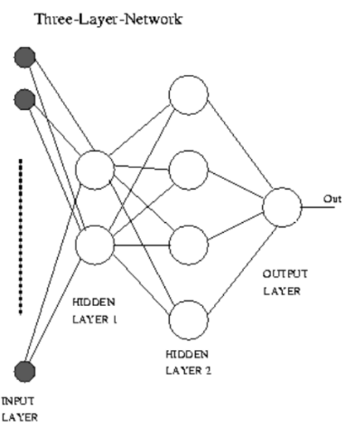

Date: 16-09-2021 Signature of faculty in-charge

