Batch: A1 Roll No.: 1911004

Experiment No. 04

Grade: A / AB / BB / BC / CC / CD /DD

Signature of the Staff In-charge with date

Title: Delta learning rule

Objective: To write a program to implement Delta learning rule.
____________________________________________________________________________________
Expected Outcome of Experiment:
CO3 : To Understand perceptron’s and counter propagation networks
____________________________________________________________________________________
Books/ Journals/ Websites referred:

- J.S.R.Jang, C.T.Sun and E.Mizutani, “Neuro-Fuzzy and Soft Computing”, PHI, 2004, Pearson Education 2004.
- Davis E.Goldberg, “Genetic Algorithms: Search, Optimization and Machine Learning”, Addison Wesley, N.Y., 1989.
- S. Rajasekaran and G.A.V.Pai, “Neural Networks, Fuzzy Logic and Genetic Algorithms”, PHI, 2003.
- http://library.thinkquest.org/C007395/tqweb/history.html
____________________________________________________________________________________
Pre Lab/ Prior Concepts:
Neural networks, sometimes referred to as connectionist models, are parallel-distributed models that have several distinguishing features-
1) A set of processing units;
2) An activation state for each unit, which is equivalent to the output of the unit;
3) Connections between the units. Generally each connection is defined by a weight w_{jk} that
determines the effect that the signal of unit j has on unit k;
4) A propagation rule, which determines the effective input of the unit from its external inputs;
5) An activation function, which determines the new level of activation based on the effective
input and the current activation;
6) An external input (bias, offset) for each unit;
7) A method for information gathering (learning rule);
8) An environment within which the system can operate, provide input signals and, if necessary,
error signals.
____________________________________________________________________________________
Implementation Details:

Delta learning rule :
Delta learning rule:
The delta learning rule is only valid for continuous activation functions as defined and in the supervised training mode. The learning signal for this rule is called delta and is defined as follows
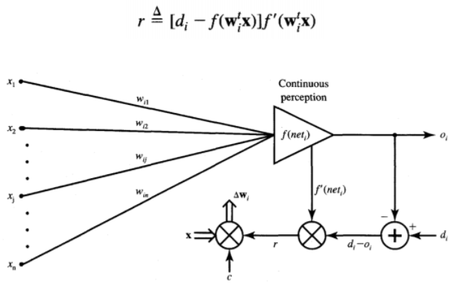
The term f '(w^{t}_{i} x) is the derivative of the activation function f (net) computed for net = w^{t}_{i}x. The explanation of the delta learning rule is shown in Figure above. This learning rule can be readily derived from the condition of least squared error between o_{i} and d_{i}. Calculating the gradient vector with respect to w_{i} of the squared error defined as
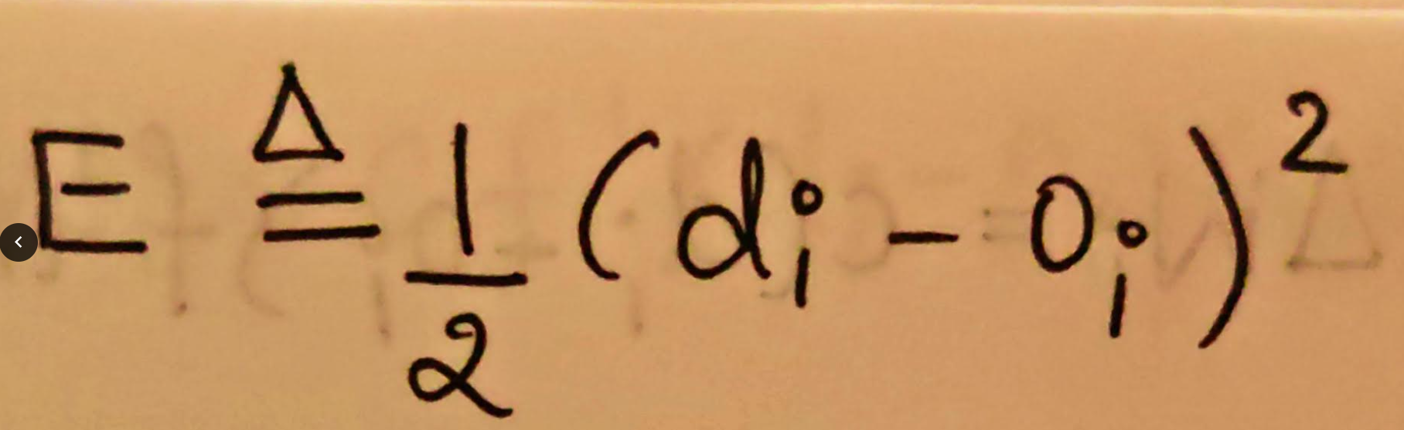
the weight adjustment becomes,
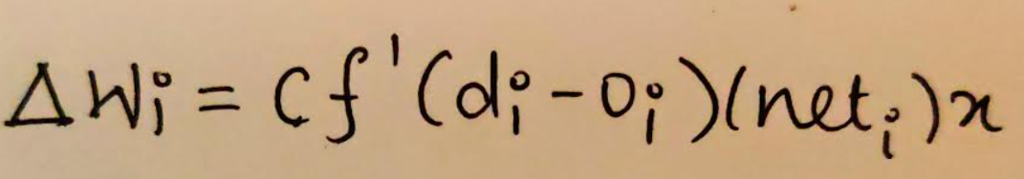
next weight,
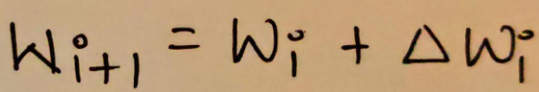
Code:
import math
n = int(input("Enter the no of neurons = "))
print("Enter the input = ")
Input = [float(input()) for i in range(n)]
T = float(input("Enter the target = "))
print("Enter the initial weight vector = ")
Wt = [float(input()) for i in range(n)]
c = float(input("Enter the learning constant = "))
s = float(input("Enter the steepness parameter = "))
net = 0
for i in range(n): net+=(Wt[i]*Input[i])
print("Net =",net)
out = ((2/(1+math.exp(-s*net)))-1);print("Out =",out)
f_ = ((1-(out**2))/2);print("f' =",f_)
print("Change in Weight = ",end = '')
delW = [];wt = []
for i in range(n): delW.append(c*f_*Input[i]*(T - out))
print(delW)
print("Weight = ",end = '')
for i in range(n): wt.append(delW[i]+Wt[i])
print(wt)
Output:
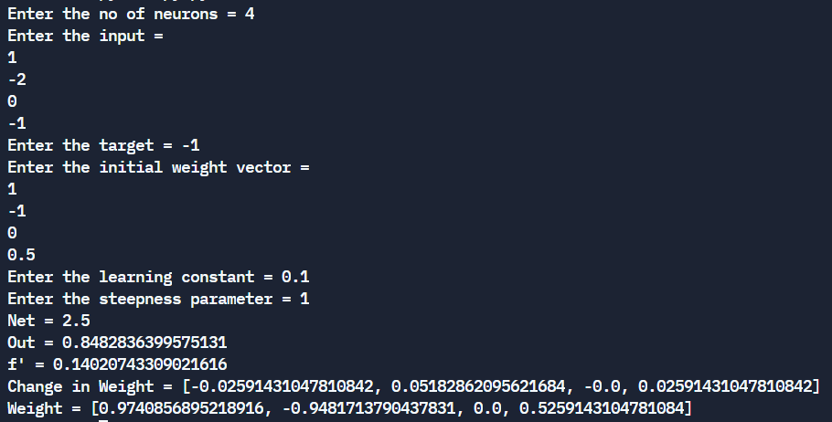

Conclusion: Thus, we have successfully implemented Delta learning algorithm of Neural Network.

Post Lab Descriptive Questions :

- Explain different types of unsupervised techniques.
Unsupervised learning problems are grouped into clustering and association problems.
- Clustering: Clustering is an important concept when it comes to unsupervised learning. It mainly deals with finding a structure or pattern in a collection of uncategorized data. Clustering algorithms will process your data and find natural clusters(groups) if they exist in the data. You can also modify how many clusters your algorithms should identify. It allows you to adjust the granularity of these groups.
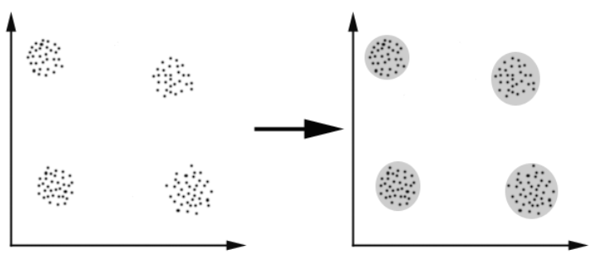
- Clustering Types
- Hierarchical clustering
- K-means clustering
- K-NN (k nearest neighbors)
- Principal Component Analysis
- Singular Value Decomposition
- Independent Component Analysis
- Association: Association rules allow you to establish associations amongst data objects inside large databases. This unsupervised technique is about discovering interesting relationships between variables in large databases. For example, people that buy a new home most likely to buy new furniture.
Other Examples:
- A subgroup of cancer patients grouped by their gene expression measurements
- Groups of shoppers based on their browsing and purchasing histories
- Movie group by the rating given by movies viewers
- Take any example and show the different steps of Delta Algorithm.
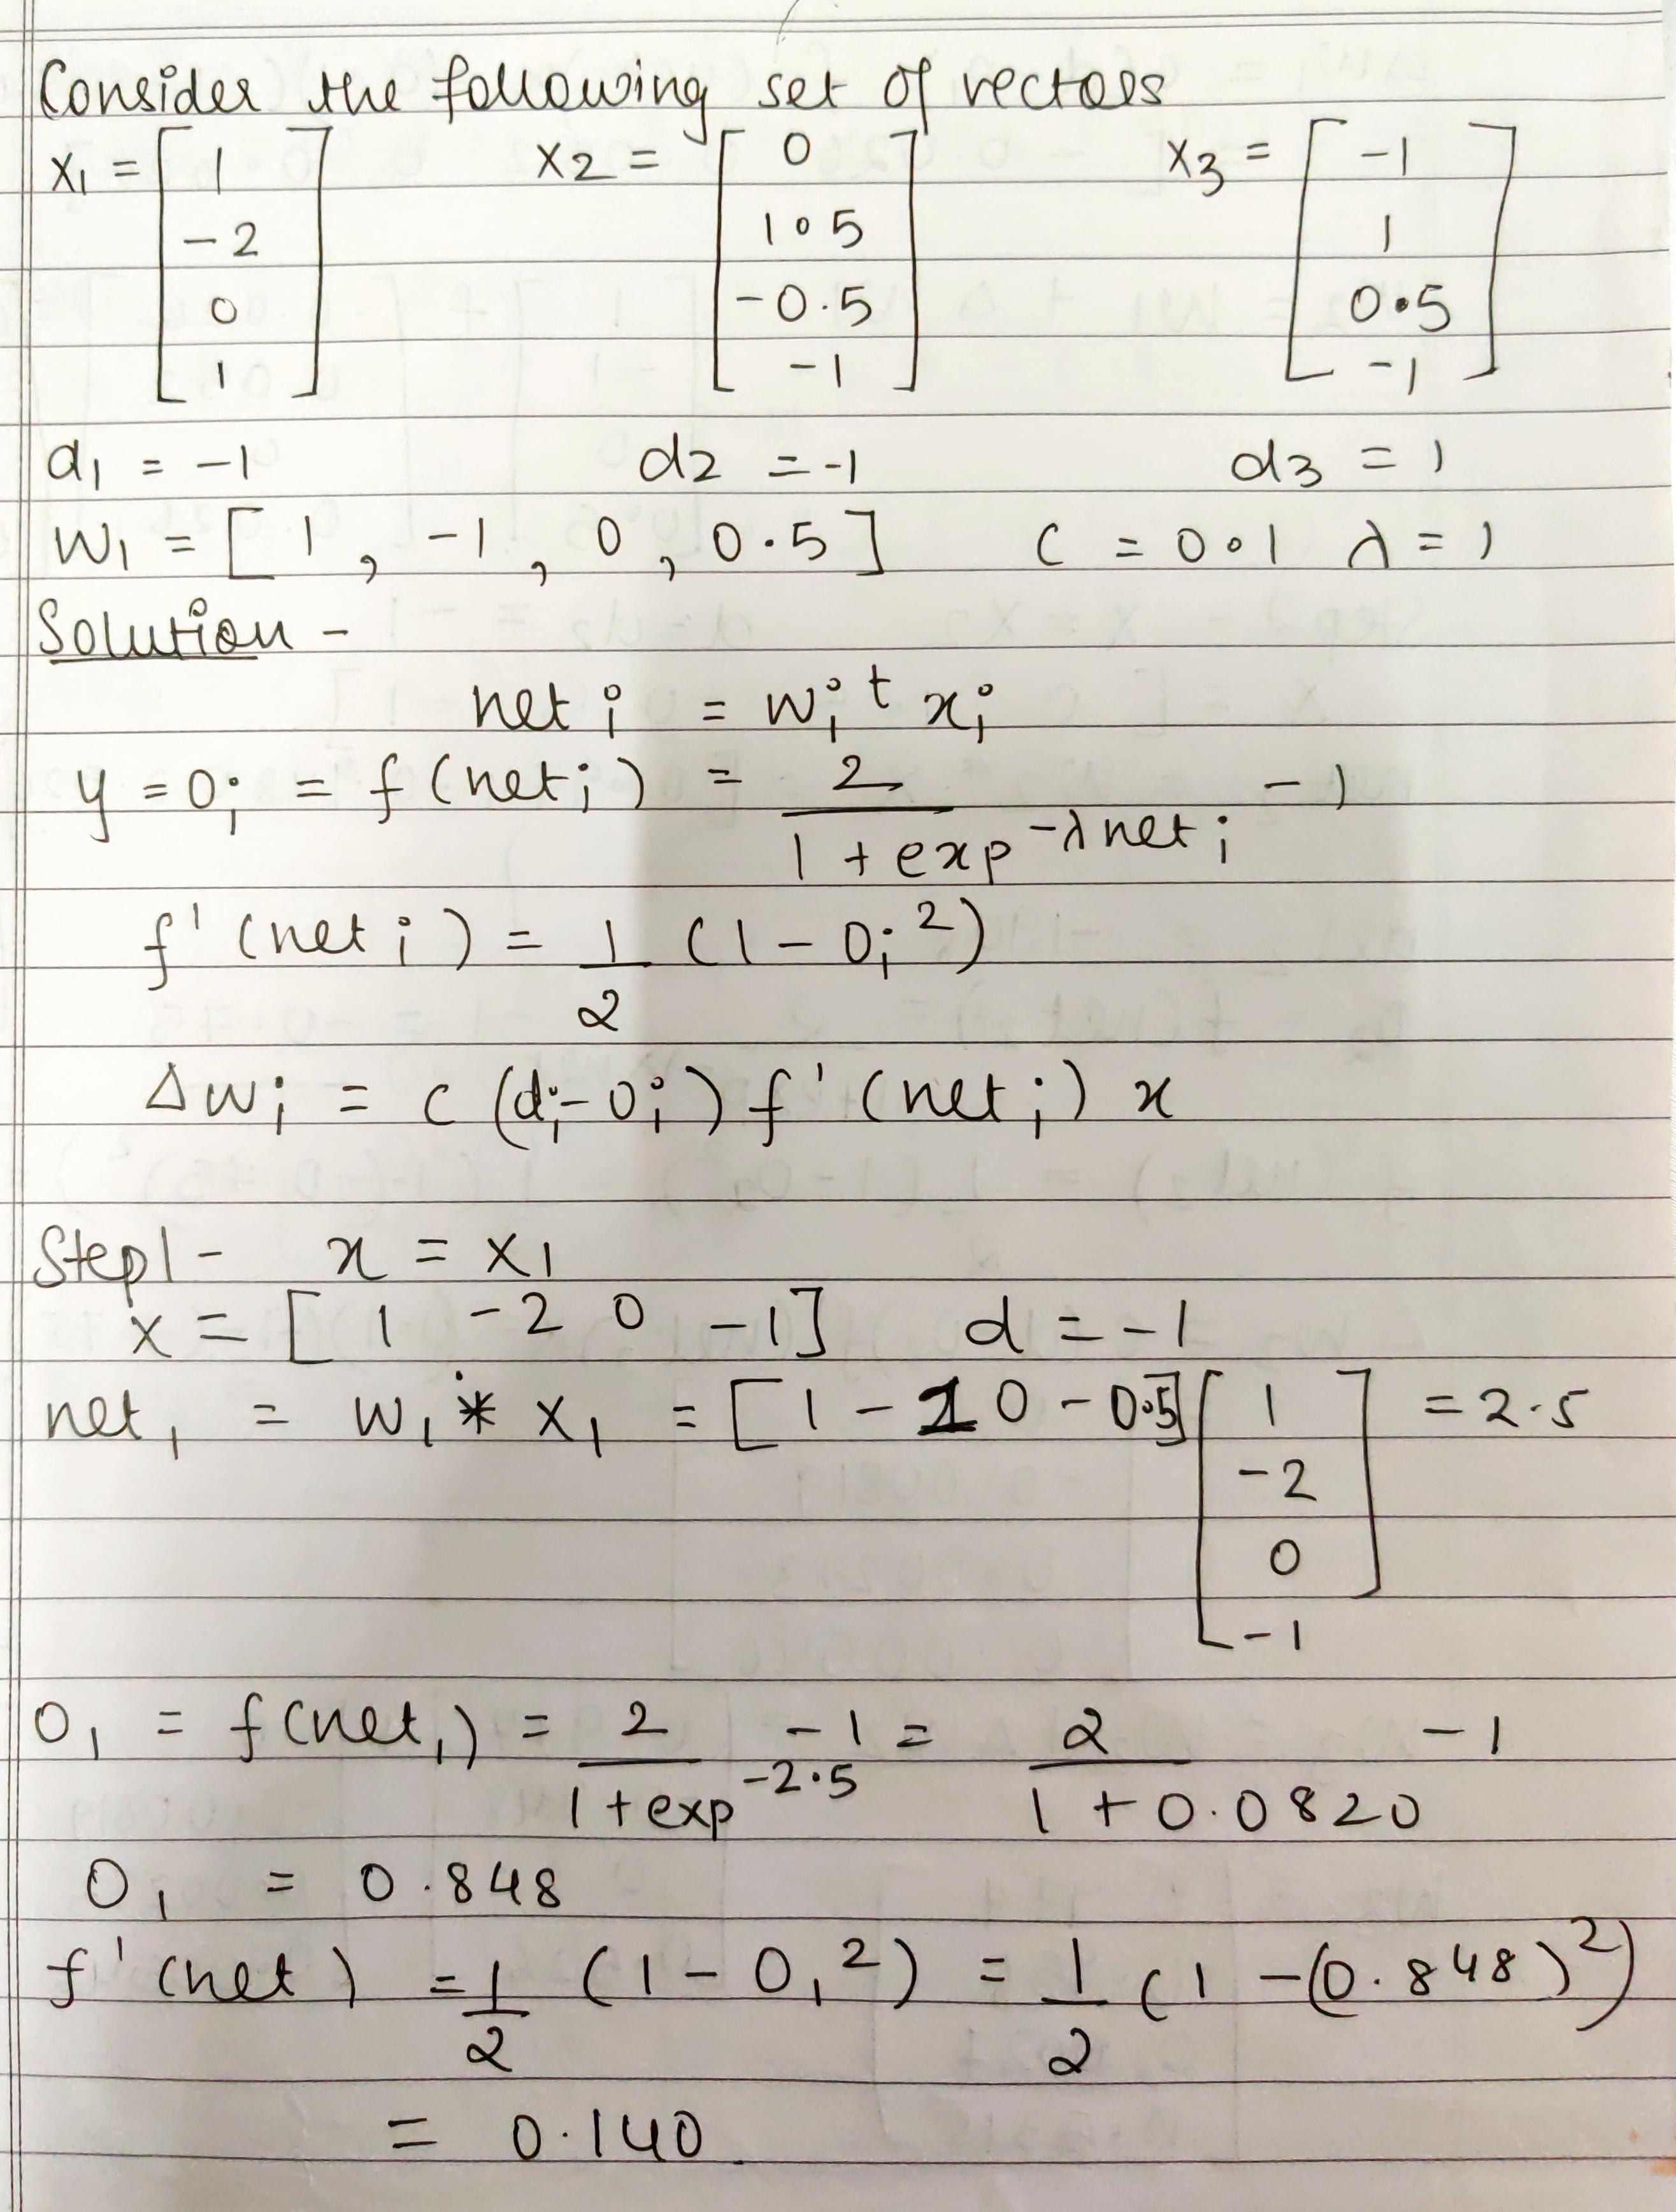
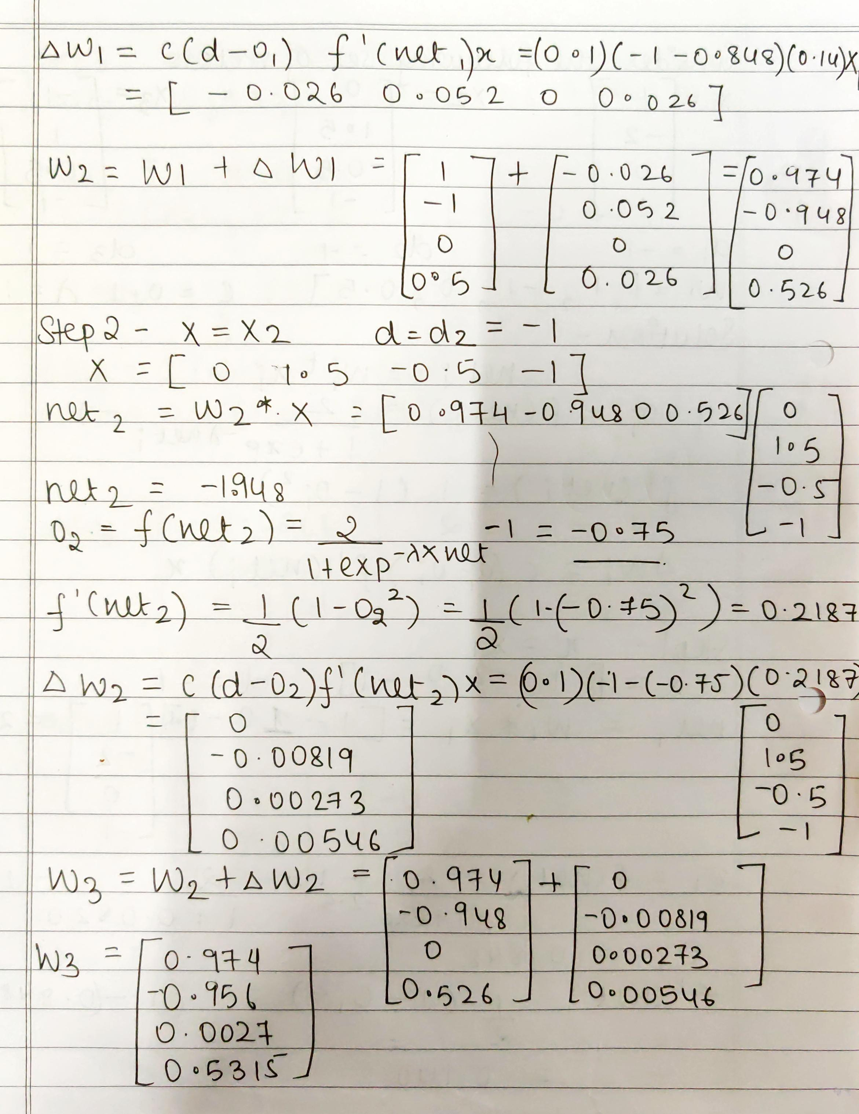
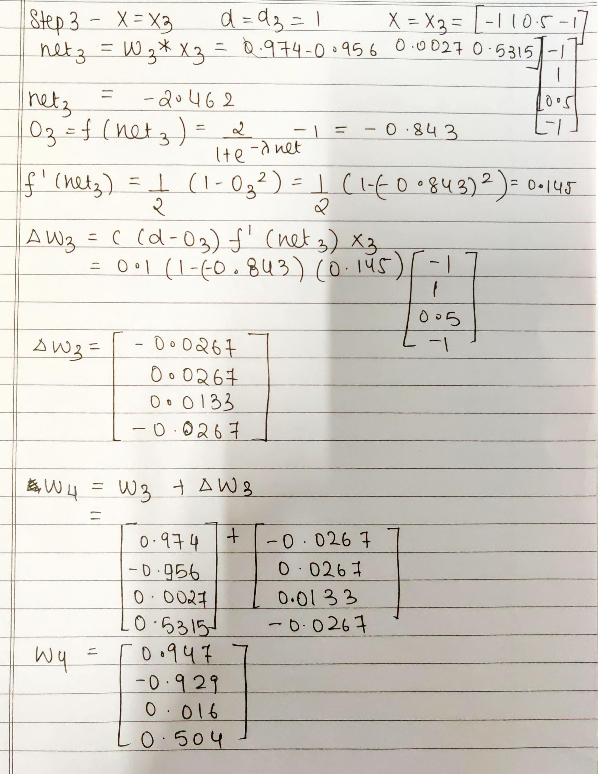
Date: 23-09-2021 Signature of faculty in-charge

