Batch: A1 Roll No.: 1911004

Experiment No. 05

Grade: A / AB / BB / BC / CC / CD /DD

Signature of the Staff In-charge with date

Title: HEBBS learning rule
Objective: To write a program to implement HEBBS learning rule.
____________________________________________________________________________________
Expected Outcome of Experiment:
CO3: Understand perceptron’s and counter propagation networks
____________________________________________________________________________________
Books/ Journals/ Websites referred:

- J.S.R.Jang, C.T.Sun and E.Mizutani, “Neuro-Fuzzy and Soft Computing”, PHI, 2004, Pearson Education 2004.
- Davis E.Goldberg, “Genetic Algorithms: Search, Optimization and Machine Learning”, Addison Wesley, N.Y., 1989.
- S. Rajasekaran and G.A.V.Pai, “Neural Networks, Fuzzy Logic and Genetic Algorithms”, PHI, 2003.
- http://library.thinkquest.org/C007395/tqweb/history.html
____________________________________________________________________________________
Pre Lab/ Prior Concepts:
Neural networks, sometimes referred to as connectionist models, are parallel-distributed models that have several distinguishing features-
1) A set of processing units;
2) An activation state for each unit, which is equivalent to the output of the unit;
3) Connections between the units. Generally each connection is defined by a weight w_{jk} that
determines the effect that the signal of unit j has on unit k;
4) A propagation rule, which determines the effective input of the unit from its external inputs;
5) An activation function, which determines the new level of activation based on the effective
input and the current activation;
6) An external input (bias, offset) for each unit;
7) A method for information gathering information (learning rule);
8) An environment within which the system can operate, provide input signals and, if necessary,
error signals.
____________________________________________________________________________________
Implementation Details:

Hebbian learning rule:
The Hebbian learning rule represents a purely feedforward, unsupervised learning. This learning rule requires the weight initialization at small random values around w_{i} = 0 prior to learning. The rule implements the interpretation of the classic statement: "When an axon of cell A is near enough to excite a cell B and repeatedly or persistently takes place in firing it, some growth process or metabolic change takes place in one or both cells such that A's efficiency, as one of the cells firing B, is increased." (Hebb 1949.)
For bipolar continuous:
- net = w^{t}_{i}x.
- 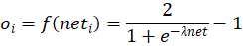
Code:
import math
n = int(input("Enter no of neurons for input = "))
print("Enter the input : ")
Input = [float(input()) for i in range(n)]
print("Enter the initial weight vector : ")
Wt = [float(input()) for i in range(n)]
c = float(input("Enter the learning constant = "))
s = float(input("Enter the steepness parameter = "))
net = 0
for i in range(n): net+=(Wt[i]*Input[i])
print("Net =",net)
out = ((2/(1+math.exp(-s*net)))-1);print("O =",out)
print("Change in Weight = ",end = '')
delW = [];wt = []
for i in range(n): delW.append(c*Input[i]*out)
print(delW)
print("Weight = ",end = '')
for i in range(n): wt.append(delW[i]+Wt[i])
print(wt)
Output:
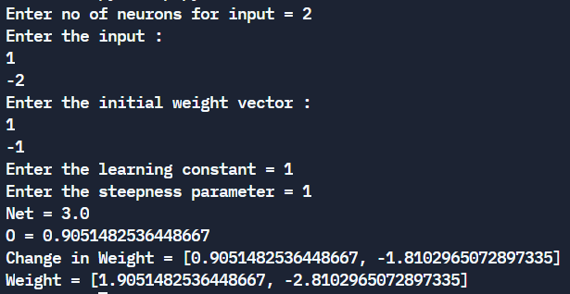
Conclusion: Thus, we have successfully implemented Hebbian learning algorithm of Neural Network.

Post Lab Descriptive Questions :
- Explain different types of learning method.
- Supervised Learning:
The learning algorithm would fall under this category if the desired output for the network is also provided with the input while training the network. By providing the neural network with both an input and output pair it is possible to calculate an error based on it's target output and actual output. It can then use that error to make corrections to the network by updating it's weights.
- Unsupervised Learning:
In this paradigm the neural network is only given a set of inputs and it's the neural network's responsibility to find some kind of pattern within the inputs provided without any external aid. This type of learning paradigm is often used in data mining and is also used by many recommendation algorithms due to their ability to predict a user's preferences based on the preferences of other similar users it has grouped together.
- Reinforcement Learning:
Reinforcement learning is similar to supervised learning in that some feedback is given, however instead of providing a target output a reward is given based on how well the system performed. The aim of reinforcement learning is to maximize the reward the system receives through trial-and-error. This paradigm relates strongly with how learning works in nature, for example an animal might remember the actions it's previously taken which helped it to find food (the reward).

- Take any example and show the different steps of Hebb’s Algorithm.
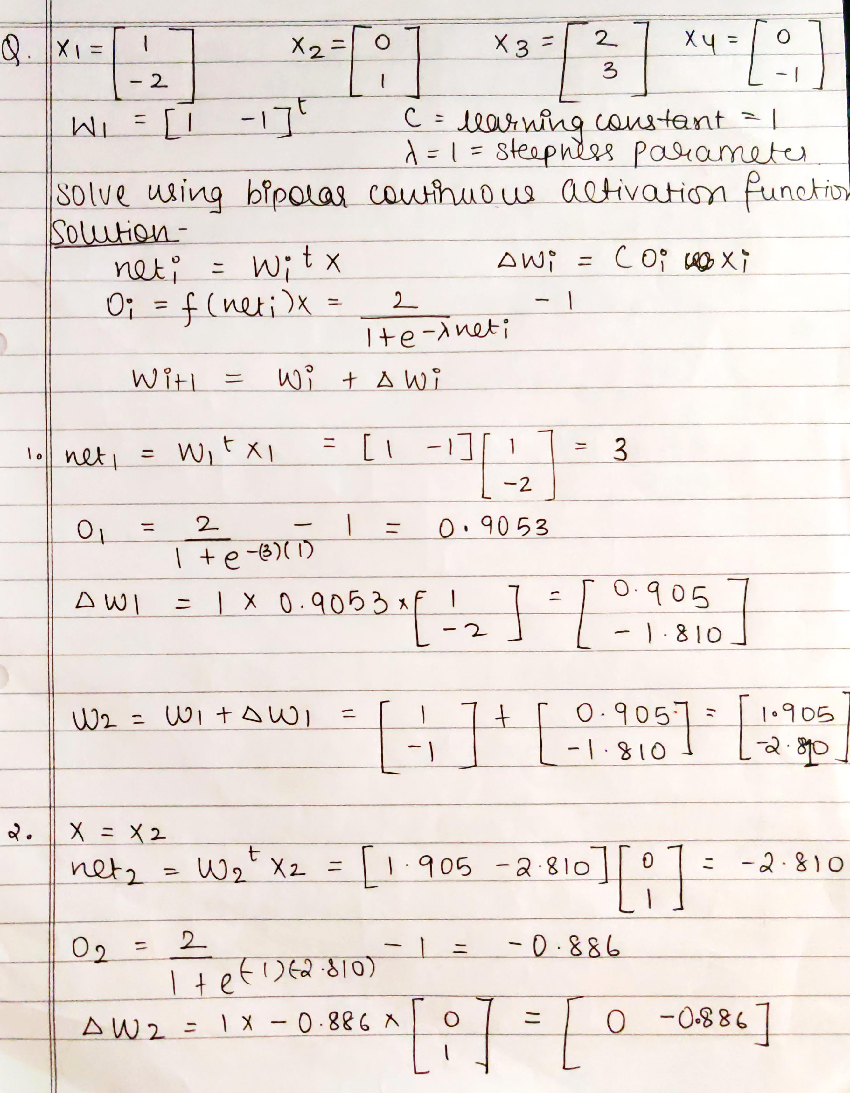
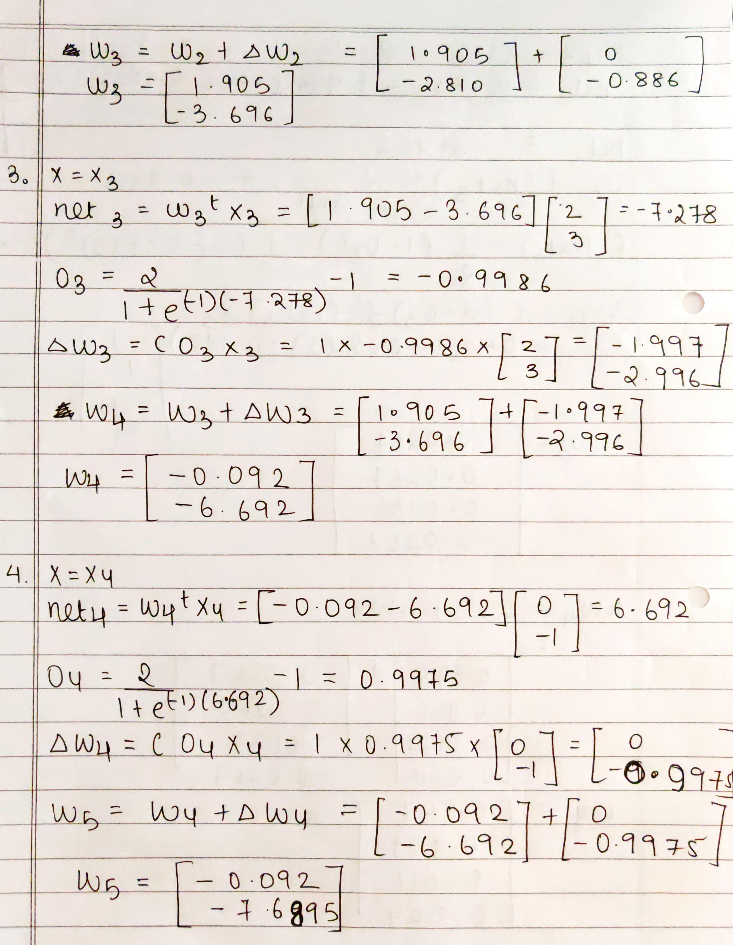
Date: 28-09-2021 Signature of faculty in-charge

