Batch: A1 Roll No.: 1911004
Experiment No. : 06
Grade: AA / AB / BB / BC / CC / CD /DD

Signature of the Staff In-charge with date

Title: Back propagation algorithm
____________________________________________________________________________________
Objective: To Write a program to implement back propagation algorithm in MLP.
____________________________________________________________________________________
Expected Outcome of Experiment:

CO3 : Understand perceptron’s and counter propagation networks
____________________________________________________________________________________
Books/ Journals/ Websites referred:

- J.S.R.Jang, C.T.Sun and E.Mizutani, “Neuro-Fuzzy and Soft Computing”, PHI, 2004, Pearson Education 2004.
- Davis E.Goldberg, “Genetic Algorithms: Search, Optimization and Machine Learning”, Addison Wesley, N.Y., 1989.
- S. Rajasekaran and G.A.V.Pai, “Neural Networks, Fuzzy Logic and Genetic Algorithms”, PHI, 2003.
- http://library.thinkquest.org/C007395/tqweb/history.html.
____________________________________________________________________________________
Pre Lab/ Prior Concepts:
Neural networks, sometimes referred to as connectionist models, are parallel-distributed models that have several distinguishing features-
1) A set of processing units;
2) An activation state for each unit, which is equivalent to the output of the unit;
3) Connections between the units. Generally each connection is defined by a weight w_{jk} that
determines the effect that the signal of unit j has on unit k;
4) A propagation rule, which determines the effective input of the unit from its external inputs;
5) An activation function, which determines the new level of activation based on the effective
input and the current activation;
6) An external input (bias, offset) for each unit;
7) A method for information gathering (learning rule);
8) An environment within which the system can operate, provide input signals and, if necessary,
error signals.
____________________________________________________________________________________
Implementation Details :

The Back propagation algorithm searches for weight values that minimize the total error of the network over the set of training examples (training set).
• Back propagation algorithm consists of the following two passes:
– Forward pass: In this step the network is activated on one example and the error of (each neuron of) the output layer is computed.
– Backward pass: In this step the network error is used for updating the weights. This process is more complex than the LMS algorithm for Adaline because hidden nodes are linked to the error not directly but by means of the nodes of the next layer. Therefore, starting at the output layer, the error is propagated backwards through the network, layer by layer. This is done by recursively computing the local gradient of each weight.
Back-propagation training algorithm:
The algorithm is used to effectively train a neural network through a method called chain rule. In simple terms, after each forward pass through a network, backpropagation performs a backward pass while adjusting the model’s parameters (weights and biases).
Steps for Backpropagation Algorithm:
- Calculate the error – How far is your model output from the actual output.
- Minimum Error – Check whether the error is minimized or not.
- Update the parameters – If the error is huge then, update the parameters (weights and biases). After that again check the error. Repeat the process until the error becomes minimum.
- Model is ready to make a prediction – Once the error becomes minimum, you can feed some inputs to your model and it will produce the output.
Network Architecture:
The 4-layer neural network consists of 4 neurons for the input layer, 4 neurons for the hidden layers and 1 neuron for the output layer.
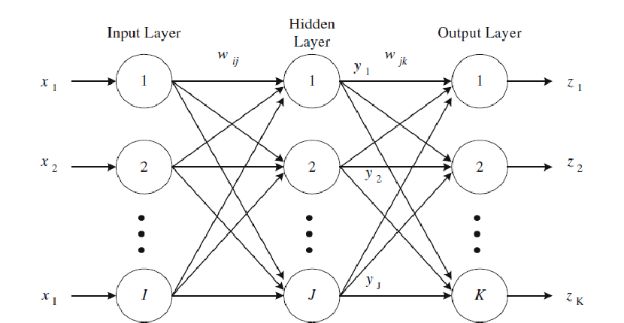

Input layer
The neurons, colored in purple, represent the input data. These can be as simple as scalars or more complex like vectors or multidimensional matrices.
The first set of activations (a) are equal to the input values. NB: “activation” is the neuron’s value after applying an activation function.
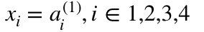

Hidden layers
The final values at the hidden neurons, colored in green, are computed using z⁽¹⁾ — weighted inputs in layer l, and a⁽¹⁾ — activations in layer l. For layer 2 and 3 the equations are:
Layer 2: Layer 3:
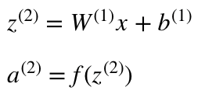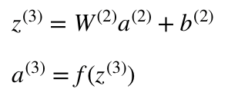
Output layer
The final part of a neural network is the output layer which produces the predicated value. In our simple example, it is presented as a single neuron, colored in blue and evaluated as follows:
S = W⁽³⁾a⁽³⁾

Algorithm: (Backpropogation)
- Inputs X, arrive through the pre-connected path
- Input is modelled using real weights W. The weights are usually randomly selected.
- Calculate the output for every neuron from the input layer, to the hidden layers, to the output layer.
- Calculate the error in the outputs
Error = Actual Output – Desired Output
- Travel back from the output layer to the hidden layer to adjust the weights such that the error is decreased.
- Keep repeating the process until the desired output is achieved
_{Code:}
import math
def activation(x): return (1/(1+math.exp(-x)))
def output(bias,i1,i2,w1,w2): return activation(bias+i1*w1+w2*i2)

print("Error Back Propagation Algorithm")
n = int(input("Enter the no of neurons in input layer = "))
inp = []
for i in range(n): inp.append(int(input("Enter the input ".format((i+1)))))
rate = float(input("Enter the learning rate = "))
w = [];v = [];vb = []
for i in range(n): w.append(float(input("Enter the outer layer wt {} = ".format((i+1)))))
for i in range(n+n): v.append(float(input("Enter the hidden layer wt {} = ".format((i+1)))))
for i in range(n): vb.append(float(input("Enter the hidden layer bias {} = ".format((i+1)))))
wb = float(input("Enter the outer layer bias = "))
zin1 = output(vb[0],inp[0],inp[1],v[0],v[2])
zin2 = output(vb[1],inp[0],inp[1],v[1],v[3])
yin = output(wb,zin1,zin2,w[0],w[1])
der = (1-yin)*yin;del1 = (1-yin)*der
print("Zin 1 =",zin1,"\nZin 2 =",zin2,"\nYin =",yin)
print("Derivative =",der,"\nChange(Del) =",del1)
delw0 = rate*del1;delw1 = delw0*zin1;delw2 = delw0*zin2
print("DEL W0 =",delw0,"\nDEL W1 =",delw1,"\nDEL W2 =",delw2)

Output:
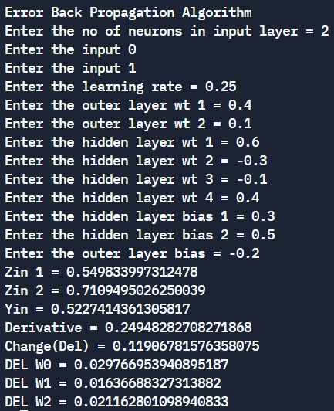
Conclusion: Thus, we have successfully implemented back propagations algorithm.

Post Lab Descriptive Questions :

- Derive the weight change equations for EBPA by using tangent activation function.
- Derivative of the error with respect to the activation
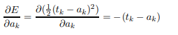
Now we see why the 1/2 in the E term was useful.
- Derivative of the activation with respect to the net input
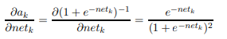
Rewrite this result in terms of the activation function:
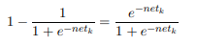
Using this fact, we can rewrite the result of the partial derivative as:
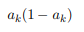
- Derivative of the net input with respect to a weight
Only one term of the net summation will have a non-zero derivative. Again the one associated with the particular weight is considered.
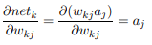
- Weight change rule for a hidden to output weight
Now substituting these results back into our original equation we have:
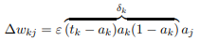
It looks very similar to the Perceptron Training Rule. The only difference is the inclusion of the derivative of the activation function. This equation is typically simplified as shown below where the δ term repesents the product of the error with the derivative of the activation function.
- Weight change rule for an input to hidden weight
Now we have to determine the appropriate weight change for an input to hidden weight. This is more complicated because it depends on the error at all of the nodes this weighted connection can lead to.
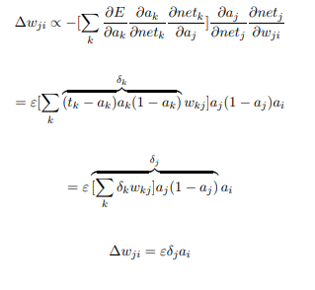

Date: 29-10-2021 Signature of faculty in-charge

