Batch: A1 Roll No.: 1911004
Experiment No. : 07
Grade: AA / AB / BB / BC / CC / CD /DD
Signature of the Staff In-charge with date

Title: Fuzzification methods and operations on fuzzy set.
__________________________________________________________________________________
Objective: To implement fuzzification methods and perform operations on fuzzy sets.
__________________________________________________________________________________
Expected Outcome of Experiment:

CO4 : Apply basics of Fuzzy logic and neural networks.
___________________________________________________________________________________
Books/ Journals/ Websites referred:

- J.S.R.Jang, C.T.Sun and E.Mizutani, “Neuro-Fuzzy and Soft Computing”, PHI, 2004, Pearson Education 2004.
- Davis E.Goldberg, “Genetic Algorithms: Search, Optimization and Machine Learning”, Addison Wesley, N.Y., 1989.
- S. Rajasekaran and G.A.V.Pai, “Neural Networks, Fuzzy Logic and Genetic Algorithms”, PHI, 2003.
- http://library.thinkquest.org/C007395/tqweb/history.html.
___________________________________________________________________________________
Pre Lab/ Prior Concepts:
A fuzzy set is a pair where is a set and
For each the value is called the grade of membership of in For a finite set the fuzzy set is often denoted by
Let Then is called not included in the fuzzy set if , is called fully included if , and is called a fuzzy member if . The set is called the support of and the set is called its kernel. The function is called the membership function of the fuzzy set
____________________________________________________________________________________
Implementation Details:

Membership functions can either be chosen by the user arbitrarily, based on the user’s experience (MF chosen by two users could be different depending upon their experiences, perspectives, etc.) or be designed using machine learning methods (e.g., artificial neural networks, genetic algorithms, etc). There are different shapes of membership functions; triangular, trapezoidal, piecewise-linear, Gaussian, bell-shaped, etc.
import numpy as np
import matplotlib.pyplot as plt
import math
import scipy.stats as stats
Triangular function:
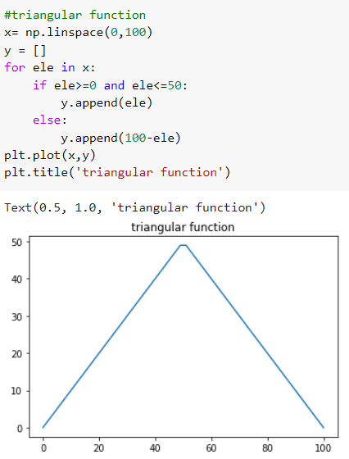
Ramp function:
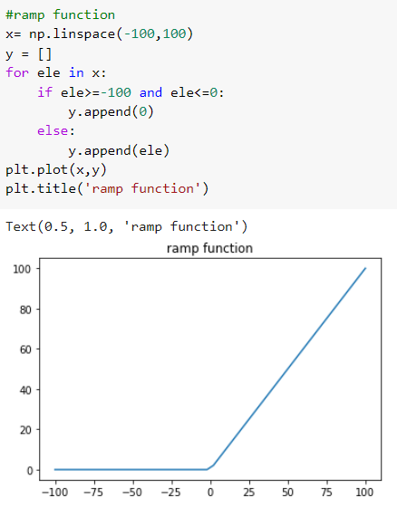
Trapezoidal function:
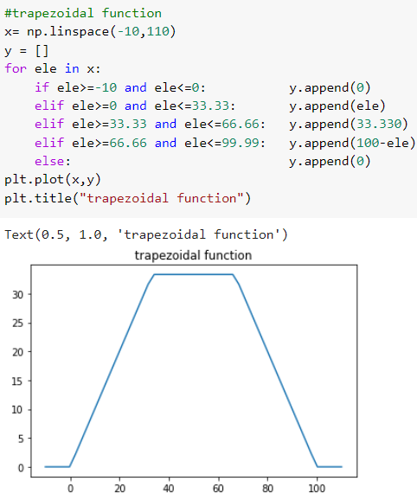
There are two special cases of a trapezoidal function, which are called R-functions and L-functions:
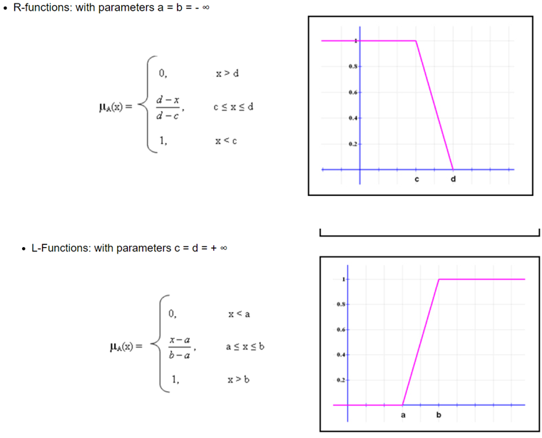
Gaussian function:
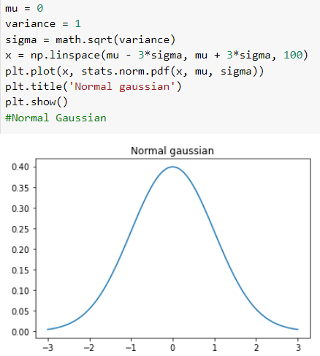

Bell Shaped Function:

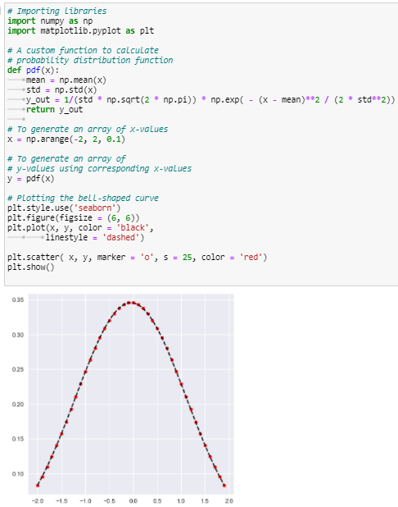
FUZZY OPERATORS:
Union:
Consider 2 Fuzzy Sets denoted by A and B
Then let’s consider Y be the Union of them, then for every member of A and B, Y will be:
Y(x)=max[A(x), B(x)]
Union is denoted as A B
Example:
The First Fuzzy Set is: {'a': 0.2, 'b': 0.3, 'c': 0.6, 'd': 0.6}
The Second Fuzzy Set is: {'a': 0.9, 'b': 0.9, 'c': 0.4, 'd': 0.5}
Fuzzy Set Union is: {'a': 0.9, 'b': 0.9, 'c': 0.6, 'd': 0.6}

Intersection:
Consider 2 Fuzzy Sets denoted by A and B
Then let’s consider Y be the Intersection of them, then for every member of A and B, Y will be:
Y(x)=min[A(x), B(x)]
Union is denoted as A ∩ B.
Example
The First Fuzzy Set is: {'a': 0.2, 'b': 0.3, 'c': 0.6, 'd': 0.6}
The Second Fuzzy Set is: {'a': 0.9, 'b': 0.9, 'c': 0.4, 'd': 0.5}
Fuzzy Set Intersection is: {'a': 0.2, 'b': 0.3, 'c': 0.4, 'd': 0.5}

Complement:
Consider a Fuzzy Sets denoted by A,
Then let’s consider Y be the Complement of it, then for every member of A , Y will be:
Y(x) =1-A(x)
Example:
The Fuzzy Set is: {'a': 0.2, 'b': 0.3, 'c': 0.6, 'd': 0.6}
Fuzzy Set Complement is: {'a': 0.8, 'b': 0.7, 'c': 0.4, 'd': 0.4}

Conclusion:
Thus, we have successfully implemented fuzzification and perform operations on fuzzy sets.
Post Lab Descriptive Questions:
- Take any example and explain all the operations on that.
Complement:
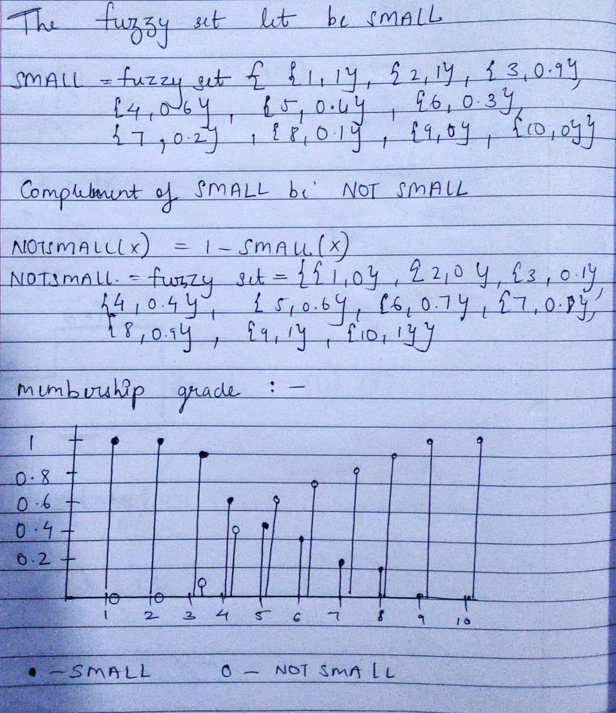

Union:

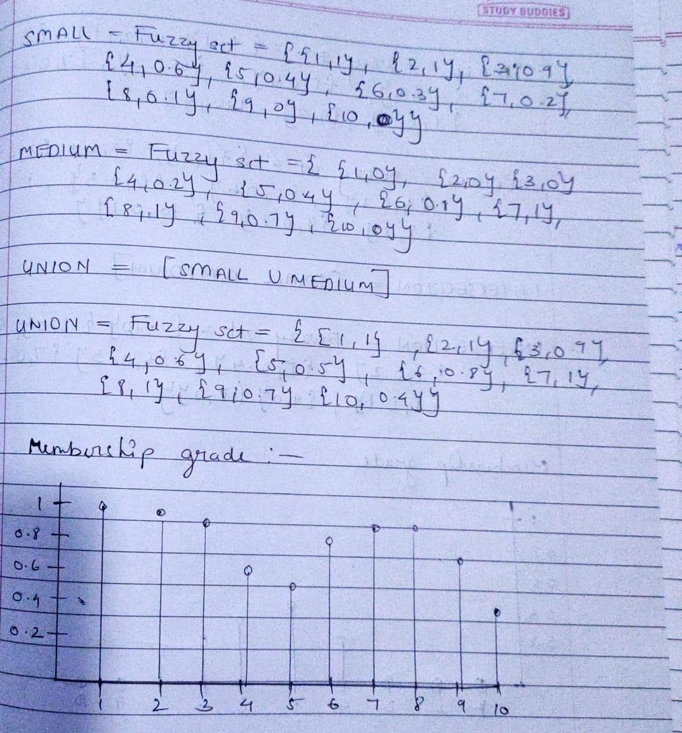

Intersection:
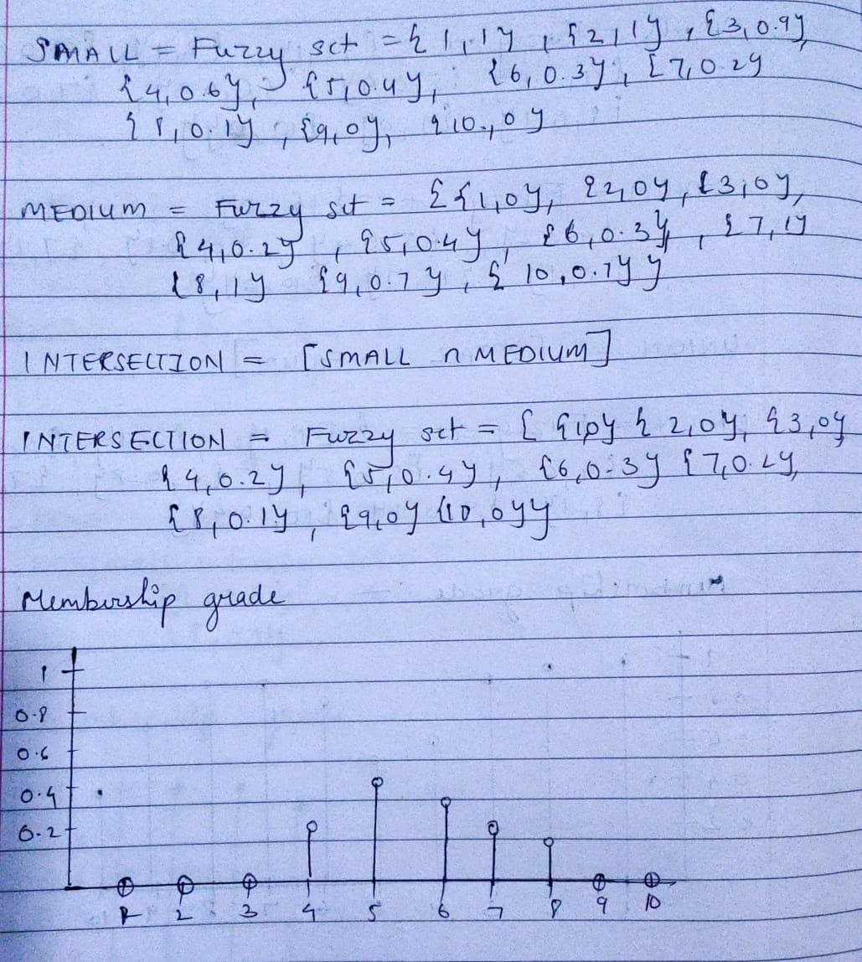

Date: 12-11-2021 Signature of faculty in-charge

