Batch: A1 Roll No.: 1911004

Experiment No. 08

Grade: AA / AB / BB / BC / CC / CD /DD

Signature of the Staff In-charge with date

Title: Defuzzification methods.
____________________________________________________________________________________
Aim : To Write a program to implement defuzzification methods. ____________________________________________________________________________________
Expected Outcome of Experiment:

CO4 : Apply basics of Fuzzy logic and neural networks ____________________________________________________________________________________
Books/ Journals/ Websites referred:

- J.S.R.Jang, C.T.Sun and E.Mizutani, “Neuro-Fuzzy and Soft Computing”, PHI, 2004, Pearson Education 2004.
- Davis E.Goldberg, “Genetic Algorithms: Search, Optimization and Machine Learning”, Addison Wesley, N.Y., 1989.
- S. Rajasekaran and G.A.V.Pai, “Neural Networks, Fuzzy Logic and Genetic Algorithms”, PHI, 2003.
- http://library.thinkquest.org/C007395/tqweb/history.html
____________________________________________________________________________________
Pre Lab/ Prior Concepts:
A fuzzy set is a pair where is a set and
For each the value is called the grade of membership of in For a finite set the fuzzy set is often denoted by
Let Then is called not included in the fuzzy set if , is called fully included if , and is called a fuzzy member if . The set is called the support of and the set is called its kernel. The function is called the membership function of the fuzzy set
____________________________________________________________________________________
Implementation Details:

Difuzzification :

Difuzzifications is the process of converting fuzzy values into crisp output.
There are five methods for diffuzzification :
- centroid of area
- bisector of area
- middle of maximum
- smallest of maximum
- largest of maximum

Suppose you have the following region to be defuzzified.
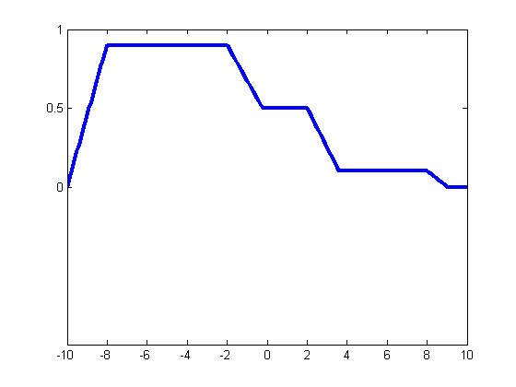
Function for the graph:

x = -10:0.1:10;
mf1 = trapmf(x,[-10 -8 -2 2]);
mf2 = trapmf(x,[-5 -3 2 4]);
mf3 = trapmf(x,[2 3 8 9]);
mf = max(0.5*mf2,max(0.9*mf1,0.1*mf3));
plot(x,mf)
h_gca = gca;
h_gca.YTick = [0 .5 1] ;
ylim([-1 1])

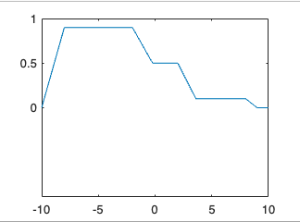

Centroid of Area :
x = -10:0.1:10;
mf1 = trapmf(x,[-10 -8 -2 2]);
mf2 = trapmf(x,[-5 -3 2 4]);
mf3 = trapmf(x,[2 3 8 9]);
mf = max(0.5*mf2,max(0.9*mf1,0.1*mf3));
plot(x,mf)
h_gca = gca;
h_gca.YTick = [0 .5 1] ;
ylim([-1 1])
xCentroid = defuzz(x,mf,'centroid');
hCentroid = line([xCentroid xCentroid],[-0.2 1.2]);
tcentroid = text(xCentroid,-0.2,'Centroid')
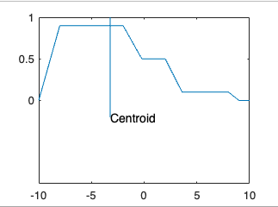

Bisector of Area :
x = -10:0.1:10;
mf1 = trapmf(x,[-10 -8 -2 2]);
mf2 = trapmf(x,[-5 -3 2 4]);
mf3 = trapmf(x,[2 3 8 9]);
mf = max(0.5*mf2,max(0.9*mf1,0.1*mf3));
plot(x,mf)
h_gca = gca;
h_gca.YTick = [0 .5 1] ;
ylim([-1 1])
xBisector = defuzz(x,mf,'bisector');
hBisector = line([xBisector xBisector],[-0.4 1.2]);
TBisector = text(xBisector,-0.4,' Bisector');

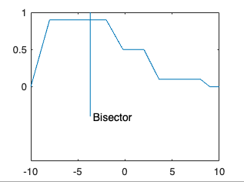

Middle, Smallest, and Largest of Maximum :

x = -10:0.1:10;
mf1 = trapmf(x,[-10 -8 -2 2]);
mf2 = trapmf(x,[-5 -3 2 4]);
mf3 = trapmf(x,[2 3 8 9]);
mf = max(0.5*mf2,max(0.9*mf1,0.1*mf3));
plot(x,mf)
h_gca = gca;
h_gca.YTick = [0 .5 1] ;
ylim([-1 1])
xMOM = defuzz(x,mf,'mom');
xSOM = defuzz(x,mf,'som');
xLOM = defuzz(x,mf,'lom');
hMOM = line([xMOM xMOM],[-0.7 1.2]);
tMOM = text(xMOM,-0.7,' MOM');
hSOM = line([xSOM xSOM],[-0.7 1.2]);
tSOM = text(xSOM,-0.7,' SOM');
hLOM = line([xLOM xLOM],[-0.7 1.2]);
tLOM = text(xLOM,-0.7,' LOM');

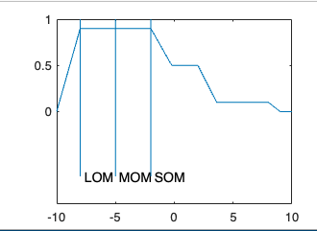

Conclusion: Thus, we have successfully implemented defuzzification methods.
Post Lab Descriptive Questions :
- Explain a fuzzy system for a fully automatic washing machine.
Question:
Design a controller to determine the wash time of a domestic washing machine. Assume that input is dirt and grease on cloths. Use three descriptors for input variables and five descriptors for output variables. Derive set of rules for controller action and defuzzification. The design should be supported by figures wherever possible. Show that if the cloths are soiled to a larger degree the wash time will be more and vice-versa.

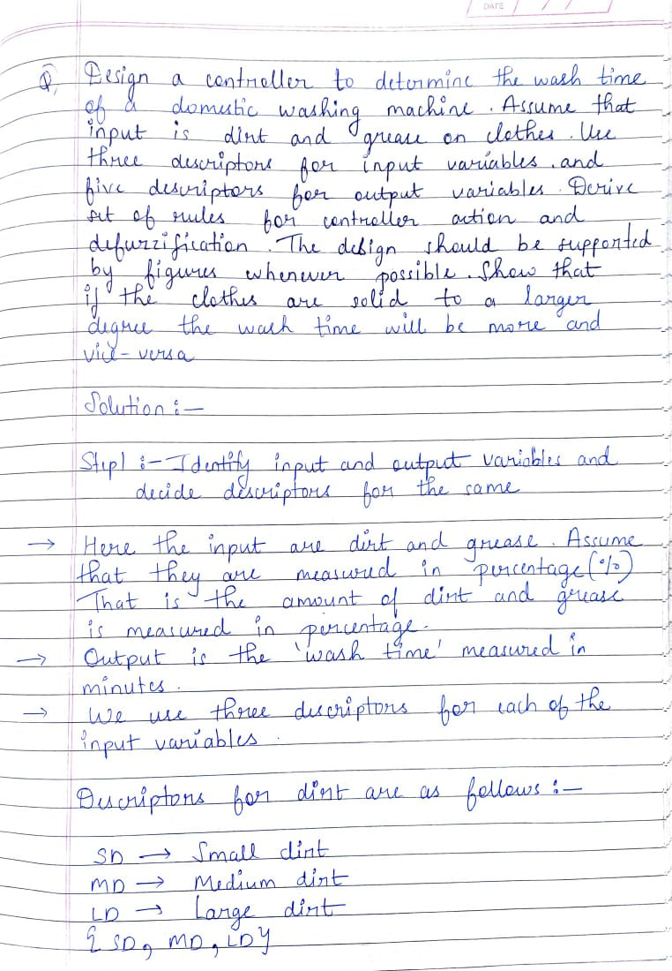
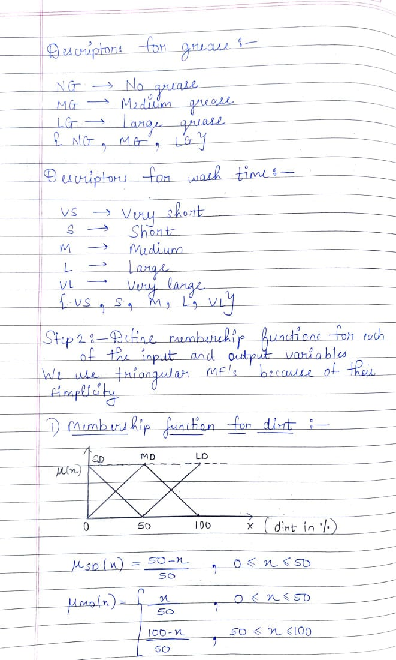
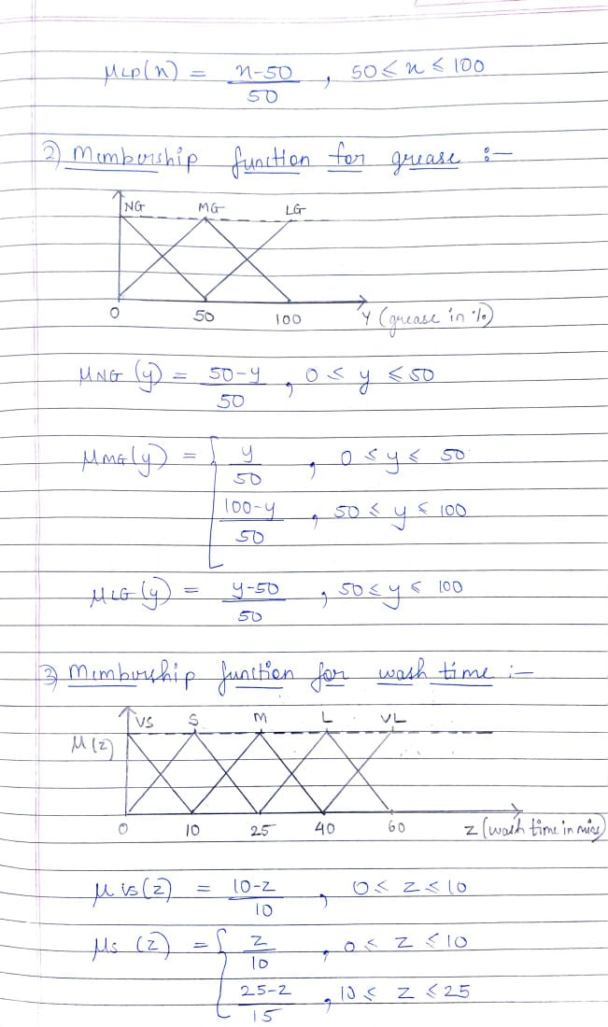
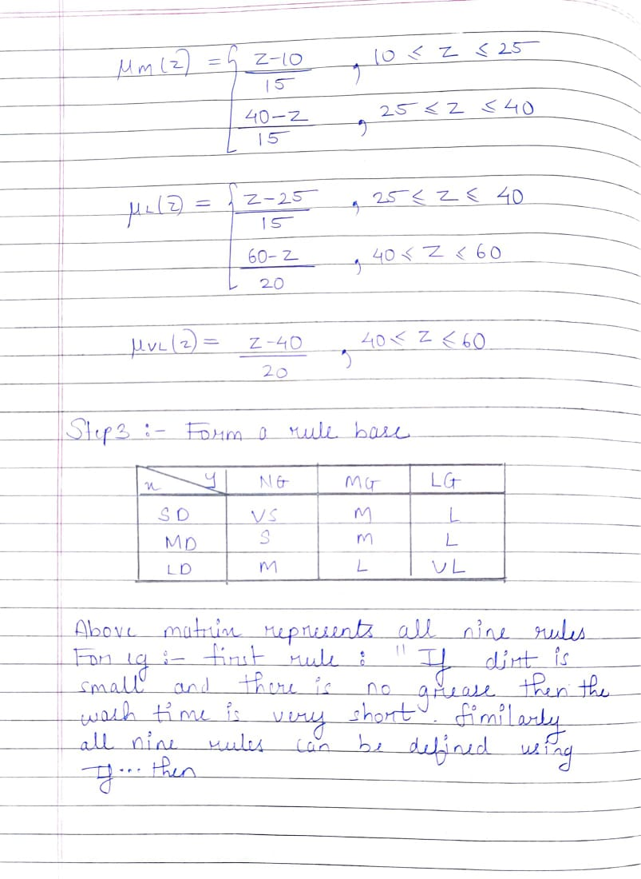
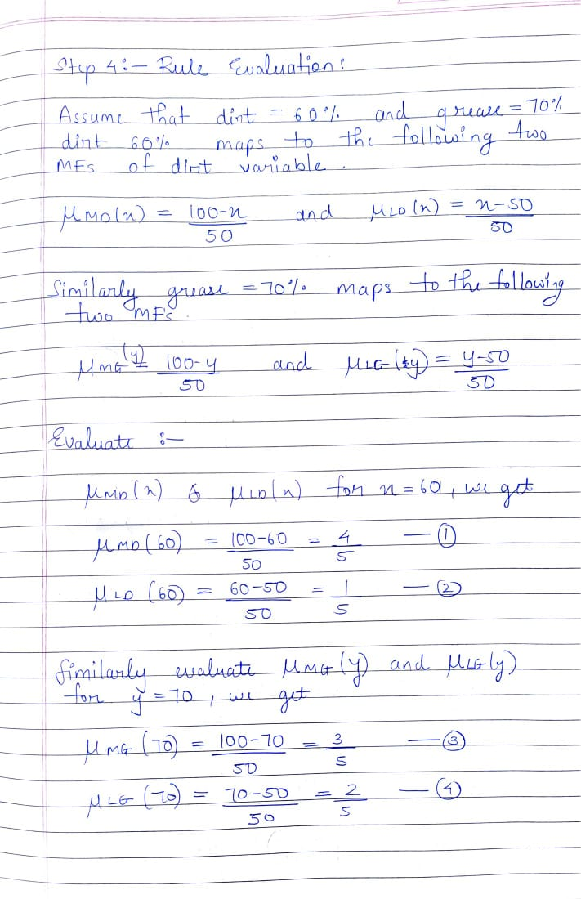
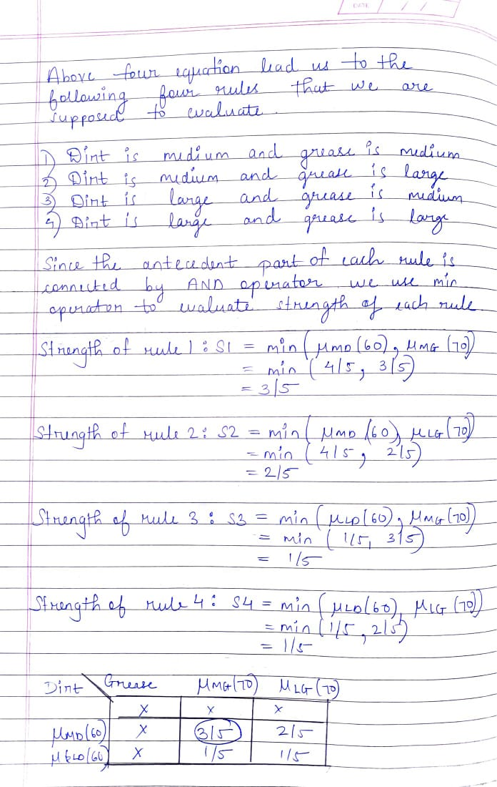
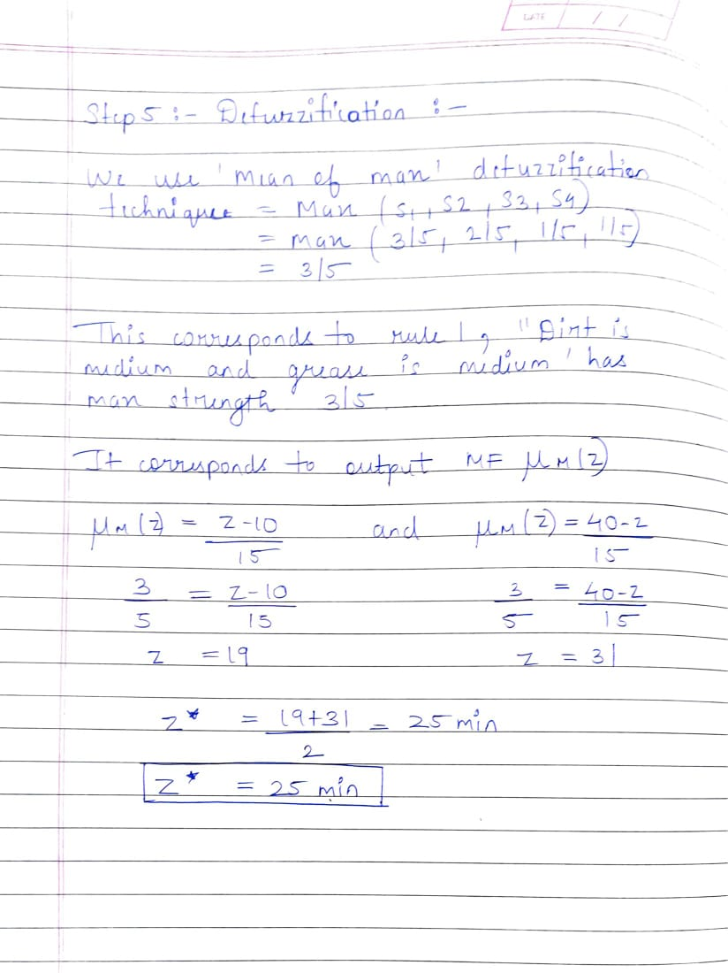

Date: 25-11-2021 Signature of faculty in-charge

