Batch: A1 Roll No.: 1911004

Experiment No. 09

Grade: AA / AB / BB / BC / CC / CD /DD

Signature of the Staff In-charge with date

Title: Case study on any one Special Neural Networks
____________________________________________________________________________________
Aim : Explain any one Special Neural Networks :Cognitron, Neocognitron, Boltzman Machine, Gaussian Machine, Simulated Annealing, SVM
____________________________________________________________________________________
Expected Outcome of Experiment:
CO3 : Understand perceptron’s and counter propagation networks
____________________________________________________________________________________
Books/ Journals/ Websites referred:

- J.S.R.Jang, C.T.Sun and E.Mizutani, “Neuro-Fuzzy and Soft Computing”, PHI, 2004, Pearson Education 2004.
- Davis E.Goldberg, “Genetic Algorithms: Search, Optimization and Machine Learning”, Addison Wesley, N.Y., 1989.
- S. Rajasekaran and G.A.V.Pai, “Neural Networks, Fuzzy Logic and Genetic Algorithms”, PHI, 2003.
- http://library.thinkquest.org/C007395/tqweb/history.html
____________________________________________________________________________________
Pre Lab/ Prior Concepts:

Fuzzification:

Fuzzification is the process of changing a real scalar value into a fuzzy value. This is done by the help of fuzzifiers (membership functions).
A membership function (MF) is a curve that defines how each point in the input space is mapped to a membership value (or degree of membership) between 0 and 1.
Many types of curves and tables can be used, but triangular or trapezoidal-shaped membership functions are the most common, since they are easier to represent in embedded controllers.
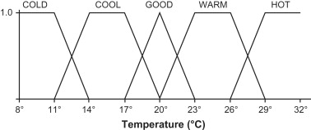

Figure shows a system of fuzzy sets for an input with trapezoidal and triangular membership functions. Each fuzzy set spans a region of input (or output) values graphed against membership. Any particular input is interpreted from this fuzzy set, and a degree of membership is obtained. The membership functions should overlap, in order to allow smooth mapping of the system. The process of fuzzification allows the system inputs and outputs to be expressed in linguistic terms to allow rules to be applied in a simple manner to express a complex system.
A temperature scale defined by fuzzy set theory.

Consider a simplified implementation of an air-conditioning system with a temperature sensor. The temperature might be read by a microprocessor that has a fuzzy algorithm that processes output to continuously control the speed of a motor which keeps the room at a “good temperature”; it also can direct a vent upward or downward as necessary. Figure 7.18 illustrates the process of fuzzification of the air temperature.

There are five fuzzy sets for temperature: COLD, COOL, GOOD, WARM, and HOT..

Di-fuzzification

Defuzzification is the process of representing a fuzzy set with a crisp number. Internal representations of data in a fuzzy system are usually fuzzy sets. But the output frequently needs to be a crisp number that can be used to perform a function such as commanding a valve to a desired position in a control application or indicate a problem risk index as discussed in next section.

The most commonly used defuzzification method is the center of area method (COA), also commonly referred to as the centroid method. This method determines the center of area of fuzzy set and returns the corresponding crisp value. The center of sums (COS) method and the mean of maximum method are two alternative methods in defuzzification.

Figure shows the complete structure of a Fuzzy Logic System. Once all input variable values are translated into respective linguistic variable values, the fuzzy inference step evaluates the set of fuzzy rules that define the evaluation. The result of this is again a linguistic value. The defuzzification step translates this linguistic result into a numerical value.
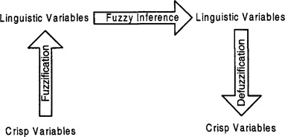

Membership functions,

The only condition a membership function must really satisfy is that it must vary between 0 and 1. The function itself can be an arbitrary curve whose shape we can define as a function that suits us from the point of view of simplicity, convenience, speed, and efficiency. A classical set might be expressed as

A = {x | x > 6}

A fuzzy set is an extension of a classical set. If X is the sample space and its elements are denoted by x, then a fuzzy set A in X is defined as a set of ordered pairs.

A = {x, µA(x) | x ∊ X}

µA(x) is called the membership function (or MF) of x in A. The membership function maps each element of X to a membership value between 0 and 1.

Designing of Fuzzy Controller

Designing fuzzy controller requires knowledge of fuzzy inference systems such as Mamdani approach of Takagi-Sugeno approach. Fuzzy logic controllers are based on fuzzy logic. Most of the embedded devices are nowadays implements one or other kind of FLC, for example air conditioner, washing machine, traffic light controller, flight navigation system and many more.

Following steps should be followed to for designing fuzzy controller:

- Identification of variables: Input, output and state variables must be identified of the plant
- Fuzzy subset configuration: The universe of information spanned by each variable is divided into number of fuzzy subsets and each subset is assigned a linguistic variable
- Obtaining membership function: Obtain membership function for each fuzzy subset
- Fuzzy Rule Base Configuration: Formulate fuzzy rule base by assigning relationship between fuzzy input and output
- Normalizing and scaling factors: Appropriate scaling factors for input and output variables must be chosen to normalize variables between [0, 1] and [-1, 1] intervals
- Fuzzification: The Fuzzification process is done in this step with the help of Fuzzifier
- Identification of output: Identify the output from each rule using fuzzy approximate reasoning and combine the fuzzy output obtained from each rule
- Defuzzification: Initiate Defuzzification process to form crisp output
____________________________________________________________________________________
Implementation Details:



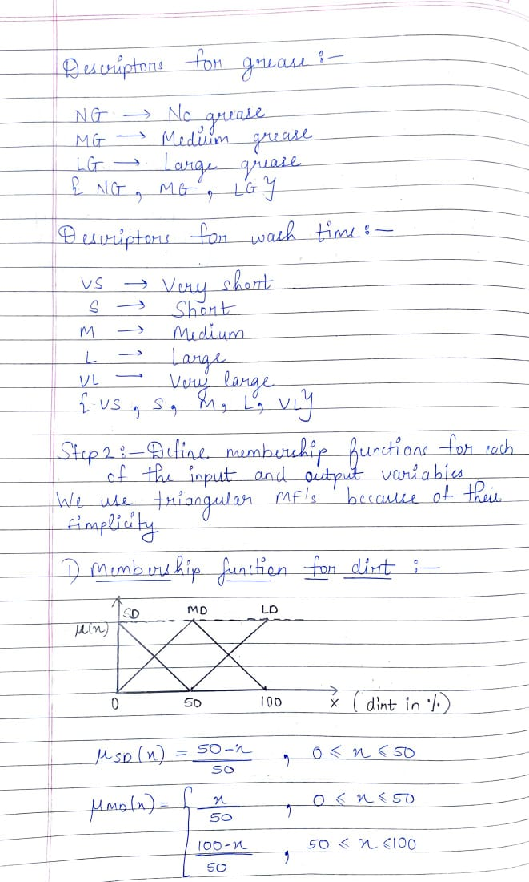
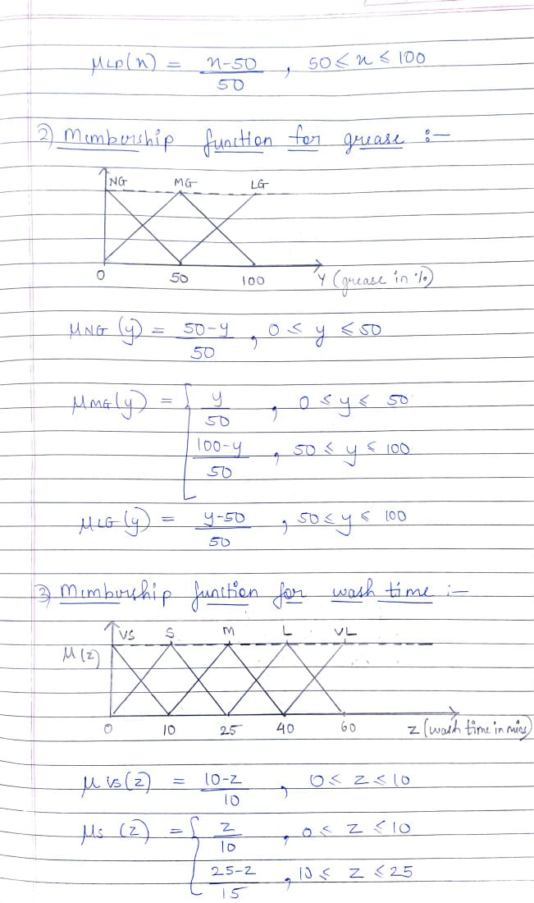
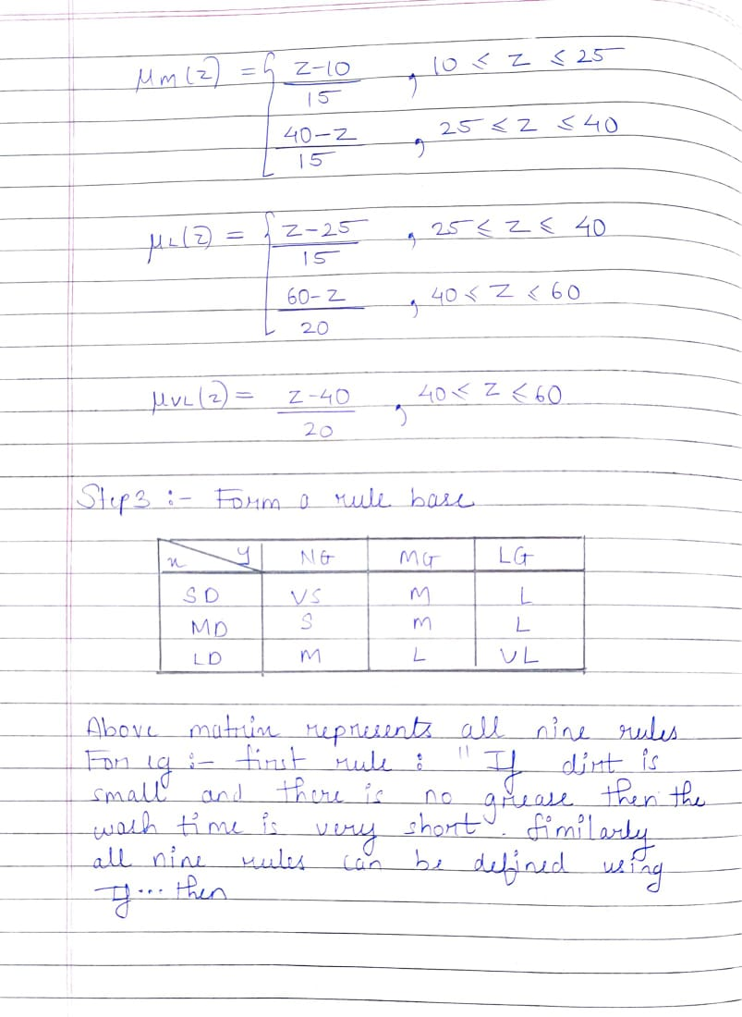
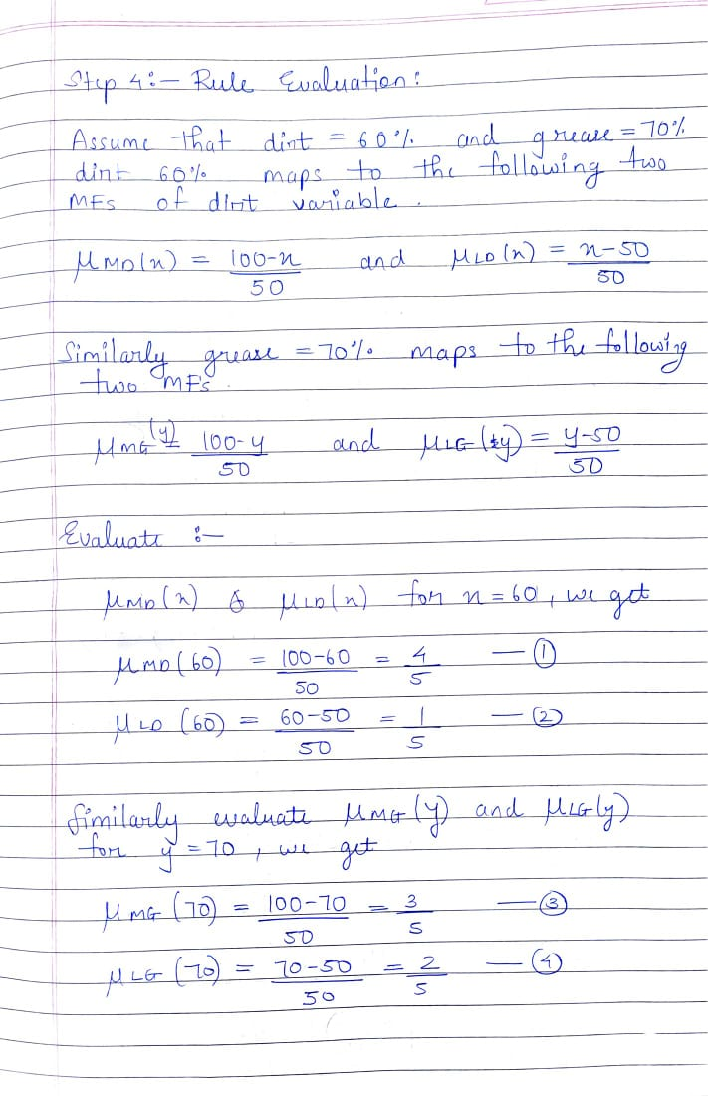
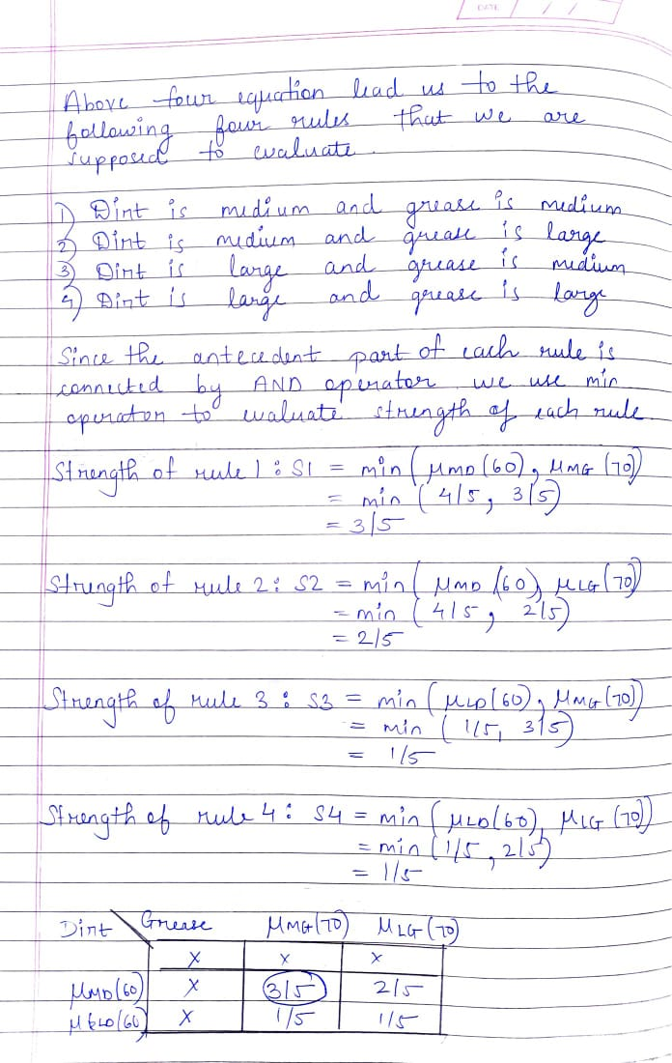
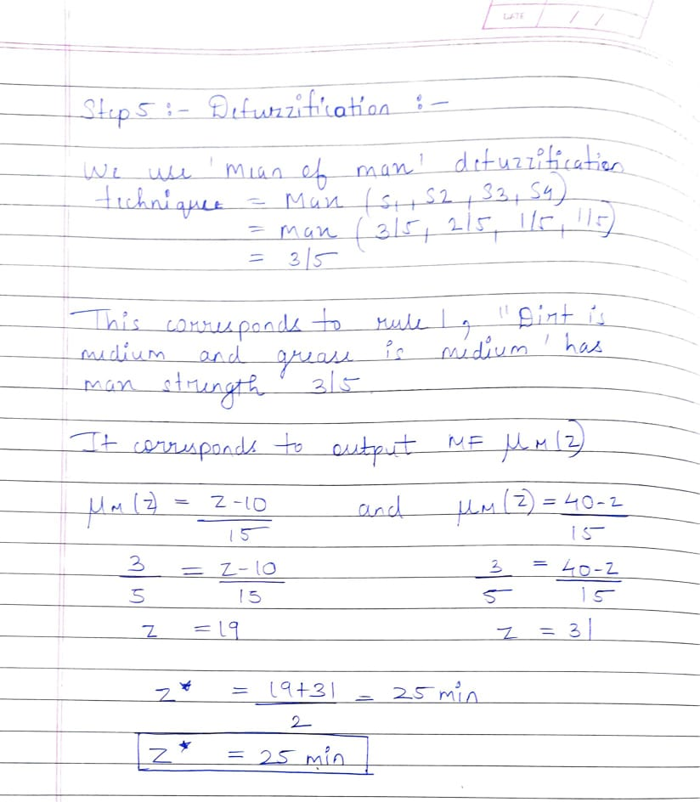

Conclusion: Thus, we have successfully implemented one special Neural Network

Date: 01-12-2021 Signature of faculty in-charge

