Batch: A1 Roll No 1911004
Experiment No. 8
Grade: AA / AB / BB / BC / CC / CD /DD

Title: Implementation of Hashing using collision resolution methods linear and quadratic probing.

Objective: To understand concept of hashing and rehashing, designing of hash function and applications of hashing.

Expected Outcome of Experiment:

CO | Outcome
CO3 | Demonstrate sorting and searching methods.

Books/ Journals/ Websites referred:
- Reema Thareja

Abstract:- (Definitions of Hashing, Hash function design, collision, collision handling method )
Searching is dominant operation on any data structure. Most of the cases for inserting, deleting, updating all operations required searching first. So searching operation of particular data structure determines it’s time complexity. If we take any data structure the best time complexity for searching is O (log n) in AVL tree and sorted array only. Most of the cases it will take O (n) time. To solve this searching problem hashing concept introduced which will take O (1) time for searching. It’s constant time. Hash function. This function decides where to put a given element into that table. If we want to search also first apply hash function decide whether the element present in hash table or not.
The formula that will be used is:
Hash Key = Key % Number Of Slots In The Table
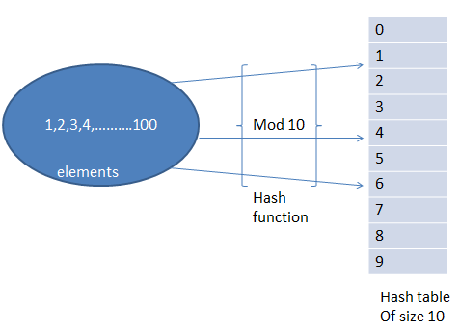

Types of Hash functions:
- Division method
In this the hash function is dependent upon the remainder of a division. For example:-if the record 9,10,12,34,108 is to be placed in a hash table and let us take the table size is 10.
h(key)=record% table size.
0 | 10
1
2 | 12
3
4 | 34
5
6
7
8 | 108
9 | 9
2=12%10
8=108%10
9=9%10
4=34%10
0 = 10%10

- Digit folding method
In this method the key is divided into separate parts and by using some simple operations these parts are combined to produce a hash key. For example: consider a record of 12565015 then it will be divided into parts i.e. 125, 650, 15. After dividing the parts combine these parts by adding it.
H(key) = 125+650+15
= 790
- Mid square method
In this method firstly key is squared and then mid part of the result is taken as the index. For example: consider that if we want to place a record of 3101 and the size of table is 1000. So 3101*3101=9616201 i.e. h (3101) = 162 (middle 3 digit)

Methods of collision resolution:
When one or more hash values compete with a single hash table slot, collisions occur. To resolve this, the next available empty slot is assigned to the current hash value. The most common methods are open addressing, chaining, probabilistic hashing, perfect hashing and coalesced hashing technique.
- Open Addressing:
This technique depends on space usage and can be done with linear or quadratic probing techniques. As the name says, this technique tries to find an available slot to store the record. It can be done in one of the 3 ways –
- Linear probing – Here, the next probe interval is fixed to 1. It supports best caching but miserably fails at clustering.
- Quadratic probing – the probe distance is calculated based on the quadratic equation. This is considerably a better option as it balances clustering and caching.
- Double hashing – Here, the probing interval is fixed for each record by a second hashing function. This technique has poor cache performance although it does not have any clustering issues.

- Chaining:
This technique implements a linked list and is the most popular collision resolution techniques. Below is an example of a chaining process.
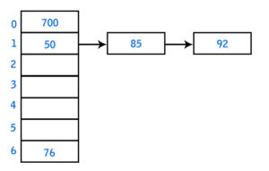
Here, since one slot has 3 elements – {50, 85, 92}, a linked list is assigned to include the other 2 items {85, 92}. When you use the chaining technique, inserting or deleting of items with the hash table is fairly simple and high performing. Likewise, a chain hash table inherits the pros and cons of a linked list. Alternatively, chaining can use dynamic arrays instead of linked lists.
- Perfect hashing:
When the slots are uniquely mapped, there is very less chances of collision. However, it can be done where there is a lot of spare memory.
- Probabilistic hashing:
This is memory based hashing that implements caching. When collision occurs, either the old record is replaced by the new or the new record may be dropped. Although this scenario has a risk of losing data, it is still preferred due to its ease of implementation and high performance.
- Coalesced hashing:
This technique is a combo of open address and chaining methods. A chain of items are stored in the table when there is a collision. The next available table space is used to store the items to prevent collision.
- Hashing with Quadratic Probing:
Quadratic probing can be a more efficient algorithm in a closed hash table, since it better avoids the clustering problem that can occur with linear probing, although it is not immune. It also provides good memory caching because it preserves some locality of reference; however, linear probing has greater locality and, thus, better cache performance.
- Hashing with Linear Probing:
Linear probing is a scheme in computer programming for resolving collisions in hash tables, data structures for maintaining a collection of key–value pairs and looking up the value associated with a given key.
When using a linear probe, the item will be stored in the next available slot in the table, assuming that the table is not already full.
This is implemented via a linear search for an empty slot, from the point of collision. If the physical end of table is reached during the linear search, the search will wrap around to the beginning of the table and continue from there.
If an empty slot is not found before reaching the point of collision, the table is full.
Hash Function chosen for experiment:
Division hash function that decides the keys after dividing the key by table size is Hash Function use in the experiment.

Implementation Details:
#include <stdio.h>
#include <stdlib.h>

int hash(int a[], int table[], int N, int n){
int index,key;
int c=0;
for(int i=0;i<n;i++){
key=a[i];
index=key%N;
if(table[index]==-1){
table[index]=key;
}else{
while(table[index]!=-1) {
index=(index+1)%N;
c++;
}
table[index]=key;
}
}
return c;
}
int searchLinear(int no, int table[], int N){
int index;
index=no%N;
while(table[index]!=no && table[index]!=-1) {
index=(index+1)%N;
}
if(table[index]==no)
return index;
else
return -1;
}
int quadHash(int a[], int table[], int N, int n){
int index, newindex, key;
int c=0,count;
for(int i=0;i<n;i++){
key=a[i];
index=key%N;
if(table[index]==-1) {
table[index]=key;
}else{
newindex=index;
count=0;
while(table[newindex]!=-1) {
c++;
count++;
newindex=(index+(count*count))%N;
}
table[newindex]=key;
}
}
return c;
}
int searchQuadratic(int no, int table[], int N){
int index, newIndex;
index=no%N;
newIndex=index;
int count=0;
while(table[newIndex]!=-1 && table[newIndex]!=no){
count++;
newIndex=(index+(count*count))%N;

}
if(table[newIndex]==no)
return newIndex;
else
return -1;
}

int main()
{
int N, n, c, ch, no, index;
printf("Enter the size of the table ");
scanf("%d",&N);
int table[N];
for(int j=0;j<N;j++)
table[j]=-1;
printf("Enter the number of elements ");
scanf("%d", &n);
int a[n];
printf("Enter the elements ");
for(int i=0;i<n;i++)
scanf("%d",&a[i]);
printf("\nEnter a choice \n1 Quadratic probing\n2 Linear probing\n");
scanf("%d",&ch);
switch(ch){
case 1:
c=quadHash(a,table,N,n);
printf("\n\nQuadratic probing\nIndex\tKey");
for(int k=0;k<N;k++)
printf("\n%d\t\t%d", k,table[k]);
printf("\n(-1 displays blank space)");
printf("\nTotal no. of collisons is %d", c);
break;
case 2:
c=hash(a, table,N,n);
printf("\n\nLinear probing\nIndex\tKey");
for(int k=0;k<N;k++)
printf("\n%d\t\t%d", k,table[k]);
printf("\n(-1 displays blank space)");
printf("\nTotal no. of collisons is %d", c);
break;
}
printf("\nEnter a number to be searched ");
scanf("%d", &no);
switch(ch){
case 1:
index= searchLinear(no, table, N);
if(index==-1)
printf("Number not found");
else
printf("Number found at index %d", index);
break;
case 2:
index=searchQuadratic(no, table, N);
if(index==-1)
printf("Number not found");
else
printf("Number found at index %d", index);
break;
}
}

Output:
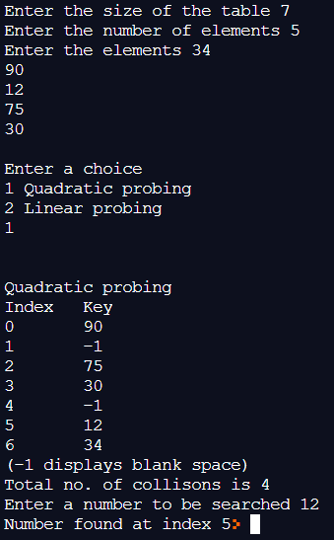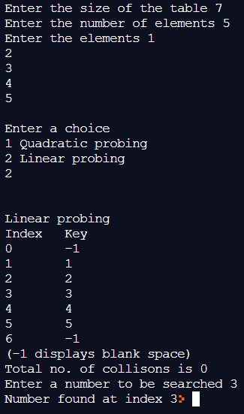

- Enlist all the Steps followed and various options explored
- int searchQuadratic(int no, int table[], int size)

DECLARE int index, newIndex;
INITIALISE index=no%size;

SET newIndex=index;
INITIALISE int count=0;
REPEAT WHILE(table[newIndex]is not -1 and table[newIndex] is not no)

increment count
SET newIndex=(index+(count*count))%size;

IF(table[newIndex] is no)
RETURN newIndex;
ELSE
RETURN -1;

- int hash(int a[], int table[], int size, int n)

DECLARE int index,key;
INITIALISE int c=0;
REPEART FOR(int i=0;i<n;i++)

SET key=a[i];
SET index= key%size;
IF(table[index] is equal to -1)

SET table[index]=key;

ELSE

REPEAT WHILE(table[index] is not -1)

SET index=(index+1)%size;
INCREMENT c

SET table[index]=key;

RETURN c;
- int searchLinear(int no, int table[], int size)

DECLARE int index;
INITIALISE index=no%size;
REPEAT WHILE(table[index] is not no and table[index] is not -1)
{
SET index=(index+1)%size;
}
IF(table[index] is no)
RETURN index;
ELSE
RETURN -1;

- int quadHash(int a[], int table[], int size, int n)

DECLARE int index, newindex, key;
INITIALISE int c=0,count;
REPEAT FOR (int i=0;i<n;i++)
SET key=a[i];

SET index=key%size;
IF(table[index] is -1)

SET table[index]=key;

ELSE

SET newindex=index;
SET count=0;
REPEAT WHILE(table[newindex] is not -1)

increment c;
increment count;
SET newindex=(index+(count*count))%size;

SET table[newindex]=key;

RETURN c;

- int main()
input data
ask for users choice
return 0;

- Explain your program logic, classes and methods used.

- int searchLinear(int, int[], int)-
Searches an element from a linear sorted hashing table. It accepts a number and decides the index of the number by finding its modulo when divided by size of the table. If the number is present at that index, it is directly returned to main. Otherwise the current index is increased by 1 and again its modulo on division with the size is found till the number is found or an empty index occurs which means that the number does not exist in the table.

- int searchQuadratic(int, int[], int)-
Searches an element from a quadratic sorted hashing table. It accepts a number and decides the index of the number by finding its modulo when divided by size of the table. If the number is present at that index, it is directly returned to main. Otherwise a new index is found by the formula newindex=(index+(count*count)) %size is found till the number is found or an empty index occurs which means that the number does not exist in the table.

- int hash(int[], int[], int, int)-
Sorts numbers using linear probing. It accepts a number and decides the index of the number by finding its modulo when divided by size of the table. If that index is empty, the number is inserted at that index. Otherwise the current index is increased by 1 and again its modulo on division with the size is found till an empty index occurs.

- int quadHash(int[], int[], int,int)-
sorts numbers using quadratic probing. It accepts a number and decides the index of the number by finding its modulo when divided by size of the table. If that index is empty, the number is inserted at that index. Otherwise a new index is found by the formula newindex=(index+(count*count)) %size. This formula is implied until an empty index is encountered.

- Explain the Importance of the approach followed by you
- The elements entered into a hashing table are successfully sorted and placed at their designated indices using linear and quadratic probing method. All functions used are in this method for sorted. This helped us to build concept of linear and quadratic probing.

Conclusion:-

We understood the concept of Hash Functions using collision resolution methods (linear & quadratic probing) & implemented them in C ; thus obtaining correct necessary output .

Post Lab questions-
- Store the given numbers in bucket of size 16, resolve the collisions if any with
20, 33, 65, 23, 11, 32, 78, 64, 3, 87, 10, 7
        - Linear probing

0 | 32 | 20=1*16+4  1 probe.  33=2*16+1  1 probe.  65=4*16+1  2 probes.  23=1*16+7  1 probe.  11=0*16+11  1 probe.  32=2*16+0  1 probe.  78=4*16+14  1 probe.  64=4*16+0  4 probes.  3=0*16+3  3 probes.  87=5*16+7  2 probes.  10=0*16+10  1 probe.  7=0*16+7  3 probes
1 | 33
2 | 65
3 | 64
4 | 20
5 | 3
6
7 | 23
8 | 87
9 | 7
10 | 10
11 | 11
12
13
14 | 78
15

        - Quadratic hashing

0 | 32 | 20=1*16+4  4  1 probe.  33=2*16+1  1  1 probe.  65=4*16+1  1 2  2 probes.  23=1*16+7  7  1 probe.  11=0*16+11  11  1 probe.  32=2*16+0  0  1 probe.  78=4*16+14  14  1 probe.  64=4*16+0  0 1 4 9  4 probes.  3=0*16+3  3  1 probe.  87=5*16+7  7 8  2 probes.  10=0*16+10  10  1 probe.  7=0*16+7  7 8 11 0 7 0 11 8 7 8 11 0 7 0 11 8  No spot available.
1 | 33
2 | 65
3 | 3
4 | 20
5
6
7 | 23
8 | 87
9 | 64
10 | 10
11 | 11
12
13
14 | 78
15

        - Chaining

0 | 32 64 | 20=1*16+4  33=2*16+1  65=4*16+1  23=1*16+7  11=0*16+11  32=2*16+0  78=4*16+14  64=4*16+0  3=0*16+3  87=5*16+7  10=0*16+10  7=0*16+7
1 | 33 65
2
3 | 3
4 | 20
5
6
7 | 23 87 7
8
9
10 | 10
11 | 11
12
13
14 | 78
15

