Batch: A1 Roll No.: 1911004
Experiment No. 9
Grade: AA / AB / BB / BC / CC / CD /DD

Title: Implementation of Graph traversal menu driven program (DFS and BFS).

Objective: To understand graph as data structure and methods of traversing Graph

Expected Outcome of Experiment:

CO | Outcome
CO3 | Demonstrate sorting and searching methods.

Books/ Journals/ Websites referred:

- Reema Thareja

Abstract :- (Definition of Graph, types of graphs, and difference and similarity between graph & tree )
- Definition:
A Graph is a non-linear data structure consisting of nodes(vertices) and edges(lines), egdes connect any two nodes in the graph. In more technical explanation a Graph can be defined as a finite set of vertices (or nodes) and set of edges(lines) that connect a pair of nodes.
- Types of Graphs:
- Simple Graph
- Multi Graph
- Null Graph
- Finite Graph
- Infinite Graph
- Trivial Graph
- Regular Graph
- Bipartite Graph
- Labelled Graph
- Complete Graph
- Pseudo Graph
- Digraph Graph
- Subgraph
- Connected Graph
- Disconnected Graph
- Cyclic Graph

- Similarity between TREES & GRAPHS:
- Both are a collection of nodes/vertices and edges
- Both are non-linear data structures.

- Difference between TREES & GRAPHS
TREE | GRAPH
Hierarchical | Network
It has exactly one root node. | Graph doesn't have a root node.
Pre-order, In-order and Post-order. | Breadth-first search and depth-first search.
Less complex | More complex comparatively

Algorithm for DFS:
- We pick up a starting node and push all its adjacent nodes into a stack.
- Pop a node from stack to select the next node to visit and push all its adjacent nodes into a stack.
- Repeat this process until the stack is empty. However, ensure that the nodes that are visited are marked. This will prevent you from visiting the same node more than once. If you do not mark the nodes that are visited and you visit the same node more than once, you may end up in an infinite loop.
Algorithm for BFS:
- First we move horizontally and visit all the nodes of the current layer
- Then we move to the next layer
- A graph can contain cycles, which may bring you to the same node again while traversing the graph. To avoid processing of same node again, use a boolean[] which marks the node after it is processed. While visiting the nodes in the layer of a graph, store them in a manner such that you can traverse the corresponding child nodes in a similar order.
- In the earlier diagram, start traversing from 0 and visit its child nodes 1, 2, and 3. Store them in the order in which they are visited. This will allow you to visit the child nodes of 1 first (i.e. 4 and 5), then of 2 (i.e. 6 and 7), and then of 3 (i.e. 7) etc.
- To make this process easy, use a queue to store the node and mark it as 'visited' until all its neighbours (vertices that are directly connected to it) are marked.
Implementation Details:
#include <stdio.h>
#include <stdlib.h>
#define SIZE 50
int M[SIZE][SIZE],visited[SIZE], q[SIZE],n,front = 0, rear = 0;

void DFS(int i){ //DFS()
int j;
printf("%d ",i);
visited[i]=1;
for(j=0;j<n;j++)
if(!visited[j] && M[i][j]==1)
DFS(j);
}
void BFS (int v){ //BFS()
visited[v] = 1;
q[rear] = v;
rear++;
while (rear != front){
int i;
int u = q[front];
printf ("%d ", u);
front++;
for (i = 0; i < n; i++){
if (!visited[i] && M[u][i]){
q[rear] = i;
rear++;
visited[i] = 1;
}
}
}
printf ("\n\n");
}

int main() {
int i,j, src, ch;
printf("Enter number of vertices: ");
scanf("%d",&n); // n*n matrix
printf("Enter adjacency matrix: \n");
for(i=0;i<n;i++)
for(j=0;j<n;j++)
scanf("%d",&M[i][j]); //n*n matrix
for(i=0;i<n;i++)
visited[i]=0;
printf("Enter source node: ");
scanf("%d", &src); //source node
do{
printf("1.BFS\n2.DFS\n0.Exit\nEnter your choice- ");
scanf("%d", &ch);
switch(ch){
case 1:
printf("\nThe BFS Traversal is:\n");
BFS(src);
for(i=0;i<n;i++)
visited[i]=0; //BFS TRAVERSAL
printf("\n");
break;
case 2:
printf("\nThe DFS Traversal is:\n");
DFS(src);
for(i=0;i<n;i++)
visited[i]=0; //DFS TRAVERSAL
printf("\n");
break;
break;
case 0:
printf("Exiting...\n");
break;
default:
printf(" Invalid Choice\n");
}
}while(ch!=0);
return 0;
} //main() ends

Output
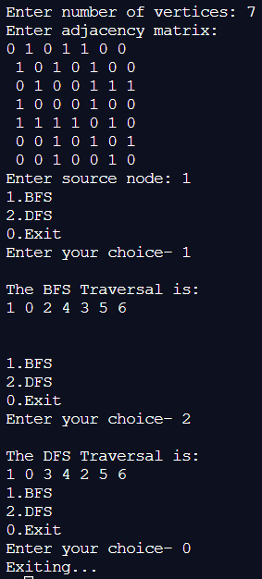
- Enlist all the Steps followed and various options explored
- We asked user for the no of vertices
- We inputted the adjacent Matrix M then
- We asked for the source node then
- We have used the menu driven approach to ask user from BFS / DFS traversal.
- According to choice function is called and we get output.

- Explain your program logic, classes and methods used.
- The code first takes input of the no of vertices & then Matrix values and asks for the source node. The created matrix which represents the connections of the graph and then checks each node for all the connections, marking the visited ones and traversing further through the graph printing all the values, in the BFS() and DFS().

- Explain the Importance of the approach followed by you
- The adjacency matrix M is populated by the function itself so that the user simply has to input the values and doesn’t have to calculate the matrix himself. Recursion is used in DFS().The status of whether the node is visited or not is stored in the visited[].

Post- Lab questions-
- Differentiate between BFS and DFS.

BFS | DFS
BFS is slower . | DFS is faster.
Require more memory. | Require less memory
Searches Breadth-wise through the graph. | Searches Depth-wise through the graph.
Uses Queue data structure to store Un-explored nodes. | Uses Stack data structure to store Un-explored nodes.
A node is fully explored before any other can begin. | Exploration of a node is suspended as soon as another unexplored is found.

- Give sequence of the nodes visited as per BFS and DFS strategy for following example. Souce- Arad, Destination- Bucharest (Traversal would stop after destination is reached)

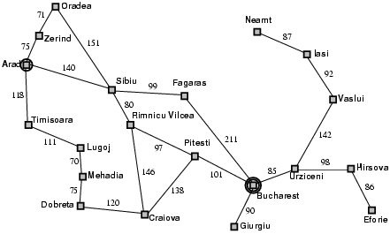

DFS: Arad , Zerind , Oradea , Sibiu , Fagaras , Bucharest

BFS: Arad , Zerind , Sibiu, Timisoara , Oradea , Fagaras , Rimnicu , Lugoj , Bucharest

Conclusion :-
We understood & implemented the concept of Graph Traversal [BFS & DFS] in C ; thus obtained correct necessary output for it.

