Batch: A1 Roll No.: 1911004

Experiment / assignment / tutorial No. 1

Grade: AA / AB / BB / BC / CC / CD /DD

Signature of the Staff In-charge with date

TITLE: Write a program to swap two numbers

AIM: Write a program to swap two numbers by
- using third variable
- Without using third variable
______________________________________________________________________
Expected OUTCOME of Experiment:
CO1. Formulate a problem statement and develop the logic (algorithm/flowchart) for its solution.
_____________________________________________________________________
Books/ Journals/ Websites referred:

- Programming in C, second edition, Pradeep Dey and Manas Ghosh, Oxford University Press.
- Programming in ANSI C, fifth edition, E Balagurusamy, Tata McGraw Hill.
- Introduction to programming and problem solving, G. Michael Schneider, Wiley India edition.
- http://cse.iitkgp.ac.in/~rkumar/pds-vlab/
_____________________________________________________________________
Problem Definition:

This program accepts two numbers from the user. Swap these numbers with and without using third variable.
For example, if in a C program we have two variables a and b where a = 4 and b = 5, then before swapping a = 4, b = 5 after swapping a = 5, b = 4.
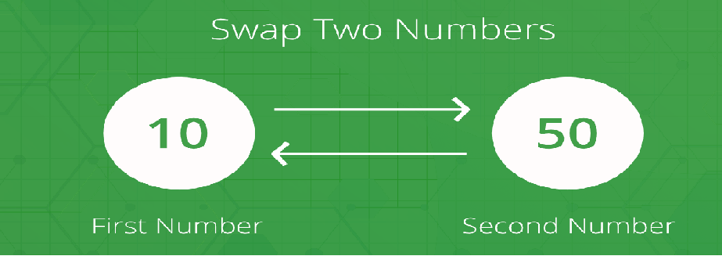

Use arithmetic operator +, - to solve given problem without using 3rd variable.

Algorithm:
- Swapping using 3rd variable
Step 1: Start
Step 2: input the value of Number1,Number2
Step 3: Number3←Number1
Step 4: Number1← Number2
Step 5: Number2←Number3
Step 6: output the value of Number1 &Number2
Step 7: End

2. Swapping without 3rd variable
Step 1: Start
Step 2: input the value of Number1,Number2
Step 3: Number1←Number1+ Number2
Step 4: Number2← Number1- Number2
Step 5: Number1←Number1- Number2
Step 6: output the value of Number1 &Number2
Step 7: End

Implementation details
- Swapping with 3rd variable
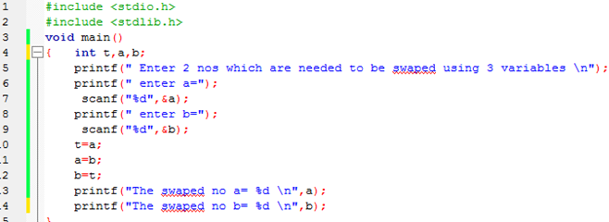

- Swapping using without 3rd variable
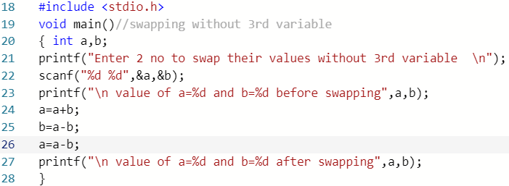
Output(s):
- Swapping using 3rd variable
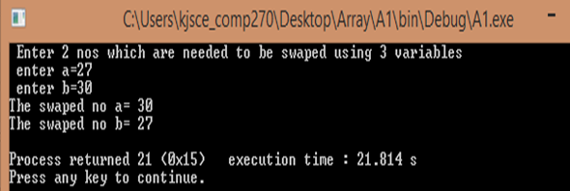

- Swapping using without 3rd variable

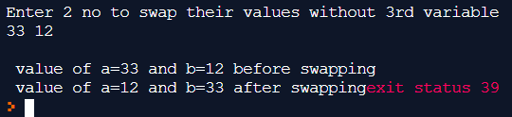
Conclusion: Values stored in two variables were successfully swapped both with and without using 3rd variable.

Post Lab Descriptive Questions:
- What is problem definition?
ANS: Problem Definition is the concise description of an problem statement given which is to be addressed or solved. It is to identify the gap between the current(problem) statement and desired (output) of a given problem statement. Focusing on the facts, needs, the problem statement should be designed to address input specifications, out specifications, special processing. Thus simple and well-defined problem statement will be used by the programmers to understand the given problem & work toward developing a application solution. It is crucial for the problem statement to be clear without any ambiguity.

- Explain the benefits of defining a Problem.
ANS: Benefits of defining a problem statement are
- A clear problem statement leads to better focus and good program output
- Application developed are according to the clients requirement and expectation
- Input, Output Specifications along with special processing are clear before creating application

- Explain Data types and Quantifiers.
ANS: Data types – data type of a variable defines the type of data that variable will take & thus operations are performed on those values.
- Primitive data types
void, int, float, double, char
- Aggregate or Derived data types
Arrays come under this category. Arrays are collection of int or float or char or double data types under same name
- User defined data types
Structures and enum fall under this category.
Primitive datatypes are:
Data type | Size(bytes) | Type explanations
char | 1 | Values in ‘ ‘
int | 4 | Integer values
float | 4 | Floating values
double | 8 | Floating values
void | 1 | Null(valueless)
-Bool | 1 | Boolean values 0&1
Quantifiers–Qualifiers or modifier(specifiers) of data type qualifies the primary data types. There are 3 types of quantifiers:
- Size -short & long
- Sign- signed & unsigned
- Type – const, volatile & restrict
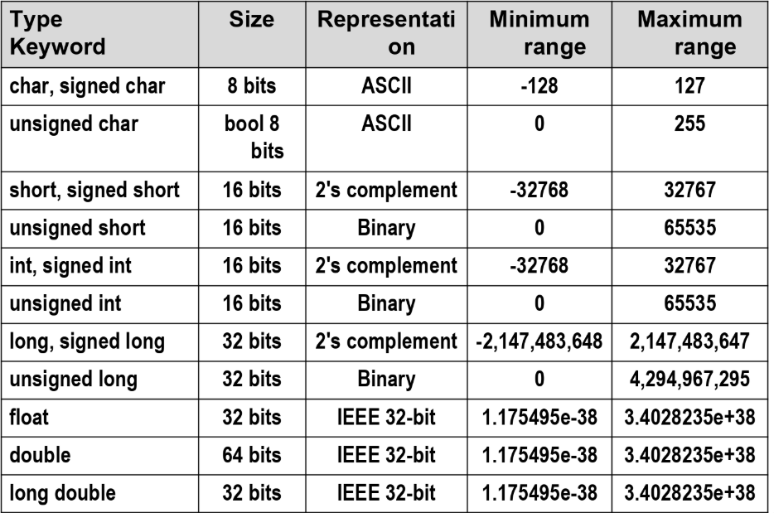

Date: 21/02/2020 Signature of faculty in-charge

