Batch: A1 Roll No.: 1911004

Experiment / assignment / tutorial No. 2

Grade: AA / AB / BB / BC / CC / CD /DD

Signature of the Staff In-charge with date

TITLE: Write a program to accept 3 numbers from the user and find the largest of the 3 numbers using
If - else if-else
Ternary operator

AIM: Write a program to accept 3 numbers from the user and find the largest of the 3 numbers using
If - else if-else
Ternary operator
______________________________________________________________________
Expected OUTCOME of Experiment:
CO1. Formulate a problem statement and develop the logic (algorithm/flowchart) for its solution. _____________________________________________________________________
Books/ Journals/ Websites referred:
- Programming in C, second edition, Pradeep Dey and Manas Ghosh, Oxford University Press.
- Programming in ANSI C, fifth edition, E Balagurusamy, Tata McGraw Hill.
- Introduction to programming and problem solving , G. Michael Schneider ,Wiley India edition.
- http://cse.iitkgp.ac.in/~rkumar/pds-vlab/
_____________________________________________________________________
Problem Definition:
Ask user to input three numbers. Compare three numbers to find the largest of them using
- If else statement
- Using ternary operator

Flowchart:
- if else statement
START

Input a, b, c

If (a>b) && (a>c)

Output “a=”a“ is largest”

True

False
If (b>c)&&(b>a)
Output “c=”c“ is largest”

False

True

Output “b=”b“ is largest”

END

- Using ternary operator
begin

read a, b, c

If
a>b
If
a>c

Print “a=”a“ is largest”

yes yes

no
If
b>c
Print “c=”c“ is largest”

no

yes

Print “b=”b“ is largest”

stop

Implementation details:
- if else statement

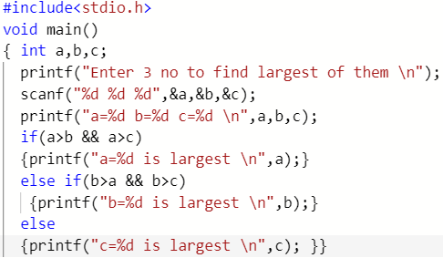

- Using ternary operator

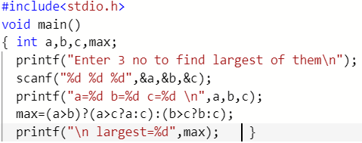
Output(s):
- if else statement

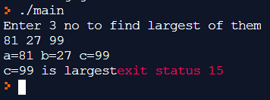

- Using ternary operator

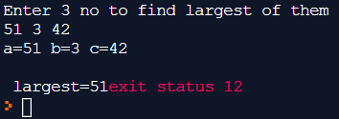

Conclusion:
- Largest of 3 numbers was successfully obtained by using if…else if… else which is condition making statement.
- Largest of 3 numbers was successfully obtained by using ternary operator ?: also called as conditional operator.

Post Lab Descriptive Questions :

- Explain bitwise operators with examples.
The operators which are used to perform binary operation on given int values. These binary operations are
A | B | AND & | OR | | COMPLEMENT ~ | EX-OR ^
0 | 0 | 0 | 0 | 1 | 0
0 | 1 | 0 | 1 | 1 | 1
1 | 0 | 0 | 1 | 0 | 1
1 | 1 | 1 | 1 | 0 | 0
- & - bitwise AND used for performing AND operations on numbers.
Eg a=12 , b=3, c=a&b
a (00001100)
& b (00000011)
c = (00000000)=00
- | - bitwise OR used for performing OR operations on numbers.
Eg a=12 , b=3, c=a | b
a (00001100)
| b (00000011)
c = (00001111)=15
- ~ - bitwise (NOT)COMPLEMENT used for performing NOT operations on numbers.
Eg a=12 b= ~a
a (00001100)
b= (11110011) =243
- << - bitwise LEFT SHIFT used for performing LEFT SHIFT by given no of bits operations on numbers.
Eg a=12 , b=a<<2
a (00001100)
b (00011000)=24
- >> - bitwise RIGHT SHIFT used for performing RIGHT SHIFT by given no of bits operations on numbers.
Eg a=12 , b=a>>2
a (00001100)
b (00000011)=3
- ^ - bitwise EX-OR used for performing EX-OR operations on numbers.
Eg a=12 , b=3, c=a ^ b
a (00001100)
^ b (00000011)
c = (00001111)=15
- Write a code snippet to perform left shifting of bits by some positions.
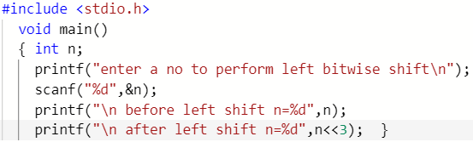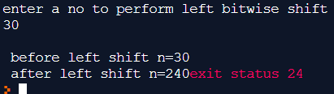
- Write associative rules and precedence table of various operators.
When 2 or more operators come together in a expression then the grouping in terms in which occur& they are evaluated operator Precedence. Certain operators have higher precedence than others, Eg the * operator has a higher precedence than the + operator . Associativity defines the order in which operators of equal precedence is evaluated when they occur together IE. in direction left -to-right or right-to-left. Eg when * / are together then which occurs first in expression is 1st executed.

Operator precedence | Type | Associativity
( ) { } [ ] . -> |  | L→R
++ -- + ! - ~ * & sizeof() | Unary | L←R
/ * % | Arithmetic | L→R
+ - | Arithmetic | L→R
<< >> | Bitwise shift | L→R
< <= => > | Relational | L→R
== != | Relational | L→R

& | Bitwise | L→R
^ | Bitwise | L→R
| | Bitwise | L→R
&& | Logic | L→R
|| | Logic | L→R
?: | ternary | L←R
= += -= *= /= &= |= <<= >>= | Assignment | L←R
, | Comma | L→R

Date: 22-02-2020 Signature of faculty in-charge

