Batch: A1 Roll No.: 1911004

Experiment / assignment / tutorial No. 3

Grade: AA / AB / BB / BC / CC / CD /DD

Signature of the Staff In-charge with date

TITLE: Write a C program to accept a decimal number and convert it into binary number without using array.

AIM: Write a C program to accept a decimal number and convert it into binary number ______________________________________________________________________
Expected OUTCOME of Experiment:
CO1. Formulate a problem statement and develop the logic (algorithm/flowchart) for its
solution.
CO2. Apply basic concepts of C programming for problem solving.
_____________________________________________________________________
Books/ Journals/ Websites referred:

- Programming in C, second edition, Pradeep Dey and Manas Ghosh, Oxford University Press.
- Programming in ANSI C, fifth edition, E Balagurusamy, Tata McGraw Hill.
- Introduction to programming and problem solving , G. Michael Schneider ,Wiley India edition.
- http://cse.iitkgp.ac.in/~rkumar/pds-vlab/
_____________________________________________________________________

Problem Definition:

This program accepts a decimal number from user and converts it into its equivalent binary number. To convert a decimal number to binary, start with the integer in question and divide it by 2 keeping notice of the quotient and the remainder. Continue dividing the quotient by 2 until you get a quotient of zero. Then just write out the remainders in the reverse order. Below diagram shows an example of converting the decimal number
17 to equivalent binary number.
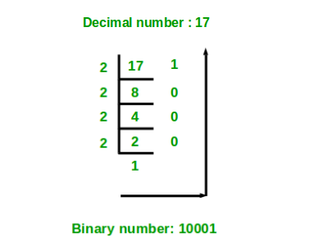
Flowchart:
START

Output “ENTER A NO TO CONVERT INTO BINARY” Input n

If
(n!=0)

n1=n; bin=0; base=1;

YES
rem=n%2; bin=bin+(rem*base); base=base*10; n=n/2;

NO
OUTPUT “binary no for n=”n “is =”bin
END

→ Flow chart for converting decimal to binary . ←

Implementation details:

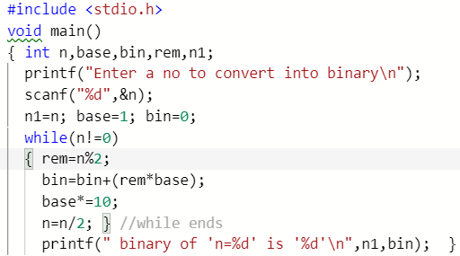

Output(s):
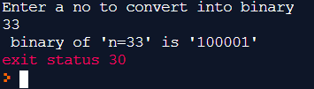

Conclusion:
The decimal number taken from the user (e.g. 12, 15) is successfully converted into its binary equivalent (i.e. 1100, 1111).
Post Lab Descriptive Questions:

- Explain decision making and branching control structures in C.

Answer: Decision making and Branching control – These are statements/structures that require the programmer to specify one or more conditions to be evaluated or tested by the program.

If the condition is determined to be TRUE, and optionally, other statements to be executed if the condition is determined to be FALSE.

Decision making or branching statements are used to select one path based on the result of the evaluated expression. It is also called as

control statements because it controls the flow of execution of a program. 'C' provides if, if-else, if else if else , switch case constructs for decision-making statements.

- Compare different looping constructs in C (for, while and do-while)
for | while | do…while
Entry control, pre-tested loop | Entry control, pre-tested loop | Exit control, post-tested loop
Used when no of iterations are known | Used when no of iterations aren’t known and may change | Used when no of iterations aren’t known and might change
Initialization, condition,  upgradation all are done together  Thus loop gets executed if condition is true | Initialization is done outside loop then condition is checked &upgradation is inside loop body  Thus loop gets executed if condition is true | Initialization is done outside loop , upgradation is inside loop body & then condition is checked at end thus loop gets executed at least once
Syntax  for(initialization; condition ;upgradation)  {//loop body} | Syntax  initialization;  while(condition)  {//loop body  // upgradation } | Syntax  initialization;  do{//loop body  // upgradation } while(condition);

- Explain use of break, continue and goto statements.
- “break” statement:
- When a break statement is encountered inside a loop, the loop is immediately terminated and the program control resumes at the next statement following the loop.
- It can be used to terminate a case in the switch statement & it terminates further loop iterations even if condition is true.
- break;
- “continue” statement:
- Continue statement is mostly used inside loops. Whenever it is encountered inside a loop, control directly jumps to the beginning of the loop for next iteration, skipping the execution of statements inside loop's body for the current iteration.
- Thus it skips the current iteration of loop
- continue;

- “goto” statement:
- goto statement is used to transfer the normal flow of a program to the specified label in the program. Below is the syntax for goto statement in C.

label:{
……….
goto label:
…}

Date: 23-02-2020 Signature of faculty in-charge

