Batch: A1 Roll No.: 1911004

Experiment / assignment / tutorial No. 4

Grade: AA / AB / BB / BC / CC / CD /DD

Signature of the Staff In-charge with date

TITLE: Write a menu driven program to print the number of days in a given month including leap year.

AIM: Write a menu driven program to print the number of days in a given month including leap year.
______________________________________________________________________
Expected OUTCOME of Experiment:
CO1. Formulate a problem statement and develop the logic (algorithm/flowchart) for its
solution.
CO2. Apply basic concepts of C programming for problem solving.

_____________________________________________________________________
Books/ Journals/ Websites referred:

- Programming in C, second edition, Pradeep Dey and Manas Ghosh, Oxford University Press.
- Programming in ANSI C, fifth edition, E Balagurusamy, Tata McGraw Hill.
- Introduction to programming and problem solving , G. Michael Schneider ,Wiley India edition.
- http://cse.iitkgp.ac.in/~rkumar/pds-vlab/

_____________________________________________________________________
Problem Definition:

Write a menu driven program to print the number of days in a given month including leap year.

Total days in a month is given by below table.

Month | Total days
January, March, May, July, August, October, December | 31 days
February | 28/29 days
April, June, September, November | 30 days

Sample Input: 3 1996

Sample Output: Number of days is 31
Input the month and year from the user.
If the year is a leap year and (month == 2), display “Number of days is 29”.
Else if (month == 2), display “Number of days is 28”.
Else if((month == 1) || (month == 3 || (month == 5) (month == 7) || (month == 8) || (month == 10) (month == 12)), display “Number of days is 31”.
Else, display, “Number of days is 30”.
Flowchart:
START

OUTPUT “ENTER month & year ”
INPUT m,y;

If y%4==0
If y%100==0

If y%400==0

TRUE TRUE TRUE
L=1

FALSE
L=0
L=1
Output y “LEAP YEAR”

L=0

Output y“ not LEAP YEAR”

If m==1|| m ==5||m==7||m==8||m==10||m==12
If m==4||m==6||m==9||m==11
If m==2

NO NO

YES YES YES
If l==1

Output m ‘‘has 30 days’’

Output m ‘‘has 31 days’’

Out put m“ has 29 days”

YES

NO
Output m ‘‘has 28 days’’

NO
Out put “invalid choice”
END

Implementation details:

#include<stdio.h>
void main()
{ int m,y,l=0;
printf("ENTER MONTH & YEAR TO FIND NO OF DAYS\n");
scanf("%d %d",&m,&y);
if(y%4==0)
{if(y%100==0)
{if(y%400==0)
{ printf("%d is a leap year.\n",y); l=1;}
else
printf("%d is not a leap year.\n",y); }
else
printf("%d is a leap year.\n",y);}
else
printf("%d is not a leap year.\n",y);
switch(m)
{ case 1:
case 3:
case 5:
case 7:
case 8:
case 10:
case 12: printf("MONTH = %d HAS 31 DAYS \n",m);
break;

case 4:
case 6:
case 9:
case (11): printf("MONTH =%d HAS 30 DAYS \n",m);
break;

case 2:
if(l==1)
{printf("MONTH =%d HAS 29 DAYS \n",m); }
else
{printf("MONTH =%d HAS 28 DAYS \n",m); }
break;

default:
printf("ENTER VALID MONTH&YEAR \n");
break;
}
}

Output(s):

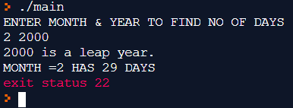

Conclusion:

Thus on entering month & year we can find if it is leap year or not & find number of days in that month.

Post Lab Descriptive Questions:
Write menu driven code for the following:

The program allows a user to enter five numbers and then asks the user to select a choice from a menu. The menu should offer the following options –
1. Display the smallest number entered
2. Display the largest number entered
3. Display the sum of the five numbers entered
4. Display the average of the five numbers entered.
5. Exit

#include <stdio.h>
void main()
{ int n1,n2,n3,n4,n5,c,min,max,sum; double avg;
printf("Enter 5 numbers\n");
scanf("%d %d %d %d %d",&n1,&n2,&n3,&n4,&n5);
printf("You can choice any one \n 1. Display the smallest number entered \n 2. Display the largest number entered \n 3. Display the sum of the five numbers entered \n 4. Display the average of the five numbers entered. \n 5. Exit \n");
printf("Enter your choice \n"); scanf("%d",&c);
switch(c)
{ case 1:
if(n1<n2 && n1<n3 && n1<n4 && n1<n5) min=n1;
else if(n2<n1 && n2<n3 && n2<n4 && n2<n5) min=n2;
else if(n3<n2 && n3<n1 && n3<n4 && n3<n5) min=n3;
else if(n4<n2 && n4<n3 && n4<n1 && n4<n5) min=n4;
else min=n5;
printf("Min of 5 number is min= %d \n",min); break;

case 2:
if(n1>n2 && n1>n3 && n1>n4 && n1>n5) max=n1;
else if(n2>n1 && n2>n3 && n2>n4 && n2>n5) max=n2;
else if(n3>n2 && n3>n1 && n3>n4 && n3>n5) max=n3;
else if(n4>n2 && n4>n3 && n4>n1 && n4>n5) max=n4;
else max=n5;
printf("Max of 5 number is max= %d \n",max); break;

case 3:
sum=n1+n2+n3+n4+n5; printf("sum of 5 number is sum= %d \n",sum);
break;

case 4:
sum=n1+n2+n3+n4+n5;
avg=sum/5; printf("average of 5 number is avg= %lf \n",avg);
break;

case 5: printf("EXIT \n"); break;
default: printf("your choice is invalid\n"); break; } }

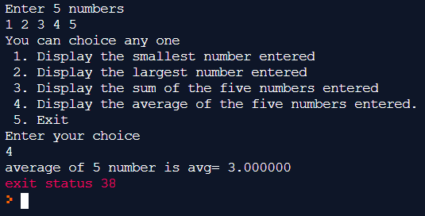

Date: 24-02-2020 Signature of faculty in-charge

