**Batch: A1 Roll No.: 1911004**

**Experiment / assignment / tutorial No. 5**

**Grade: AA / AB / BB / BC / CC / CD /DD**

**Signature of the Staff In-charge with date**

|  |
| --- |
| **TITLE:** Write a program to calculate the sum of the fibonacci series upto ‘n’ terms |

**AIM:** Write a program to calculate the sum of the fibonacci series upto ‘n’ terms

**______________________________________________________________________**

**Expected OUTCOME of Experiment:**

CO1. Formulate a problem statement and develop the logic (algorithm/flowchart) for its

 solution.

CO2. Apply basic concepts of C programming for problem solving.

**_____________________________________________________________________**

**Books/ Journals/ Websites referred:**

1. Programming in C, second edition, PradeepDey and ManasGhosh, Oxford University Press.
2. Programming in ANSI C, fifth edition, E Balagurusamy, Tata McGraw Hill.
3. Introduction to programming and problem solving , G. Michael Schneider ,Wiley India edition.
4. Let’s C by YashwantKanetkar
5. [**http://cse.iitkgp.ac.in/~rkumar/pds-vlab/**](http://cse.iitkgp.ac.in/~rkumar/pds-vlab/)

**____________________________________________________________________**

**Problem Definition:**

Write a program to calculate the sum of the Fibonacci series upto ‘n’ terms

We need to print Fibonacci; upper limit will be entered by the user.

Ex.

0, 1, 1, 2, 3, 5, 8, 13, 21, 34……………

**Flowchart:**

**start**

**Input n**

**f=0;s=1;i=1;**

**t=0;sum=f+s;**

**Print f , s**

**t=f+s; sum=sum+t;**

**f=s; s=t;**

**i++;**

**If**

**i<=n-2**

**true**

**false**

**end**

**Print sum;**

**Implementation details:**

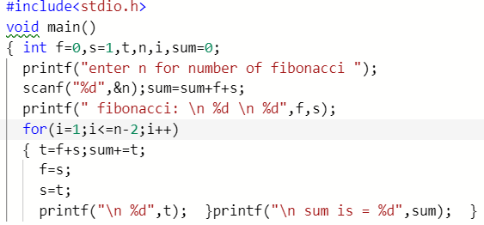

**Output(s):**

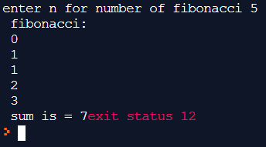

**Post Lab Descriptive Questions:**

1. **How many times the do- while loop in the following C code will get executed?**

**#include<stdio.h>**

**int main( )**

**{**

**int m = 0;**

**char n=m;**

**do**

**{**

**printf(“%c %d”,n,m);**

**m++;**

**} while(m<=255);**

**return 0;**

**}**

**🡪This loop gets executed 256 times.**

1. **Which keyword is used to take the control to the beginning of the loop? And under what conditions might the *goto* statement be helpful? What types of usage should be avoided and why?.**
2. **To take control to the beginning of loop we can use jump statement**

* **continue ;**

**It is the control statement keyword used to transfer the control to the beginning of the loop skipping the remaining statements after it in the loop. It will only skip current iteration.**

* **goto (label-loop)**

**It is the control statement keyword using which we can transfer the control to any where in program/label mentioned.**

1. **GOTO Statement:-**

* **The goto statement is a jump statement which is known as unconditional jump statement. The goto statement can be used to jump from anywhere to anywhere in the given program. A goto statement in C programming provides an unconditional jump from the ' goto' to a labelled statement in that program.**
* **In some case where there an unconditional jump is needed ‘goto’ is helpful.**
* **Use of goto statement is highly discouraged in any programming language because it makes difficult to trace the control flow of a program, making the program hard to understand and hard to modify. Any program that uses a goto can be rewritten to avoid them. Thus excessive use of goto is not advised.**

**Date: 26.02.2020 Signature of faculty in-charge**