**Batch: A1 Roll No.: 1911004**

**Experiment / assignment / tutorial No. 6**

**Grade: AA / AB / BB / BC / CC / CD /DD**

**Signature of the Staff In-charge with date**

|  |  |  |  |  |  |  |  |  |  |  |  |  |  |  |  |  |  |  |  |  |  |  |  |  |  |
| --- | --- | --- | --- | --- | --- | --- | --- | --- | --- | --- | --- | --- | --- | --- | --- | --- | --- | --- | --- | --- | --- | --- | --- | --- | --- |
| **TITLE:** Write a program to print the following pattern for ‘n’ rows   |  |  |  |  |  | | --- | --- | --- | --- | --- | |  |  | * |  |  | |  | * | * | * |  | | * | * | * | * | * | |  | * | * | * |  | |  |  | * |  |  | |

**AIM:** Write a program to print the following pattern for ‘n’ rows

|  |  |  |  |  |
| --- | --- | --- | --- | --- |
|  |  | * |  |  |
|  | * | * | * |  |
| * | * | * | * | * |
|  | * | * | * |  |
|  |  | * |  |  |

**______________________________________________________________________**

**Expected OUTCOME of Experiment:**

CO1. Formulate a problem statement and develop the logic (algorithm/flowchart) for its

 solution.

CO2. Apply basic concepts of C programming for problem solving.

**_____________________________________________________________________**

**Books/ Journals/ Websites referred:**

1. Programming in C, second edition, PradeepDey and ManasGhosh, Oxford University Press.
2. Programming in ANSI C, fifth edition, E Balagurusamy, Tata McGraw Hill.
3. Introduction to programming and problem solving , G. Michael Schneider ,Wiley India edition.
4. Let’s C by YashwantKanetkar
5. [**http://cse.iitkgp.ac.in/~rkumar/pds-vlab/**](http://cse.iitkgp.ac.in/~rkumar/pds-vlab/)

**_____________________________________________________________________**

**Problem Definition:**

A program to print the following pattern for ‘n’ rows

|  |  |  |  |  |
| --- | --- | --- | --- | --- |
|  |  | * |  |  |
|  | * | * | * |  |
| * | * | * | * | * |
|  | * | * | * |  |
|  |  | * |  |  |

**Flowchart:**

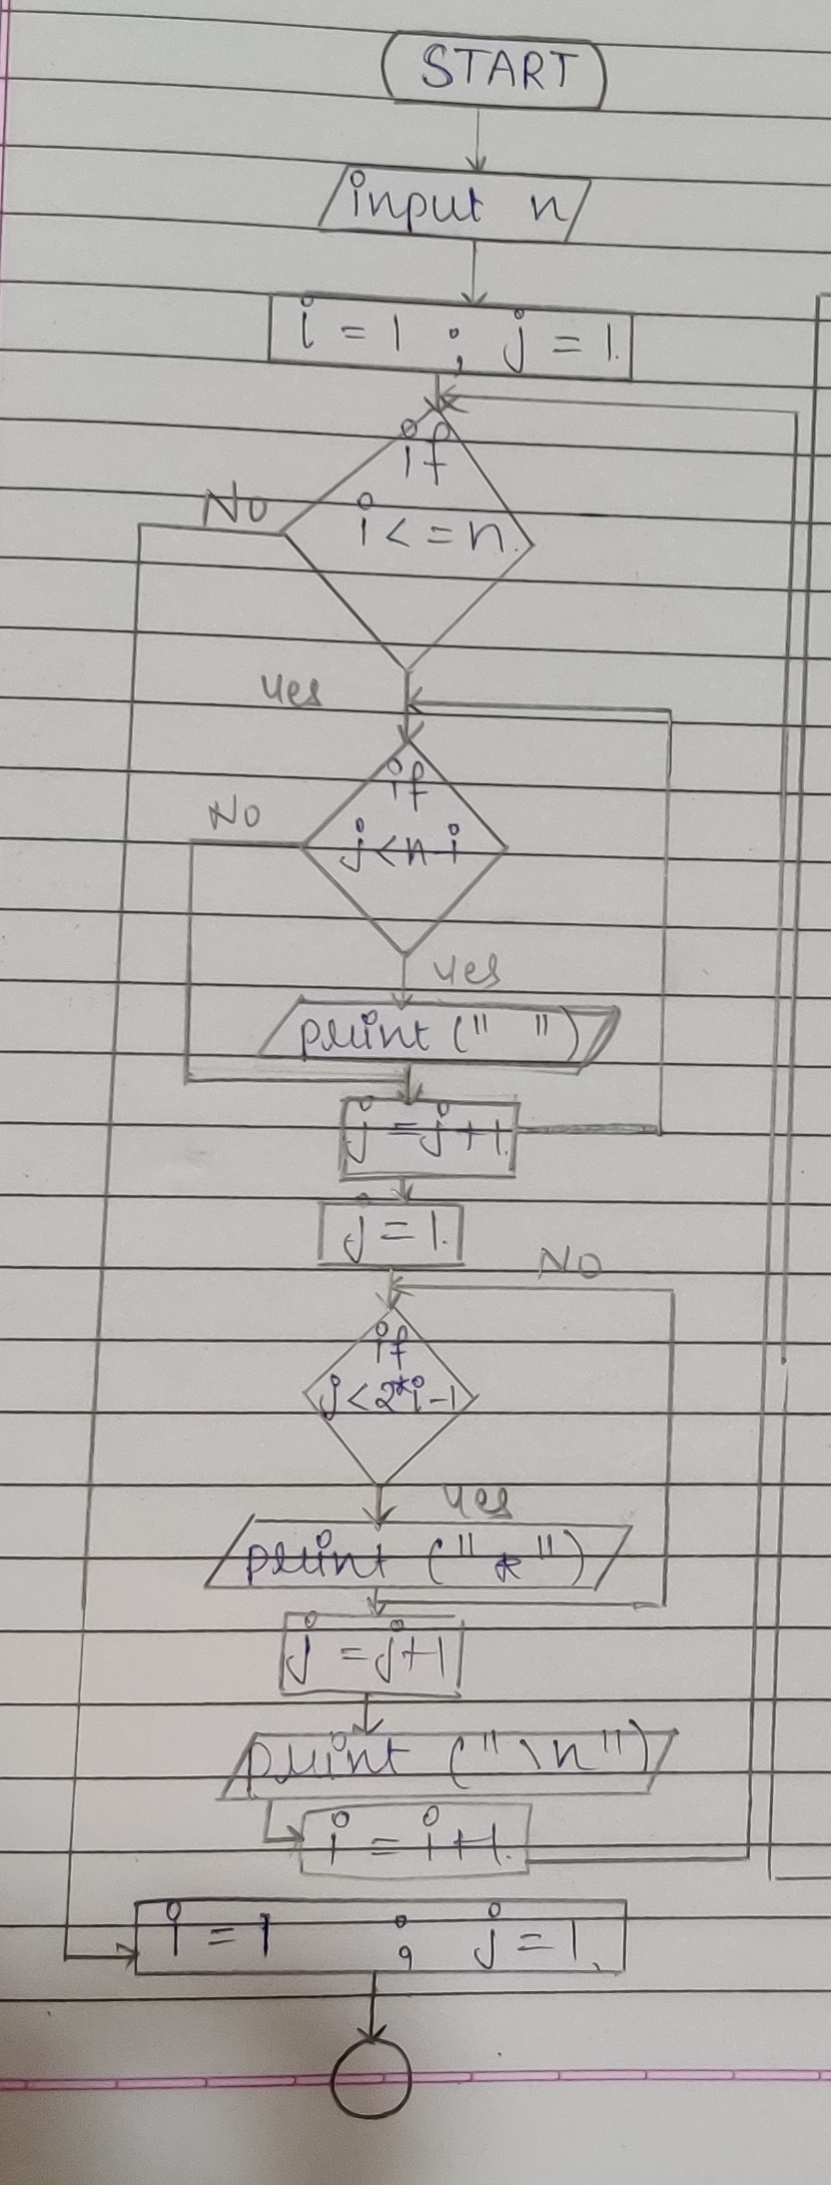

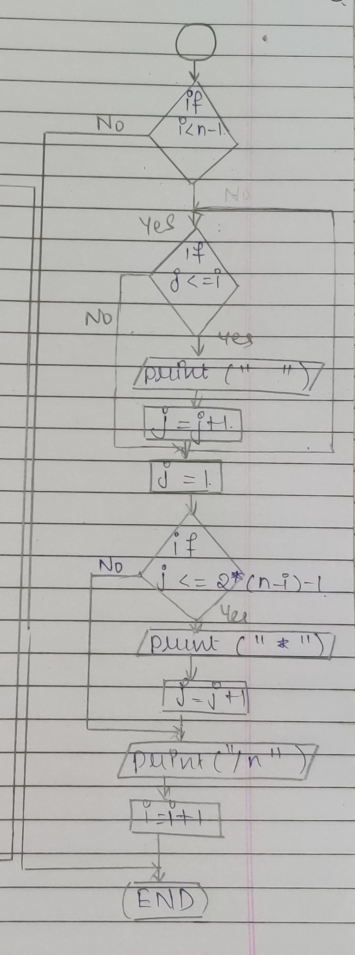

**Implementation details:**

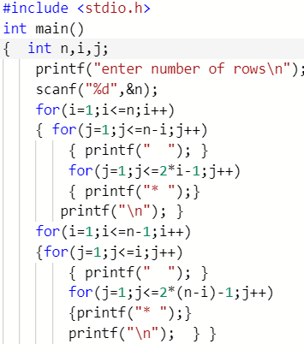

**Output(s):**

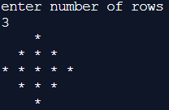

**Conclusion:**

**The required pattern is printed with n rows.**

**Post Lab Descriptive Questions:**

**1. Compare the for loop, while loop and Do while loop**

|  |  |  |
| --- | --- | --- |
| **for** | **while** | **do…while** |
| **Entry control, pre-tested loop** | **Entry control, pre-tested loop** | **Exit control, post-tested loop** |
| **Used when no of iterations are known** | **Used when no of iterations aren’t known and may change** | **Used when no of iterations aren’t known and might change** |
| **Initialization, condition,**  **upgradation all are done together**  **Thus loop gets executed if condition is true** | **Initialization is done outside loop then condition is checked &upgradation is inside loop body**  **Thus loop gets executed if condition is true** | **Initialization is done outside loop , upgradation is inside loop body & then condition is checked at end thus loop gets executed at least once** |
| **Syntax**  **for(initialization; condition ;upgradation)**  **{//loop body}** | **Syntax**  **initialization;**  **while(condition)**  **{//loop body**  **// upgradation }** | **Syntax**  **initialization;**  **do{//loop body**  **// upgradation } while(condition);** |

**2. Write a program to print the sum of the following series .**

**S = 1 + 1/2!+1/3! +1/4!+…..1/n! teams**

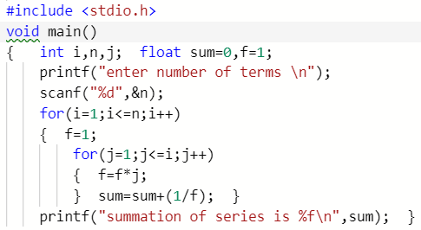

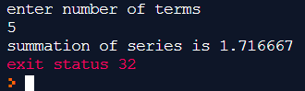

**Date: 27.02.2020**

**Signature of faculty in-charge**