**Batch: A1 Roll No.: 1911004**

**Experiment / assignment / tutorial No. 7**

**Grade: AA / AB / BB / BC / CC / CD /DD**

**Signature of the Staff In-charge with date**

|  |
| --- |
| **TITLE:**  To print sum and average of all alternate elements for an array |

**AIM:**

Write a program to print sum and average of all alternate elements for an array of integers inputted by the user, denoting mathematics marks scored by students and their gender.

The alternating elements marks[0], marks[2] and so on denote the marks of boys. Similarly marks[1], marks[3] so on denote the marks of girls.

**______________________________________________________________________**

**Expected OUTCOME of Experiment:**

**CO1. Formulate a problem statement and develop the logic (algorithm/flowchart) for its solution.**

**CO2. Apply basic concepts of C programming for problem solving.**

**CO3. Illustrate the use of derived and structured data types such as arrays, strings, structures and unions.**

**_____________________________________________________________________**

**Books/ Journals/ Websites referred:**

1. Programming in C, second edition, Pradeep Dey and Manas Ghosh, Oxford University Press.
2. Programming in ANSI C, fifth edition, E Balagurusamy, Tata McGraw Hill.
3. Introduction to programming and problem solving, G. Michael Schneider, Wiley India edition.
4. Let’s C by Yashwant Kanetkar
5. [**http://cse.iitkgp.ac.in/~rkumar/pds-vlab/**](http://cse.iitkgp.ac.in/~rkumar/pds-vlab/)

**_____________________________________________________________________**

**Problem Definition:**

Input: arr = {1, 2, 3, 4, 5, 6}

Output: Even index positions sum 9

Odd index positions sum 12

Explanation: Here, n = 6 so there will be 3 even index positions and 3 odd index positions in an array

Even = 1 + 3 + 5 = 9

Odd = 2 + 4 + 6 = 12

**Flowchart:**

**START**

**I/P N**

**i=0;j=0;n1=n/2;sum_b=0;**

**sum_g=0;marks[n];**

**sum_g+=marks[j]; sum_b+=marks[i];**

**i+=2; j+=2;**

**If j<n**

**no**

**j=1;**

**yes**

**yes**

**If i<n**

**i/p marks[j]**

**j++;**

**no**

**avg_g=sum_g/n1;**

**avg_b=sum_b/n1;**

**output avg_g, sum_g, avg_b ,sum_b;**

**END**

**Implementation details:**

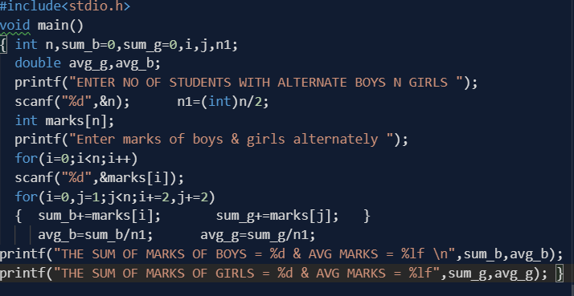

**Output(s):**

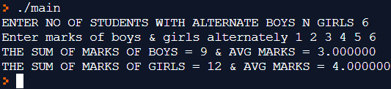

**Conclusion: Thus sum & average of alternate elements of marks array with boys marks at even index & girls marks at odd index, is found & printed.**

**Post Lab Descriptive Questions:**

1. **What is base address?**

**The base address of an array is the address of the first element on the array and always appears in the lowest memory location. The 2nd array element directly follows the first in memory, the 3rd element follows the second, and thus last element(nth element) at array[n-1] location .**

**Base address = array[0];**

**So if printf(“BASE ADDRESS = ”,&array); is same as printf(“BASE ADDRESS = ”,&)**

1. **Predict the output :**

**int main()**

**{**

**int a[5] = {5, 1, 15, 20, 25};**

**int i, j, m;**

**i = ++a[1]; // i=2; a[1]=2**

**j = a[1]++; // j=2; a[1]=3**

**m = a[i++]; // a[2]=m=15; i=3;**

**printf("%d, %d, %d", i, j, m);**

**return 0;**

**}**

**// out put of above code is 🡪**

**3,2,15**

**Date: 26.03.2020 Signature of faculty in-charge**