**Batch: A1 Roll No.: 1911004**

**Experiment / assignment / tutorial No. 1**

**Grade: AA / AB / BB / BC / CC / CD /DD**

**Signature of the Staff In-charge with date**

**Experiment No. 1**

|  |
| --- |
| **TITLE:**  Study of Networking devices (Hub, router, Gateway, Switch, etc.) and Transmission Media |

**_______________________________________________________________________________**

**AIM:** To study different Networking devices used in day-to-day networks.

**________________________________________________________________________________**

**Expected Outcome of Experiment:**

**CO:**

Brief understanding of the various types of commonly used transmission media and connecting devices.

**________________________________________________________________________________**

**Books/ Journals/ Websites referred:**

1. A. S. Tanenbaum, “Computer Networks”, Pearson Education, Fourth Edition
2. B. A. Forouzan, “Data Communications and Networking”, TMH, Fourth Edition

_______________**________________**__________________________________________________

**Pre-Lab/ Prior Concepts:** Basics of LAN and Connecting devices

**_________________________________________________________________________________**

**New Concepts to be learned:** Layer wise connecting devices

**________________________________________________________________________________**

**Stepwise-Procedure:**

Understanding connecting devices & transmission media based on :

* Functionality
* OSI Layer of Operation
* Technical Features
* Advantages
* Limitations.

**Study of Connecting Devices**

1. **Hub -** For the collective connection of networking devices, hubs are mainly used. It can act as a repeater where it boosts the poor signals those lose their strength after traveling for long distances over cables. The hub contains multiple ports. When a packet arrives at one port, it is copied to the other ports so that all segments of the LAN can see all packets. They operate at physical layer of OSI Model.

Hubs and switches serve as a central connection for all of your network equipment and handles a data type known as frames. Frames carry your data. When a frame is received, it is amplified and then transmitted on to the port of the destination PC.

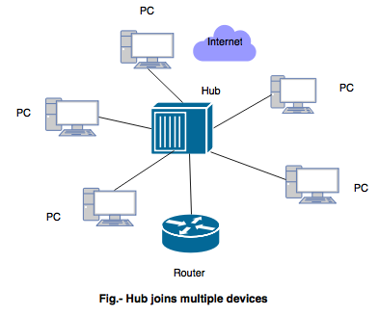

In a hub, a frame is passed along or "broadcast" to every one of its ports. It doesn't matter that the frame is only destined for one port.

**Types of Hub:**

* Active Hub - These are the hubs which have their own power supply and can clean, boost and relay the signal along with the network. It serves both as a repeater as well as wiring center. These are used to extend the maximum distance between nodes.
* Passive Hub - These are the hubs which collect wiring from nodes and power supply from active hub. These hubs relay signals onto the network without cleaning and boosting them and can’t be used to extend the distance between nodes.
* Intelligent Hubs − Intelligent hubs are active hubs that provide additional network management facilities. They perform various functions of more intelligent network devices like network management, switching, etc.

**Advantages:**

* It has less impacts on the network performance as it operates using a broadcast model that doesn't affects the network.
* They connect different types of media all at once with a central hub. When compared, it is less expensive compared to switch.

**Limitations:**

* The hub has no way of distinguishing which port a frame should be sent to. Passing it along to every port ensures that it will reach its intended destination. This places a lot of traffic on the network and can lead to poor network response times.
* Compared to a switch, the hub is slower as it can send or receive information just not at the same time. It can't support larger networks like a token ring.

1. **Repeater**

Repeater is a network hardware device that is worked at the physical layer of OSI model, and it helps to amplify or regenerate the signals before retransmitting it. Repeater is also known as “Signal Boosters”.

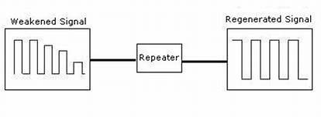

A repeater has ability to extend the data signal from one network segment and then pass it to another network segment, thus scaling the size of network. The repeater allows to transfer the data through large area distance, and it can ensure for security and quality of data as well as retransmitting the data with securely preserving the signals.

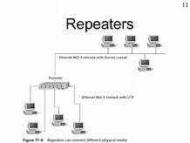

It is that repeater is capable to carry signal and broadcast it to other network without damaging any signals. The repeater is intelligent device that helps to control the flow of signals. If, to determine any defect in the signals then repeater is able to detect it and transported to the linked port.

**Types of Repeaters**:

* According to **networks that they connect**
* Wired Repeaters − They are used in wired LANs.
* Wireless Repeaters − They are used in wireless LANs and cellular networks.
* According to the **domain of LANs they connect**
* Local Repeaters − They connect LAN segments separated by small distance.
* Remote Repeaters − They connect LANs that are far from each other.
* According to **the types of signals that they regenerate**
* Analog Repeaters − They can only amplify the analog signal.
* Digital Repeaters − They can reconstruct a distorted signal.

**Advantages**:

* The primary function of repeater is to receive the signals for one LAN terminal cable and then to regenerate and retransmit the all signals as its original form over other cable segments.
* A repeater ensures that the amplified signals are not discard or weak before arriving the destination point.

**Limitations**:

* With using of repeater, network can be scaled the size limit of a single, physical, cable segment.
* The number of repeaters that can be used intended is generally limited by a particular LAN implementation.
* Using a repeater between two or more LAN cables segment requires that the same physical layer protocol be used to send signal over all the cable segments.

1. **Switch**

When compared with hubs, switches have more creative functionality. This is a multiport device that enhances network performance. A switch supports restricted routing data regarding nodes in the internal network and it permits connections for systems such as routers and hubs. In general, switches have the functionality of knowing hardware addressing of incoming packets and transmission of those to the proper destination.

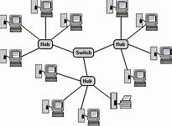

Implementation of switches in the networking devices enhances network performance over routers or hubs as because of virtual circuit ability. They also increase the network protection due to the reason that virtual circuits are more complicated to determine with network monitors.

The functionality of the switch is the Data Link layer of the OSI model. A multilayer switch has the ability to function both at network or data link layers of the OSI thus making the device to function as a router and switch.

**Types of Switches**:

* Unmanaged switches – They are mostly used in home networks and small businesses as they plug-in and instantly start doing their job and so it doesn’t need to be looked after.
* Managed switches – They are used in large network; can be customized to enhance the functionality of a certain network. It has features like the highest levels of security, precision control and full management of the network.
* Lan switches – They are used in LAN to connect points on it. Also called data /ethernet switches, they decrease network traffic by dividing packets of data.

**Advantages:**

* Compared to a hub, it is faster & increases network performance. It is efficient as it does not forward packets that have errors and forward good packets selectively to correct port only.
* It supports both unicast and multicast communications. Has more bandwidth & secure.

**Limitations:**

* Proper planning and arrangement are required to deal with multicast parcels.
* When compared costs more than a hub. Also broadcast traffic may results in issues.

1. **Bridge**

A bridge in a computer network is one kind of network device, used to separate a network into sections. Every section in the network represents a collision domain that has separate bandwidth. So that network performance can be improved using a bridge. In the OSI model, it works at layer2 namely the Data link layer. The main function of this is to examine the incoming traffic and examine whether to filter it or forward it.

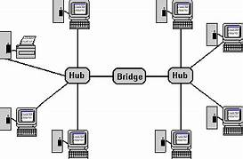

It blocks or forwards the data depending on the destination MAC address and this address is written into every data frame. It has a single input and single output port, thus making it a 2 port device. It is used for interconnecting two LANs using the single and same protocol.

**Types of Bridges**:

* Transparent Type - It is used to block or forward the data packet based on the MAC address. It is the most popular type of bridge used in computer networks.
* Translational Type - It is used to convert one networking system to another. That means it translates the received data.
* Source-route Type - This bridge is designed by IBM for using it in token ring networks

**Advantages** :

* Extension of the Network: The bridges are used as a repeater to extend the network. That means thee networks with different topologies can be connected.
* Increases Bandwidth: Separate collision domain is shared by some of the individual nodes present on the network, which results in increased bandwidth.
* No special installation: No special hardware or software or architecture is required to install the bridge in the network

**Limitations**:

* Cost - The cost of the bridges is more when compared to hubs and repeaters.
* Speed- The speed of the network is slow when compared to the repeater due to the frame buffering and relays.

1. **Router**

A router is a device that analyzes the contents of data packets transmitted within a network or to another network. Routers determine whether the source and destination are on the same network or whether data must be transferred from one network type to another, which requires encapsulating the data packet with routing protocol header information for the new network type.

Router operates at Level 3 – Network Layer of OSI Model.

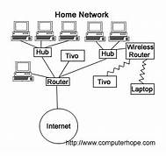

When we request anything on web browser, our request is stream of packets that straightaway don’t go to sever but they go through a series of router that accepts this packets & forwards them to correct path thus it reaches to the destination server. Thus, main function is Forwarding packets & routing these packets through best path. It uses Network Address Translation.

**Types of Router:**

* Wireless Router: Wireless routers are used to offer Wi-Fi connectivity to smartphones, laptops & devices with Wi-Fi network capabilities, also provides standard ethernet routing for a small number of wired network systems.
* Core router: A core router can route the data within a network, but it is not able to route the data between the networks. It is used by Internet Service Providers.

**Advantages:**

* It doesn’t by default forward the broadcasts. Thus, save the bandwidth of network. Also, it filters the network based on level 3 Network layer, IP address(information). It can choose the best path across by dynamic routing techniques so reduces the network traffic by creating the collision domains & the broadcast domains.
* It works with LAN & WAN both. It offers the path selection & can filter the broadcasts while leading them between two interfaces. Thus, it offers packet switching & filtering.

**Limitations:**

* It is slower than a bridge/repeater as it analyzes the data transmission from the physical to the network layer. It works only with the routable protocols as not all protocols are routable.
* It is complex to maintain as it has security risks. Also, it is expensive compared to others

1. **Gateway**

Gateway is a network device, used for communication between two networks with different transmission protocol together. It is an entry and exit 'gate' for the networks that helps to bypass the all data with the gateway prior to being routed. Gateways can be used for both WAN and LAN interconnects.

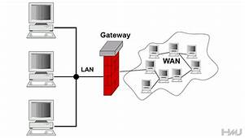

It is the passage in connecting two networks that might operate upon various networking approaches. Usually, these network devices act as messenger drivers who collect information from one system, interpret it, and then establishes transmission of data to other systems. It may be a server, router, firewall or other network device that allows to flow the traffic in and out of the network. It plays the role of proxy server or firewall. Mainly it operates at Network Level but it can operate at any level of OSI Model depending on use & need.

**Types of Gateways:**

- Unidirectional Gateways − They allow data to flow in only one direction. Changes made in the source node are replicated in the destination node, but not vice versa. They can be used as archiving tools.

- Bidirectional Gateways − They allow data to flow in both directions. They can be used as synchronizationtools**.**

**Advantages:**

* It is more flexible as it can transfer information from computers on different systems. Thus, different kinds of computers can be set up on the same gateway & the same information can be accessed to all computers.
* It provides more security as it can be programmed to deny/grant certain features. Thus, use when transferring sensitive information over network.

**Limitations:**

* It translates information from different protocols before passing it on, thus this takes more time. So instant transfer are rarely possible using gateway.
* These are complicated than router or switch. Thus even trouble shooting is difficult as network can’t be restored till issue is resolved.

**Transmission Media:**

1. **Twisted pair cable**

The most popular network cable that is used for data transmission is the twisted pair cable. These types of cables are lightweight, inexpensive, simple to install and support 100 Mbps data speed. This cable includes two conductor wires which are separately insulated where every pair of cables can be twisted together to make a single media. The main function of these two wires is, the first wire is used to carry the actual signal whereas the other wire is used as ground. These two cables are colour-coated so that cables can be easily identified. A twisted cable reduces the noise as well as cross-talk. These cables are used in telephone networks to provide voice & data transmission. Again, twisted pair cable is two types like unshielded twisted pair (UTP) and shielded twisted pair (STP).

**Types Of Twisted Pair**:

* + Unshielded Twisted Pair This type of cable, there is no metal foil or shield. As compared to STP, this cable is very common so, it is easily used in LANs & telephone connections. The main benefits of UTP are; less cost, simple installation, high speed, etc. The drawbacks are; as compared to STP, this has less performance, less capacity, transmission can be done up to a short distance because of attenuation.
* Shielded Twisted Pair This type of cable covers a special jacket to block exterior interference. STP is used in data, voice channels of telephone lines & in an Ethernet with fast-data-rate. The main benefits of STP as compared to UTP are, it gives better performance at a high data rate, cross talk can be eliminated, faster, etc. The disadvantages are expensive and bulky.

**Advantage**:

* The frequency range is 0 to 3.5 kHz.
* Repeater spacing is 2 KM

**Limitations:**

* No capacity to carrying a signal over long distances without the use of repeaters.
* Not suitable for broadband applications because of low bandwidth capacity.
* Poor security and easy to tap.

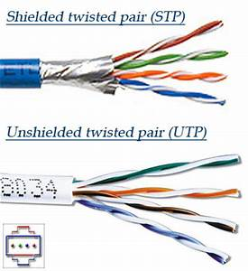

Fig 7.Twisted Pair Cable

1. **Coaxial cable**

The coaxial cable has an external plastic jacket with two parallel conductors where each conductor has an individual insulated protection cover. By using this cable, the data transmission can be done in two ways like baseband mode & broadband mode. These cables are widely used in analog TV networks, cable TVs, etc. It is used in analog telephone networks, could carry 10,000 voice signals.

**Types of Coaxial Cable**

* Base Band: (50 ohms) used for digital transmission.
* Broad Band: uses for analog transmission on standard TV cable.

**Advantages** - high bandwidth, noise immunity is better, low cost. It is used in analog telephone networks and traditional Cable TV networks.

**Limitation** - the failure of a single cable can disturb the whole network, expensive and difficult to install when compared with twisted pair.

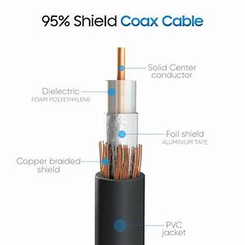

Fig 8.Coaxial Cable

1. **Optical Fiber**

The concept used by the optical fiber cable is the reflection of light through a core that is made up of plastic or glass & data transmits through. The core can be covered with a less dense glass/plastic called the cladding. This cable is mainly used for transmitting large volumes of data. The OFC can be bidirectional or unidirectional where the wavelength division multiplexer (WDM) supports these two modes like unidirectional & bidirectional.

**Two types of Propagation Modes**

* Multimode mode

Multiple light beams from a light source move through the core in different paths.It is implemented in two forms:

* Step-index: density of the core remains constant from the centre to the edges.
* Graded-index: decreases this distortion of the signal through the cable
* Single mode

Single-mode uses step-index fiber and a focused source of light which limits beams to a small range of angles, all close to the horizontal.

**Advantages** of optical fiber cable are lightweight; signal attenuation is less, high capacity & bandwidth, etc.

**Limitations** are high cost, fragile, maintenance and installation is difficult.

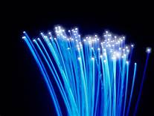

Fig 9.Fiber Optics Cable

**Summary**

The features of the connecting devices and transmission media can be explained in brief as follows:

Connecting Devices:

* HUB: Connects multiple devices in a single LAN network.
* BRIDGE: Breaking a large network into smaller segments, Connecting different media types. Such as connects UTP with the fibre optic, Connecting different network architectures. Such as connects Ethernet with the Token ring.
* SWITCH: Switch is used to connect the multiple devices together in a LAN. It is an ungraded version of the bridge. The biggest advantage of Switch is that, it makes switching decisions in hardware by using application specific integrated circuits (ASIC’s).
* GATEWAY: Gateway is used to forward the packets which are generated from the local host or network and but intended for the remote network. If a data packet does not find its destination address in the local network then it takes the help of the gateway device to find the destination address in the remote network. A gateway device knows the path of the remote destination address. If require, it also changes the encapsulation of the packet so it can travel through the other networks to get its destination address.
* REPEATERS - Repeaters are small devices that receive incoming electrical, wireless, and optical signals and retransmit them to spots that Ethernet and Wi-Fi data transmissions can't reach. Repeaters attempt to preserve signal integrity and extend the distance over which data can travel. Also known as signal boosters and range extenders.
* ROUTER: The router connects the different network segments. It switches the data packets between those networks which are either located in the different logical segments or built with the different network layer protocols.
* To connect different network segments, network protocols such as IP and IPX.
* To connect several smaller networks into a large network (known as the Internetwork)
* To break a large network into smaller networks.
* To connect two different media types such as UTP and Fiber optical, network architectures.

Transmission Media

* TWISTED PAIR CABLE: UTP cables are found in many ethernet network , telephone system , security camera system . Twisted-pair cables are used in the telephone lines to provide voice and data channels. The DSL lines that are used by the telephone companies in order to provide high-data-rate connections also use the high-bandwidth capability of the unshielded twisted-pair cables.
* COAXIAL CABLE: Used in the home and small offices, short coaxial cables are used for cable television, home video equipment, amateur radio equipment and measuring devices. Historically, coaxial cables were also used as an early form of Ethernet, supporting speeds of up to 10 Mbps, but coax has supplanted by the use of twisted pair cabling. However, they remain widely in use for cable broadband internet. Coaxial cables are also used in automobiles, aircraft, military and medical equipment, as well as to connect satellite dishes, radio and television antennae to their respective receivers.
* FIBRE OPTICS: It works on reflection of lights principle for data transmission.It provides the following benefits:
* Very high resistance to noise
* Excellent security
* Extremely high throughput
* Ability to carry signals for much longer distances before requiring repeaters than copper cable,
* Industry standard for high-speed networking

**Conclusion:**

We successfully understood about various commonly used transmission media & connecting devices in computer network in brief.

**Post Lab Questions**

1. Compare Hub, switch, bridge, and gateway and specify the use in different cases.

* The key difference between hubs, switches and bridges is that hubs operate at Layer 1 of the OSI model, while bridges and switches work with MAC addresses at Layer 2. Hubs broadcast incoming traffic on all ports, whereas bridges and switches only route traffic towards their addressed destinations. A hub is the least expensive, least intelligent, and least complicated. Its job is very simple: anything that comes in one port is sent out to the others. A switch does what a hub does, but more efficiently. By paying attention to the traffic that comes across it, it learns which computers are connected to which port. In the physical world, a bridge connects roads on separate sides of a river or railroad tracks. In the technical world, bridges connect two physical network segments. Each network bridge keeps track of the MAC addresses on the network attached to each of its interfaces. When network traffic arrives at the bridge and its target address is local to that side of the bridge, the bridge filters that Ethernet frame, so it stays on the local side of the bridge only. As is suggested by its name, a gateway is a network entity and also called the protocol converter. It can connect a computer of one network to another and define the boundaries of a network. If two networks of different protocols want to connect with each other, both networks need to have gateways which provide exist and entry points for computers from the two networks to communicate. In another word, a gateway can join dissimilar systems. So, none of the other systems can perform these tasks that a gateway can.

1. Which of the following device is used to connect two systems, especially if the systems use different protocols?

A. hub

B. bridge

C. gateway

D. repeater

E. None of the above

**Ans C. Gateway**

1. Frames from one LAN can be transmitted to another LAN via the device

A. Router

B. Bridge

C. Repeater

D. Modem

**Ans B. Bridge**