Batch: **A1** Roll No.: **1911004**

Experiment / assignment / tutorial No **8**

Grade: AA / AB / BB / BC / CC / CD /DD

**Signature of the Staff In-charge with date**

|  |
| --- |
| **TITLE:** Study Cisco Router Configuration Command using Cisco packet tracer |

**AIM:** To study basic Cisco Router configuration Commands and Implementation of Static Routing using Cisco Packet Tracer

**Expected Outcome of Experiment:**

**CO: Concept of Static Routing**

**Books/ Journals/ Websites referred:**

1. S. Tanenbaum, “Computer Networks”, Pearson Education, Fourth Edition
2. Forouzan, “Data Communications and Networking”, TMH, Fourth Edition

________________________________________________________________

**Pre-Lab/ Prior Concepts:**  Basics of Routing and Cisco Packet Tracer

**________________________________________________________________**

**New Concepts to be learned:** Different Modes of Operation of Cisco router

**Cisco IOS Modes of Operation:**

* The Cisco IOS software provides access to several different command modes. Each command mode provides a different group of related commands.
* For security purposes, the Cisco IOS software provides two levels of access to commands:
  + User mode
  + Privileged mode
* The unprivileged user mode is called user EXEC mode. The privileged mode is called privileged EXEC mode and requires a password. The commands available in user EXEC mode are a subset of the commands available in privileged EXEC mode.
* The following table describes some of the most commonly used modes, how to enter the modes, and the resulting prompts. The prompt helps you identify which mode you are in and, therefore, which commands are available to you

|  |  |  |  |
| --- | --- | --- | --- |
| **Modes of Operation** | **Usage** | **How to enter the mode** | **Prompt** |
| **User EXEC** | Change terminal settings on a temporary basis, perform basic tests, and list system information. | First level accessed. | Router> |
| **Privileged EXEC** | System administration, set operating parameters. | From user EXEC mode, enter enable password command | Router# |
| **Global Config** | Modify configuration that affect the system as a whole. | From privileged EXEC, enter configure terminal. | Router(config)# |
| **Interface Config** | Modify the operation of an interface. | From global mode, enter interface type number. | Router(config-if)# |
| **Setup** | Create the initial configuration. | From privileged EXEC mode, enter command setup. | Prompted dialog |

**User EXEC Mode:**

When you are connected to the router, you are started in user EXEC mode. The user EXEC commands are a subset of the privileged EXEC commands.

**Privileged EXEC Mode:**

Privileged commands include the following:

• Configure – Changes the software configuration.

• Debug – Display process and hardware event messages.

• Setup – Enter configuration information at the prompts.

Enter the command disable to exit from the privileged EXEC mode and return to user EXEC mode.

**Configuration Mode:**

Configuration mode has a set of submodes that you use for modifying interface settings, routing protocol settings, line settings, and so forth. Use caution with configuration mode because all changes you enter take effect immediately.

To enter configuration mode, enter the command configure terminal and exit by pressing Ctrl-Z.

**Note:** Almost every configuration command also has a no form. In general, use the no form to disable a feature or function. Use the command without the keyword no to re-enable a disabled feature or to enable a feature that is disabled by default. For example, IP routing is enabled by default. To disable IP routing, enter the no ip routing command and enter ip routing to re-enable it.

**IMPLEMENTATION:** (printout of code)

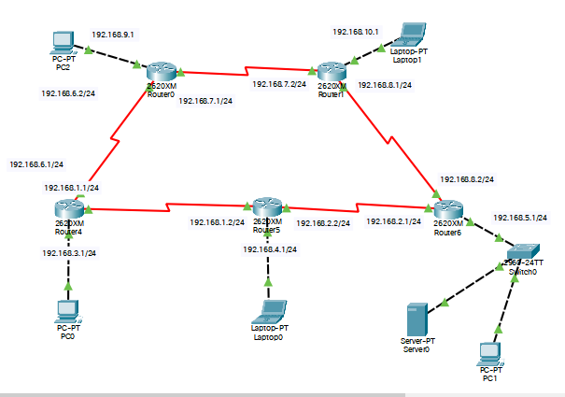

**Router 4-**

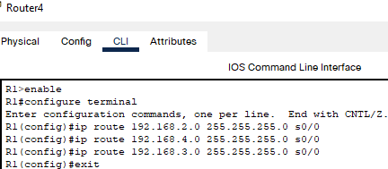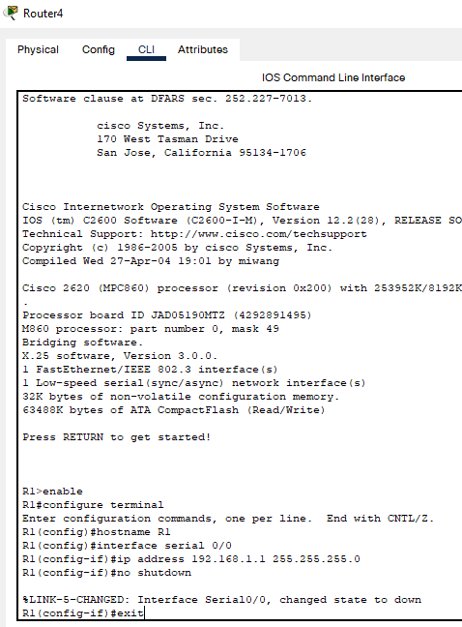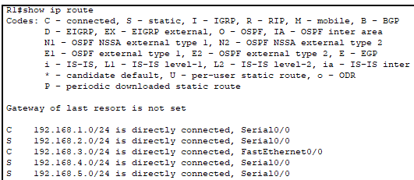

**Router 6-**

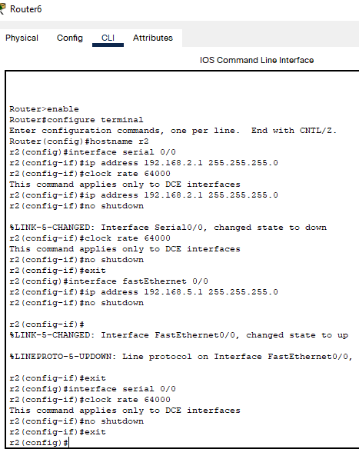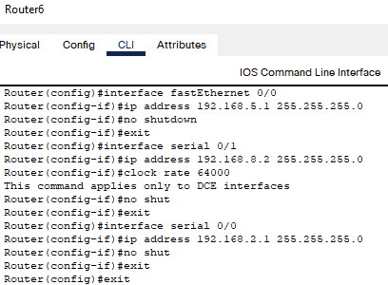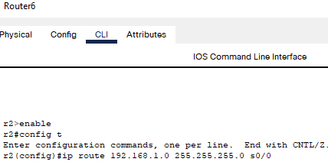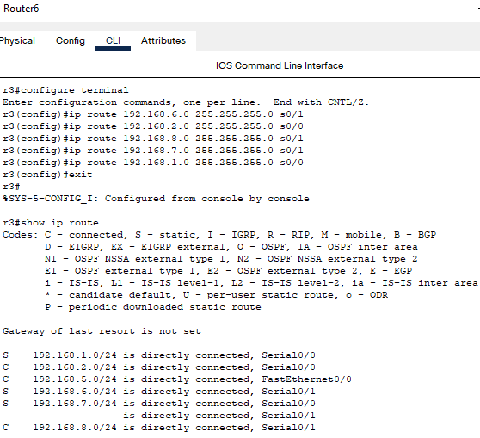

**Router-1**

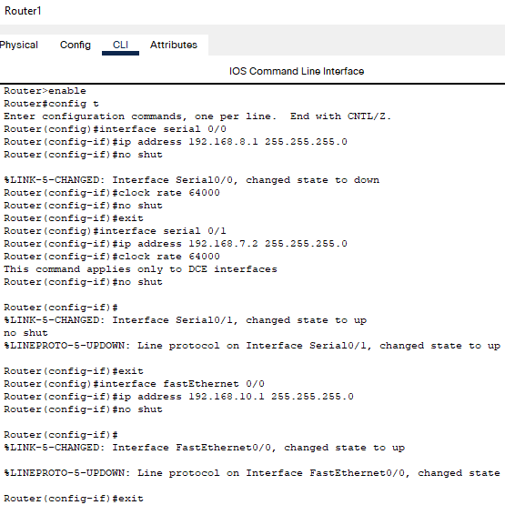 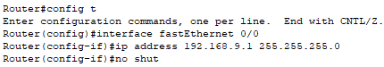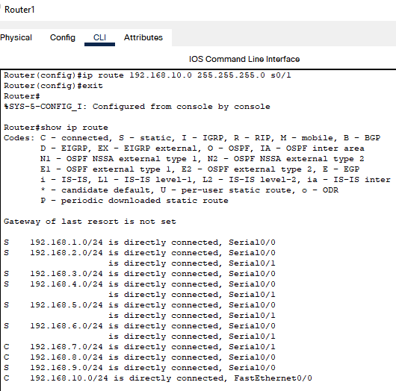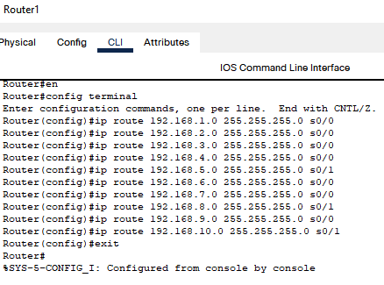

**Router 0-**

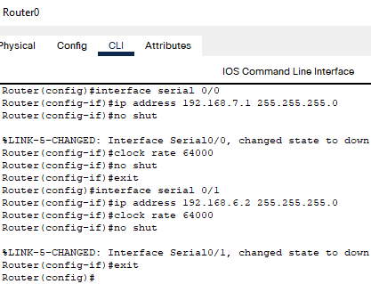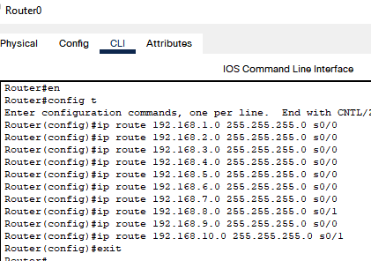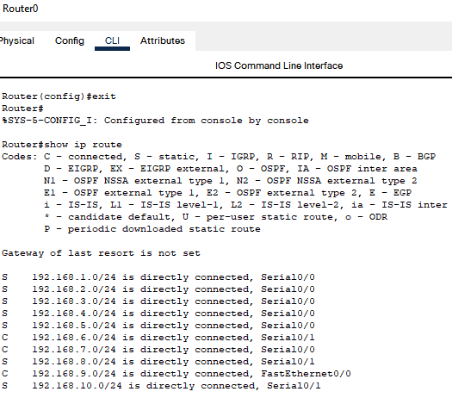

**Router 5-**

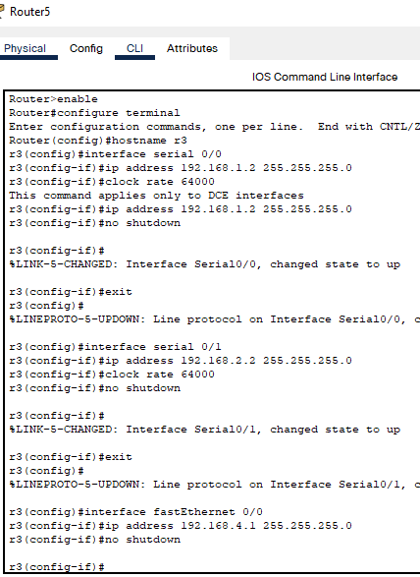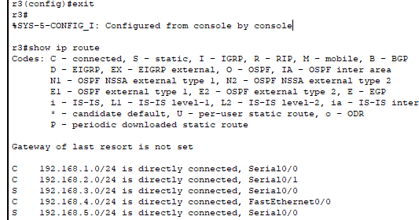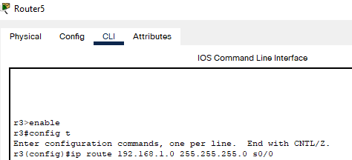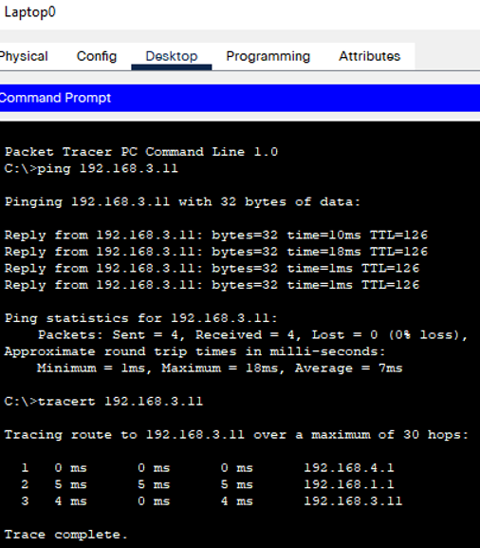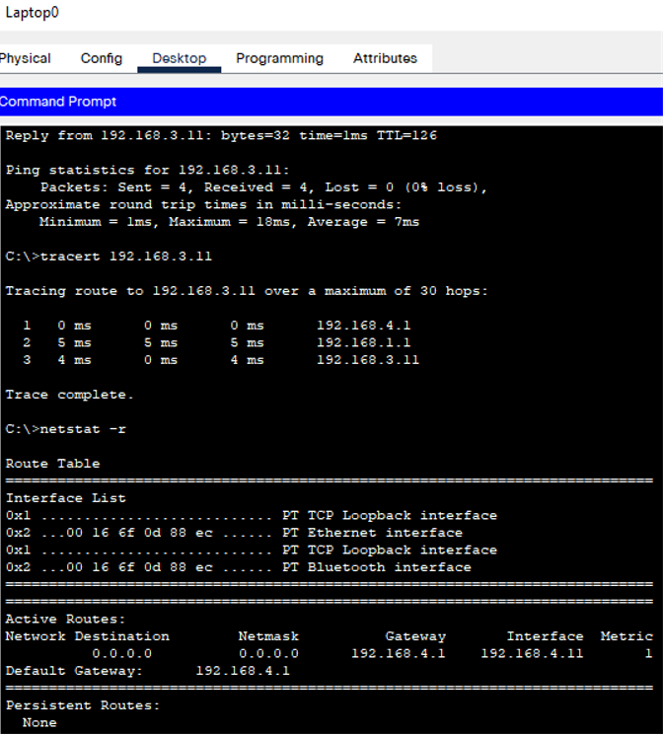

**CONCLUSION:**

We successfully understood the concept of static routing and implemented it using Cisco Packet Tracer.

**Date: 03-11-2021 Signature of faculty in-charge**