Batch: A1 Roll No.: 1911004

Experiment / assignment / tutorial No 9

Grade: AA / AB / BB / BC / CC / CD /DD

**Signature of the Staff In-charge with date**

**Experiment No.: 9**

|  |
| --- |
| **TITLE: Study and configure RIP protocol using Cisco Packet tracer** |

**AIM:** To study and configure RIP protocol using Cisco Packet tracer

**______________________________________________________**

**Expected Outcome of Experiment:**

**CO: Concept of Dynamic Routing**

**________________________________________________________________**

**Books/ Journals/ Websites referred:**

1. A. S. Tanenbaum, “Computer Networks”, Pearson Education, Fourth Edition
2. B. A. Forouzan, “Data Communications and Networking”, TMH, Fourth Edition

________________________________________________________________

**Pre Lab/ Prior Concepts:**

IPv4 Addressing, Subnetting, Distance Vector Protocol, Router configuration Commands

**________________________________________________________________**

**New Concepts to be learned:** RIP Protocol and its configuration.

**________________________________________________________________**

**RIP (Routing Information Protocol)**

RIP is a standardized Distance Vector protocol, designed for use on smaller networks. RIP was one of the first true Distance Vector routing protocols, and is supported on a wide variety of systems.

RIP adheres to the following Distance Vector characteristics:

• RIP sends out periodic routing updates (every 30 seconds)

• RIP sends out the full routing table every periodic update.

• RIP uses a form of distance as its metric (in this case, hopcount).

• RIP uses the Bellman-Ford Distance Vector algorithm to determine the best “path” to a particular destination

Other characteristics of RIP include:

• RIP supports IP and IPX routing.

• RIP utilizes UDP port 520

• RIP routes have an administrative distance of 120.

• RIP has a maximum hopcount of 15 hops.

**RIP Versions**

RIP has two versions, Version 1 (RIPv1) and Version 2 (RIPv2).

RIPv1 (RFC 1058) is ***classful***, and thus does not include the subnet mask with its routing table updates. Because of this, RIPv1 does not support **Variable Length Subnet Masks (VLSMs)**. When using RIPv1, networks must be contiguous, and subnets of a major network must be configured with identical subnet masks. Otherwise, route table inconsistencies (or worse) will occur.

RIPv1 sends updates as broadcasts to address 255.255.255.255.

RIPv2 (RFC 2543) is ***classless***, and thus does include the subnet mask with its routing table updates. RIPv2 fully supports VLSMs, allowing discontiguous networks and varying subnet masks to exist.

Other enhancements offered by RIPv2 include:

• Routing updates are sent via multicast, using address 224.0.0.9

• Encrypted authentication can be configured between RIPv2 routers

• Route tagging is supported.

RIPv2 can interoperate with RIPv1. By default:

• RIPv1 routers will sent only Version 1packets

• RIPv1 routers will receive both Version 1 and 2 updates

• RIPv2 routers will both send and receive only Version 2 updates

We can control the version of RIP a particular interface will “send” or “receive.”

Unless RIPv2 is manually specified, a Cisco will default to RIPv1 when configuring RIP.

**RIPv1 Basic Configuration**

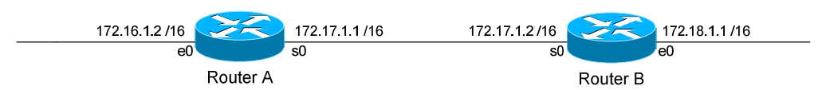

Routing protocol configuration occurs in Global Configuration mode. On Router A, to configure RIP, we would type:

**Router(config)#** router rip

**Router(config-router)#** network 172.16.0.0

**Router(config-router)#** network 172.17.0.0

The first command, router rip, enables the RIP process.

The network statements tell RIP which networks you wish to advertise to other RIP routers. We simply list the networks that are directly connected to our router. Notice that we specify the networks at their classful boundaries, and we do not specify a subnet mask.

To configure Router B:

**Router(config)#** router rip

**Router(config-router)#** network 172.17.0.0

**Router(config-router)#** network 172.18.0.0

The routing table on Router A will look like:

**RouterA#** show ip route

Gateway of last resort is not set

C 172.16.0.0 is directly connected, Ethernet0

C 172.17.0.0 is directly connected, Serial0

R 172.18.0.0 [120/1] via 172.17.1.2, 00:00:00, Serial0

The routing table on Router B will look like:

**RouterB#** show ip route

Gateway of last resort is not set

C 172.17.0.0 is directly connected, Serial0

C 172.18.0.0 is directly connected, Ethernet0

R 172.16.0.0 [120/1] via 172.17.1.1, 00:00:00, Serial0

**IMPLEMENTATION: (**printout of code)

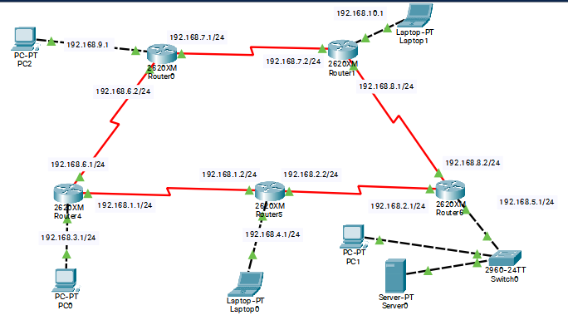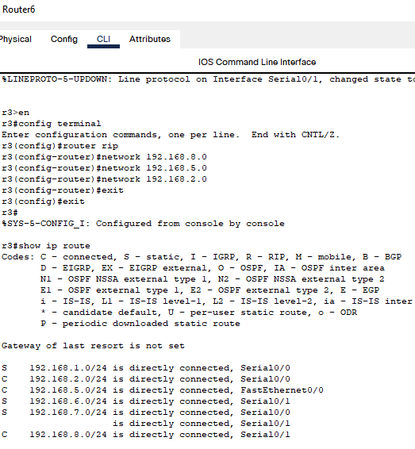

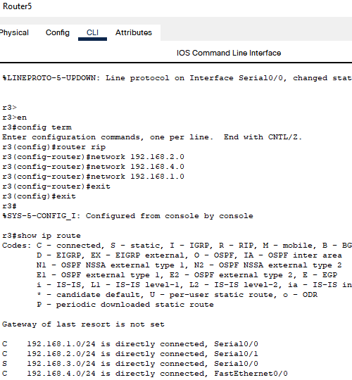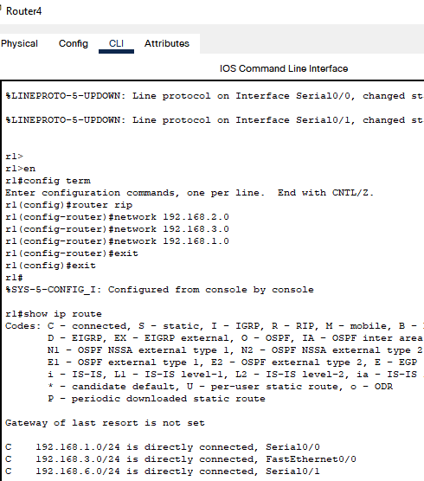

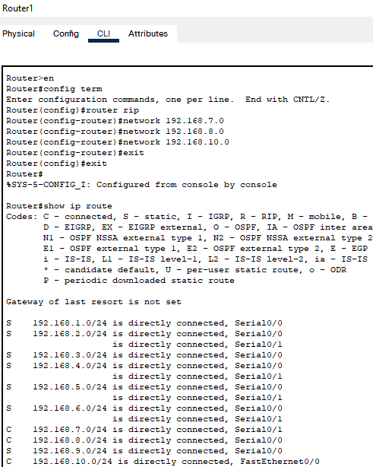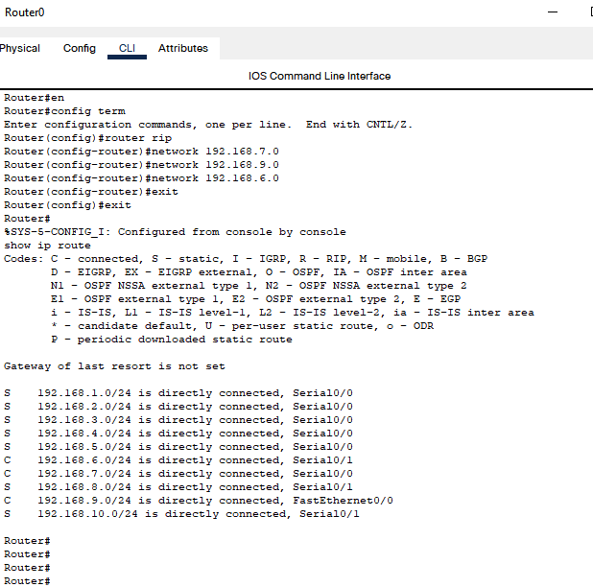

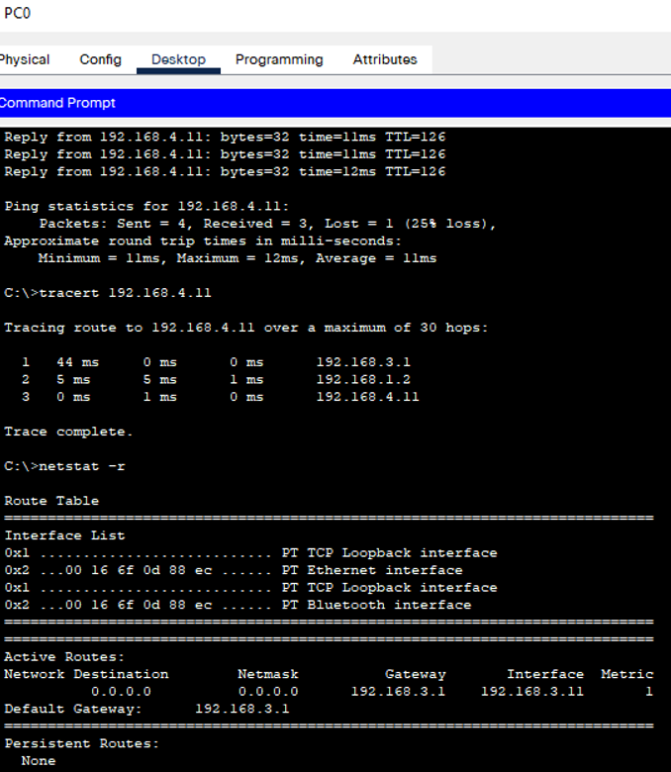

**CONCLUSION:**

We successfully understood the concept of dynamic routing and implemented it using Cisco Packet Tracer.

**Post Lab Questions**

1. ............ are two popular examples of distance vector routing protocols.  
A. OSPF and RIP  
B. RIP and BGP  
C. BGP and OSPF  
D. BGP and SPF

Ans: RIP and BGP

2. A ......... routing table contains information entered manually.  
A. static  
B. dynamic  
C. hierarchical  
D. non static

Ans: Static

3. A .......... routing table is updated periodically using one of the dynamic routing protocols.  
A. static  
B. dynamic  
C. hierarchical  
D. non static

Ans: dynamic

4. Which of the following is not the category of dynamic routing algorithm.  
A. Distance vector protocols  
B. Link state protocols  
C. Hybrid protocols  
D. Automatic state protocols

Ans: Automatic state protocols

5. In .......... forwarding, the mask and destination addresses are both 0.0.0.0 in the routing table.  
A. next-hop  
B. network-specific  
C. host-specific  
D. default

Ans: default

6. Differentiate between Distance Vector Routing and Link State Routing.

|  |  |
| --- | --- |
| Distance Vector Routing | Link State Routing |
| It is a dynamic routing algorithm in which each router computes a distance between itself and each possible destination i.e. its immediate neighbours. | It is a dynamic routing algorithm in which each router shares knowledge of its neighbours with every other router in the network. |
| The router shares its knowledge about the whole network to its neighbours and accordingly updates the table based on its neighbours. | A router sends its information about its neighbours only to all the routers through flooding. |
| The sharing of information with the neighbours takes place at regular intervals. | Information sharing takes place only whenever there is a change. |
| It makes use of Bellman-Ford Algorithm for making routing tables. | It makes use of Dijkstra’s Algorithm for making routing tables. |
| Eg Good news spread fast and bad news spread slowly | Eg Heavy traffic due to flooding of packets |

**Date: 03-12-2021 Signature of faculty in-charge**