**Experiment / Assignment / Tutorial No. 7**

**Grade: AA / AB / BB / BC / CC / CD /DD**

**Signature of the Staff In-charge with date**

|  |
| --- |
| **Batch: A1 Roll No.: 1911004 Experiment / assignment / tutorial No.: 7** |

|  |
| --- |
| **Title:** VHDL programming for gates |

**______________________________________________________________________________**

**Objective:** Implements a simple OR, AND, XOR, NOR, NAND, XNOR gate in VHDL

**______________________________________________________________________________**

**Expected Outcome of Experiment:**

**CO4:** Implement digital networks using VHDL.

**______________________________________________________________________________**

**Books/ Journals/ Websites referred:**

* ModelSim Software Link:

https://www.mentor.com/company/higher_ed/modelsim-student-edition

* J. Bhasker, “VHDL Primer”, Pearson Education
* Douglas L. Perry, “VHDL Programming by Example”, Tata McGraw Hill
* http://esd.cs.ucr.edu/labs/tutorial/

**Pre Lab/ Prior Concepts:**

VHDL is an acronym for VHSlC Hardware Description Language (VHSIC is an acronym for Very High Speed Integrated Circuits). It is a hardware description language that can be used to model a digital system at many levels of abstraction ranging from the algorithmic level to the gate level. The complexity of the digital system being modeled could vary from that of a simple gate to a complete digital electronic system, or anything in between. The digital system can also be described hierarchically. Timing can also be explicitly modeled in the same description.

**VHDL Programming Structure**

Entity and Architecture are the two main basic programming structures in VHDL.

**Entity:** Entity can be seen as the black box view of the system. We define the inputs and outputs of the system which we need to interface. It is used to declare the I/O ports of the circuit.

Eg:

Entity ANDGATE is

Port (A: in std_logic;

B: in std_logic;

Y: out std_logic);

End entity ANDGATE;

Entity name ANDGATE is given by the programmer, each entity must have a name.

**Architecture:** Architecture defines what is in our black box that we described using ENTITY. The description code resides within architecture portion. Either behavioral or structural models can be used to describe our system in the architecture. In Architecture we will have interconnections, processes, components, etc.

Eg:

Architecture AND1 of ANDGATE is

--declarations

Begin

--statements

Y <= A AND B;

End architecture AND1;

Entity name or architecture name is user defined. Identifiers can have uppercase alphabets, lowercase alphabets, and numbers and underscore (_). First letter of identifier must be an alphabet and identifier cannot end with an underscore. In VHDL, keywords and user identifiers are case insensitive.

VHDL is strongly typed language i.e. every object must be declared. Standardized design libraries are typically used and are included prior to the entity declaration. This is accomplished by including the code "library ieee;" and "use ieee.std_logic_1164.all;"

**Implementation Details:**

**VHDL program code**

**OR**

library ieee;

use ieee.std_logic_1164.all;

--------------------------------------

entity OR_ent is

port( x: in std_logic;

y: in std_logic;

F: out std_logic

);

end OR_ent;

---------------------------------------

architecture OR_arch of OR_ent is

begin

process(x, y)

begin

-- compare to truth table

if ((x='0') and (y='0')) then

F <= '0';

else

F <= '1';

end if;

end process;

end OR_arch;

architecture OR_beh of OR_ent is

begin

F <= x or y;

end OR_beh;

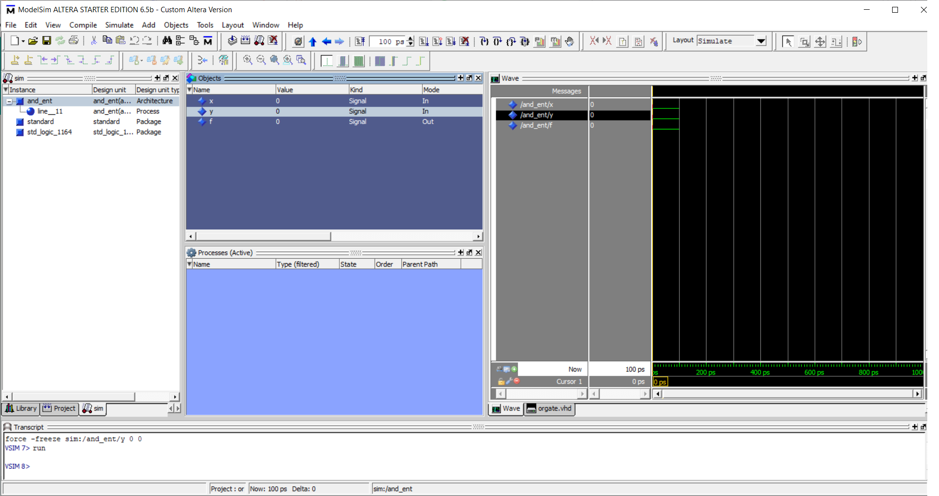

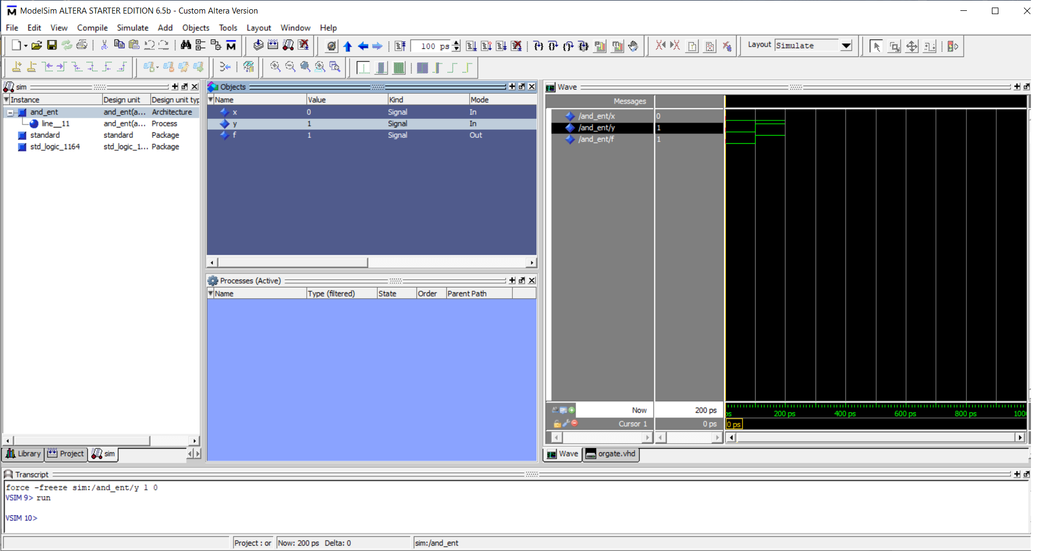

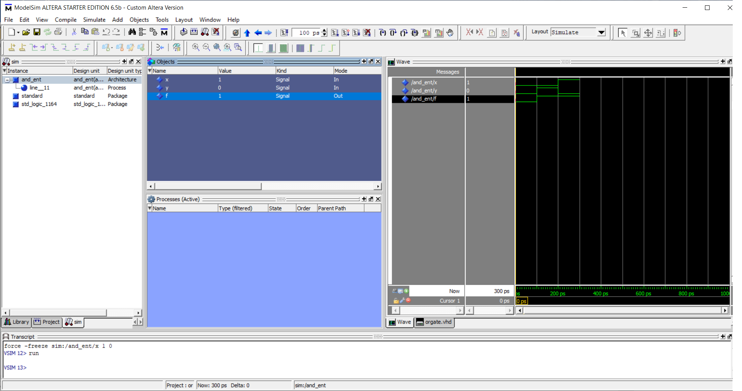

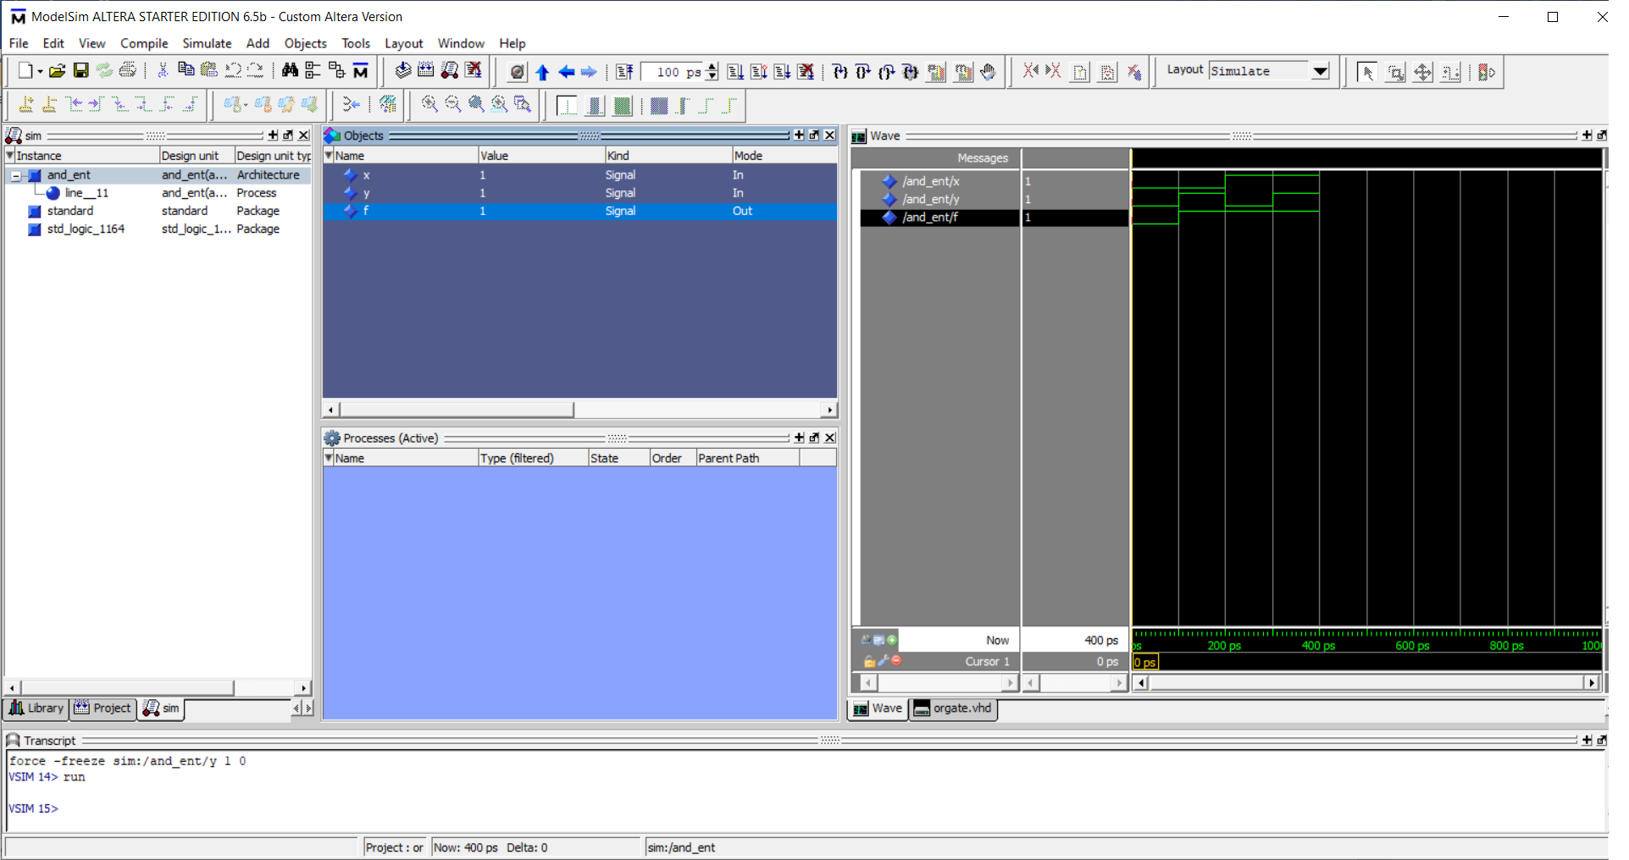

**AND**

library ieee;

use ieee.std_logic_1164.all;

--------------------------------------

entity AND_ent is

port( x: in std_logic;

y: in std_logic;

F: out std_logic

);

end AND_ent;

---------------------------------------

architecture AND_arch of AND_ent is

begin

process(x, y)

begin

-- compare to truth table

if ((x='0') and (y='0')) then

F <= '0';

else

F <= '1';

end if;

end process;

end AND_arch;

architecture AND_beh of AND_ent is

begin

F <= x and y;

end AND_beh;

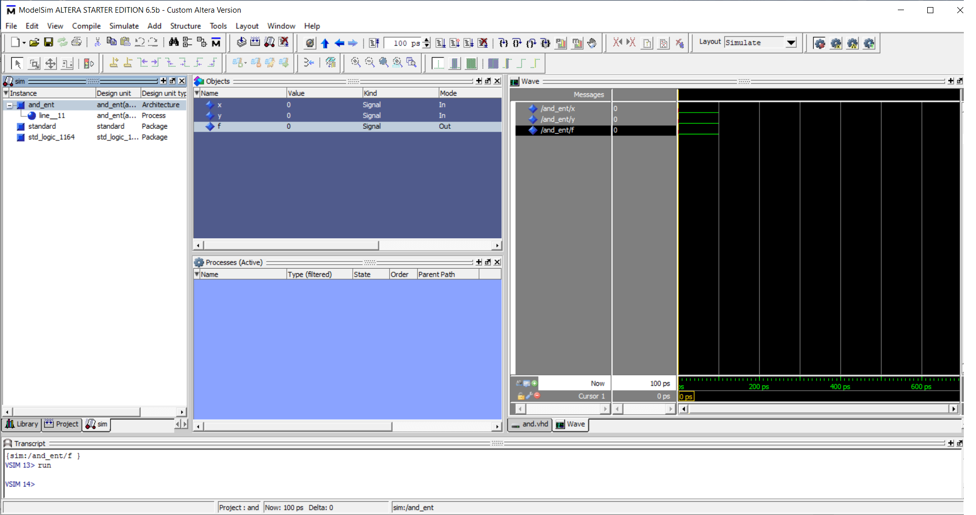

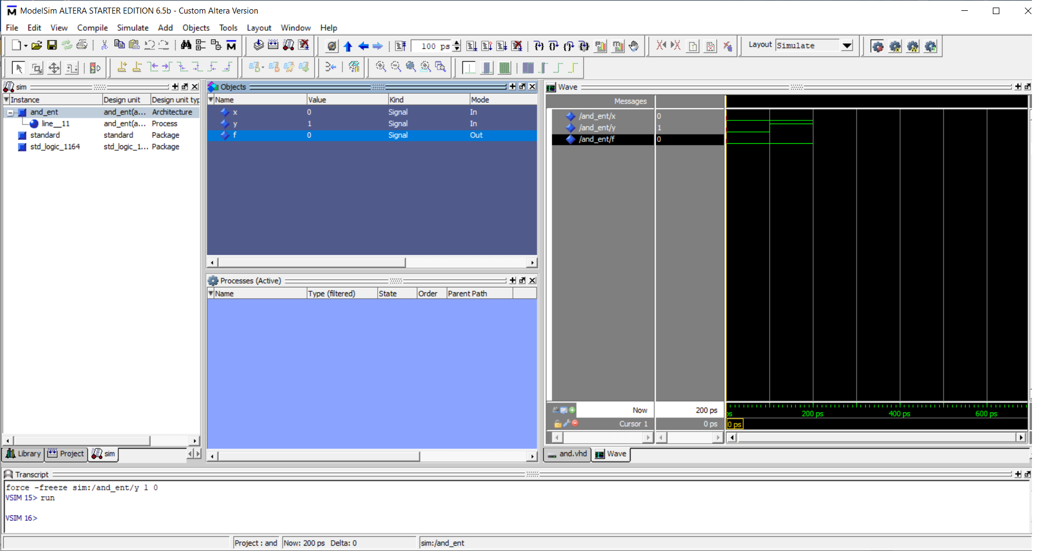

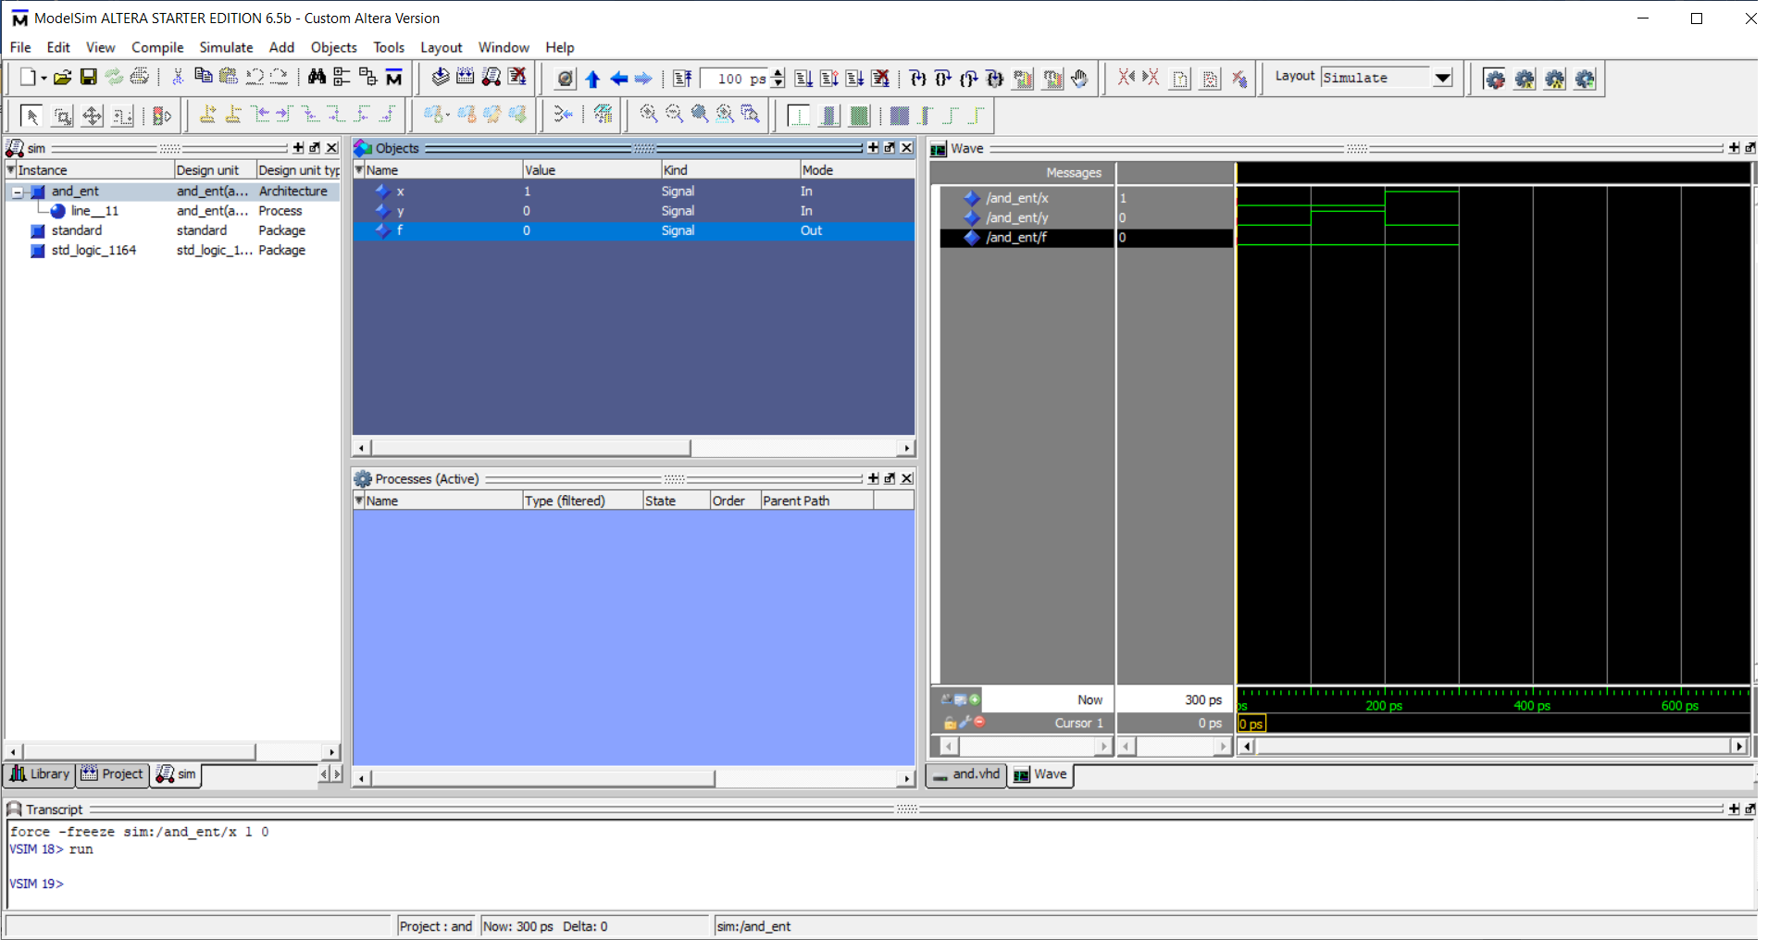

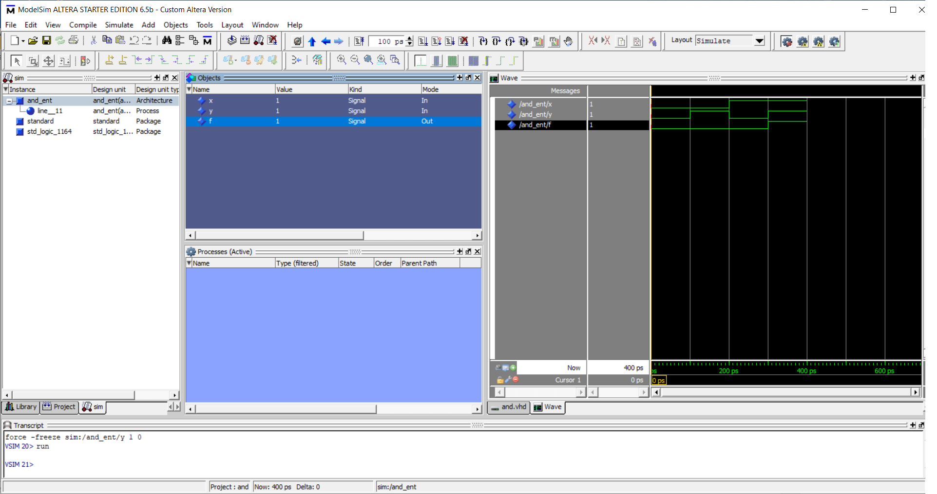

**NAND**

library ieee;

use ieee.std_logic_1164.all;

--------------------------------------

entity NAND_ent is

port( x: in std_logic;

y: in std_logic;

F: out std_logic

);

end NAND_ent;

---------------------------------------

architecture NAND_arch of NAND_ent is

begin

process(x, y)

begin

-- compare to truth table

if ((x='0') and (y='0')) then

F <= '1';

else

F <= '0';

end if;

end process;

end NAND_arch;

architecture NAND_beh of NAND_ent is

begin

F <= x nand y;

end NAND_beh;

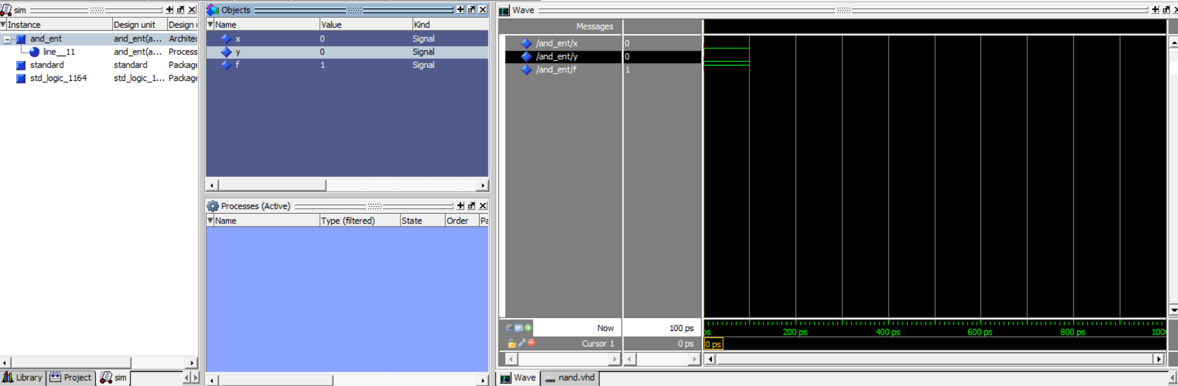

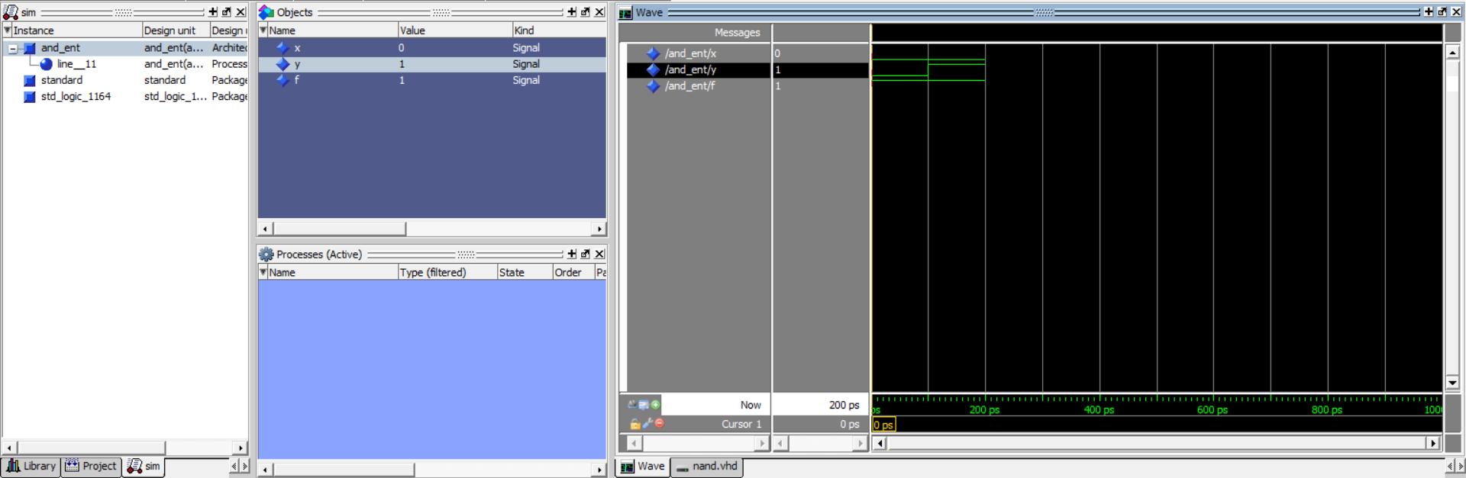

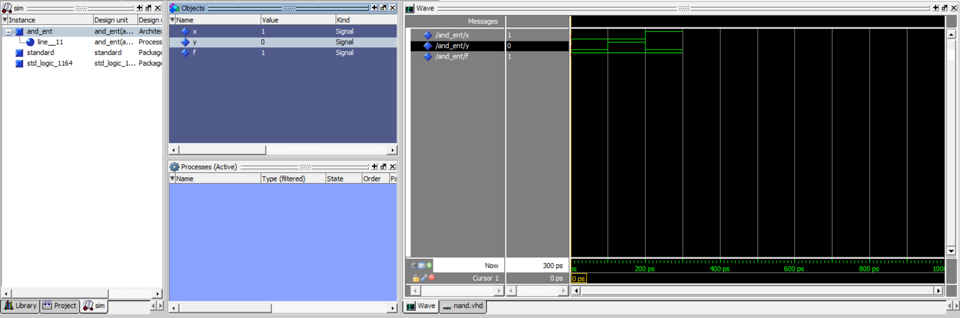

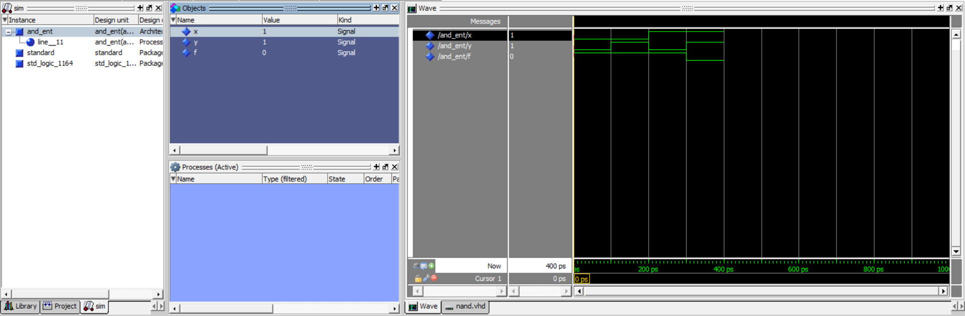

**NOR**

library ieee;

use ieee.std_logic_1164.all;

--------------------------------------

entity NOR_ent is

port( x: in std_logic;

y: in std_logic;

F: out std_logic

);

end NOR_ent;

---------------------------------------

architecture NOR_arch of NOR_ent is

begin

process(x, y)

begin

-- compare to truth table

if ((x='0') and (y='0')) then

F <= '1';

else

F <= '0';

end if;

end process;

end NOR_arch;

architecture NOR_beh of NOR_ent is

begin

F <= x nor y;

end NOR_beh;

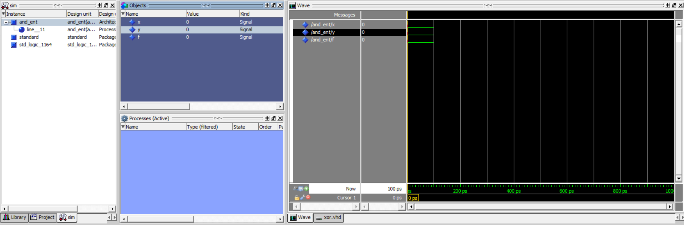



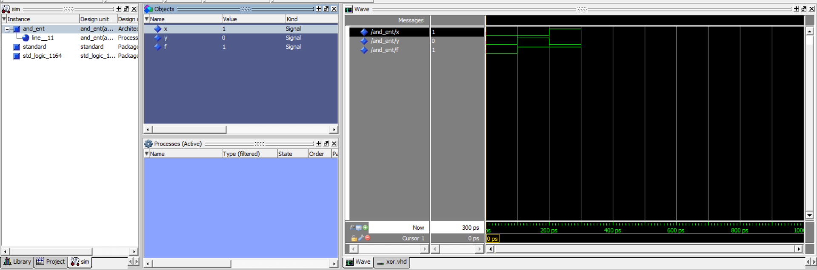

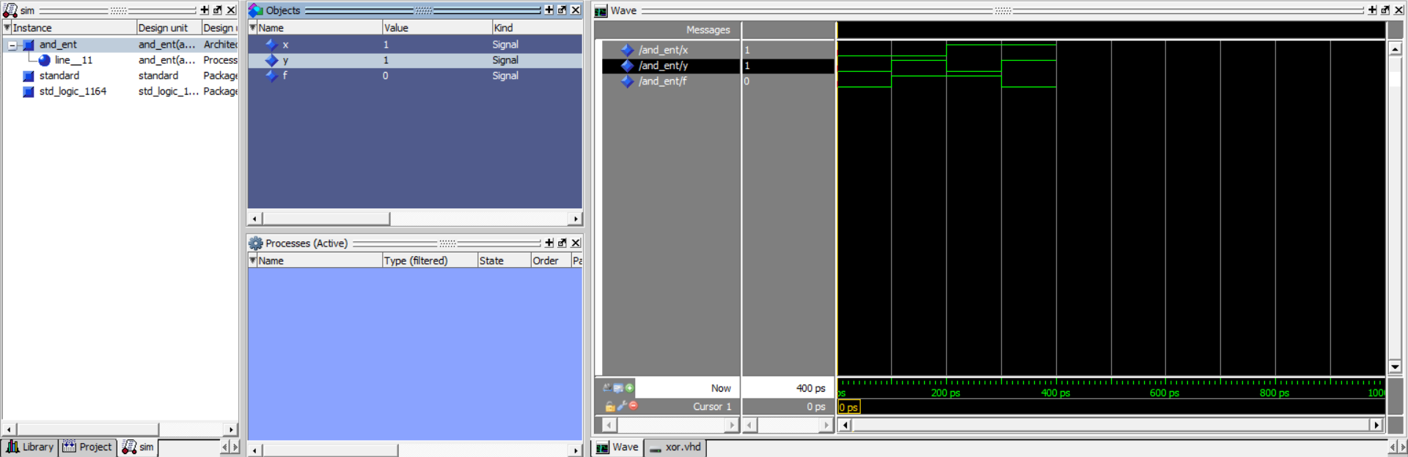

**XOR**

library ieee;

use ieee.std_logic_1164.all;

--------------------------------------

entity XOR_ent is

port( x: in std_logic;

y: in std_logic;

F: out std_logic

);

end XOR_ent;

---------------------------------------

architecture XOR_arch of XOR_ent is

begin

process(x, y)

begin

-- compare to truth table

if (x=y) then

F <= '0';

else

F <= '1';

end if;

end process;

end XOR_arch;

architecture XOR_beh of XOR_ent is

begin

F <= x xor y;

end XOR_beh;



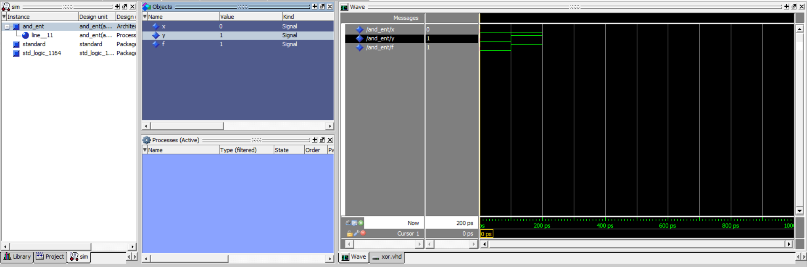





**XNOR**

library ieee;

use ieee.std_logic_1164.all;

--------------------------------------

entity XNOR_ent is

port( x: in std_logic;

y: in std_logic;

F: out std_logic

);

end XNOR_ent;

---------------------------------------

architecture XNOR_arch of XNOR_ent is

begin

process(x, y)

begin

-- compare to truth table

if (x=y) then

F <= '1';

else

F <= '0';

end if;

end process;

end XNOR_arch;

architecture XNOR_beh of XNOR_ent is

begin

F <= x xnor y;

end XNOR_beh;

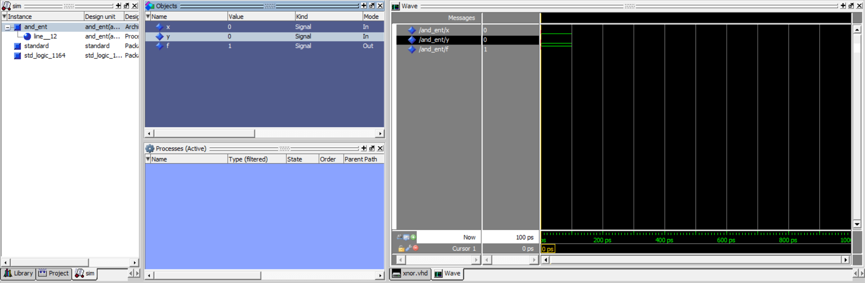

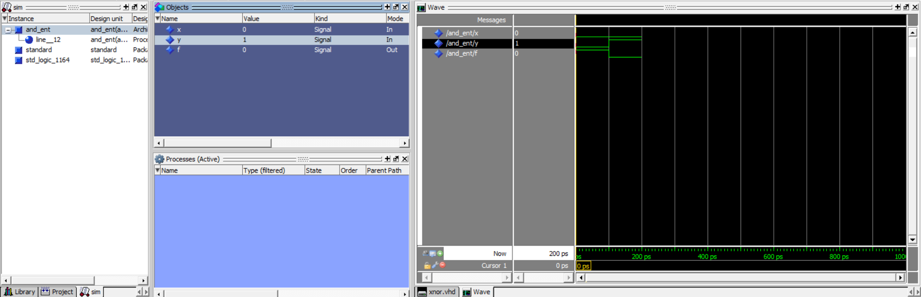

**NOT**

library ieee;

use ieee.std_logic_1164.all;

--------------------------------------

entity NOT_ent is

port( x: in std_logic;

y: in std_logic;

F: out std_logic

);

end NOT_ent;

---------------------------------------

architecture NOT_arch of NOT_ent is

begin

process(x, y)

begin

-- compare to truth table

if (x='0') then

F <= '0';

else

F <= '1';

end if;

end process;

end NOT_arch;

architecture NOT_beh of NOT_ent is

begin

F <= x not y;

end NOT_beh;

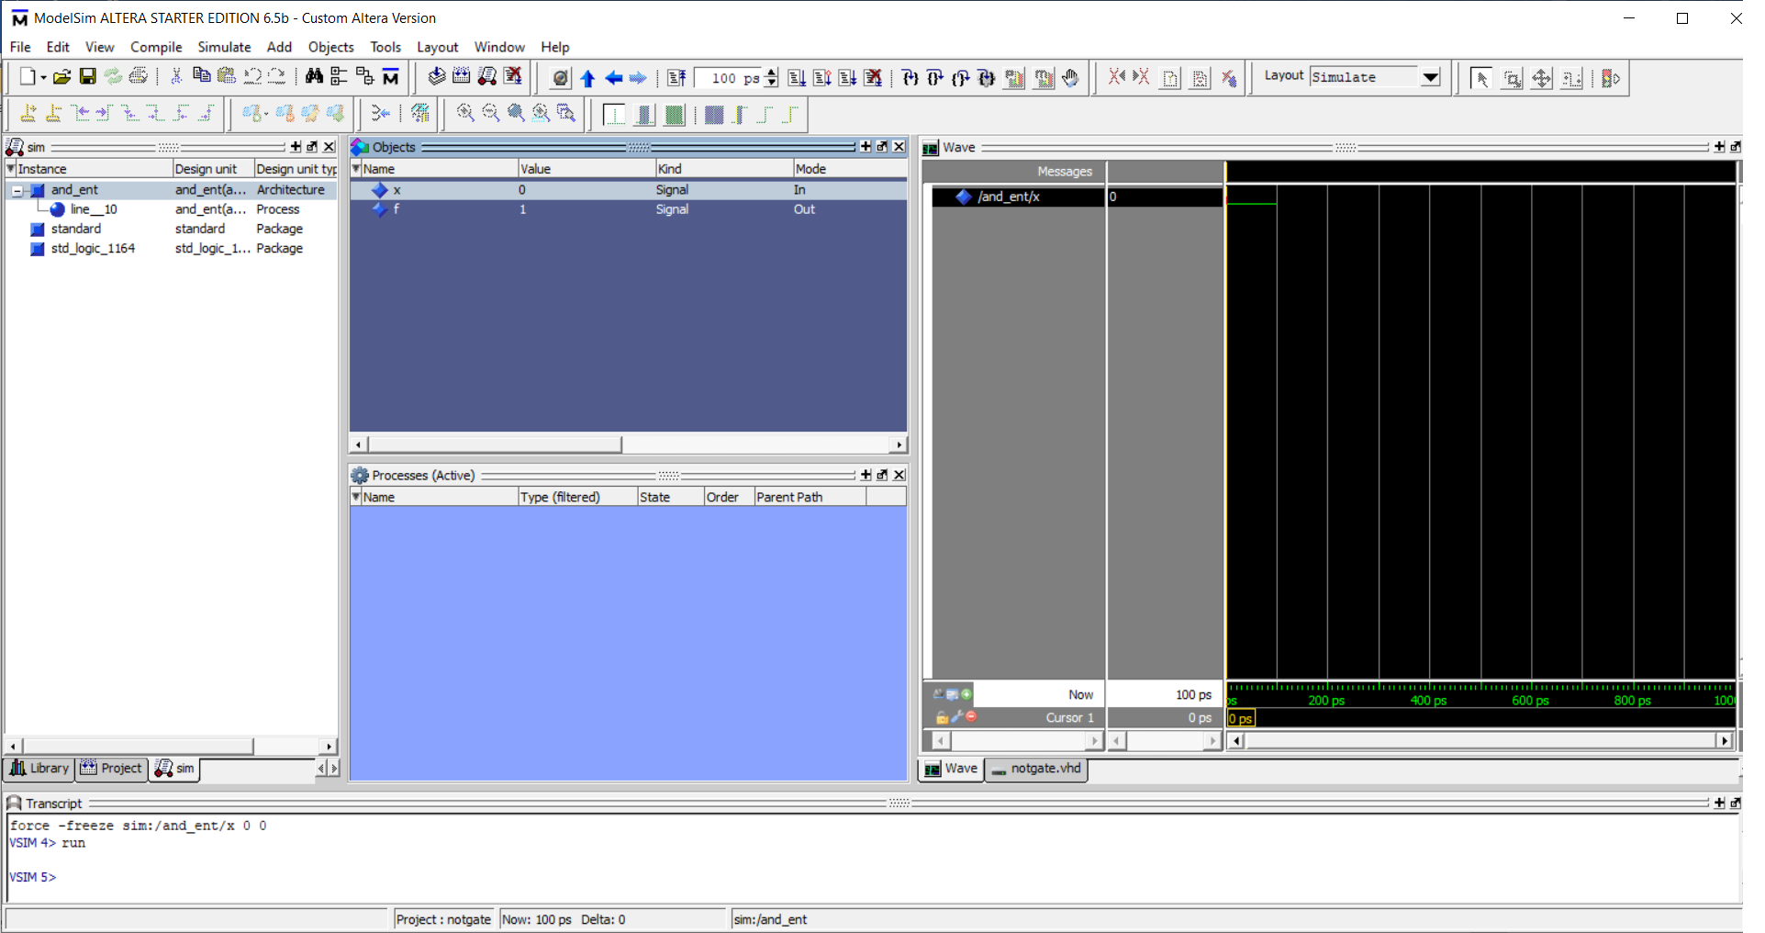

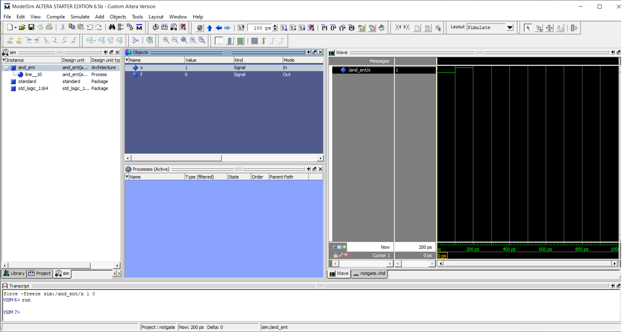

**Conclusion:**

We successfully implemented logic gates using VHLD programming; thus, obtained correct output.

**Post Lab Descriptive Questions:**

1. What are two types of HDL?

Hardware description languages need the ability to Describe ; Simulate at behavioural,structural ,mixed level. and to synthesize (structure from behaviour)

1. **VHDL**

it stands for very high-speed integrated circuit hardware description language. It is a programming language used to model a digital system by dataflow, behavioral and structural style of modeling.It is used in electronic design automation to describe digital and mixedsignal systems such as field-programmable gate arrays and integrated circuits

1. **Verilog**

it standardized as IEEE 1364, is a hardware description language (HDL) used to model electronic systems. It is most commonly used in the design and verification of digital circuits at the register-transfer level of abstraction. It is also used in the verification of analog circuits and mixed-signal circuits, as well as in the design of genetic circuits