**Roll no : 1911004**

**Batch: ML1**

**Title: Implementation of Bayesian networks – Exp 5**

**Objective:** To implement Bayesian belief networks

# Expected Outcome of Experiment:

|  |  |
| --- | --- |
| **CO** | **Outcome** |
| **CO2** | Describe and apply supervised learning methods |

**Books/ Journals/ Websites referred:**

1. <https://machinelearningmastery.com/introduction-to-bayesian-belief-networks/>
2. [https://towardsdatascience.com/introduction-to-bayesian-belief-networks-c012e3f59f 1b](https://towardsdatascience.com/introduction-to-bayesian-belief-networks-c012e3f59f1b)

# Theory of Bayesian networks algorithm:

A Bayesian network (also known as a Bayes network, belief network, or decision network) is a probabilistic graphical model that represents a set of variables and their conditional dependencies via a directed acyclic graph (DAG). Bayesian networks are ideal for taking an event that occurred and predicting the likelihood that any one of several possible known causes was the contributing factor. For example, a Bayesian network could represent the probabilistic relationships between diseases and symptoms. Given symptoms, the network can be used to compute the probabilities of the presence of various diseases.

Efficient algorithms can perform inference and learning in Bayesian networks. Bayesian networks that model sequences of variables (e.g. speech signals or protein sequences) are called dynamic Bayesian networks. Generalizations of Bayesian networks that can represent and solve decision problems under uncertainty are called influence diagrams.

Bayesian Belief Network or Bayesian Network or Belief Network is a Probabilistic Graphical Model (PGM) that represents conditional dependencies between random variables through a Directed Acyclic Graph (DAG).

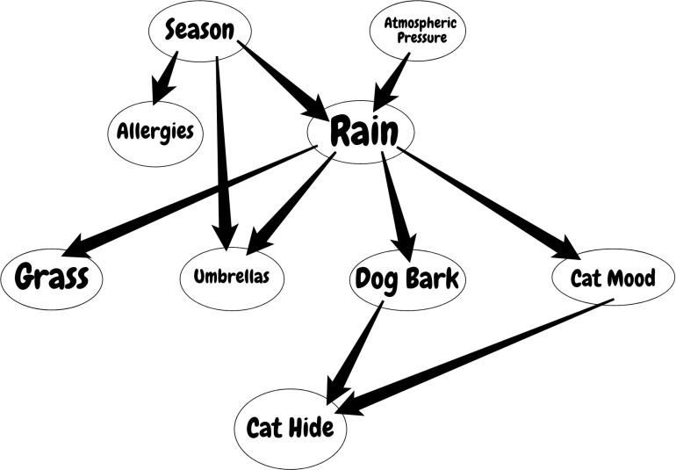

Bayesian Networks are applied in many fields. For example, disease diagnosis, optimized web search, spam filtering, gene regulatory networks, etc. And this list can be extended. The main objective of these networks is trying to understand the structure of causality relations. To clarify this, let’s consider a disease diagnosis problem. With given symptoms and their resulting disease, we construct our Belief Network and when a new patient comes, we can infer which disease or diseases may have the new patient by providing probabilities for each disease. Similarly, these causality relations can be constructed for other problems and inference techniques can be applied to interesting results.

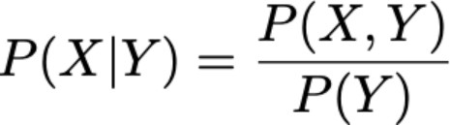

As you would understand from the formula, to be able to calculate the joint distribution we need to have conditional probabilities indicated by the network. But further that if we have the joint distribution, then we can start to ask interesting questions. For example, in the first example, we ask for the probability of “RAIN” if “SEASON” is “WINTER” and “DOG BARK” is “TRUE”.

# Details of data set used:

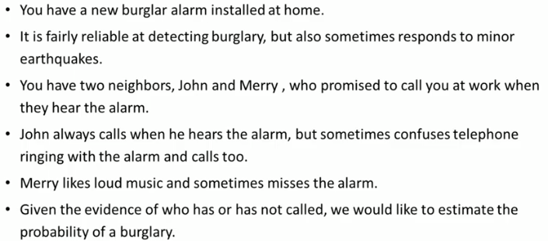

**Code with output screenshots**

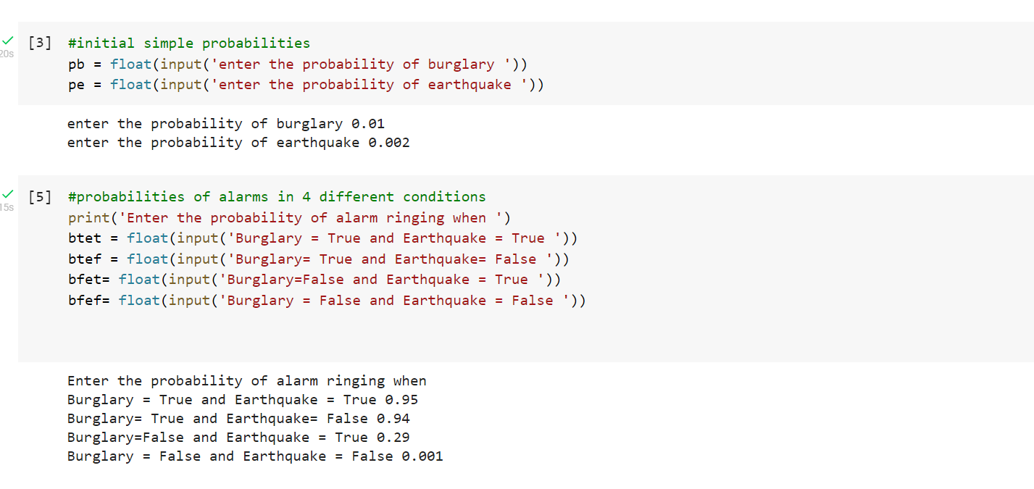

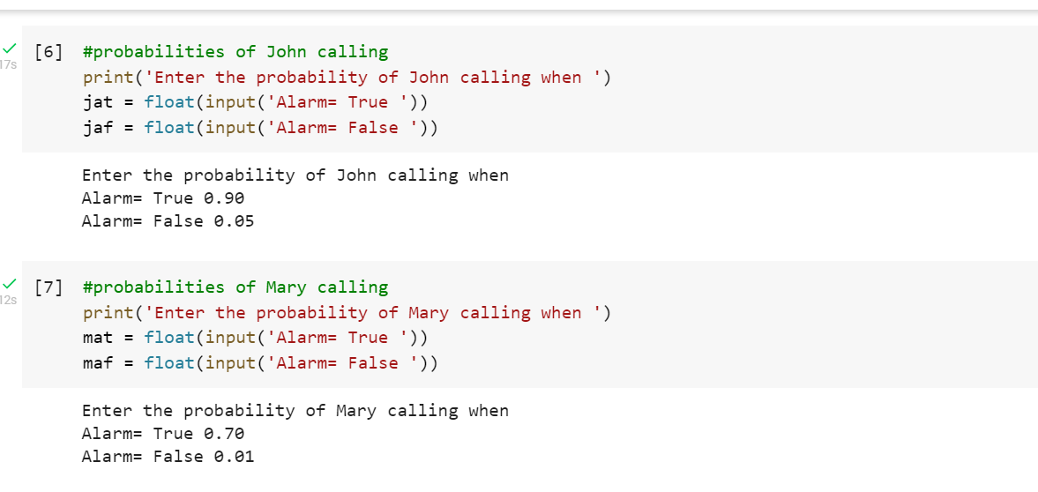

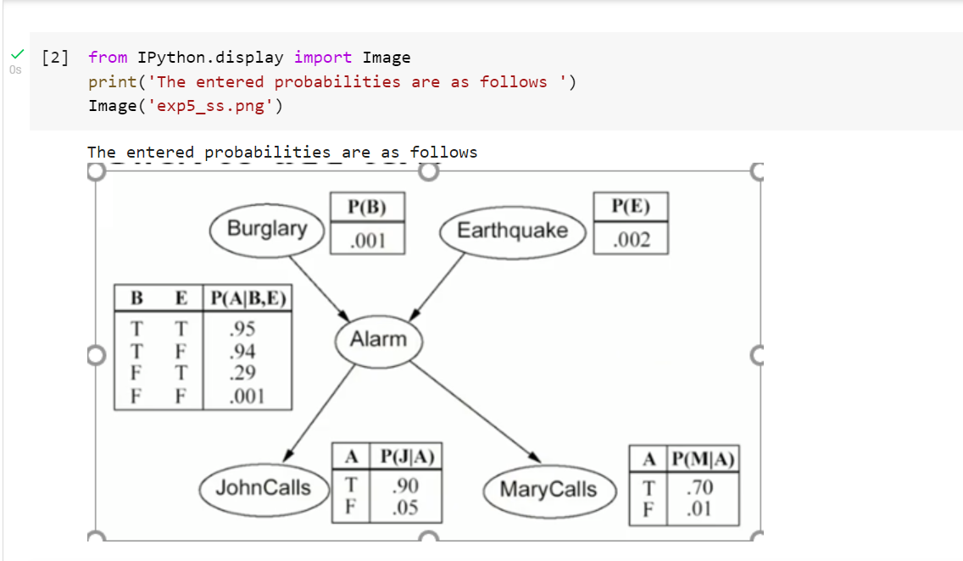

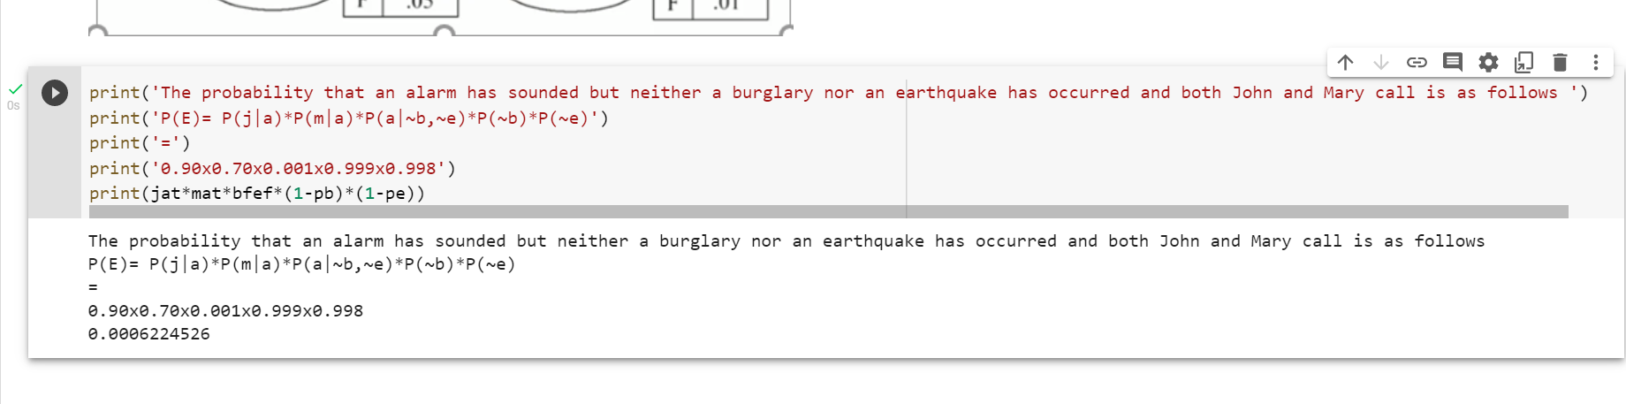

**Conclusion:** We have successfully understood and implemented a Bayesian Network using Python.