**Batch: A1**

**Roll No.: 1911004 ,1911005, 1911012**

**Experiment / assignment / tutorial No. 7**

|  |
| --- |
| **TITLE: Generate test cases using Black box testing techniques** |

**AIM:** To learn Black box testing techniques **______________________________________________________________________**

**Expected OUTCOME of Experiment:**

To learn Black box testing techniques

**_____________________________________________________________________**

**Books/ Journals/ Websites referred:**

1. Roger Pressman, Software Engineering: A practitioners Approach, McGraq Hill, 2010 ,6th edition

2. Ian Somerville , Software Engineering , Addison Wesley,2011,9th edition

1. http://en.wikipedia.org/wiki/Software_requirements_specification

**_____________________________________________________________________**

**Introduction:**

**Black-box testing** is a method of software testing that examines the functionality of an application without peering into its internal structures or workings.

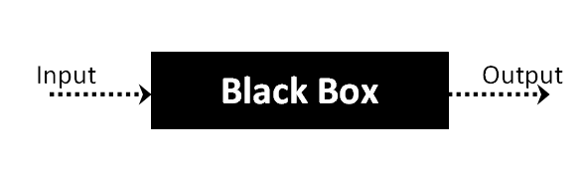

**Implementation**:

**REGISTRATION**

Functional Specification:

This Module is a mandatory part of our system where the user has to create a teacher or a student profile. This module will need users EmailID, User generated password and Mobile numberof the user. There will be checks on each of the above mentioned fields before actually creating a profile for the User. The rights given to the teacher profile and student profile will vary.

|  |  |
| --- | --- |
| **Test Case** | **Output** |
| If email id entered is valid | Accepted |
| If email id entered is invalid | Not accepted |
| If email id not entered | Not accepted |
| If entered email id already exists in the database | Not accepted |
| If entered password length less than 8 | Not accepted |
| If entered password length greater than 25 | Not accepted |
| If password not entered | Not accepted |
| If entered password doesn’t contains capital alphabet | Not accepted |
| If entered password doesn’t contains small case alphabet | Not accepted |
| If entered password doesn’t contains any number | Not accepted |
| If entered password doesn’t contains any special character | Not accepted |
| If entered password contains capital alphabet, small case alphabet, numbers, special character and length of password is between 8 and 25 | Accepted |
| If mobile number not entered | Not accepted |
| If length of mobile number entered less than 10 or more than 10 | Not accepted |
| If length of mobile number entered equal to 10 | Accepted |

**Boundary Value analysis for password length:**

· **Min - 6**

· **Max – 15**

**P.T.O.**

|  |  |  |
| --- | --- | --- |
| **Length** | **Value** | **Result** |
| Min - 1 | 5 | Fail |
| Min | 6 | Pass |
| 6 - 15 | [6, 15] | Pass |
| Min + 1 | 7 | Pass |
| Max - 1 | 14 | Pass |
| Max | 15 | Pass |
| Max + 1 | 16 | Fail |

**Boundary Value analysis for phone number :**

● **Length : 10**

|  |  |  |
| --- | --- | --- |
| **Length** | **Value** | **Result** |
| 10 | 9198498155 | Pass |
| 9 | 919849815 | Fail |
| 11 | 91984981551 | Fail |

**LOGIN**

Functional Specification:

This section is mandatory to get into the system without this neither teacher nor student will be able to view insights of the system. In this section users have to enter an email and password (which is provided by the user in registration) and based on that the user is verified and will get access to the system. This section will have different security checks to validate the user.

|  |  |
| --- | --- |
| **Test Case** | **Output** |
| If password or email not entered | Not accepted |
| If entered email doesn’t exist in the database | Not accepted |
| If entered password is incorrect | Not accepted |
| If entered email is correct and its corresponding password is also correct | Accepted |

**SCHEDULE A LECTURE**

Functional Specification:

This Module is specifically designed for the Teacher class. When a teacher has successfully created a profile and then logs into the system, he/she gets an option to schedule a lecture for the current upcoming class. Once the teacher wishes to Schedule a lecture and initiates the process a random pin would be generated. This pin is a security check which the teacher has to share with the students, without this the students won't be able to mark their attendance.

|  |  |
| --- | --- |
| **Test Case** | **Output** |
| Entered lecture details are incorrect or empty | Not accepted |
| Entered lecture details are correct | Accepted |
| After successful creation of lecture pin should be generated and shown to the teacher | Accepted |
| After successful creation of lecture pin not generated | Not accepted |

**Assignments & notes**

Functional Specification:

This Module is specifically designed for the Teacher class. When a teacher has successfully created a profile and then logs into the system, he/she gets an option to give assignment and notes to the student. once the teacher uploads the file the file he/she has to select the category of students to which it is to be shared and finally it gets shred to the students.

|  |  |
| --- | --- |
| **Test Case** | **Output** |
| After the upload of the file. all the category of students should be visible to teacher | Accepted |
| After the selection of category, the notes should be visible to that category of students | Accepted |
| notes will be visible to all students | Not Accepted (will be visible only to the student’s which teacher selected the category) |

**Conclusion:**

Black box testing is understood and test cases have been generated using Black

box testing techniques

**Post Lab Subjective Questions**

1. **What are the advantages and disadvantages of Equivalence Class Partitioning?**

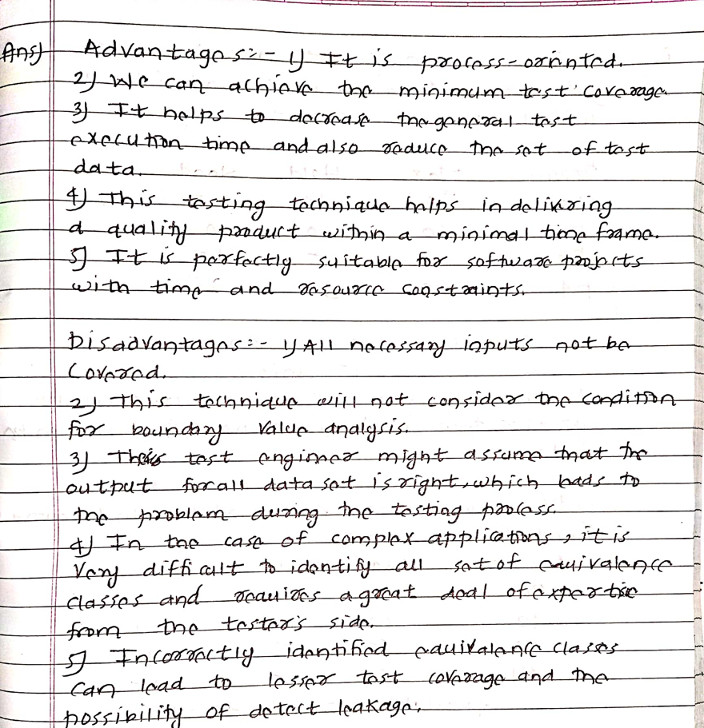

**2. State the applications of Black Box Techniques?**

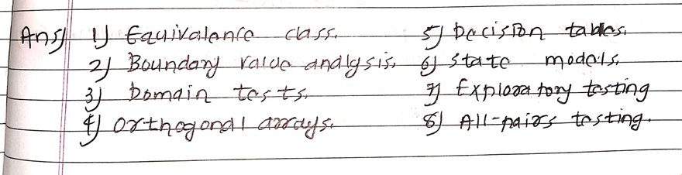

**Post Lab Descriptive Questions**

1. State various Scheduling principles and explain them in detail.