**Batch: A1**

**Roll No.: 1911004 ,1911005, 1911012**

**Experiment / assignment / tutorial No. 8**

**Grade: AA / AB / BB / BC / CC / CD /DD**

**Signature of the Staff In-charge with date**

|  |
| --- |
| **TITLE: Generate test cases using White box testing techniques** |

**AIM:** To learn White box testing techniques

**Expected OUTCOME of Experiment:**

**CO: Test the given software for different test cases with proper test planning.**

**Books/ Journals/ Websites referred:**

1. Roger Pressman, Software Engineering: A practitioners Approach, McGraq Hill, 2010 ,6th edition
2. Ian Somerville , Software Engineering , Addison Wesley,2011,9th edition
3. <http://en.wikipedia.org/wiki/Software_requirements_specification>

**Introduction:**

White Box Testing (also known as clear box testing, glass box testing, transparent box testing, and structural testing) is a method of software testing that tests internal structures or workings of an application. White Box Testing is software testing technique in which internal structure, design and coding of software are tested to verify flow of input-output and to improve design, usability and security. In white box testing, code is visible to testers so it is also called Clear box testing, Open box testing, Transparent box testing, Code-based testing and Glass box testing. It is one of two parts of the Box Testing approach to software testing. Its counterpart, Blackbox testing, involves testing from an external or end-user type perspective. On the other hand, White box testing in software engineering is based on the inner workings of an application and revolves around internal testing.

* White box testing technique: Statement Coverage
* Decision Coverage
* Branch Coverage
* Condition Coverage
* Multiple Condition Coverage
* Finite State Machine Coverage
* Path Coverage
* Control flow testing
* Data flow testing

**Advantages of White Box Testing:**

* Code optimization by finding hidden errors.
* White box tests cases can be easily automated.
* Testing is more thorough as all code paths are usually covered.
* Testing can start early in SDLC even if GUI is not available.

**Disadvantages of WhiteBox Testing:**

* White box testing can be quite complex and expensive.
* Developers who usually execute white box test cases detest it. The white box testing by developers is not detailed can lead to production errors.
* White box testing requires professional resources, with a detailed understanding of programming and implementation.
* White-box testing is time-consuming, bigger programming applications take the time to test fully.

**Implementation**:

Step by Step process of White Box Techniques and generate the test cases:

**Register module:**

**Functional specification:** For using different functionalities provided by the system a user (Teacher / student) will have to register first. During registration depending on whether the user is a teacher or student various details will be required and if all the details are validated then the user will be registered.

**Algorithm:**

**Step 1:** Home page will be shown to the user where the user will click the register button and if the back button is clicked then goto step 5.

**Step 2:** Then the user has to enter registration details(name, email, password, mobile number).

**Step 3:** If all the details entered above are valid go to step 4 else goto step 1.

**Step 4: S**how prompt that student registered successfully and show login page.

**Step 5:** End.

**Flow chart:**

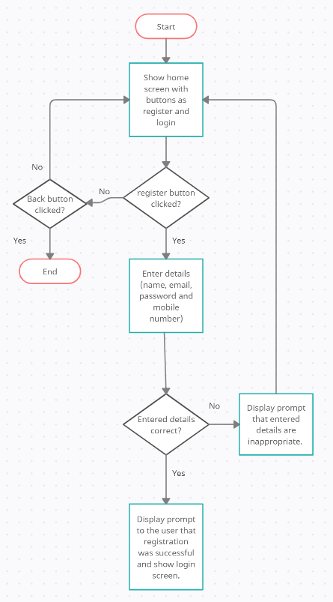

**Flow graph:**

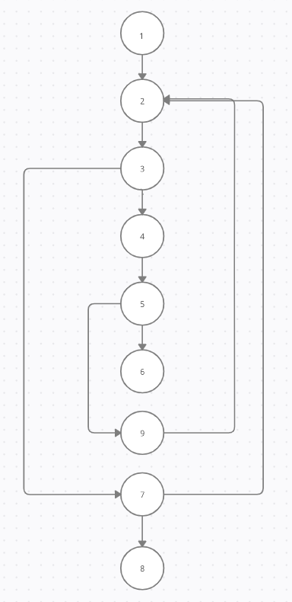

**Cyclomatic complexity:**

**No. of edges (E): 11**

**No. of nodes (N): 9**

**No. of predicate nodes (P): 3(3, 5, 7)**

**V(G) = E – N + 2 = 11 – 9 + 2 = 4**

**V(G) = P + 1 = 3 + 1 = 4**

**Therefore the cyclomatic complexity of graph is 4.**

**Test cases:**

|  |  |  |
| --- | --- | --- |
| **Input value** | **Expected output** | **Actual output (Determined only after implementation)** |
| Registration details entered are valid. | Display registration successful and display login page. | ------ |
| Registration details entered are invalid. | Display registration is unsuccessful and display register page again. | ------ |

**Login module:**

**Functional specification:** After registration users must login to use the different functionalities provided by the system. Here details like email id and password will be asked and if both are entered correctly then only the user will be logged in.

**Algorithm:**

**Step 1:** Show Splash Screen having two options either to login or register.(Or back to close the app)

**Step 2:** Choose Login option

**Step 3:** Enter User Credentials (Email and Password)

**Step 4:** Give feedback of successful login and redirect to Main Page if credentials entered are correct else goto step 1.

**Step 5:** End.

**Flow chart:**

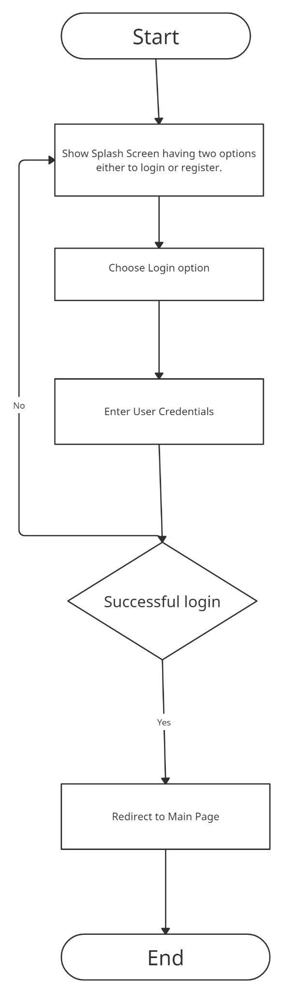

**Flow graph:**

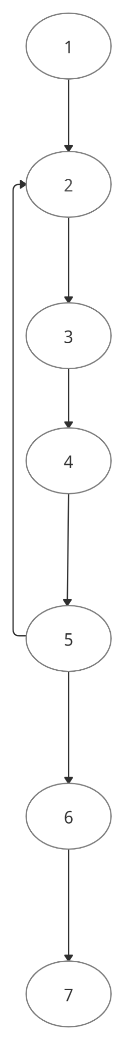

**Cyclomatic complexity:**

**No. of edges (E): 7**

**No. of nodes (N): 7**

**No. of predicate nodes (P): 1(5)**

**V(G) = E - N + 2 = 7 – 7 + 2 = 2**

**V(G) = P + 1 = 1 + 1 = 2**

**Therefore the cyclomatic complexity of graph is 2.**

**Test cases:**

|  |  |  |
| --- | --- | --- |
| **Input value** | **Expected output** | **Actual output (Determined only after implementation)** |
| Login credentials entered are invalid. | Display login unsuccessful and show login page again. | ------ |
| Login credentials entered are valid. | Display login successful and show home page. | ------ |

**Teacher module:**

**Functional specification:** From our system teachers will get various options like scheduling a lecture, view timetable etc.. In the timetable section teachers will be able to view the timetable of the class for reference. Teacher will be able to upload notes and assignments

**Algorithm**

Step 1: Teacher will upload notes and assignments of desired subject and time

Step 2: If uploaded documents are visible to teacher else go to step 1

Step 3: The teacher will now select the category of students for the notes. If category is not selected then a prompt will be shown to the teacher for the same.

Step 4: If the above step is successful then notes will be visible to students.

Step 5: If the above step is unsuccessful go to step 4.

Step 6: End

**Flow chart:**

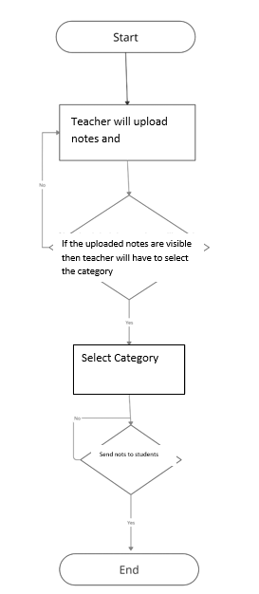

**Flow graph:**

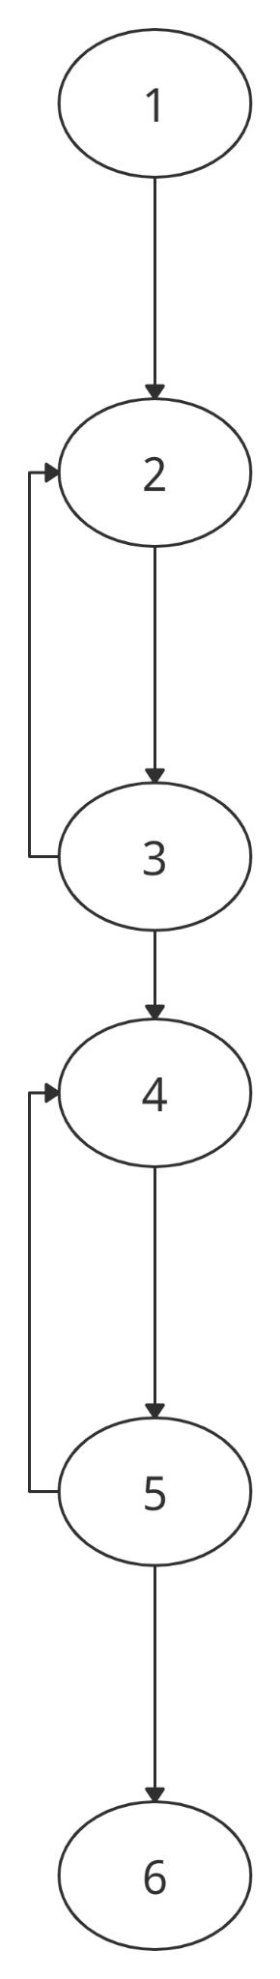

**Cyclomatic complexity:**

**No. of edges (E): 7**

**No. of nodes (N): 6**

**No. of predicate nodes (P): 2(3,5)**

**V(G) = E - N + 2 = 7 – 6 + 2 = 3**

**V(G) = P + 1 = 2 + 1 = 3**

**Therefore the cyclomatic complexity of graph is 3.**

**Test cases:**

|  |  |  |
| --- | --- | --- |
| **Input value** | **Expected output** | **Actual output**  **(Determined only after implementation)** |
| Details entered about the Notes are invalid. | Display failed to uploadand show home page. | ------ |
| Details entered about the lecture are valid. | Notes and videos uploaded successfully | ------ |

**Student module:**

**Functional specification:** After the student has registered and logged into the system there are a few options that the student will have. Firstly a student can view an upcoming lecture i.e see the next lecture scheduled for the day. The student can also view the notes and the lecture videos. He/ she should also be able to view the assignments

**Flow chart:**

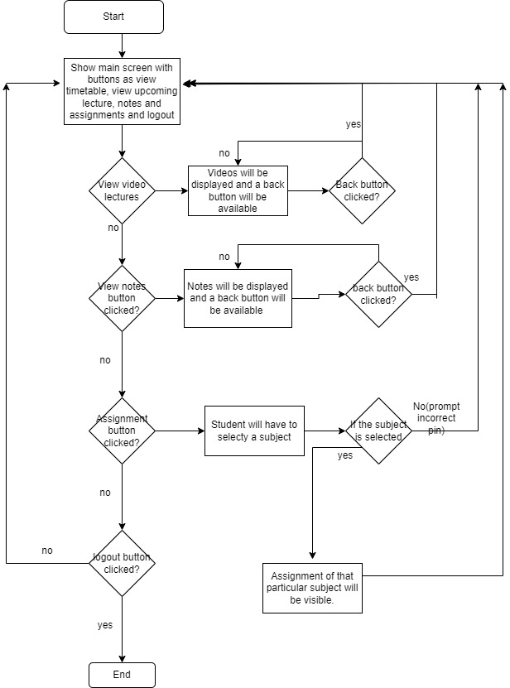

**Flow graph:**

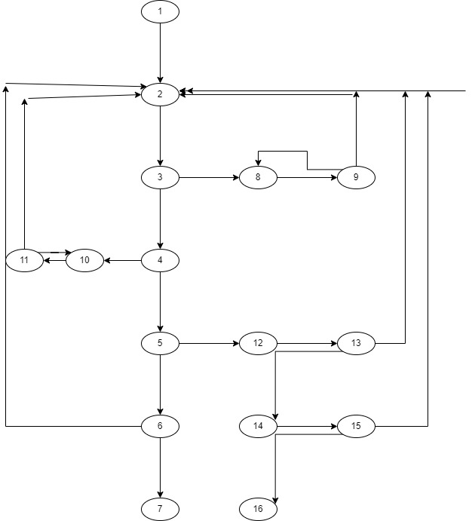

**Cyclomatic complexity:**

**No. of edges (E): 24**

**No. of nodes (N): 16**

**No. of predicate nodes (P): 9(3, 4, 6, 11, 9, 13, 15, 17, 5)**

**V(G) = E - N + 2 = 24 – 16 + 2 = 10**

**V(G) = P + 1 = 9 + 1 = 10**

**Therefore the cyclomatic complexity of graph is 10.**

**Test cases:**

|  |  |  |
| --- | --- | --- |
| **Input value** | **Expected output** | **Actual output**  **(Determined only after implementation)** |
| View videos button is clicked by the student. | Timetable should be shown to the student. | ------ |
| View videos button clicked but timetable not visible. | Display error message showing there is some server error and after some time show home screen. | ------ |
| View lecture button is clicked by the student. | lecture should be shown. | ------ |
| View lecture button is clicked button details are not visible. | Display error message showing there is some server error and after some time show home screen. | ------ |

**Conclusion: Understood the importance of testing phase in software development. Understood the concept of white box testing. Prepared a test case document using white box technique and also calculated cyclomatic complexity of each module.**

**Post Lab Subjective Questions**

1. **State the applications of White Box Techniques?**

**ANS)s**

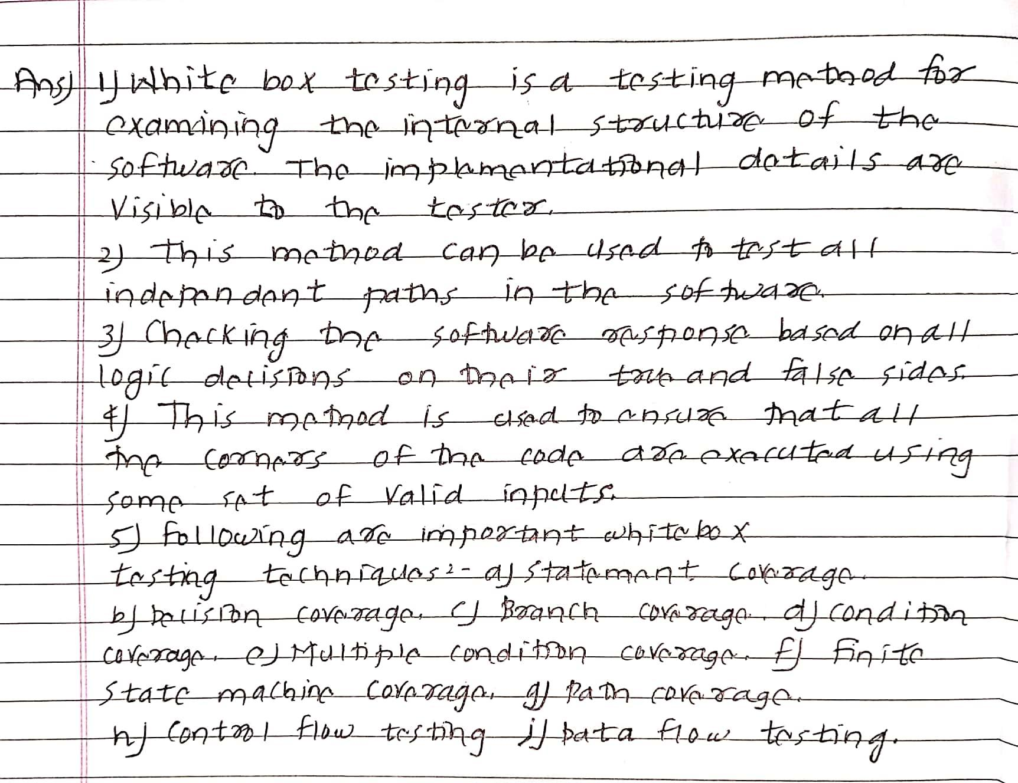

**Post Lab Descriptive Questions**

1. State various Scheduling principles and explain them in detail.

ANS)

