**Batch: A1**

**Roll No.: 1911004**

**Experiment / assignment / tutorial No. 3**

**Grade: AA / AB / BB / BC / CC / CD /DD**

**Signature of the Staff In-charge with date**

|  |
| --- |
| **Title:** Implementation of Goal based agent architecture using PROLOG. |

**______________________________________________________________________ Objective:** To use the concepts of knowledge engineering to design and solve moderate complex problem.

**______________________________________________________________________**

**Expected Outcome of Experiment:**

|  |  |
| --- | --- |
| **Course Outcome** | **After successful completion of the course students should be able to** |
| **CO1** | Understand the history & various application of AI and choose appropriate agent architecture to solve the given problem. |

**______________________________________________________________________**

**Books/ Journals/ Websites referred:**

1. **https://www.csupomona.edu/~jrfisher/www/prolog_tutorial/contents.html**
2. **http://www.csupomona.edu/~jrfisher/www/prolog_tutorial/pt_framer.html**
3. **http://www.doc.gold.ac.uk/~mas02gw/prolog_tutorial/prologpages/**
4. **http://classes.soe.ucsc.edu/cmps112/Spring3/languages/prolog/PrologIntro.pdf**
5. **“Prolog: Programming for Artificial Intelligence” by Ivan Bratko, Pearson education Publications**
6. **“Artificial Intelligence: a Modern Approach” by Russel and Norving, Pearson education Publications**
7. **“Artificial Intelligence” By Rich and knight, Tata Mcgraw Hill Publications**

**______________________________________________________________________**

**Pre Lab/ Prior Concepts:**

Agents, Agent Architecture, Programming with PROLOG

**______________________________________________________________________**

**Historical Profile:**

Knowledge is vast, uncertain and continuously changing. These properties of knowledge make it difficult to arrive at a result. A murder mystery is a kind of situation which depicts the uncertain nature of knowledge and also emphasizes the need of choosing right clauses from entire knowledgebase to make a decision. He goal based agent architecture and some knowledge engineering can help in solutioning of such problems.

The logical agents are complex but they can reason and learn from the actions and new precepts. They are less like acting and think like humans but more like acting and thinking rational agents.

Knowledge and reasoning play a crucial role in dealing with partially observable environments. A knowledge based agent can combine the general knowledge with current percept to infer the hidden aspects of the current state prior to selecting actions.

**_____________________________________________________________________**

**New Concepts to be learned:**

Knowledge engineering, implementing complex agent architecture, uncertainty in knowledge.

**_____________________________________________________________________**

**The Knowledge Engineering Process**

1. Identify the task
2. Assemble the relevant knowledge
3. Decide on vocabulary of predicates, functions and constants
4. Encode general knowledge about the domain
5. Encode description of specific problem instance
6. Pose queries to the inference procedure and get answers
7. Debug the knowledge base

**Algorithm for KB-Agent:**

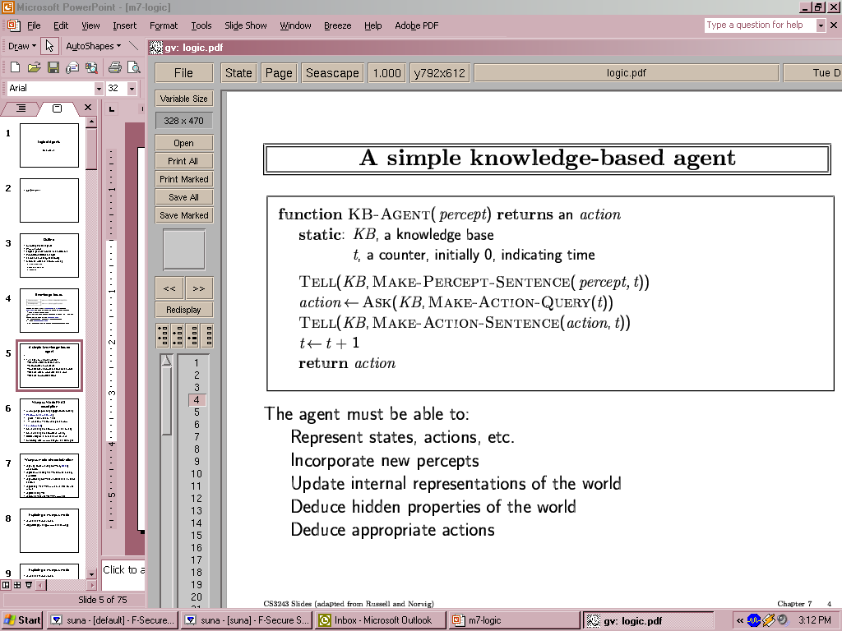

**Problem Statement: Kaahaani**

Murders including the murder of Anmol (a local business shopkeeper), Bhatt (a company worker), Shila(a designer) and Devan(a serviceman) have been committed. A serial killer is said to be behind these killings as the victims are not related to each other in any way. The killings are said to be proceeding in an alphabetical manner but have stopped after the murder of Devan.  
Suspect include : Vidya, Bob, Anges, Sridha, Rana, Khan. Some weapons obtained are poison, knife, pistol, rope, pillow, pistol. Their locations: home, office, unknown, mall, unknown, bar.  
Thus their motives are analysed.  
Task is to find the murderer and uncover the mystery behind the murder of all these people by following the sets of clues at every step of this journey.  
Khan has no relation to any of the victims but three victims sold their gold at his shop.  
It is found that the killer has used multiple crimes to cover up one crime as the crimes stopped after the fourth murder. The weapon used was a pistol.  
The weapon has been analysed and it doesn't belong to Khan.  
It was later found out that Shila had been getting murder threats since a long time & so she was the prime victim.

**Knowledge Engineering steps applied to chosen problem:**

female(vidya).  
female(anges).  
female(sridha).  
  
male(bob).  
male(rana).  
male(khan).  
  
rl(vidya, bhatt, wife).  
rl(bob, bhatt, co-worker).  
rl(anges, shila, sister).  
rl(sridha, anmol, wife).  
rl(rana, shila, brother).  
  
relation_of(X, Y, Z):-  rl(X, Y, Z).  
  
clue1:-  
write(' khan has no relation to any of the victims but three victims sold their gold at his shop.').  
motive(vidya, affair).  
motive(anges, money).  
motive(sridha, jealousy).  
motive(bob, profit).  
motive(rana, money).  
motive(khan, insanity).  
  
find_motive:-  
write('Whose motive do you wish to know'),nl,  
read(Input), motive(Input, Output),  
write('The possible motive of '), write(Input),  
write(' is '), write(Output), write(' . ').  
  
weapons(vidya, poison).  
weapons(anges, pistol).  
weapons(sridha, rope).  
weapons(bob, knife).  
weapons(rana, pillow).  
weapons(khan, pistol).  
  
weapons_assoc:-  
read(Input), weapons(Input, Output),  
write(Input), write(' can have access to '),  
write(Output),write('.').  
  
clue2:-  
write('It is found that the killer has used multiple crimes to cover up one crime as the crimes stopped after the fourth murder. The weapon used was a pistol.').  
  
suspect(X):- weapons(X, pistol), motive(X,Y).  
  
who_suspect:-suspect(X),  
write('Suspect is '), write(X), write(' because he/she had the weapon pistol and motive was '), write(Y).  
  
clue3:-  
write('The weapon has been analysed and it doesnt belong to khan.').  
seen(vidya, home).  
seen(sridha, mall).  
seen(bob, office).  
seen(anges, unknown).  
seen(rana, unknown).  
seen(khan, bar).  
  
was_seen:-  
read(Input), seen(Input, Output),  
write(Input), write('s location: '), write(Output).  
clue4:-  
write('It was later found out that Shila had been getting murder threats since a long time & so she was the prime victim.').  
  
murderer(X):-  
seen(X, unknown),  
suspect(X),  
rl(X,shila,Y).

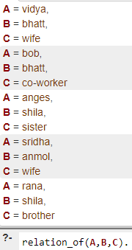 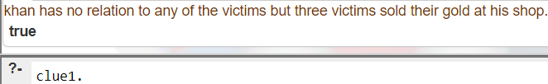 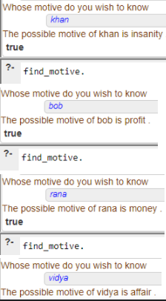

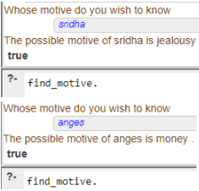

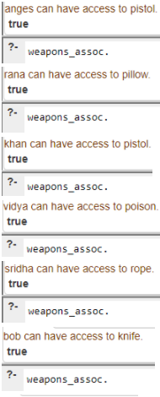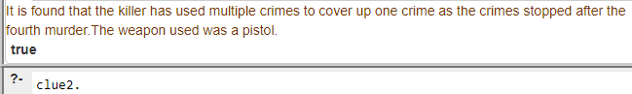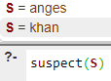

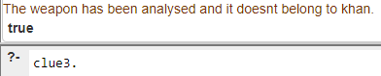

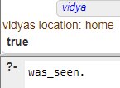 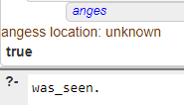 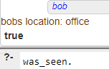

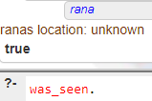 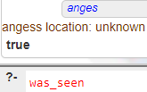 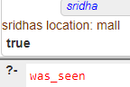

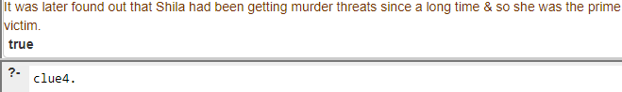

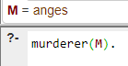

Thus, from the prolog program we can see that Anges is Shila's sister; she had access to the pistol & her location was unknown during crime scene.

Relating all, the prime victim was Shila, Anges was related to Shila, was found guilty according to the murder mystery and her main motive was greed for money.

Therefore, through prolog we justify the murderer to be Anges.

**Agent Architecture** *(Justify the blocks)***:**

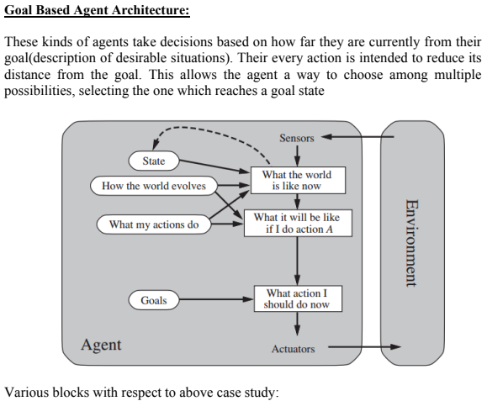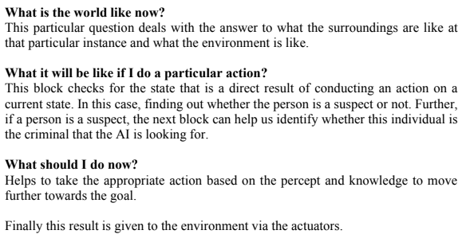

**Post Lab Objective Questions**

**1. Which is not a Goal-based agent?**

1. Inference
2. Search
3. Planning
4. Conclusion
5. Dynamic search.

**Answer: ` d. Conclusion**

**2. Which were built in such a way that humans had to supply the inputs and  
interpret the outputs?**

1. Agents
2. Sensor
3. AI System
4. Actuators

**Answer: d. Actuators**

**Post Lab Subjective Questions**

**Explain the role of PEAS and task environment in choosing the agent architecture. Justify your answer with an example.**

**Ans:-**

PEAS stands for Performance measure, Environment, Actuators and Sensors. In designing an agent, the first step must always be to specify the task environment as fully as possible.

The task environment helps us answer whether the environment is:

- Discrete / Continuous − If there are a limited number of distinct, clearly defined, states of the environment, the environment is discrete (For example, chess); otherwise it is continuous (For example, driving).

- Observable / Partially Observable − If it is possible to determine the complete state of the environment at each time point from the percepts it is observable; otherwise it is only partially observable.

- Static / Dynamic − If the environment does not change while an agent is acting, then it is static; otherwise it is dynamic.

- Single agent / Multiple agents − The environment may contain other agents which may be of the same or different kind as that of the agent.

- Accessible / Inaccessible − If the agent’s sensory apparatus can have access to the complete state of the environment, then the environment is accessible to that agent.

- Deterministic / Non- deterministic − If the next state of the environment is completely determined by the current state and the actions of the agent, then the environment is deterministic; otherwise it is non- deterministic.

- Episodic / Non- episodic − In an episodic environment, each episode consists of the agent perceiving and then acting. The quality of its action depends just on the episode itself. Subsequent episodes do not depend on the actions in the previous episodes. Episodic environments are much simpler because the agent does not need to think ahead.

- Once the environment has been fully understood, the appropriate agent architecture can be chosen based on the characteristics of the environment.

Eg:

1) In case of a Chess playing bot, the environment is fully observable, with multiple agents (pieces). It is deterministic and discrete since every move is atomic and only one move can be made at a time. Therefore, Goal Based architecture is the most appropriate for the Chess Bot, since all actions will be dynamic (based on the opponent’s moves) but the goal will remain the same throughout, that is, to checkmate the opponent.

2) Let’s take an example of autonomous Mars rover. Since the rover is autonomous, this implies that the rover moves on its own, taking all necessary decisions by itself, without any human interference, which is anyways impossible as of now on Martian surface. The PEAS description for this agent would be as follows: Performance: The terrain explored and reported, speed of the rover, samples gathered and analyzed.

Environment: Launch vehicle, lander, Mars.

Actuators: Wheels/legs, sample collection device, analysis devices, radiotransmitter.

Sensors: Camera, touch sensors, accelerometers, orientation sensors, wheel/joint encoders, radio receiver.