**Batch: A1**

**Roll No.: 1911001, 1911003, 1911004**

**Chapter 02**

**Group No: 1**

|  |
| --- |
| **Title: Design Document for MiniProject.** |

**______________________________________________________________________Objective:** **Apply the heuristics principles of User Interface Design.**

**______________________________________________________________________**

**Expected Outcome of Experiment:**

**_________________________________________________________________**

**Books/ Journals/ Websites referred:**

**1. https://www.nngroup.com/articles/ten-usability-heuristics/**

**2. https://uxdesign.cc/10-usability-heuristics-for-ui-design-c60c10e795aa**

**3. https://www.interaction-design.org/literature/topics/design-guidelines**

**______________________________________________________________________**

**Introduction:**

As the process of development of a project progresses, the second stage will be analysis & the design.

In this document, two levels of designs are expected to be prepared:

1. Frontend interface
2. Backend/ database design

**Frontend design:**

In this part of the document, the number of screens, their navigation etc. are to be prepared. The screens and navigation should comply the UI principles, not limited to but, such as; accessibility, use of colors, consistency etc.

So, we have a front page that introduces the users to our application and can help them make use of all the services available. They can get to know about the team as well as other features.

From this page, they can login to their respective accounts, from which user can add various image from gallery thus use app according to need.

Nav Bar helps them to avail all these features faster.

All the things visible on the app are easy to understand which makes it user friendly as well.

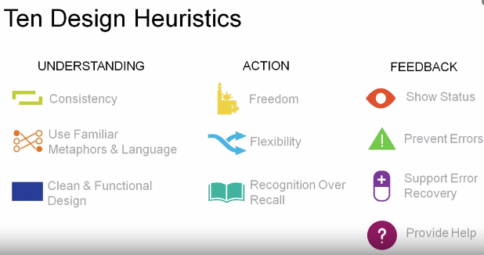

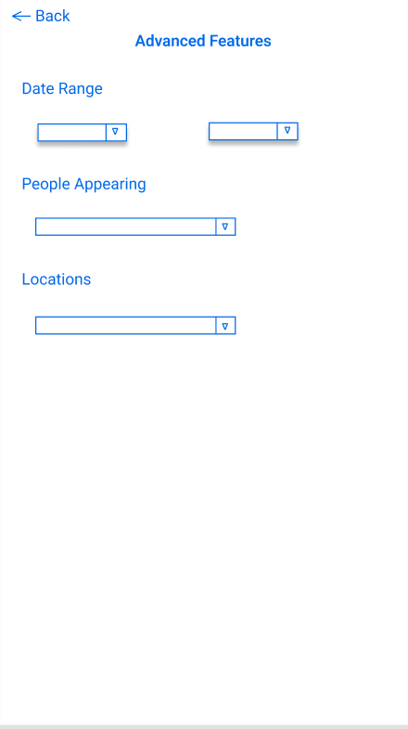

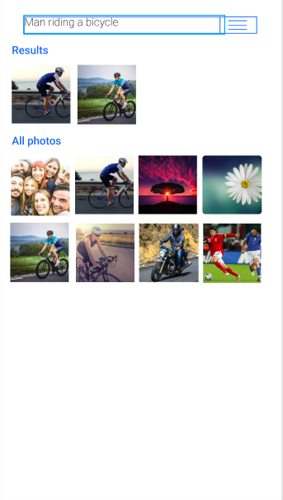



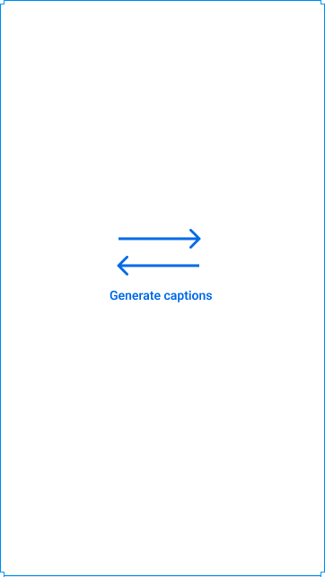

**Activity:**

# [10 Heuristic Principles – Jakob Nielsen’s (Usability Heuristics)](https://www.uxness.in/2015/02/10-heuristic-principles-jakob-nielsens.html)

## 1. Visibility of system status

The system should always keep users informed about current state and actions through appropriate visual cues and feedback within reasonable time.

Our website allows users to directly go on to the login page which allows them to know the process to get to the system and not be bothered by any other information that they may not need at the moment. They can start with their work instantly.

## 2. Match between system and the real world

The system should speak the users' language, with words, phrases and concepts familiar to the user, rather than system-oriented terms. Follow real-world conventions, making information appear in a natural and logical order.

The entire manner in which we have designed our website is to make things readily available to them, in a language that they understand.

## 3. User control and freedom

Users often choose system functions by mistake and will need a clearly marked "emergency exit" to leave the unwanted state without having to go through an extended dialogue. Support undo and redo.

We have a feature that allows them to go back to the previous section if they reach somewhere else, as well as they can start from again or where they left, without having to go through a complete new procedure each time they make a mistake.

## 4. Error prevention

Even better than good error messages is a careful design which prevents a problem from occurring in the first place. Either eliminate error-prone conditions or check for them and present users with a confirmation option before they commit to the action.

We have specifications for all the features that the users might use so that there is no confusion and they don’t commit any mistakes. For this reason, we have separate sections for as no error take place.

## 5. Help users recognize, diagnose, and recover from errors

Error messages should be expressed in plain language (no codes), precisely indicate the problem, and constructively suggest a solution.

If there is an error while using app or wrong caption generated, a feedback message regarding the same will be generated. Test cases implemented will check for all these conditions too.

## 6. Consistency and standards

Users should not have to wonder whether different words, situations, or actions mean the same thing. Follow platform conventions.

Specific and straight forward way of communicating with the users is used so that it comes across as the same thing for all the users, including different user and even while using the system. There is uniformity throughout.

## 7. Recognition rather than recall

Minimize the user's memory load by making objects, actions, and options visible. The user should not have to remember information from one part of the dialogue to another. Instructions for use of the system should be visible or easily retrievable whenever appropriate.

Users can directly access the nav bar. This is available to them across the complete app, hence there is no need for them to remember from where to login or from where to check records or any other task whatsoever.

## 8. Flexibility and efficiency of use

Accelerators --unseen by the novice user --may often speed up the interaction for the expert user such that the system can cater to both inexperienced and experienced users. Allow users to tailor frequent actions.

A button right at the center that directly leads to the login page is implemented, which allows everyday users, to proceed with using the app and thus accelerate their process.

## 9. Aesthetic and minimalist design

Dialogues should not contain information which is irrelevant or rarely needed. Every extra unit of information in a dialogue competes with the relevant units of information and diminishes their relative visibility.

We have used minimum number of words or options to make things clear and to the point for our users. Even while logging in to their account, users have to give in minimum knowledge and then they can proceed to take use app

## 10. Help and Documentation

Even though it is better if the system can be used without documentation, it may be necessary to provide help and documentation. Any such information should be easy to search, focused on the user's task, list concrete steps to be carried out, and not be too large.

An About section where users can get to know everything about us will be included.

**Backend Design:**

In this section, the various module/ components, their interaction, database structure is to be described. The algorithms used must be mentioned with justification.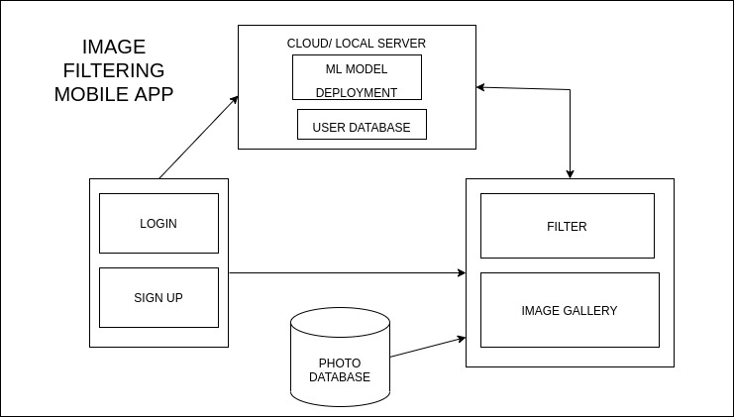

The user will be asked to Login/ Sign up before using the app. The login details and the last time the user has synced the app are a part of user database which will be stored on the cloud. The ML model for generating captions will also be deployed on the cloud.

This app will request access to the photo gallery app of the user’s phone. The stored images will be passed through the ML model on the cloud and the corresponding captions will be stored in the user’s device.

When the user enters a query for searching an image in the database, the images corresponding to the caption(s) closely matching the query will be retrieved for the user.

**Architecture**

This section should describe the architecture necessary to achieve the system design for the project. This will usually consist of both hardware and software architecture. Additionally, it may be that the existing architecture (either hardware or software) is already in place, in which case the requirements should still be documented. The description of the architecture should include a list and summary of each component and, depending on the complexity of the design, it may be beneficial to include diagrams showing the relationship/connectivity between these components.  
**Architecture overview**

Give a general description of the system, from the point of view of the user:

* In what environment it works
* Who the users are
* What it is for,
* The main functions,
* The main interfaces, inputs and outputs.

If your software is integrated in a larger system, you may reference a document that describes this system.

**Conclusion:**

We successfully understood the concept of the Heuristics principles of UI Design

and implemented them in our applications.

**Post Lab Activities (with reference to your tool):**

1. What is the importance of user interfaces in application development?

Ans - Our application is image text retriever. UI is focus on the app’s look and interacts with the users. Each screen, page, buttons and other visual elements you see while using an application is the User Interface of that application.

The primary goal of any application is to keep user interact with backend through front-end only & increase its usage, sales and increase the growth of the business and user satisfaction while using the services. UX/UI Design plays an essential role in achieving this goal. The UX/UI Design of the application improves the user experience and customer satisfaction that ultimately helps increase the number of users of the our application. The UI and UX Design help to win the consumers’ confidence and make them use our application providing them what they are looking for.

The number of consumers you are getting on your website / application can measure the success of the great UI and UX.

We are using ML model to retrieve the information thus a layman/ user won't be interested/can't understand that and will need UI to interact with our ML model & backend.

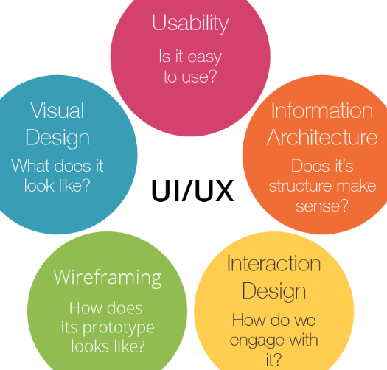

1. List and briefly mention about at least five tools for user interface design.

|  |  |
| --- | --- |
| Tool | Use |
| 1. Sketch | Being able to make universal changes — whether it's through their library of symbols, layer styles, or text styles, or its smooth resizing and alignment features — saves designers time to deliver consistent prototypes. |
| 1. Invision studio | Along with these easy-to-use UI design tools, they also make communication easy — with collaboration features that let developers share their work as they design it, receive feedback, and make documented changes at each step |
| 1. Adobe XD | [Adobe XD](https://www.adobe.com/products/xd.html?sdid=12B9F15S&mv=Search&ef_id=EAIaIQobChMI1vf__r6G5gIVUxitBh3SMgj0EAAYASAAEgJr3_D_BwE:G:s&s_kwcid=AL!3085!3!315233774139!e!!g!!adobe%20xd) offers vector-based user interface tools for creating prototypes and mockups with an interface that’s familiar to anyone who has used other Adobe products. |
| 1. Sigma | [Figma](https://www.figma.com/) lets designers build dynamic prototypes and mockups, test them for usability, and sync up all of the progress. Figma allows for a collaborative environment where multiple people can work on a project at the same time |
| 1. FrameX | [Framer X](https://www.framer.com/) has evolved from its early days as a code-only prototyping application. Today it offers a host of UI design tools for building functional prototypes and testing for usability. Its ability to work with [React](https://reactjs.org/) makes it ideal for UI designers who like to stay on top of the newest web design innovations |

1. What is heuristic evaluation of user interfaces?

Ans- Heuristic evaluation is a usability engineering method for finding usability problems in a user interface design, thereby making them addressable and solvable as part of an iterative design process. It involves a small set of expert evaluators who examine the interface and assess its compliance with “heuristics,” or recognized usability principles. Such processes help prevent product failure post-release

1. Planning - It is a usability evaluation technique, you should have a clear objective of what you are hoping to achieve with your evaluation. In other words, we need to set our goals prior to any inspections. We should understand what exactly needs to be evaluated and make sure that the faculty who are involved are briefed accordingly.

2. Executing- Once our goals are clear, we target demographic and a set of heuristics defined and a team of evaluators ready, we can move on to the execution phase. The evaluators will go through our product’s flows and respective interfaces independently.

3. Reviewing- After the evaluations have been completed, we should summarize our findings to eliminate duplicates and create a list of usability issues that should be addressed. These issues should also be prioritized in terms of severity and use the different severity ratings that can be used to prioritize usability problems.

1. How the user interface of a mobile-based application is different from web-based applications? Mention at least five points of difference.

|  |  |
| --- | --- |
| Mobile based UI Application | Web based UI Application |
| Needs to be more compact | Need not be as compact |
| May need to develop in both landscape and portrait mode | Need to develop in only one mode |
| Need not be responsive | Needs to be responsive |
| Mobiles have slower processors, thus a simple layout of the app is more essential | Computers have faster processors, can have relatively complex layout |
| Details should be minimised as the user may be on the go when accessing their mobile | More functionalities can be added as the user is usually comfortably seated when accessing a website via a desktop |