

**Experiment: 2**

**Title:** Simulation of Multi Server System: Able – Baker Carhop Problem.

**Problem Statement:** Consider a drive in restaurant where carhops take order and bring food to the cars. Cars arrive in manner as shown:

| Time between  Arrival(minutes) | 1 | 2 | 3 | 4 |
| --- | --- | --- | --- | --- |
| Probability | 0.25 | 0.4 | 0.2 | 0.15 |

There are 2 carhops Able & Baker. Able is better to do the job and works a bit faster than Baker. Their service distribution is as follows:

| Service  Time(minutes) | 2 | 3 | 4 | 5 |
| --- | --- | --- | --- | --- |
| Probability | 0.3 | 0.28 | 0.25 | 0.17 |

Service Distribution time of Baker:

| Service  time(minutes) | 3 | 4 | 5 | 6 |
| --- | --- | --- | --- | --- |
| Probability | 0.35 | 0.25 | 0.2 | 0.2 |

Able gets the customer if both carhops are idle. The problem is to find how well the current arrangement is working.

**Expected Outcome of Experiment:**

| **Index** | **Outcome** |
| --- | --- |
| CO1 | Understand the concepts of discrete event simulation and its importance in business, science, engineering, industry and other services. |
| CO2 | Ability to analyse and apply general principles of event scheduling algorithms & various statistical methods on different applications. |

**Books/ Journals/ Websites referred:**

1. Jerry Banks, John Carson, Barry Nelson, and David M. Nicol, “Discrete Event System Simulation”; Fifth Edition, Prentice-Hall.

2. Averill M Law, “System Modeling & Analysis”; 4th Edition TMH.

3. Banks C M, Sokolowski J A, “Principles of Modeling and Simulation”, Wiley

**Pre Lab/ Prior Concepts:**

**Theory:**

**Conceptual Model:**

1. Discrete event model of system used for multichannel queuing. E.g. of Able & baker problem.
2. This problem is simulated using an event scheduling simulation.
3. A simulation table is used to record the excessive system snapshot as time proceeds.
4. The simulation requires mainly an activity table representing a service time distribution of able & baker & inters arrival of customers.
5. Activity duration is specified by a modeller.

**Characteristics of System:**

I) Calling Population: Infinite in nature.

II) System capacity: Infinite.

III) Nature of Arrival: Random arrival nature.

IV) Service Mechanism: At a time maximum two customers can be served one by Able & other by Baker. If able & baker both are busy, the customer has to wait. If both servers are free, priority goes to Able.

V) Queuing Discipline: Customers are chosen in FIFO manners.

**System State:**

System state for Able or Baker indicating Able being Idle or Busy at given instant.

**Entities:**

Neither the customers nor the server needs to be explicitly represented except in terms of state variable unless customer averages are desired.

**Events:**

1. Arrival Event
2. Service Completion by Able
3. Service completion by Baker.

**Delay:**

A customer waits in queue until Able or Baker becomes free.

**Use of Random Numbers:**

I. To generate random nos. in simulation packages, RAND ( ) of function is used.

II. In Able & Baker problem random nos. are used for arranging inter arrival timer & service required for customers.

**Real time example:**

I. Public Telephone Booth with Two Telephones

II. Customers are chosen in FIFO manner.

**Result: (Performance Measures):**

Average Waiting Time = (Total time customers wait in queue) / (Total no. of Customers)

Prob. of Customers waiting = (No. of Customers who waits) / (Total no. of Customers)

Prob. of Idle Server = (Total Idle Time of Server) / (Total runtime of simulation)

Average Service Time = (Total Service Time) / (Total no. of Customers)

Average Time between Arrival = (Total Time between arrivals) / (No. of arrivals)

Average Waiting Time of Those Who Wait = (Total Time Customer waits in system) / (Total no. of Customers)

Average Time Customers Spends in System = (Total Time Customer spends in system) / (Total no. of Customers)

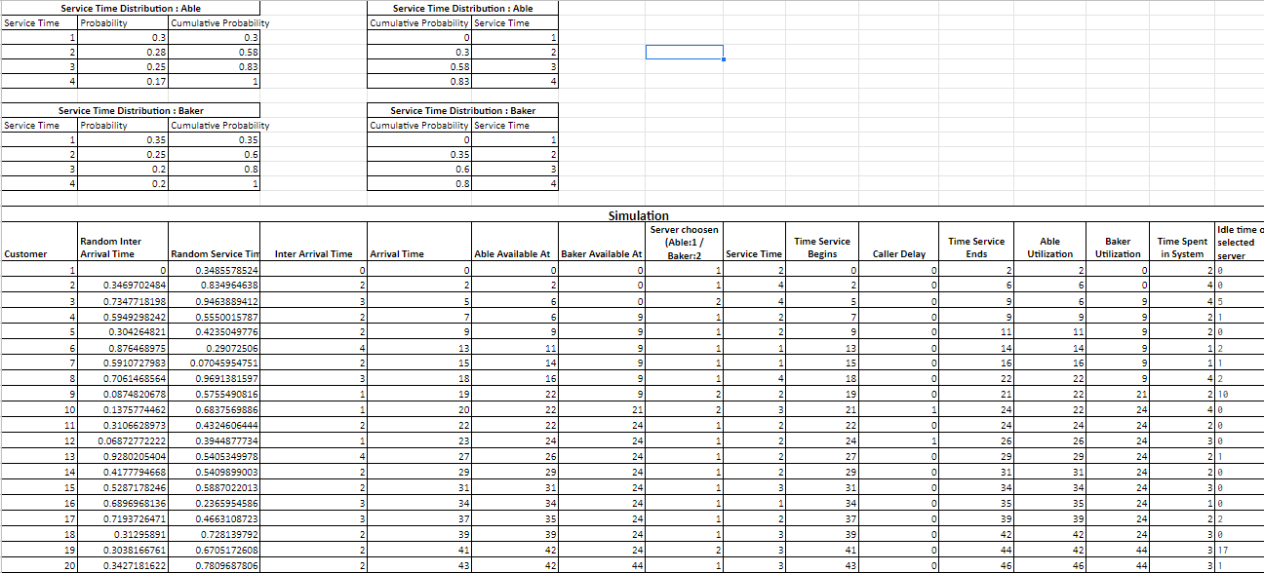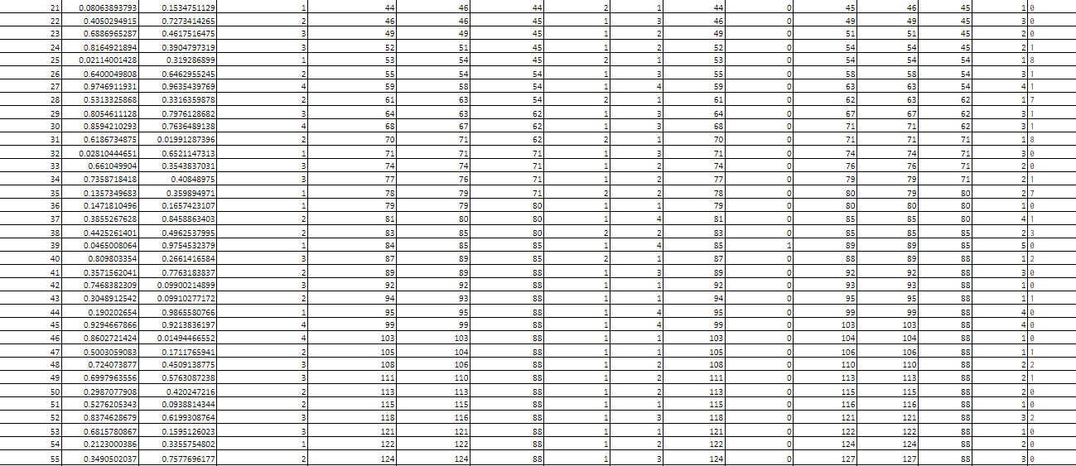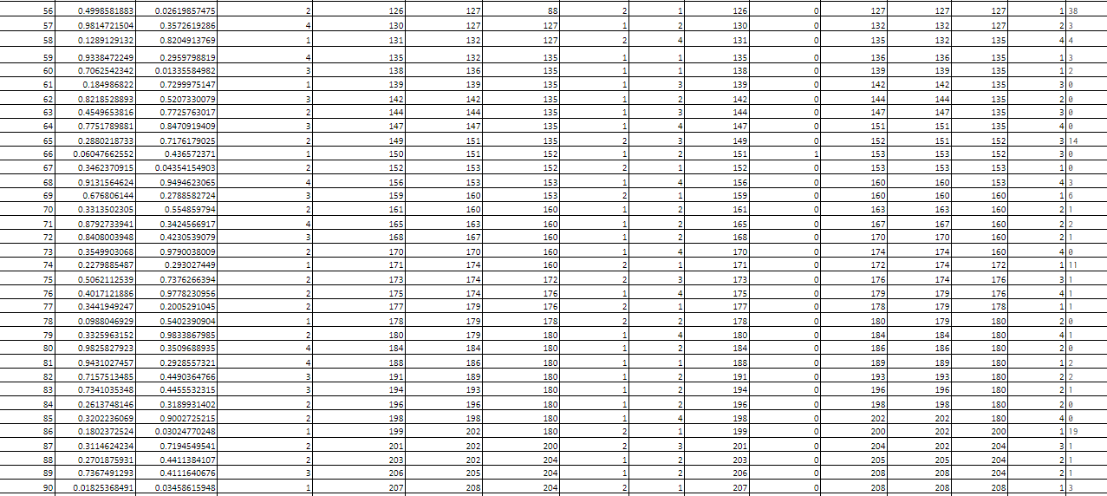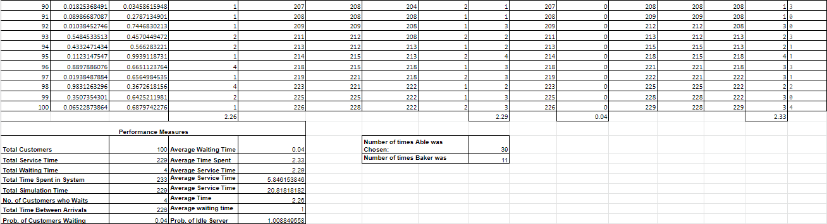

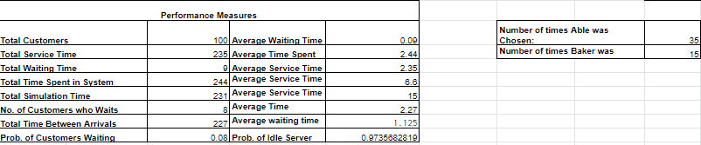

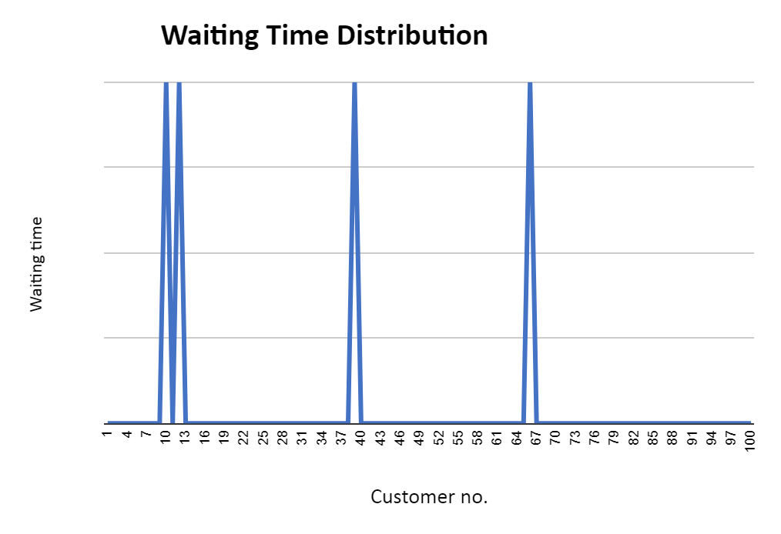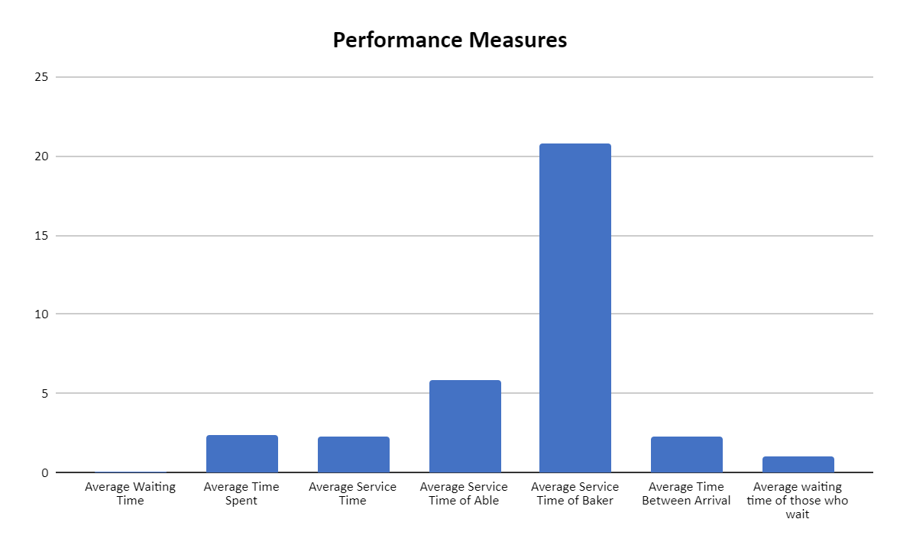

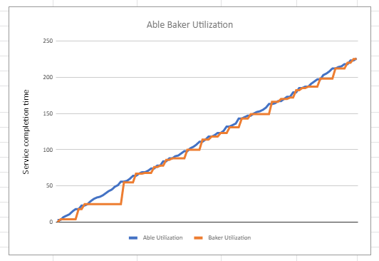

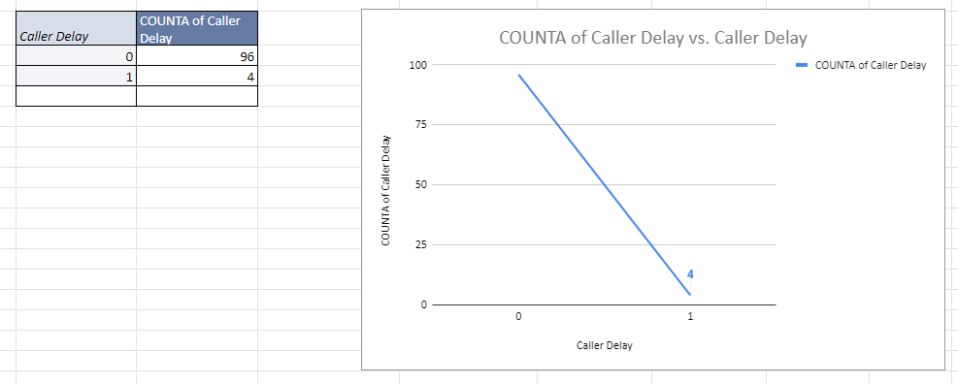

**Conclusion:** Thus, we successfully simulated for the Multi Server System – Able Baker Carhop Problem

**Post Lab Questions:**

Plot the frequency of caller delay & average caller delay for 30 trials.