

| **Title:**  Mini project: Creation of a simple application using any web development tools to demonstrate the working of blockchain |
| --- |

**Objective:** To Create and Demonstrate working of Blockchain using simple application.

**Expected Outcome of Experiment:**

| **CO** | **Outcome** |
| --- | --- |
| CO1 | Build your own Blockchain businesses with acquired knowledge. |
| CO2 | Learn Solidity language & Multiple Technology-based developments |
| CO3 | Apply the algorithm and techniques used in Blockchain |
| CO4 | Grasp the in-depth understanding of Blockchain, Smart Contracts & how it works |
| CO5 | Describe the methods of mining. |

**Books/ Journals/ Websites referred:**

1. [**HTML, CSS, JS official Docs**](https://developer.mozilla.org/en-US/docs)
2. [**https://jquery.com/**](https://jquery.com/)
3. [**https://trufflesuite.com/ganache/**](https://trufflesuite.com/ganache/)
4. [**https://web3js.org/**](https://web3js.org/)
5. [**https://soliditylang.org/**](https://soliditylang.org/)
6. [**https://www.mysql.com/**](https://www.mysql.com/)

**Abstract**:-

Blockchain is one of the most disruptive technologies to ever be invented is not an understatement. Integrating blockchain in any industry can enhance its proceedings, and the article will talk about the Supply Chain Management circle. The sector has come a long way in a few years and nowadays, it can garner a global reach. But its international expansion has brought several complications as well. Since consumer expectations and patterns change frequently, industries need to integrate solutions like blockchain to flourish in the coming time. Blockchain can offer the supply chain management market abilities like origin tracking and transparency to keep it relevant. This article will talk about how blockchain can bring such changes and what will be its role in Supply Chain Management.

SCM (Supply Chain Management) is the approach to managing the flow of resources, goods, information, and services throughout the procedure of converting raw inputs into complete outputs for end consumers. The entire procedure holds seven crucial elements, namely: Information, Source, Planning, Production, Inventory, Goods Return, and Transportation. The components are used to build the fundamental structure of an organization. Since the components act as the industry’s future, it packs a pivotal punch in the domain. The only issues that surround the industry are fluctuating consumer needs and security concerns; the standard supply chain is facing difficulties to sustain its relevance. Both problems are significant but can be solved with the help of blockchain technology.

**Related Theory: -**

Today’s supply chains are global networks that generally include manufacturers, suppliers, logistics companies, and retailers that work together to deliver products to consumers. As modern supply chains continue to expand, they also are becoming more complex and disparate. Typically, traditional supply chains use paper based and disjointed data systems that lead to information silos and make tracking products a time-consuming task. Lack of traceability and transparency is an industry-wide challenge that leads to delays, errors, and increased costs. Modern supply chain participants need a unified view of data, while still being able to independently and privately verify transactions such as production and transport updates.

Some of the prominent problems faced in Supply Chain Management are as follows,

* Lack of a Universal Database - Despite the global market being interconnected, most businesses do not share their database. This leads to communication barriers between firms, helping exploiters.
* Low Asset Traceability - Tracing assets is difficult in Supply Chain Management despite offering advanced processes and equipment. This leads to the exploiters replacing original products with counterfeits.
* Unnecessary Costs - As the data is kept confined within organizations, every firm spends funds on collecting the same data individually. This leads to an unnecessary rise in its capital and efforts.
* Long Assessments - Assessing an asset’s quality in the SCM process is difficult due to its lengthiness. Since there is no effective risk management system involved, the industry is faced with grim consequences.
* Unrequited Consumer Needs - Keeping up with the latest consumer needs is difficult, but taking viable measures to counter them is even tougher.

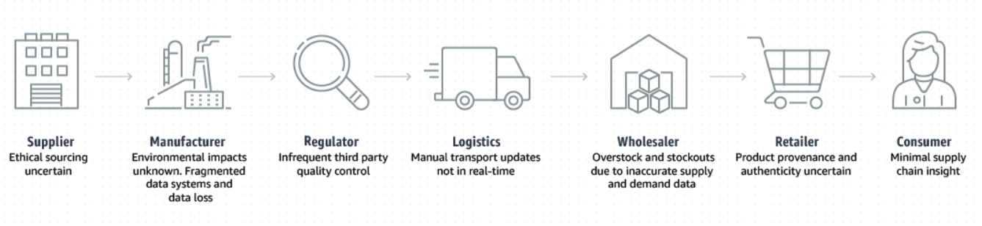

Blockchain in Supply-Chain:

* Live Tracking - A blockchain-based SCM system has been built to facilitate decentralization and transparency. It helps the business monitor every activity in real-time.
* Quick Processing - Although supply chains handle large and sophisticated databases, the process is overextended because of intermediaries. Smart Contracts have been prepared to eliminate their dependencies on paper.
* Better Traceability - Integrating blockchain in the supply chain has reduced counterfeit products’ supply in the market. With better traceability, such practices are reduced significantly.
* Healthy Consumer Relationships - Providing the needed product-related information is simple with blockchain, taking customer experience to a new level. Plus, it allows them to check the product’s genuineness.
* High ROI - With blockchain, businesses are establishing premium brand prestige, resulting in a higher return on investment.
* Enhanced Trading - Ownership and licensing evolve a bit with the help of blockchain. Since every organization possesses a similar ledger version, they can easily monitor the ownership records.

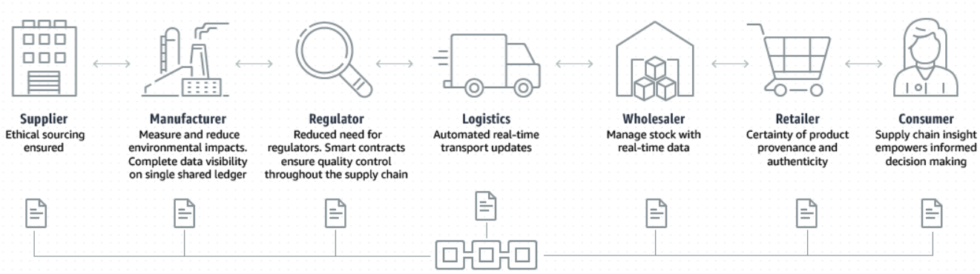

**Application s-chain:**

A Decentralized E2E Logistics Application which handles & stores the whereabouts of product in supply chain after manufacturing at every freight hub using the Blockchain & SQL. Consumers can enter & search or scan a product's QR code to get all the detailed info about that product which can be of importance and thus know more on the origin of the product. Thus, it guides consumers to only invest & buy in authentic and quality products.

Technologies used:

* HTML, CSS, JS, JQuery
* MySQL
* Web3.0 & Web3JS
* Solidity
* Ganache
* Ethereum Smart Contracts

Blockchain in Supply Chain is used by:

* Amazon
* Fedex
* Walmart
* Flipkart

**Implementation Details:**

**Code:**  <https://github.com/NidhiBhanushali3701/s-chain>

**Output:**

Signup

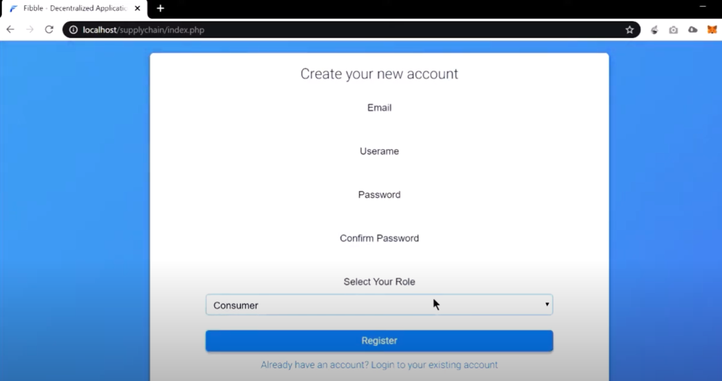

Login

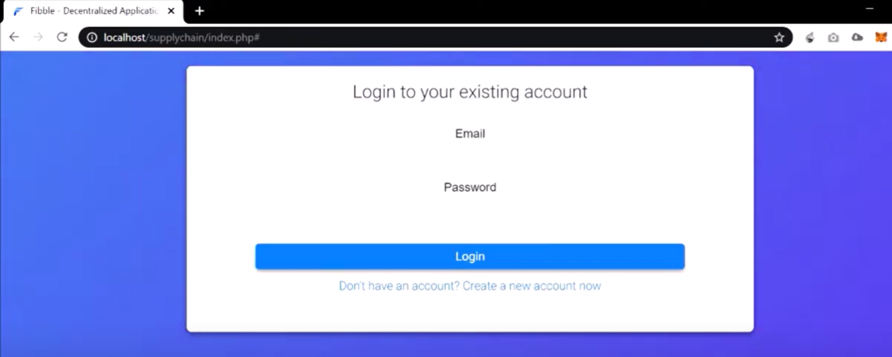

Ganache

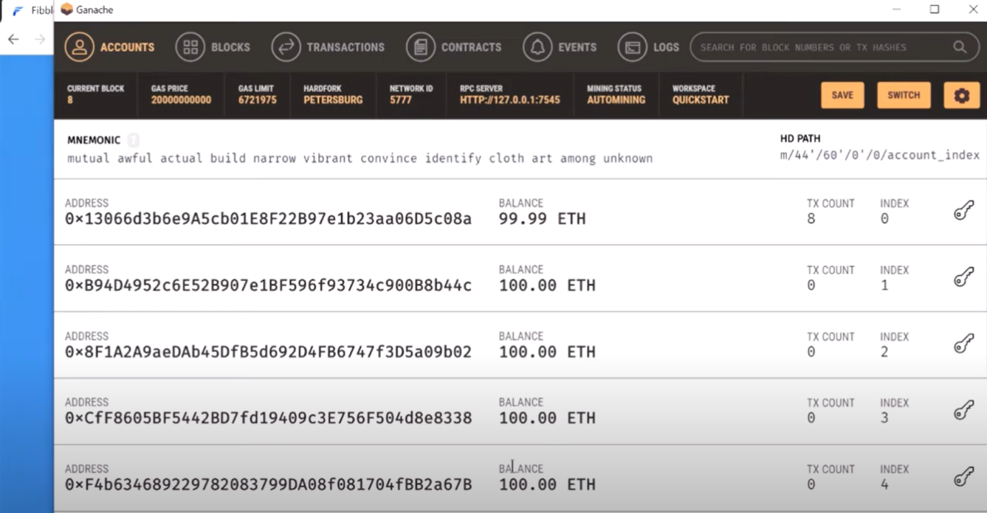

Login with customer email

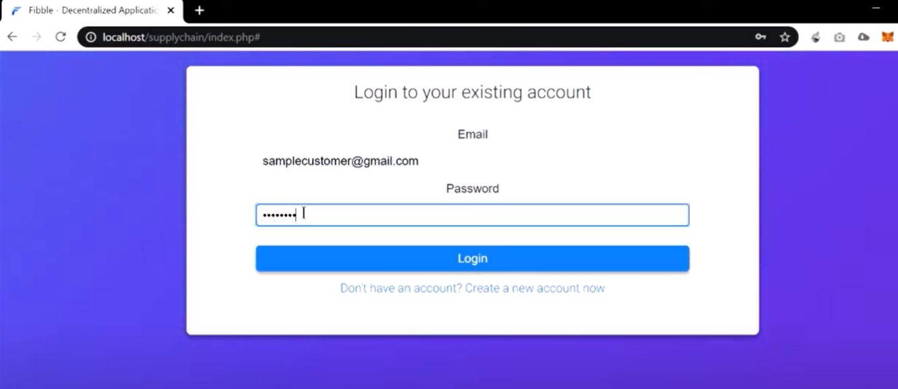Check product & it manufactued date & location in homepage

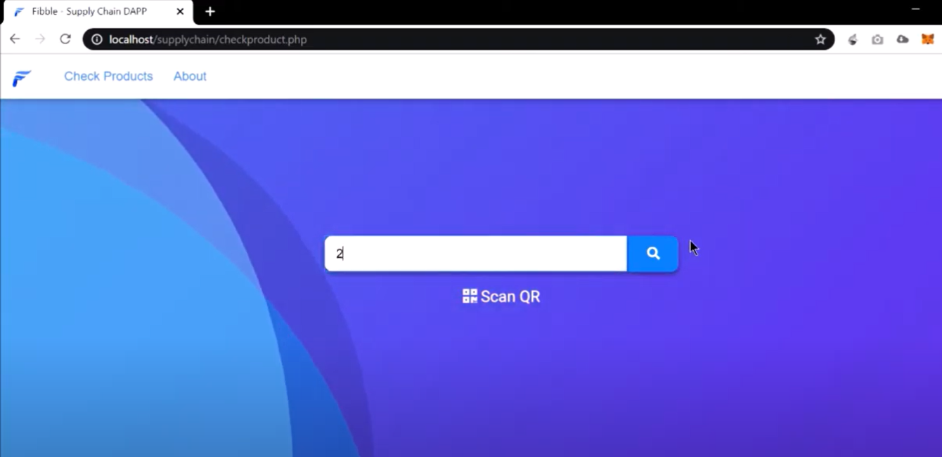

Check product & it manufactued date & location

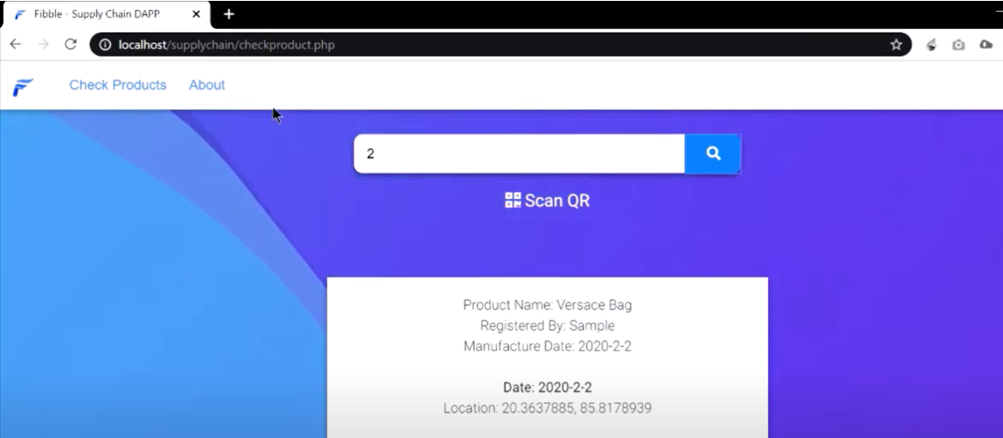

Login with manufacture email

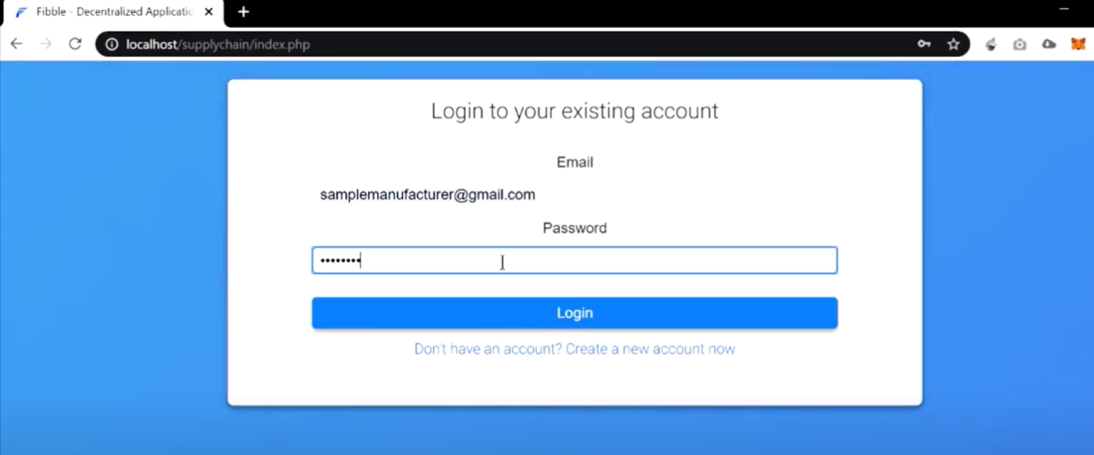

Homepage

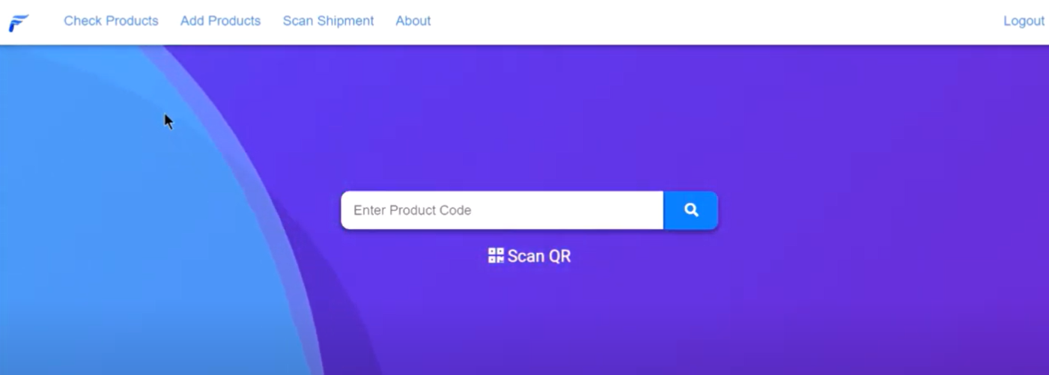

Items manufactured in Supply chain for customer after manufacturing

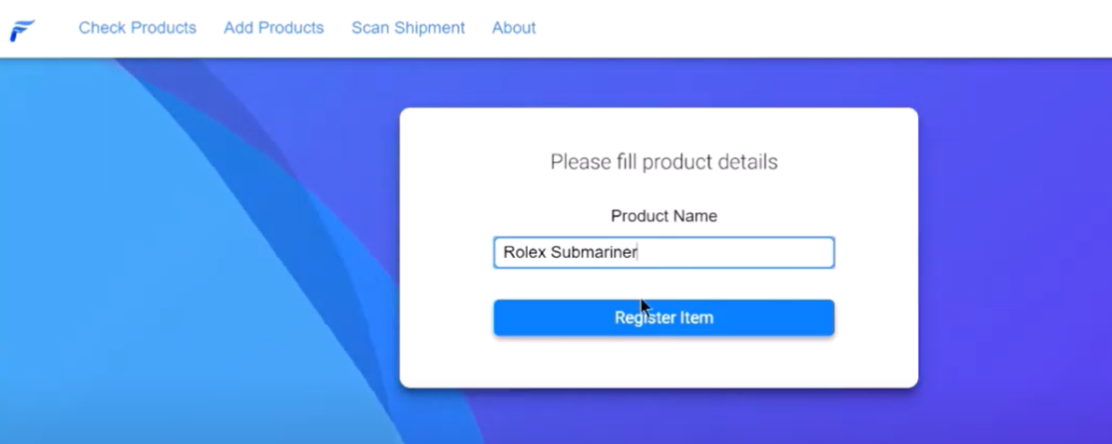

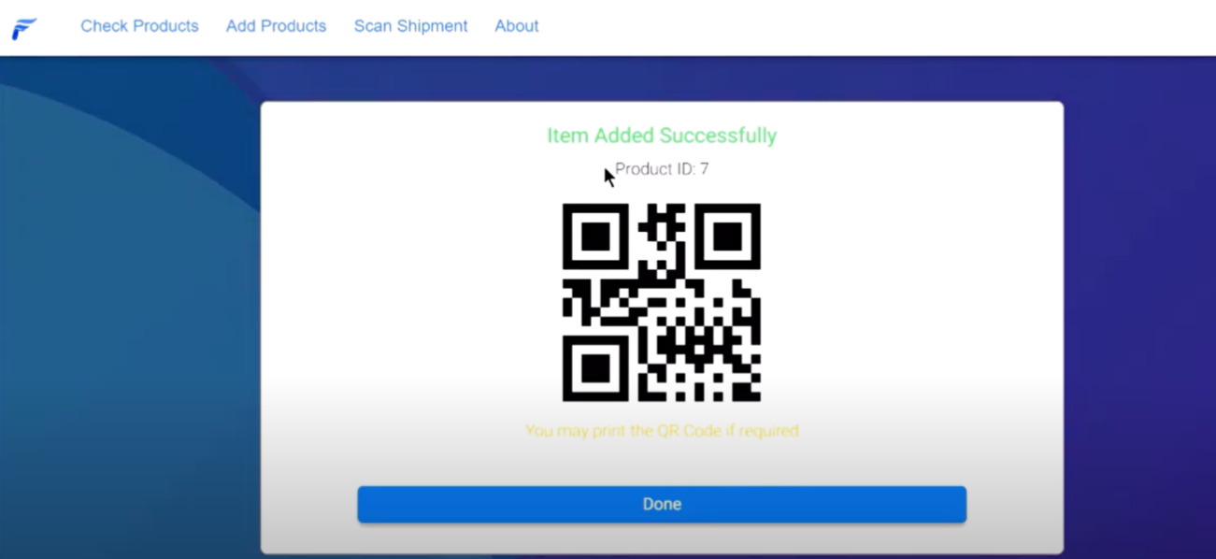

Scan product with QR code for info

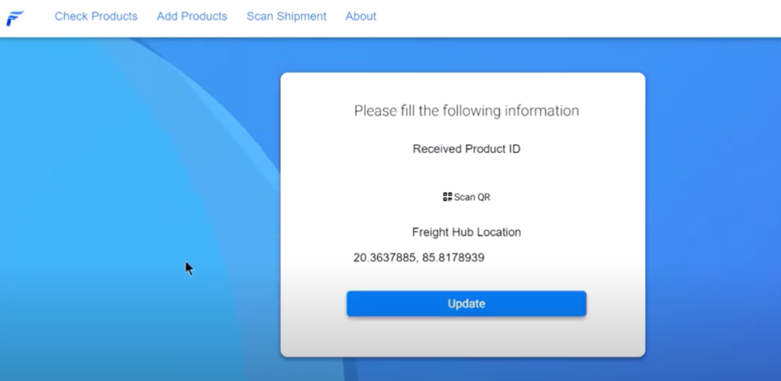

In Customer search with QR

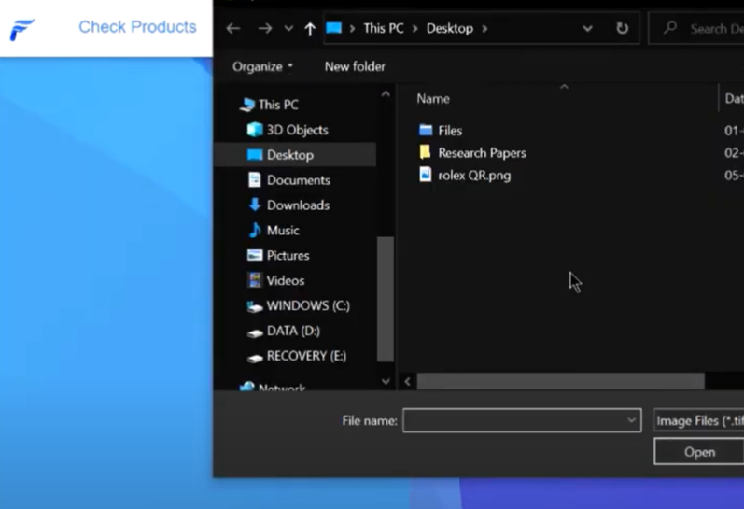

Details from QR product added in by manufacture after manufacturing

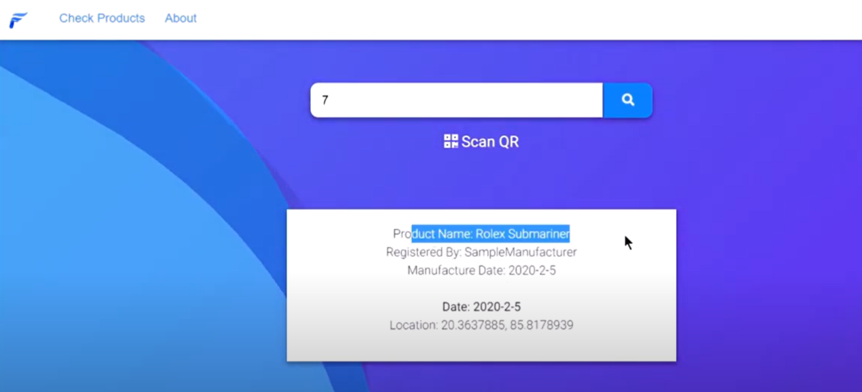

**Conclusion:-**

We successfully understood & implemented concept of Blockchain & smart contracts for Supply Chain management to create decentralised E2E application for customer to obtain provenance of any product & buy only authentic products using Solidity & Ganache. Thus, demonstrate working of blockchain.