

**Experiment: 3**

**Title:** Simulation of Inventory System: Newspaper Dealer Problem

**Problem Statement:** The newsstand buys the papers for 33 cents and sells them for 50 cents each. Newspapers not sold at the end of the day are sold as scrap for 5 cents each. Newspapers can be purchased in the bundles of 10. There are 3 types of news days: good, fair, poor with probabilities 0.35, 0.45 and 0.20 respectively. The distribution of newspaper demand is given. The problem is to estimate by simulation the optimal number of newspapers the newsstand should buy.

**Expected Outcome of Experiment:**

| **Index** | **Outcome** |
| --- | --- |
| CO1 | Understand the concepts of discrete event simulation and its importance in business, science, engineering, industry and other services. |
| CO2 | Ability to analyse and apply general principles of event scheduling algorithm & various statistical methods on different applications. |

**Books/ Journals/ Websites referred:**

1. Jerry Banks, John Carson, Barry Nelson, and David M. Nicol, “Discrete Event System Simulation”; Fifth Edition, Prentice-Hall.

2. Averill M Law, “System Modeling & Analysis”; 4th Edition TMH.

3. Banks C M, Sokolowski J A, “Principles of Modeling and Simulation”, Wiley

**Pre Lab/ Prior Concepts:**

**Theory:**

**Objective of Simulation:**

The objective is to simulate the problem. The problem is to estimate the optimal number of newspapers should be kept at newsstand.

Consider Newspapers Demand per day and distribution for type of news day as follows:

| Distribution of Daily Demand | | | |
| --- | --- | --- | --- |
| Demand | Good | Fair | Poor |
| 40 | 0.03 | 0.1 | 0.44 |
| 50 | 0.05 | 0.18 | 0.22 |
| 60 | 0.15 | 0.40 | 0.16 |
| 70 | 0.20 | 0.20 | 0.12 |
| 80 | 0.35 | 0.08 | 0.06 |
| 90 | 0.15 | 0.04 | 0.0 |
| 100 | 0.07 | 0.0 | 0.0 |

| Newsday | Probability |
| --- | --- |
| Good | 0.35 |
| Fair | 0.45 |
| Poor | 0.20 |

**Conceptual Model:**

**1. Characteristics:**

* Daily purchase : 70
* Purchase in bundles of 10
* End of day , remaining newspapers are sold as scrap
* Demand: Random.
* Type of news day: Random
* Shortage: Occurs when stock falls to zero.
* The profit calculation formula:

**Profit = revenue from sales – cost of news papers – lost profit from excess demand + salvage of sale of scrap papers**

**2. Random numbers used**

* Demand
* Type of newsday

# Result:

Simulation

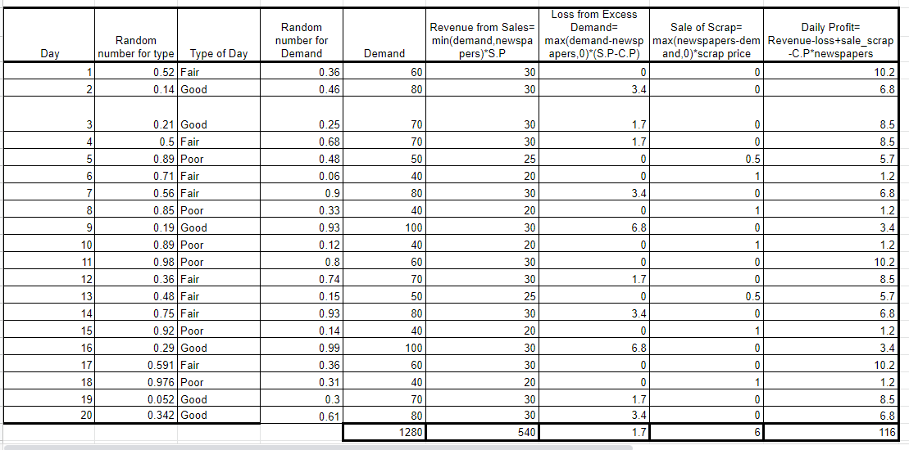

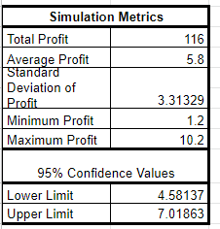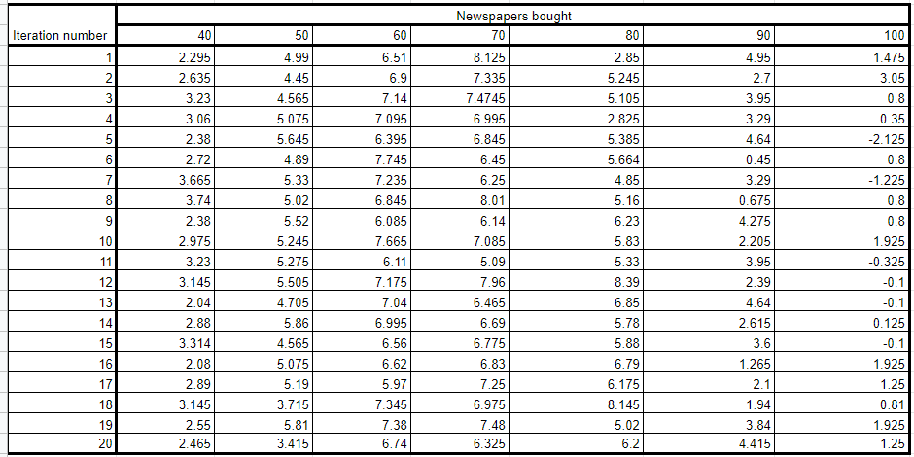

Results

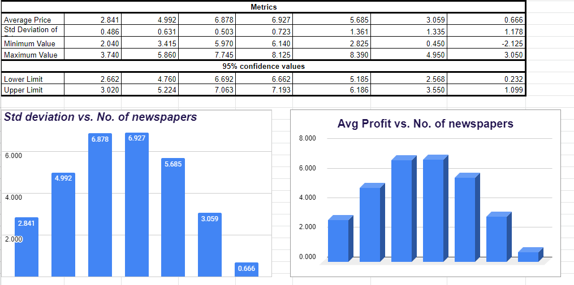

Experiment - [csm_exp3](https://docs.google.com/spreadsheets/d/12iLTfg4cL87FoUSdr3_U2EUU_fuaFTAC9hSc525v5mA/edit?usp=sharing)

# Conclusion:

The simulation for the Newspaper Dealer problem was performed.The maximum Average Profit was obtained for a daily purchase of 70 newspapers.

# Post Lab Questions

**Analyze the effect of change in probability of news days to 0.25, 0.5 and 0.25 for good, fair and poor types, respectively..**

Keeping the daily purchase as 70 newspapers. Following are the change in statistics :

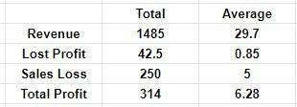

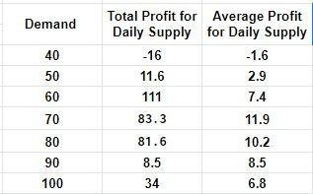

Analysis:

With the change in probabilities, the average profit has decreased with a certain amount of increase in salvation of scrap papers.Thus, daily supply needs to be changed with change in type of any day.