

**Experiment: 4**

**Title:** Simulation of (M, N) - Inventory System: Refrigerator Inventory Problem

**Problem Statement:** The simulation of an (M, N) inventory system follows the pattern of the probabilistic order level inventory system as shown in figure. Suppose that the maximum inventory level M is 11 units and the review period is 5 days. The problem is to estimate by simulation the average ending units in the inventory and number of days when a shortage condition occurs.

**Expected Outcome of Experiment:**

| **Index** | **Outcome** |
| --- | --- |
| CO1 | Understand the concepts of discrete event simulation and its importance in business, science, engineering, industry and other services. |
| CO2 | Ability to analyse and apply general principles of event scheduling algorithm & various statistical methods on different applications. |

**Books/ Journals/ Websites referred:**

1. Jerry Banks, John Carson, Barry Nelson, and David M. Nicol, “Discrete Event System Simulation”; Fifth Edition, Prentice-Hall.

2. Averill M Law, “System Modeling & Analysis”; 4th Edition TMH.

3. Banks C M, Sokolowski J A, “Principles of Modeling and Simulation”, Wiley

**Pre Lab/ Prior Concepts:**

**Theory:**

**Objective of Simulation:**

The objective is to simulate the problem. The problem is to estimate the average number of lost sales per week for an inventory system under various conditions.

Consider Daily Demand and Lead Time distribution as follows:

| Distribution of Daily Demand | | |
| --- | --- | --- |
| Demand | Probability | Cumulative |
| 0 | 0.10 | 0.10 |
| 1 | 0.25 | 0.35 |
| 2 | 0.35 | 0.70 |
| 3 | 0.21 | 0.91 |
| 4 | 0.09 | 1.00 |

| Distribution of Lead Time | | |
| --- | --- | --- |
| Lead Time | Probability | Cumulative |
| 1 | 0.60 | 0.60 |
| 2 | 0.30 | 0.90 |
| 3 | 0.10 | 1.00 |

**Characteristics Inventory System: Conceptual Model:**

**1. Characteristics:**

* Level of inventory (M): 11 units.
* Review period (N): 5 days.
* Policy (M, N): To select M in such a way to maximize profit.
* Demand: Random.
* Lead Time: Random between 0 to 5.
* Reordering: At the beginning of 6th day.
* Shortage: Occurs when stock falls to zero.
* Cost: Cost of renting, loss due to shortage, space cost.
* System state: Represented by values of M & N.
* Entities: The inventory supervisor & Goods delivery personnel.
* Activities: Delivery of goods.
* Delay : Zero
* Order quantity = (order up to level) – (ending inventory) – (on order) + (shortage quantity)

**2. Random numbers used:**

* Demand
* Lead Time

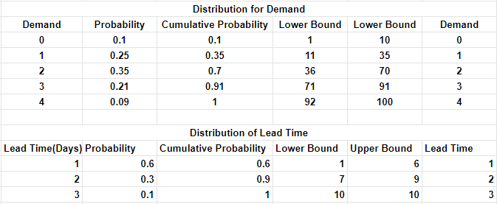

**Result:**

Simulation

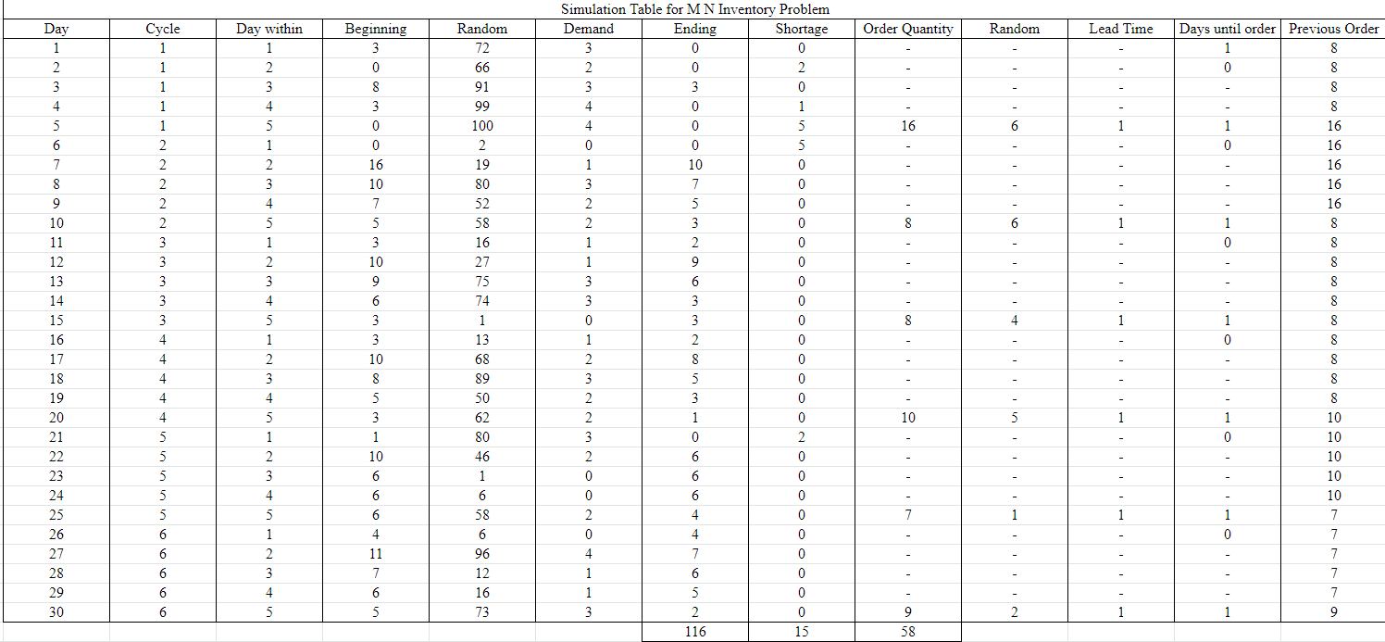

Performance measures:

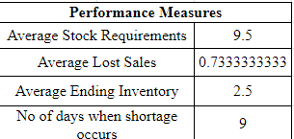

Experiment - [csm_exp4](https://docs.google.com/spreadsheets/d/1r9tyS0G7DjbmeBQttE6yLqKjCq3zWKBvlw6Bj5o7Fis/edit?usp=sharing)

**Conclusion:**

(M,N) Inventory Problem has been successfully implemented and analyzed.

**Post Lab Questions:**

Analyze the effect of change in values of M & N on average ending inventory.

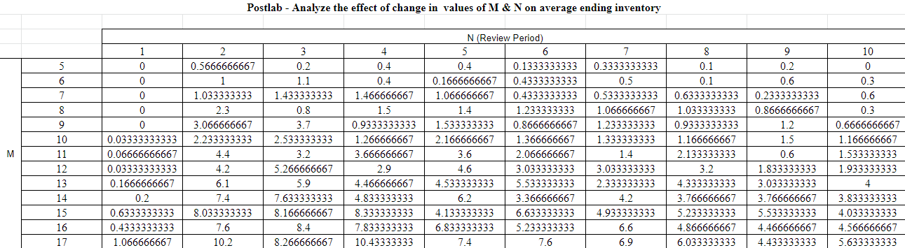

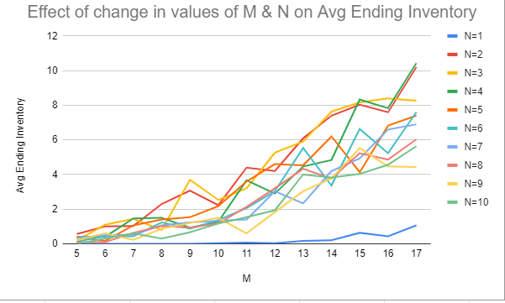

Thus, we can see that for a bigger value of M and N, the number of days on which shortage occurs is less than for a smaller value. The average ending inventory however, is much more when M and N are greater. When M and N are smaller, the ending inventory is not affected much.