

| **Title:**  Resource utilization and smoothing with Gantt Chart. |
| --- |

**Objective:** To Identify resource utilization and demonstrate resource smoothing

**Expected Outcome of Experiment:**

| **Course Outcome** | **After successful completion of the course students should be able to** |
| --- | --- |
| CO4 | Monitor the progress of projects and to assess the risk of slippage so that project’s requirements can be controlled. |

**Books/ Journals/ Websites referred:**

1. *Bob Hughes, Mike cotterell, Rajib Mall“Software Project Management”, fifth Edition, Tata McGraw Hill, Special Indian Edition*
2. *Royce, “Software Project Management”, Pearson Education, 1999.*
3. *Project Management Institute: “A Guide to the Project Management Body of Knowledge (PMBOK Guide)” 5th Edition Project Management Institute.*
4. *John Nicholas, Herman Steyn, “Project Management for Business Engineering and Technology” 4th Edition.*

**Team Members :**

**Nidhi Bhanushali – 1911004**

**Mayank Chopra – 1911006**

**Shubh Gosalia – 1911015**

**Pre Lab/ Prior Concepts:**

* Representation of project activities with Gnatt chart.
* Understand the need of Resource Smoothing

______________________________________________________________________

**New Concepts to be learned**

* Effective utilization of resources.
* Resource Optimization

**_____________________________________________________________________**

**Work-out :**

**Students are needed to represent the resources utilized in their project in Resource histogram and perform the activity of Resource smoothing.**

**___________________________________________________________________________**

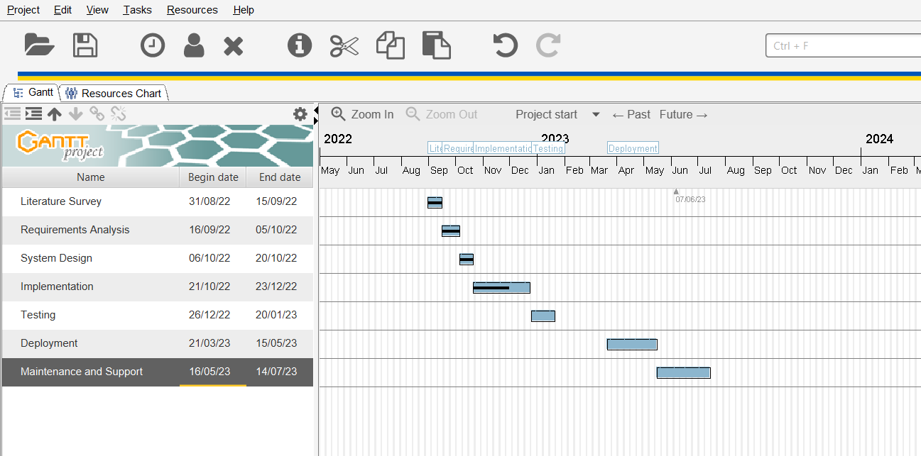

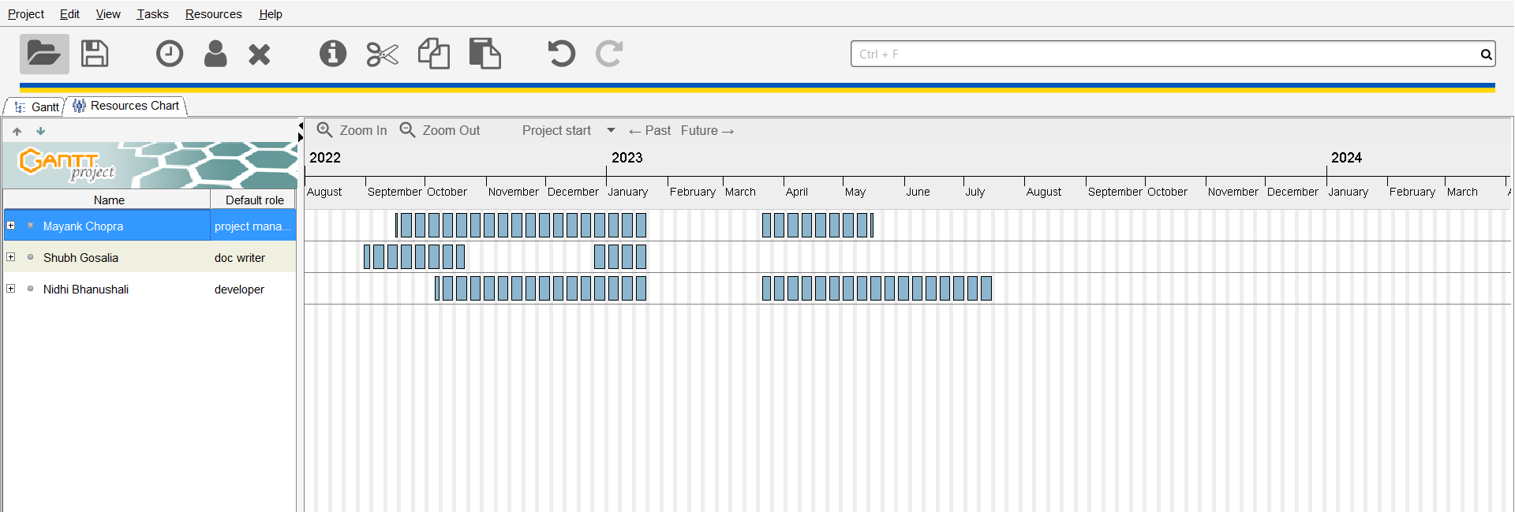

**Post Lab Questions:**

1. What is the difference between Resource Smoothing and Resource Levelling?

Ans:

**Resource levelling:** Resource levelling is when the resources need to be provided in proper order to satisfy the demand from the available supply and for achieving this, the start and finish dates of the project are adjusted.

**Resource Smoothing**: Resource smoothing is a bit different than Resource levelling as here the activities of the project are adjusted so that the demands do not exceed the limits.

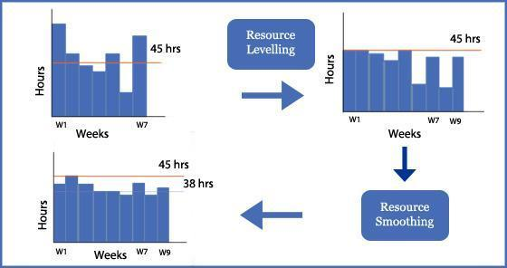

Resource smoothing is used when the work is to be completed in the same amount of time but with balanced distribution of resources. Resource levelling is used when the project duration needs to be extended so as to include the constraint on available supply or resources. It simply answers the question ‘With the resources available, when will the work be finished?

Few re-usable resources are limitless, so the time schedule has to be adjusted to take into account the limited availability of resources over time.

A smoothed resource profile will be achieved by delaying some work. This will remove some flexibility from the schedule and its ability to deal with unavoidable delays, but the advantage is usually a more efficient and cost-effective use of resources.

1. Does critical path changes with resource smoothing. Justify your answer.

Ans:

Resource smoothing is used when the work is to be completed in the same amount of time but with balanced distribution of resources.

When performing project planning activities, the manager will attempt to schedule certain tasks simultaneously. To achieve efficiency, the utilisation of resources and machines or humans should be well distributed as in there shouldn’t be peaks and troughs but rather a smooth distribution of the workforce and resources. To adjust this in the same amount of time, the manager may require to change the critical path as per the type of resources that are required for an activity and when that type of resource is available.

In either definition, smoothing could result in the same project finish date if the resources are adjusted properly by changing the activity order. So critical path can change with resource smoothening.

1. For a Project, following information is made available. Apply Resource Smoothing/Levelling methodology for the same. Assume that only a single type resource is used for the project. Apply it for Early start and Late Start approach.

| Activity | Immediate Predecessor | Duration(weeks) | Required Labour days/week | Total labour |
| --- | --- | --- | --- | --- |
| A | - | 5 | 8 | 40 |
| B | - | 3 | 4 | 12 |
| C | A,B | 8 | 3 | 24 |
| D | A | 7 | 2 | 14 |
| E | - | 7 | 5 | 35 |
| F | C,D,E | 4 | 9 | 36 |
| G | F | 5 | 7 | 35 |

Ans:

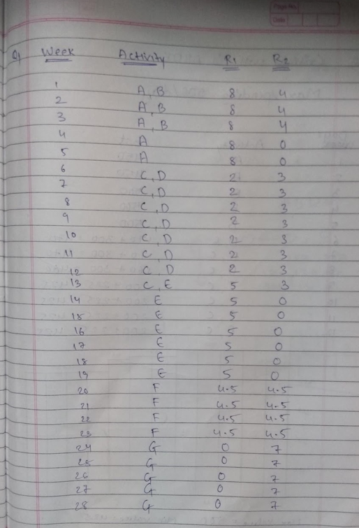

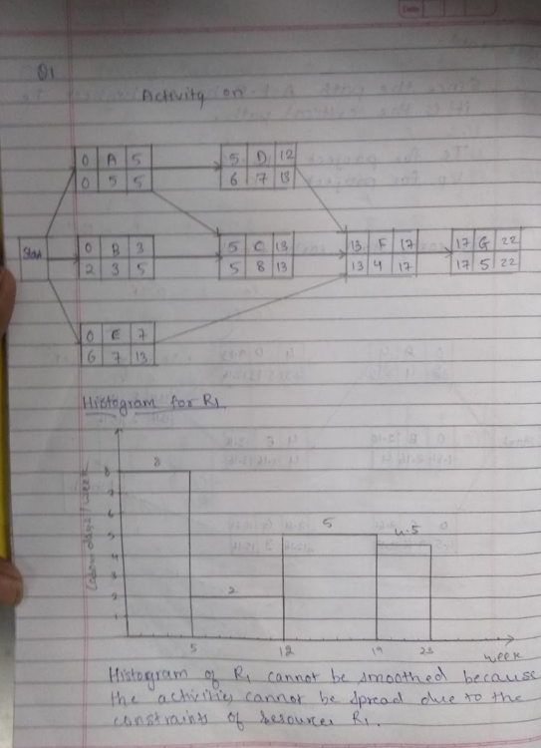

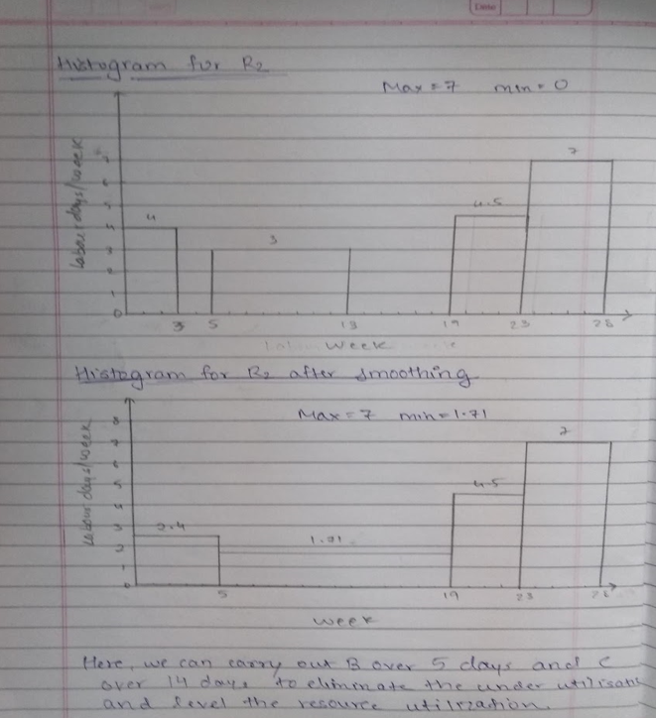

1. For the given project, the table represents Activity, duration, predecessors and cost/day. The constraint to spend is Max. 500/day. Plot a graph of Cost vs Time mentioning the activities to be carried out in such a way that fluctuation in the expenditure is minimum.

| Activity | Predecessors | Duration (Days) | Cost |
| --- | --- | --- | --- |
| A | - | 2 | 600 |
| B | A | 3 | 1200 |
| C | B | 3 | 1200 |
| D | B | 2 | 400 |
| E | D | 3 | 300 |

Ans :

