

| **Title:**  Calculating Earned Value. |
| --- |

**Objective:** To Demonstrate Earned Value Analysis and prepare baseline budget calculation.

**Expected Outcome of Experiment:**

| **Course Outcome** | **After successful completion of the course students should be able to** |
| --- | --- |
| CO4 | Monitor the progress of projects and to assess the risk of slippage so that project’s requirements can be controlled. |

**Books/ Journals/ Websites referred:**

1. *Bob Hughes, Mike cotterell, Rajib Mall“Software Project Management”, fifth Edition, Tata McGraw Hill, Special Indian Edition*
2. *Royce, “Software Project Management”, Pearson Education, 1999.*
3. *Project Management Institute: “A Guide to the Project Management Body of Knowledge (PMBOK Guide)” 5th Edition Project Management Institute.*
4. *John Nicholas, Herman Steyn, “Project Management for Business Engineering and Technology” 4th Edition.*

**Team Members :**

Nidhi Bhanushali – 1911004

Mayank Chopra – 1911006

Shubh Gosalia – 1911015

**Pre Lab/ Prior Concepts:**

Work Breakdown Structure of Project, Project Plan

______________________________________________________________________

**New Concepts to be learned**

* Planned Value (PV), Actual Cost (AC), Earned Value (EV)
* Cost Efficiency indicator
* Baseline schedule and budget

**_____________________________________________________________________**

**Work-out :**

**Students are needed to calculate Earned Value by assigning ‘value’ to each task or work package and create Baseline budget**

**___________________________________________________________________________**

**THE TABLE**

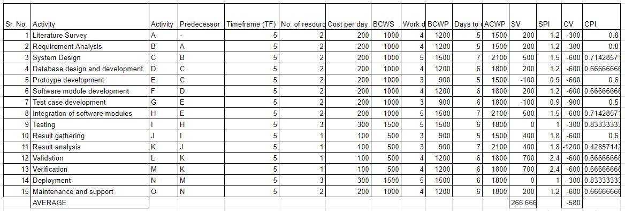

**Post Lab Questions:**

1. Explain what is Schedule Variance (SV), Time Variance (TV) and Cost Variance (CV)  
   **Schedule Variance (SV)**  
   It is very important for you to keep your project on schedule. Not only does it help you complete your project on time, but it also helps you avoid unnecessary cost overruns due to slippage of schedule, because as you go over the stipulated time, your costs start rising exponentially.

**Cost Variance (CV)**Cost Variance deals with the cost baseline of the project. It provides you with information about whether you are over budget or under budget, in terms of dollars. Cost Variance is a measure of cost performance of a project.

**Time Variance (TV)**  
The time variance is the difference between the estimated time for a task to be completed and the actual amount of time required to do so. If the variance is positive, it was completed ahead of schedule. If it’s negative, the task is behind schedule. The implication for a project manager depends on where the task lies on the critical path and what options he has at his disposal.

1. A project having the following 200 modules is to be developed in 40 weeks. On an average 5

modules are expected to be developed in a week. Cost of development of each module is

8000 INR.

* A review is taken after 10th week and it was observed that 47 modules are developed and the amount spent is 4, 50,000 INR.  
  Comment on progress of the project. Also state when the project is expected to complete if continued with the same pace and what will be expected cost when the project gets completed.
* Similar activity is carried out after 24th week and the status was 124 modules completed and amount spent is 9,50,000.  
  Comment on progress of the project. Also state when the project is expected to complete if continued with the same pace and what will be expected cost when the project gets completed.

| Parameters | After 12th week | After 24th week |
| --- | --- | --- |
| BCWP | 4,05,000 | 9,30,000 |
| ACWP | 5,00,000 | 9,00,000 |
| BCWS | 4,50,000 | 9,00,000 |
| SV | -45,000 | 30,000 |
| SPI | 0.9 | 1.033 |
| CV | -95,000 | 30,000 |
| CPI | 0.81 | 1.033 |
| BAC | 11,25,000 | 11,25,000 |
| EAC | 13,88,889 | 10,89,060 |
| VAC | -2,63,889 | 35,940 |
| ISAC | 33.33 weeks | 29.041 weeks |
| TCPI | 0.81 | 1.031 |

**Comment on progress of project**

The evaluation shows that the project is behind schedule after 12 weeks and if continued at the same rate as it could take 3 weeks longer than the actual deadline. The project work caught on and after 24 weeks, however, is ahead of the scheduled timeline and will result in the project being completed successfully within the deadline.

If the work proceeds at the same pace as it was after 24th week, it will be completed within the deadline and in reality 1 week early with a total cost of 10,89,060 INR well below the budgeted cost of almost 36K.

Therefore, we can see that the project manager has taken appropriate steps to monitor the project after the evaluation in the 12th week, thereby enhancing the project status as shown by the evaluation after the 24th week.