

| **Title:**  Identify various project risks and perform risk assessment. (PERT). |
| --- |

**Objective:** To Identify various project risks. Draw PERT diagram and show calculation of Time(Te) and variance.

**Expected Outcome of Experiment:**

| **Course Outcome** | **After successful completion of the course students should be able to** |
| --- | --- |
| CO4 | Monitor the progress of projects and to assess the risk of slippage so that project’s requirements can be controlled. |

**Books/ Journals/ Websites referred:**

1. *Bob Hughes, Mike cotterell, Rajib Mall“Software Project Management”, fifth Edition, Tata McGraw Hill, Special Indian Edition*
2. *Royce, “Software Project Management”, Pearson Education, 1999.*
3. *Project Management Institute: “A Guide to the Project Management Body of Knowledge (PMBOK Guide)” 5th Edition Project Management Institute.*
4. *John Nicholas, Herman Steyn, “Project Management for Business Engineering and Technology” 4th Edition.*

**Pre Lab/ Prior Concepts:**

Project Breakdown Structure, Implementation & operation of Project activities,

Cost Benefit Analysis ______________________________________________________________________

**New Concepts to be learned**

* Risk identification and ranking
* Project risk matrix
* Risk of slippage
* PERT Network

**_____________________________________________________________________**

**Work-out :**

**Students are needed to identify the possible factors putting a project at risk. They need to classify risks of their Project according to their relative importance and likelihood.**

**___________________________________________________________________________**

The factors of risk pertaining to our project are :-

1. **late delivery of the product**: we need the product to come out during this pandemic to maximize our consumer reach which will subsequently drive our initial revenue if the product is delivered late then we might lose a major chunk of our user base and revenue.
2. **consumer base not building up:** consumers might not want to shift to a new platform, and rather continue using the known platform for convenience
3. **UI doesn’t suit all types of users:** the UI of the system might not suit all types of people with different levels of comfort and proficiency with technology.
4. **server shut down:** server might shut down due to heavy load during peak office hours
5. **certain features taken down for servicing:** if the users experience trouble with certain features they might have to be taken down for servicing to fix the issues.
6. **unavailability of customer service personnel during peak hours:** during peak hours customers service personnel might get busy and thus not be able to provide service to all customers.

**Probability Impact Matrix:**

| **High risk low impact** | **High risk High Impact** |
| --- | --- |
| unavailability of customer service personnel during peak hours | late delivery of the product |
| **Low risk Low impact** | **Low risk High Impact** |
| certain features taken down for servicing | 1. late delivery of the product 2) UI doesn’t suit all types of users 3) server shut down |

| Activity Code | Particulars |
| --- | --- |
| **A** | **Requirement Gathering** |
|  | No previous work on the taken hypothesis. |
|  | Similar projects are already in use. |
| **B** | **Design Phase** |
|  | Unclear and ever changing system requirements. |
|  | Not a defined data system. |
|  | Inconsistent design. |
| **C** | **Development Phase** |
|  | Budgeting issues. |
|  | Team conflict. |
|  | Impractical deadlines. |
|  | Change management failure. |
| **D** | **Testing Phase** |
|  | Missing documentation. |
|  | Unstable testing environment. |
|  | Undefined quality standards. |
|  | Missing requirement gathering. |
| E | **Integration and Final Delivery** |
|  | Integration issues. |
|  | Miscommunication leading to different expectations |
|  | Late delivering of the product |

**Post Lab Questions:**

1. How will you reduce possible risks in your project?

Ans :

**Approach specific to the risks listed above:**

1. taking regular status updates from all parties concerned with the execution; maintaining a log of things done and not done in the scheduled time frame; tweaking execution strategy as and when required to meet any unforeseen conditions/situations arising during the execution of the project.
2. a. making sure the UI design is easy to use for all types of users

b. doing enough testing of the final UI on all people from different groups so as to ascertain their level of comfort in using the system

c. marketing and PR campaigns centrally based on the usability of the product, so that the image any person who watches the ads has about the project is that the product's primary purpose is to make their WFH experience better and smoother.

1. In addition to the steps mentioned above, making required changes into the system on the basis of the results of the usability test and testing the system again to check whether the changes have solved the issues that the users where facing; doing this iteratively until optimal results are obtained

**Steps to reduce project risks in general:**

**1. Clarify The Requirements**

What is it that you want to achieve with this project? Knowing that, and having true, deep clarity about that, is a huge mitigating factor for risk. It eliminates all the ‘we didn’t know what we were doing,’ and ‘you never said’ type risks that relate to scope.

Making full use of feasibility studies, workshops and user groups to test out the ideas before making a full commitment. Agile techniques can ensure end users and clients are engaged at every step of the way, feeding into the outcomes and making sure that what is delivered is really what is wanted.

Hold workshops. Interview stakeholders. Produce a comprehensive scope document and project brief, even if it takes much longer. It will pay off in a big way.

**2. Get The Right Team**

People introduce all kinds of risk to a project, largely due to their availability and skills. People with inadequate skills make your project take longer because they are slower. People who aren’t available when you need them also impact your project timescales.

If possible, ringfence the resources that you need into the team. This mitigates a lot of the people-related risks. The highest priority projects should attract and retain the best resources in the company (and interpret ‘best’ to mean whatever is most appropriate for your project: person with the most Java skills or whatever).

How To Do It: Use resource allocation techniques to identify the resources you require for the project and then to secure them. Will ensure that we know when our resources are available for project work and book their time accordingly.

**3. Spread The Risk**

How To Do It: Quantify the risk. Will think about cost of transfer and likelihood of occurrence. Will look for ways to manage risks jointly with contractors or other stakeholders to spread out the actions and also the impact should the risk occur.

**4. Communicate and Listen**

There is another way that people add risk to a project: through their actions when they are overlooked as stakeholders.

Will Plan our communications and take third parties into account too. Consumer, environmental or other external groups can have a huge impact on your project (positive and negative) so involve them early and consistently.

**5. Assess Feasibility**

Make use of feasibility studies and prototypes to test out ideas and solutions before you move to a full build. This is a simple way of de-risking a project because you can use this early stage as a test bed for checking your concepts, methodology and solution.

Break the project down into phases and include time at the beginning for a feasibility or investigation stage. This is a short period of time where you can fully scope out the initial underpinning or enabling work and test out your solution in a limited way prior to a full rollout. The learning can be incredibly helpful for shaping the rest of the project, and it can prove (or disprove) the business case without having to commit the full investment.

**6. Test Everything**

Experienced project managers will tell you that when project timescales are under pressure, testing is often the task that gets cut.

Testing is an important part of making sure that your project risk is lower and manageable. Testing helps flush out problems that might bring the project to a standstill later. Test everything: training materials, implementation plans, and obviously software and the deliverables.

Estimate carefully and have dedicated schedule contingency for testing.

**7. Have A Plan B**

The best way to plan for the unplannable is to have alternatives in your back pocket. This could be:

Contingency funds

Float in the plan

Additional resources on standby

Options to break the project into segments and/or reduce scope

1. What are the advantages of PERT?

Ans :

Due to the critical nature of some project objectives, a small business implements controls to make sure projects are successfully completed. One such control mechanism is the Program Evaluation and Review Technique, a program network analysis method used to plan and control large projects, including performance improvement efforts. A project manager arranges the activities of a new project -- one without historic precedent -- in a diagram, or program network, estimating the time and resources needed to complete each project activity. PERT charts have advantages, but managers need to be aware of disadvantages in weighing their use.

## Advantage: Activity Analyses

A project manager views information about the likely completion of a project on time and on budget by viewing PERT activities and events independently and in combination. For example, software implementation requires the completion of critical activities such as hardware installation, programming, system testing and end-user training. Using a PERT chart, a project manager can evaluate the time and resources needed for any one of these activities, such as program installation. The project manager can also evaluate the sum requirements of all activities simultaneously, from hardware installation to end-user training.

## Advantage: Department Coordination

PERT analysis improves planning and decision-making by integrating and presenting data from multiple departments. Gathering qualitative and quantitative data from multiple sources also helps coordinate project activities and improves communication among departments. PERT identifies responsible departments and each person's project role. The visibility of areas of responsibility encourages management commitment to the project. In addition, PERT reveals activity inter-dependencies and contributes to the development of a master plan that provides a current view of business operations.

## Advantage: What-if Analysis

PERT requires that project activities be sequenced in a network under a set of rules specifying critical and sub-critical paths. The critical path is the longest sequence of activities and events -- milestones -- in the project, and determines the number of days required to completion. A what-if analysis identifies possibilities and uncertainties related to project activities. Different permutations and combinations of activities are tried, and the most useful possibility selected, minimizing project surprises and waste. The what-if analysis also highlights the activities with the greatest project risk that require careful monitoring during the project.

1. Understand the difference between High level, low level and medium level risks, with respect to your project. Justify your answer.

Ans :

**High level risk example:**

Farmer unresponsiveness: if the farmer doesn’t understand the interface and the utility, then the purpose of the project would be defeated as major stakeholders won;t understand what’s going on.

**Medium Level risk:**

Improper accuracy of prediction algorithm: if the accuracy is not there, then the usage would dwindle and there won’t be any use of the project that is being created. Hence, care must be taken during the modelling phase to choose the appropriate learning methodology.

**Low level risk:**

Crashing of server: Since ample time would be spent in creation and maintenance of systems, it’s likelihood is low and hence it’s a low level risk

**Post Lab Activities (with reference to your Project/ other project ):**

**Prepare the optimistic, pessimistic and most likely duration of completion of activities and also calculate the probability of completion of the activities.**

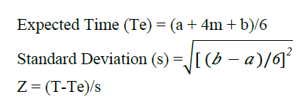

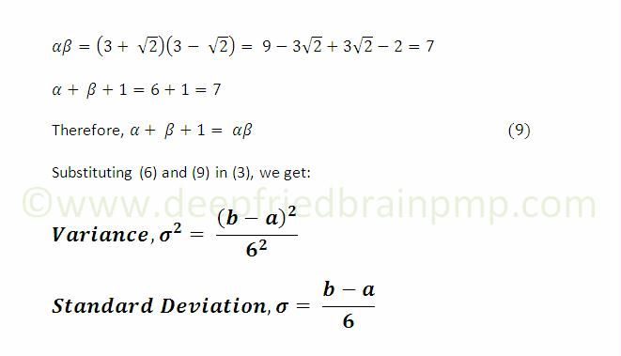

| **Activity** | **Description** | **Immediate**  **Predecessor** | **a /**  **T(optimistic)** | **m/**  **T(most likely)** | **b/**  **T(pessimistic)** | **Mean/**  **T(e) - Expected Duration**  **(a+4m+b)/ 6** | **S.D**  **(b-a)/6** | **Variance** |
| --- | --- | --- | --- | --- | --- | --- | --- | --- |
| A | **Requirement Gathering** | __ | 12 | 15 | 20 | 15.33 | 1.33 | 1.7689 |
| B | **Literature Survey** | A | 4 | 5 | 6 | 5 | 0.33 | 0.1089 |
| C | **Design** | A | 4 | 5 | 7 | 5.167 | 0.5 | 0.25 |
| D | **Database creation** | B | 1 | 1 | 2 | 1.167 | 0.164 | 0.026 |
| E | **Development** | C | 1 | 1 | 3 | 1.33 | 0.33 | 0.1089 |
| F | **Testing** | D | 2 | 4 | 4 | 3.67 | 0.33 | 0.1089 |
| G | **Integration** | D,E | 20 | 25 | 30 | 25 | 1.67 | 2.56 |
| H | **Documentation** | G | 5 | 6 | 8 | 6.167 | 0.5 | 0.25 |
| I | **Deployment and delivery of the system** | H | 1 | 2 | 2 | 1.167 | 0.167 | 0.0278 |

**PERT Diagram:**

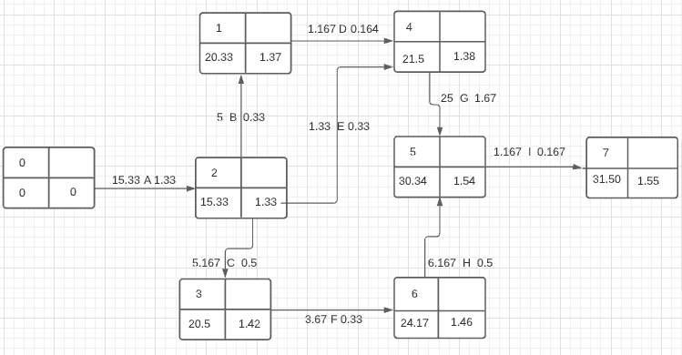

**Critical Path : A-C-F-H-I**

**Path duration : 31.5**