

|  |
| --- |
| **Title:**  Plan various project activities based on duration estimation and Draw AOA and AON diagrams to represent the activities and dependencies. (CPM). |

**Objective:** Identify various activities in the project and represent it with a Gnatt chart. Draw AOA & AON diagrams.

**Expected Outcome of Experiment:**

|  |  |
| --- | --- |
| **Course Outcome** | **After successful completion of the experiment students should be able to** |
| CO 2 | Plan various project activities based on efforts and duration estimations by analyzing risks involved in it. |

**______________________________________________________________________________**

**Books/ Journals/ Websites referred:**

1. *Bob Hughes, Mike cotterell, Rajib Mall“Software Project Management”, fifth Edition, Tata McGraw Hill, Special Indian Edition*
2. *Royce, “Software Project Management”, Pearson Education, 1999.*
3. *Project Management Institute: “A Guide to the Project Management Body of Knowledge (PMBOK Guide)” 5th Edition Project Management Institute.*
4. *John Nicholas, Herman Steyn, “Project Management for Business Engineering and Technology” 4th Edition.*
5. *Davis J. Anderson, Andy Carmichael, “Essentials Kanban Condensed”, LeanKanban University Press, 2016.*

**______________________________________________________________________________**

**Pre Lab/ Prior Concepts:**

After receiving the confirmation about the approval and awarding of the project proposal, the project manager will start planning the project execution. Understand the content of the Project Proposal submitted to the sponsor.

**______________________________________________________________________**

**New Concepts to be learned:**

The Project Manager will now start preparing the project execution / implementation plan. The Scope of the work is broadly divided into various activities. These activities are represented in a form of activity table. This activity table typically will have following structure:

|  |  |  |  |  |
| --- | --- | --- | --- | --- |
| Activity Code | Particulars | Duration in Days | Predecessor(s) | Resource(s) |
| **A** | **Requirement Gathering** | | | |
| A1 | Literature Survey | 18 |  |  |
| A2 | Requirement analysis | 22 |  |  |
| **B** | **Design Phase** | | | |
| B1 | System design | 14 | A1,A2 |  |
| B2 | Database Design | 14 | B1 |  |
| B3 | UI Design | 20 | B1 |  |
| **C** | **Development Phase** | | | |
| C1 | Frontend Module | 38 | B1,B3 |  |
| C2 | Database Creation | 17 | B2 |  |
| C3 | Backend Module | 40 | B1,C2 |  |
| C4 | Authentication module | 17 | B3,C2 |  |
| **D** | **Testing Phase** | | | |
| D1 | Unit testing of C1 | 10 | C1 |  |
| D2 | Unit testing of C2 | 14 | C2 |  |
| D3 | Unit testing of C3 | 14 | C3 |  |
| D4 | Unit testing of C4 | 14 | C4 |  |
| D5 | Integration testing | 17 | D1,D2,D3,D4 |  |
| D6 | System testing | 12 | D5 |  |
| E | User documentation | 8 | C1,C2,C3,C4 |  |
| F | Deployment | 20 | D6 |  |
| G | Final Delivery | 1 | E,F |  |

As mentioned in the table above A, B, & C are the major activities which could be further broken down in sub activities such as A1, A2 etc. The duration required for implementation/ completion of these activities is typically represented in days / weeks ( use a common unit for all the activities). Usually these activities are sequenced based on priorities and are also dependent on one another. The sequencing of activities is essential for appropriate utilization of resources. The name(s) of the (human) resource(s) are also mentioned. This will help not only to understand the flow of implementation but also utilisation of the resources.

Number of tools can be used for visualising the project development process. They are MicroSoft Project, Scrum Boards, Kanban Boards etc.

**____________________________________________________________________**

**Work-out :**

The students are required to prepare a project activity table and draw AOA/AON diagrams.

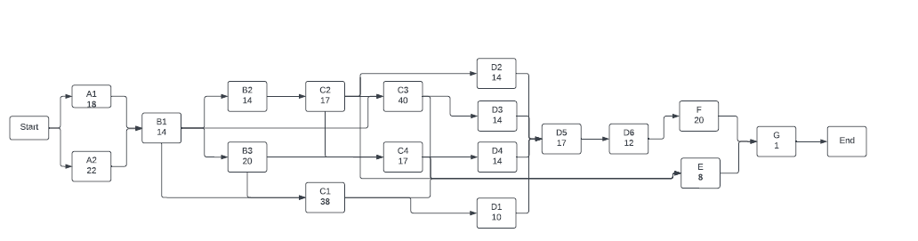

**Activity on Arrow diagram:**

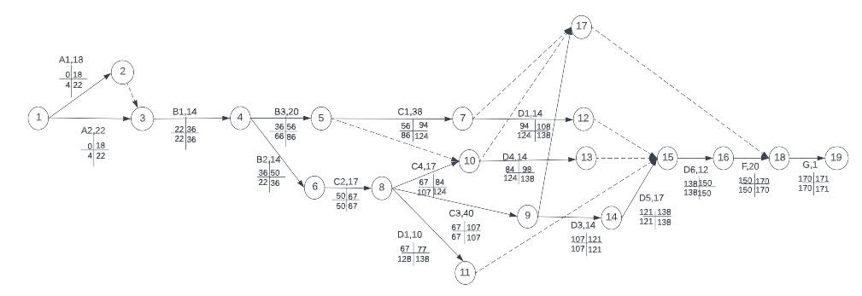

**Post Lab Questions**

1. What are Kanban Values? Explain them in brief
2. What are Kanban Agendas?
3. Explain in brief, the general practices of Kanban.

PDF - <https://drive.google.com/drive/folders/1kEHzM3XCt0okS3dvWmrQAn98zmzUm82L?>