

|  |
| --- |
| **Title:**  Case study of any Block chain application as per students choice |

**Objective:** Study any Blockchain Application.

**Expected Outcome of Experiment:**

|  |  |
| --- | --- |
| **CO** | **Outcome** |
| CO1 | Build your own Blockchain businesses with acquired knowledge. |
| CO2 | Learn Solidity language & Multiple Technology-based developments |
| CO3 | Apply the algorithm and techniques used in Blockchain |
| CO4 | Grasp the in-depth understanding of Blockchain, Smart Contracts & how it works |
| CO5 | Describe the methods of mining. |

**Books/ Journals/ Websites referred:**

1. A. F. Mendi, K. K. Sakaklı and A. Çabuk, "A Blockchain Based Land Registration System Proposal for Turkey," *2020 4th International Symposium on Multidisciplinary Studies and Innovative Technologies (ISMSIT)*, 2020, pp. 1-6, doi: 10.1109/ISMSIT50672.2020.9255078.
2. https://www.blockchain.gov.in/landrecords.html

**Abstract**:-

Even though Land & Real Estate is an important part of a country's economy, the current system has a lot of problems. These include problems with finding a home, lease agreements, sales and purchases, financial transactions, the use of middlemen, and more. Blockchain and real estate can go hand in hand. In order to firmly support the real estate premise in more than one of its donning exercises, the land business process utilizes the blockchain model. In any event, a significant portion of the digital data is enabled on several frameworks, putting an end to the lack of transparency and a larger incidence of errors that create a more obvious possibility for fraud. Blockchain technology has the potential to enhance apartment trading activity. A novel strategy for firms that are steadily uncovering a portion of these facts is the blockchain disintermediation of estates.

**Related Theory: -**

Land registry in India as well as in many parts of the world is a very slow and cumbersome process. There are also many intermediaries involved in the process of land registration. Developing a system that not only accelerates the process of land registration, but also makes it easier for Buyers, Sellers and Government registrars to transfer the land ownership from seller to a new buyer, is only possible by creating a distributed system that stores all the transactions made during the process of land buying. In this paper we'll try to explore the possibilities and problems solved by using a block-chain based system for land ownership transfer. The system that we are trying to implement is based on Ethereum's Block-chain that will store all the transactions made during the process of land ownership transfer. Using the concept of smart contracts of block-chain technology we can trigger various events like access of land documents to a land inspector and fund transfer event from buyer to seller after successful verification of the land ownership transfer. This system will solve the problems faced by all the three parties during the land registration and will also remove the intermediaries like property dealers. This system makes the process of land registration resilient and decreases the cases of fraud in the process. Using the system, validation of the lands is also possible as immutable transactions are being stored in the public ledger.

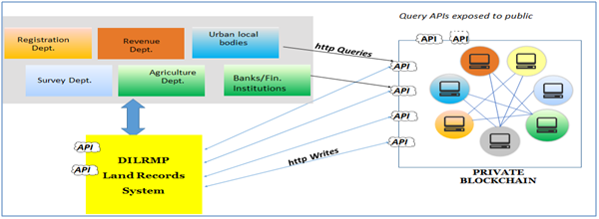

**Challenges of Land Registration Process:**

In principle, land registries simply need to maintain records of land and real estate ownership, recording changes of hands as they happen over the years. It sounds like a simple enough task, but it comes with myriad challenges. Historically, land registries were based on paper documents, which can be lost, destroyed, falsified, or otherwise manipulated. In countries like the UK, governments have largely moved to digital land registration systems. However, if someone wants to sell an older property that hasn’t previously been registered, and the paper title deeds have been lost or destroyed, the process to register the property in order to sell it can become highly arduous. The seller will need to somehow prove the basis of their claim to ownership without the relevant paperwork, as well as explain how the documents came to be lost or destroyed. They’ll also have to engage professional surveyors and conveyancing professionals to handle the requirements of registration. Even a standard transaction takes time, with the UK government citing that it takes between two and five days to process each application for a change.

**Putting Land Registries on the Blockchain**

Blockchain provides a potential solution for many of the challenges of land registration. This use case for blockchain extends beyond a pure database, leveraging the opportunity to create a permanent, unbreakable record of ownership for land or real estate. The simplest implementation of a blockchain-based land registry could enable the ownership documents to be recorded and assigned to the owner’s user account. If there are structural changes to the building, these can be added to the blockchain, and if the property is sold, all the relevant documentation can be transferred to the new owner. Every transaction is traceable, timestamped, and indisputable. Used in this way, blockchain could provide a highly secure record of ownership that cannot be manipulated.

In contrast to storage on a central server or a central archive, which — if lost — means the end to all claims, blockchain allows information to survive any disaster. Not the entire archive has to be stored on blockchain, though. It is enough to keep the fingerprint of the data and replicate it all over the world. With this fingerprint any copy of the data can be validated and unambiguously found to be “real” or “fake”. A single surviving genuine copy allows to restore all claims. The frosting on the cake can be end-to-end encryption of sensitive records and tokenizing the access right. This access token can be attached to the land registry, and the owner is in control to grant access to authorized parties. For example, if the owner wants to take out a mortgage on the property, they can grant access rights to non-public data to the mortgage company. This can be done whenever needed, unconstrained by office working hours. No paper-based system can provide such flexibility, resilience and durability.

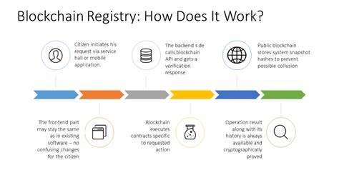

**Work on Land Registry using Blockchain**

In a study it is proposed an easy to use efficient platform for making the land registration process more easy and robust by using Ethereum’s Blockchain. This paper describes the current process of land records maintenance. It emphasizes on the importance of smart contracts for land registry using Blockchain in particular, developing countries like Pakistan face severe Land Record Management issues, such as data tampering with land record. This article aimed at using proof concept in conceptual algorithm and hybridisation of blockchain in various sector. There is an article aimed at using proof concept in conceptual algorithm and hybridisation of blockchain in various sector. In this paper we have proposed an easy to use efficient platform for making the land registration process more easy and robust by using Ethereum’s Blockchain. It descibes the current process of land records maintenance. It emphasizes the importance of smart contracts for land registry using Blockchain. In particular, developing countries like Pakistan face severe Land Record Management issues, such as data tampering with land records. The study describes a safe land register based on majority consensus that is implemented using blockchain. The security issue is addressed to a large part by integrating the land registration in blockchain. Each block's hash value will be unique since it is connected to the hash of the preceding block. Hashing is done using the SHA256 technique. In addition to SHA256, the Proof Of Work (PoW) technique is also utilised. The capability is built-in to decentralised systems such as Blockchain. The aforementioned issues are addressed in this proposal.

By creating a smart contract, the lands are registered on the Blockchain network. For various organisations and procedures involved in purchasing and selling a property, the suggested research can give multiple qualities to stakeholders, including efficiency, transparency, trustworthiness, and integrity. Even while Blockchain technology has cons, such as being difficult to adopt and slower than a centralised system, it has a lot of pros. Miners are also required to validate transactions; however, this may be avoided by employing suitable consensus procedures. The land registration procedure in India is one of the most time-consuming, and many individuals are unaware of all of the requirements that must be followed during the registration process. The registration technique uses the current system's weaknesses. The user who owns the land submits his land data as well as the market value of the land by giving all required evidence. The registration procedure can be completed by a government authority who is typically responsible for land registration and has been designated as a super admin. Only the super admin assigned to that village can register lands that fall under that village's jurisdiction in the system. There are many stories of counterfeit property titles, fraudulent land registries, delays in ownership transfer, and the involvement of government personnel in fraudulent operations are common in today's headlines. It's possible to offer appropriate framing for digital assets, online payments, and remittance transfers. It may also be used to detect black money laundering. Enterprise Consumer trust may be gained by companies that employ blockchain technology.

**Solution by using existing concept**

A decentralised application using blockchain for Land Registray. Specifically, for building and deploying, we can utilize Ethereum’s network to create the smart contract. The land registration process in every nation is governed by the laws of the constitution. The general steps for the current system of land registration and ownership of various nations can be described as follows: The property/land documents need to be submitted to the appropriate authority within whose jurisdiction the property is located.

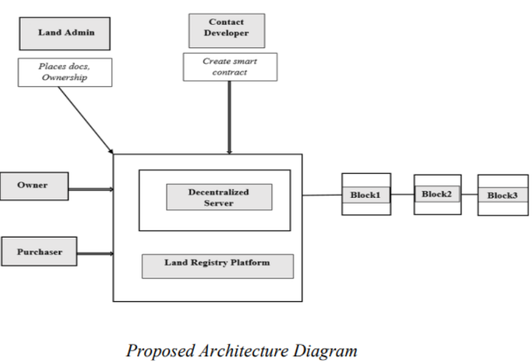

For registration of the documents, the authorized signatures of seller and buyer need to be presented along with witnesses. A proof of payment of necessary fees and duty should also be presented to the sub-registrar along with the property card. In case of any discrepancy, the authority has all the rights to reject the registration procedure and registration documents. The Netherlands Land registry is willing to test the Blockchain technology for the real estate data along with Artificial Intelligence for cognitive systems to make predictable models. Other countries like Russia, the United Kingdom and Brazil have initiated their projects on the land registry system. Dubai, on the other hand, has become the world’s first government entity to adopt Blockchain technology for land ownership registration. Blockchain has been used as a secure database of records including lease registrations and linked them to the Dubai Electricity and Water Authority(DeWA), the telecommunications system and various property related billing systems. The method of IPFS for storing the Emirates Identity Cards and the validity of the visas of the residents and the provision of the tenants to pay the rents electronically via their interface has multiplied the positive impact of the system on the residents of the nation.

**Conclusion: -**

We successfully understood the concept of using Blockchain for Land Registry System with challenges faced, ideas to overcome it and make it more useful and secure & reliable.