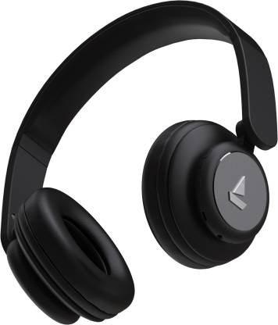

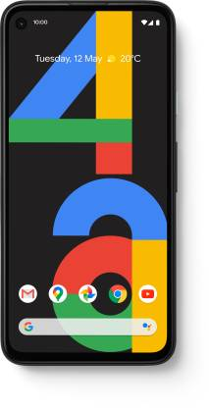

Google Pixel 4a (Just Black, 128 GB)  (6 GB RAM)

4.6/5

https://www.flipkart.com/google-pixel-4a-just-black-128-gb/p/itm023b9677aa45d?pid=MOBFUSBNAZGY7HQU&lid=LSTMOBFUSBNAZGY7HQUWHTF0C&otracker=clp_banner_1_6.bannerX3.BANNER_flagship-fest-35d6-19w7-store_V02VYLY9VORC&fm=neo%2Fmerchandising&iid=M_5994d1bf-d89c-46a0-a9e3-7ef55867d32c_6.V02VYLY9VORC&ppt=hp&ppn=homepage

3.

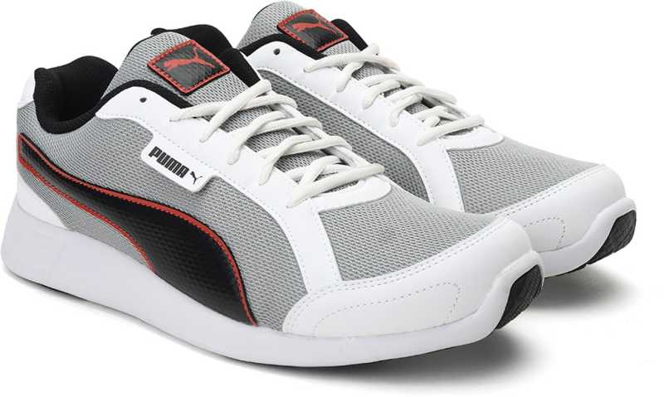

Electro 2 IDP Sneakers For Men  (Multicolor)

4/5

https://www.flipkart.com/puma-electro-2-idp-sneakers-men/p/itmedd3fc960e4c3?pid=SHOFYBAAGWRPKD5T&lid=LSTSHOFYBAAGWRPKD5TGWNBGO&marketplace=FLIPKART&store=osp%2Fcil&srno=b_1_34&otracker=hp_omu_Fashion%2BFor%2BEveryone_3_14.dealCard.OMU_VPVKQ54UBPX8_9&otracker1=hp_omu_WHITELISTED_neon%2Fmerchandising_Fashion%2BFor%2BEveryone_NA_dealCard_cc_3_NA_view-all_9&fm=neon%2Fmerchandising&iid=en_3Tsi5QW43hBPeqML0sN3r5v%2BTdCCyRh0cuZuyL9ixHO%2Bw9xZ6dtK5UHgB7KrtDovmngg3u03Clq8sj6COhsA%2FA%3D%3D&ppt=browse&ppn=browse&ssid=68sf8lc5b40000001620658039999

4.

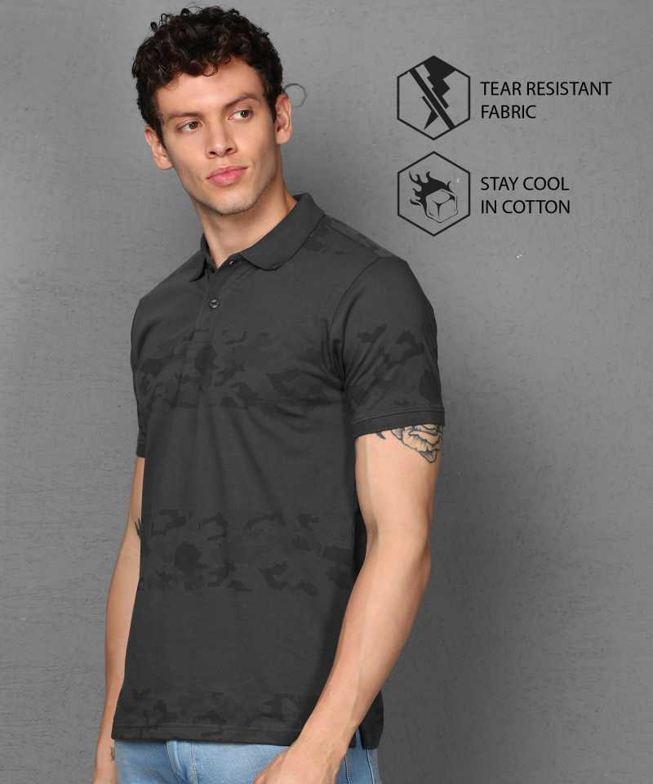

Military Camouflage Men Polo Neck Grey T-Shirt

4.4/5

https://www.flipkart.com/metronaut-military-camouflage-men-polo-neck-grey-t-shirt/p/itma3468edfcbd3f?pid=TSHFRDMJYEAUTHUQ&lid=LSTTSHFRDMJYEAUTHUQQWHNUC&marketplace=FLIPKART&store=clo%2Fash%2Fank%2Fedy&srno=b_1_1&otracker=hp_rich_navigation_2_1.navigationCard.RICH_NAVIGATION_Fashion~Men%2527s%2BTop%2BWear~Men%2527s%2BT-Shirts_IF56C41VGEYS&otracker1=hp_rich_navigation_PINNED_neo%2Fmerchandising_NA_NAV_EXPANDABLE_navigationCard_cc_2_L2_view-all&fm=organic&iid=en_q7km4YcOea0pvsy7Iq1%2B83p1SG%2FqPepyRKtPhOUNYsnfgf79l4qMxHKKo4H6gg1t0cx0KjVJxBXqBtInTYpwmw%3D%3D&ppt=browse&ppn=browse&ssid=jsfssi6lvk0000001620658092900

5.

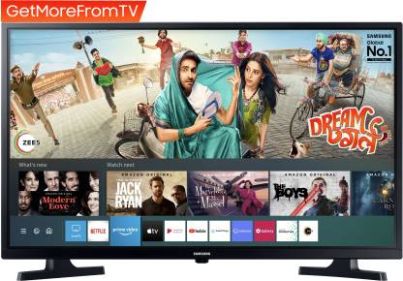

SAMSUNG 80 cm (32 inch) HD Ready LED Smart TV 2020 Edition  (UA32T4340AKXXL)

4.4/5

https://www.flipkart.com/samsung-80-cm-32-inch-hd-ready-led-smart-tv-2020/p/itma5db0294e13fe?pid=TVSFQXFKMHUDYCJ3&lid=LSTTVSFQXFKMHUDYCJ3IOJXHJ&marketplace=FLIPKART&store=ckf%2Fczl&srno=b_1_1&otracker=browse&fm=organic&iid=28f9d6f3-d20d-4774-a7f1-23216ef2ee17.TVSFQXFKMHUDYCJ3.SEARCH&ppt=browse&ppn=browse&ssid=wl2p0u8cwg0000001620658143202

6.

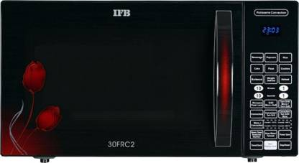

IFB 30 L Convection Microwave Oven  (30FRC2, Black)

4.3/5

https://www.flipkart.com/ifb-30-l-convection-microwave-oven/p/itmeftrwdw5pmwnh?pid=MRCEFTRWYHXDHPDA&lid=LSTMRCEFTRWYHXDHPDASMR2RU&marketplace=FLIPKART&store=j9e%2Fm38%2Fo49&srno=b_1_2&otracker=clp_banner_1_8.bannerX3.BANNER_microwave-oven-store_5QXLKY5LZNRZ&fm=neo%2Fmerchandising&iid=9c68befe-12f4-4124-a5fa-e029d3b1724f.MRCEFTRWYHXDHPDA.SEARCH&ppt=clp&ppn=microwave-oven-store&ssid=sbyrmo6yk00000001620658205791

7.

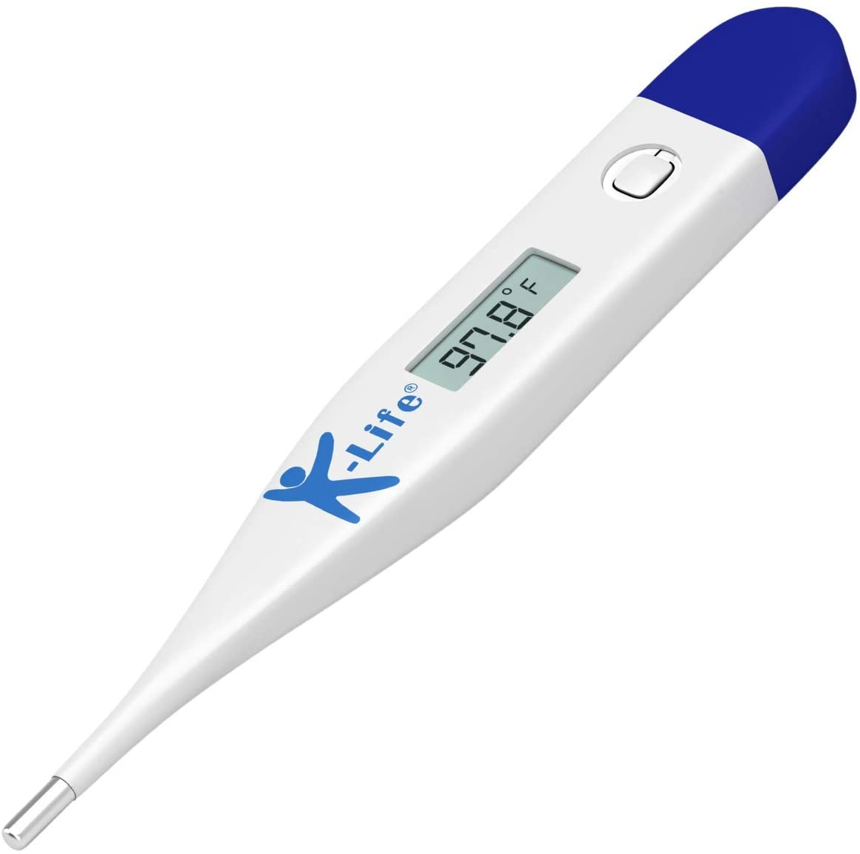

K-Life KLT-100 Digital Thermometer with storage case

3.8/5

https://www.amazon.in/K-Life-KLT-100-Digital-Thermometer-White/dp/B07HHHTRQZ/ref=lp_21505763031_1_5

8.

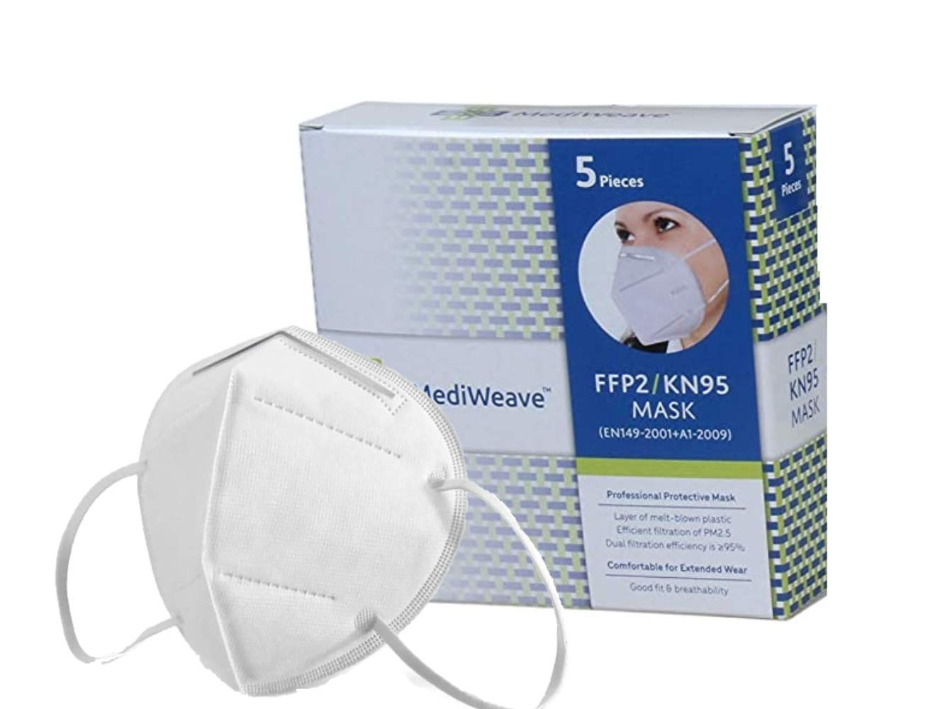

# Mediweave K95 Face Mask (White) - Pack of 5

4/5

https://www.amazon.in/Mediweave-KN95-Willow-shaped-4-ply/dp/B089XY2RMX/?_encoding=UTF8&pd_rd_w=n0UZF&pf_rd_p=d840980e-926d-4f25-9115-4c035c061def&pf_rd_r=7Y8RXDQDKRQ74YQ5GS84&pd_rd_r=c29c8805-23e9-4ca6-b3db-75524461e6d3&pd_rd_wg=r0ihO&ref_=pd_gw_unk

9.

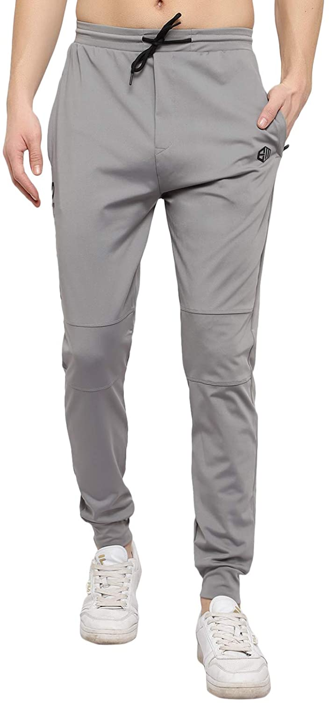

# ENDEAVOUR WEAR Men's Lycra Stretchable Regular Fit Joggers Track Pant Lower Payjama

4.6/5

https://www.amazon.in/ENDEAVOUR-WEAR-Stretchable-Regular-Joggers/dp/B08Z3LWZ8K/ref=sr_1_11?dchild=1&fst=as%3Aoff&pf_rd_i=1968024031&pf_rd_m=A1VBAL9TL5WCBF&pf_rd_p=2a6463b7-5f6e-4760-a2ef-50ba07f05487%2C3818f0c9-a03d-4d4e-8a5b-be428afd4787%2Cebc3a412-ae34-4d92-89ac-a4afe3e0b318&pf_rd_r=BXNFAG0Z9DGCYS450RC1&pf_rd_s=merchandised-search-17%2Cmerchandised-search-7%2Cmobile-hybrid-17&pf_rd_t=30901&qid=1620658534&refinements=p_72%3A1318477031%2Cp_36%3A-59900&rnid=1571272031&s=apparel&sr=1-11

10.

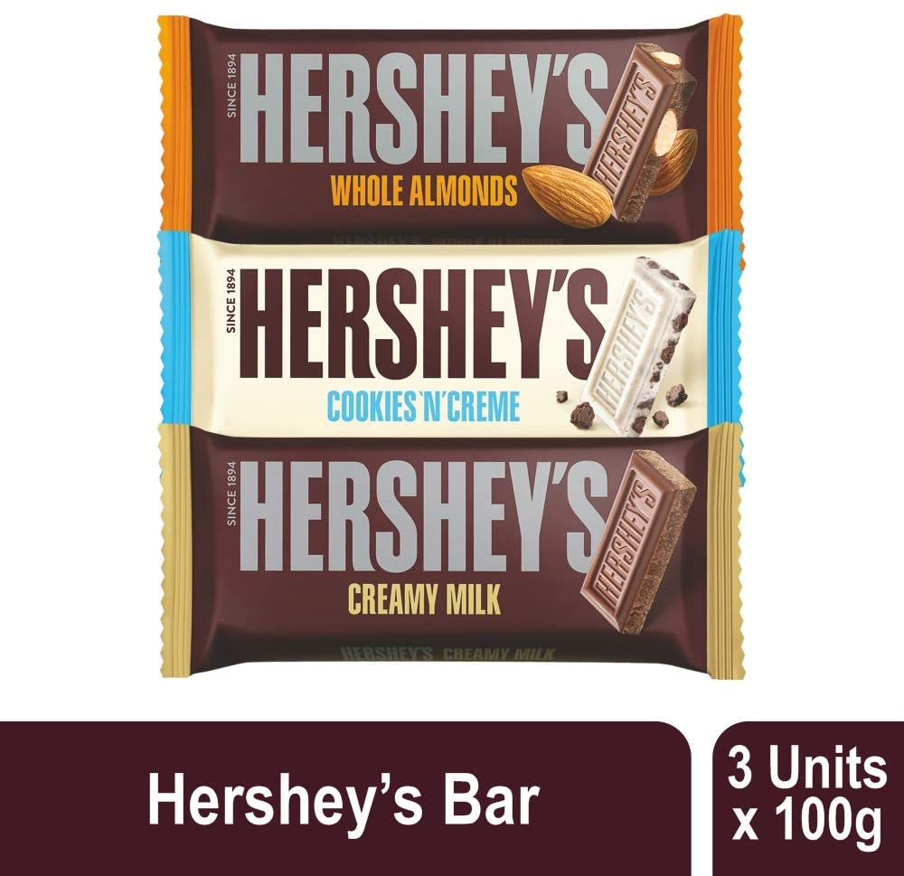

# Hershey's Creamy Milk, Whole Almonds & Cookies n CrÃ¨me Chocolate Bar, 100g (Pack of 3)

4.2/5

https://www.amazon.in/dp/B0834TDKJ2/ref=s9_acsd_al_bw_c2_x_2_i?pf_rd_m=A1K21FY43GMZF8&pf_rd_s=merchandised-search-2&pf_rd_r=HVD6FCW28N71AYMB5JVA&pf_rd_t=101&pf_rd_p=34ab24fe-66d9-4a4c-9fd2-cd69a355d87e&pf_rd_i=13993588031

11.

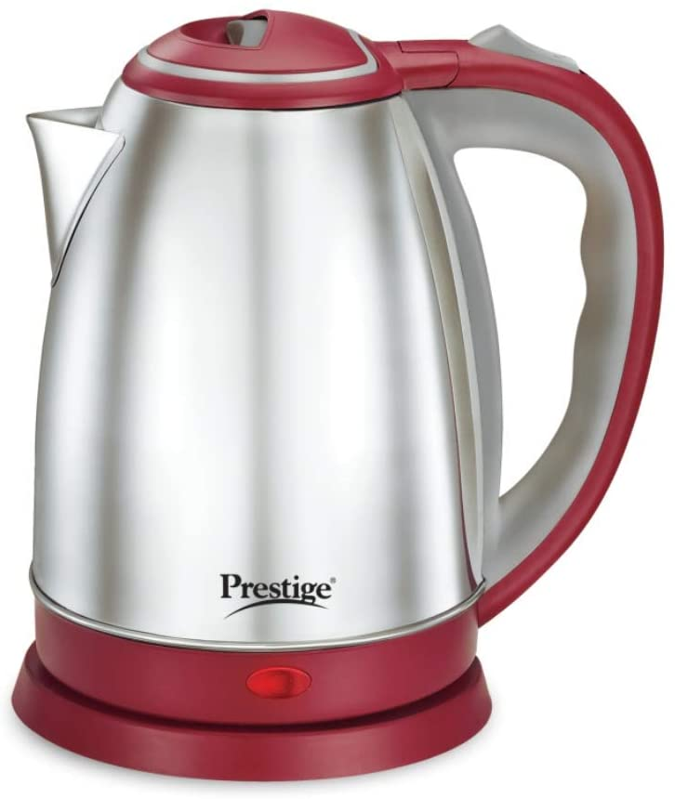

# Prestige 1.2 Litre Kettle 1200-watts, Maroon

3.9/5

https://www.amazon.in/Prestige/dp/B08FCZ2HYL/?_encoding=UTF8&pd_rd_w=b5NI7&pf_rd_p=e60c70f0-0541-4ba5-b6fc-ada95198a5fe&pf_rd_r=TT2KFV3YQKRMS7BR3ESJ&pd_rd_r=b04f7fa5-cf5b-433b-90a9-ab69c89b69ab&pd_rd_wg=mUn8m&ref_=pd_gw_crs_zg_bs_976442031

12.

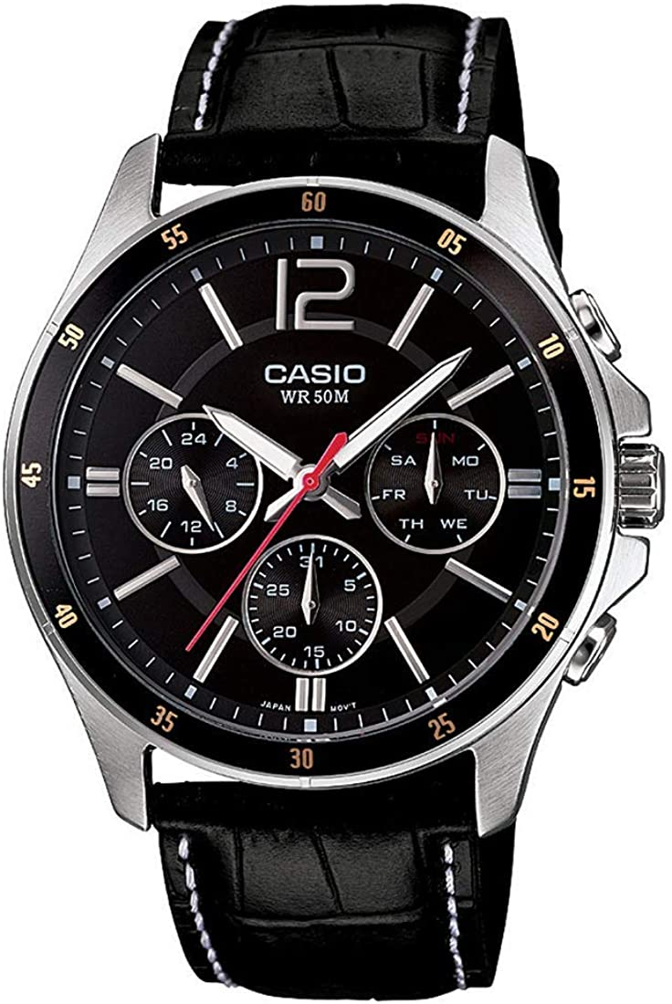

# Casio Enticer Chronograph Black Dial Men's Watch - MTP-1374L-1AVDF (A834)

4.4/5

https://www.amazon.in/Casio-Enticer-Multi-Watch-MTP-1374L-1AVDF-A834/dp/B00GRROOOS/ref=sr_1_2?dchild=1&fst=as%3Aoff&pf_rd_i=2563504031&pf_rd_m=A1VBAL9TL5WCBF&pf_rd_p=f5c725bb-9e36-4d56-a19c-b4937909514a&pf_rd_r=W1MAJA7B0769DBDT1PBR&pf_rd_s=merchandised-search-7&qid=1620658898&refinements=p_89%3ACasio&rnid=3837712031&s=watch&sr=1-2