**GLOBAL GDP TRENDS**

**FROM 1980 to 2028**

M.Sc. Agri Analytics

Programming for Geodata Processing

Gusai Nidhi

202319015

**Submission date**

18/01/2024

**Submitted to**

Mr. Prasun Kumar Gupta



Indian Institute of Remote Sensing

**Abstract**

Global GDP is affected by many factors by overcoming those factors a strong economy of the world emerges therefore finding which country will economically lead the world in the next 5 years is crucial for policymakers, economists, and businesses to make precise decisions. The economic planning of each country is also based on GDP, which enables countries to navigate annual challenges by utilizing available sources.

This project contributes to the existing knowledge base by providing a data-driven analysis of historical trends and future trends with a special focus on per capita GDP because Per capita GDP is an indication of the economic health of people of countries. If people of the countries are financially strong it creates a huge impact on the country's overall growth.

The methods involved in this project are data gathering of per capita GDP of countries in US dollars from 1980 to 2028 from two different sources followed by data cleaning to ensure accessibility of data during analysis. Utilize Python’s data visualization libraries including pandas, NumPy, Plotly, and Matplotlib to identify trends and create interactive charts for data visualization.

The results of this analysis proved that 10 different countries of the world are economically strong in per capita GDP.

**Introduction**

The global economy is constantly evolving with various factors that influence its growth and trends. One of the most important indicators of economic growth is the per capita GDP of country. A higher per capita GDP generally suggests that a stable and prosperous economic environment which may create more business opportunities. It can be associated with better access to goods and services.

Per Capita GDP is a valuable metric that goes beyond total GDP, it offers insights into the distribution of economic prosperity among a country’s population. It is a key tool for any country to address economic challenges and foster sustainable development. To claim the state, authenticate data are gathered from two different websites. Data contains missing values and different datatypes data manipulation is done by filing missing values by mean and create different data frame for ease of analysis.

**Data source 1:** From International Monetary funds

<https://www.imf.org/external/datamapper/NGDPDPC@WEO/OEMDC/ADVEC/WEOWORLD>

**Data source 2:** Form USDA’s Economic Research Service

<https://www.ers.usda.gov/data-products/international-macroeconomic-data-set/>

**Supporting articles**

According to reports the world GDP growth became slower as 2.4% to 3% due to major reasons like Covid-19 pandemic, conflict between Russia and Ukraine, China and Taiwan, Israel and Palestine, the impact of those reasons leads to decrease per capita GDP of countries.

**Weblink for articles:**

1) <https://www.statista.com/statistics/270180/countries-with-the-largest-gross-domestic-product-gdp-per-capita/>

* This article talks about top 20 countries with higher Per capita GDP and how it fluctuates.

2) <https://blog.commonwealth.com/independent-market-observer/taking-the-long-view-where-will-the-economy-and-markets-be-in-2028#:~:text=New%20Highs%20for%20Markets&text=Further%2C%20as%20noted%20earlier%2C%20while,signs%20productivity%20may%20be%20accelerating>.

* This article talks about what is benefits and risk of market based on GDP growth.
* It shows that after 5 year there will be new political challenges but challenges face by world in present will be resolved.

**The Research questions which support these articles are:**

* To find out world challenges really decreases the per capita GDP.
* To find out which countries are becoming economically strong in case of per capita GDP growth.
* To find out fluctuation in per capita GDP during last 4 decades.

**Analysis**

Flow chart of Analysis

Data Gathering

Creating Data frame

Missing value analysis

Imputing Missing value by mean

Get description of data

Data aggregation

Data visualization

Analyse Correlation between both dataset

Conclusion

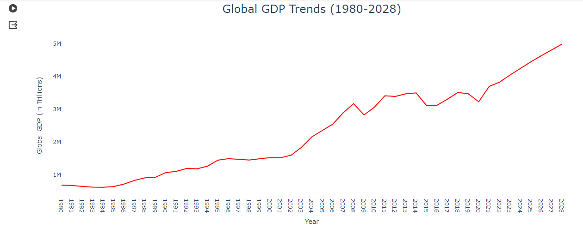**Graph 1:**

This graph is for analyse Global GDP trends over the 4 decades which shows that there are higher fluctuations in year 2009 due to subprime mortgage ,2015 due to sudden decreasing commodity prices and tight financial condition of developing countries ,2019-20 due to Covid- 19 pandemic, and in 2023 there is moderate decline due to wars.

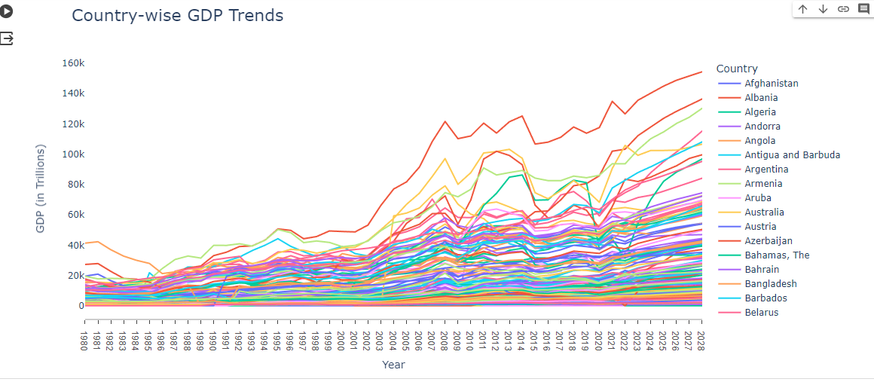**Graph 2:**

This graph for analyse GDP trend of each country from 1980 to 2028 which shows most of developing countries have lower GDP in 1980 but try to improve GDP over the year.

The Luxemburg have highest GDP growth over the year.

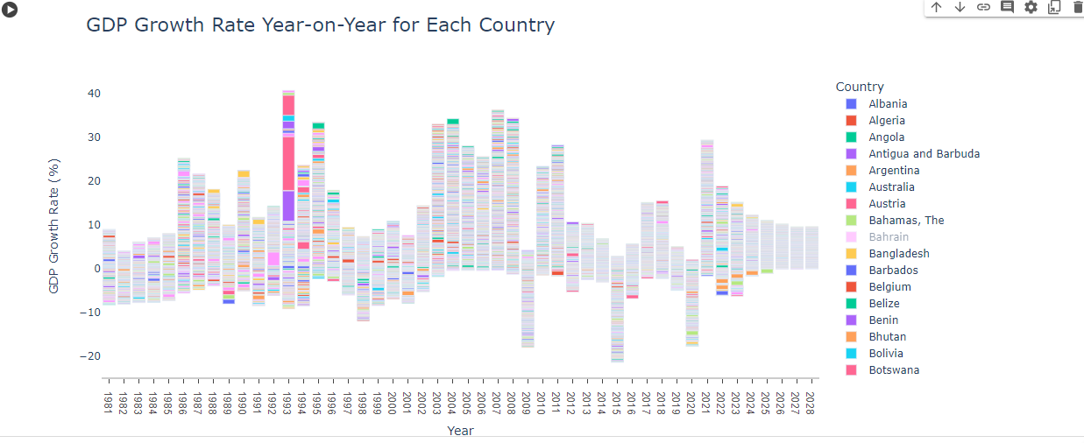**Graph 3:**

This graph clearly represents decline of Global GDP rate in percentage during the 2009,2015 and 2020 and due impacts of wars there is slow growth of GDP in 2023 which also effects GDP of future.

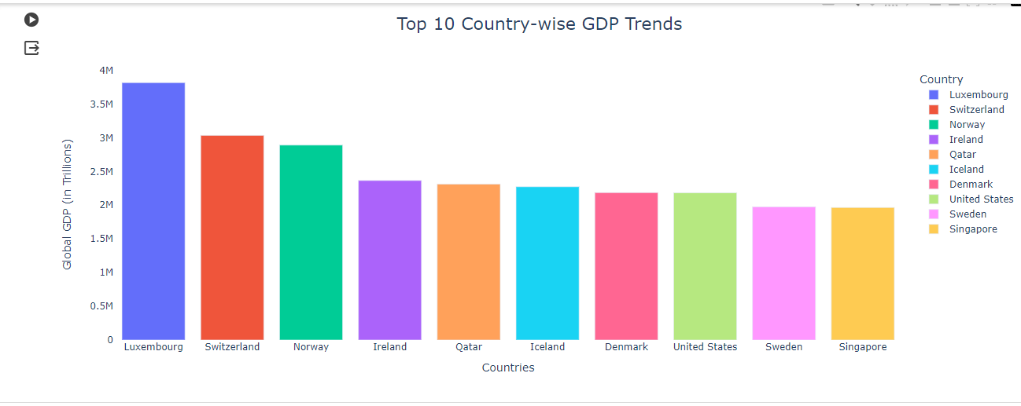**Graph 4:** Finally analyse 10 economically stronger and leading countries in world.

Name of top 10 economically strong countries from data set 1.

|  |  |  |
| --- | --- | --- |
| **Rank** | **Countries name** | **Per capita GDP** |
| 1 | Luxembourg | 3816338.977 |
| 2 | Switzerland | 3034494.233 |
| 3 | Norway | 2890512.049 |
| 4 | Ireland | 2365562.304 |
| 5 | Qatar | 2312094.329 |
| 6 | Iceland | 2273110.698 |
| 7 | Denmark | 2185868.168 |
| 8 | United  States | 2182771.370 |
| 9 | Sweden | 1975329.657 |
| 10 | Singapore | 1964935.558 |

Name of top 10 economically strong countries from data set 2.

|  |  |  |
| --- | --- | --- |
| **Rank** | **Countries name** | **Per capita**  **GDP** |
| 1 | Luxembourg | 4.067816e+06 |
| 2 | Switzerland | 3.667153e+06 |
| 3 | Norway | 3.187188e+06 |
| 4 | United Arab  Emirates | 2.731614e+06 |
| 5 | Qatar | 2.502607e+06 |
| 6 | United States | 2.419471e+06 |
| 7 | Macau | 2.390206e+06 |
| 8 | Denmark | 2.382961e+06 |
| 9 | Australia | 2.369436e+06 |
| 10 | Ireland | 2.343849e+06 |

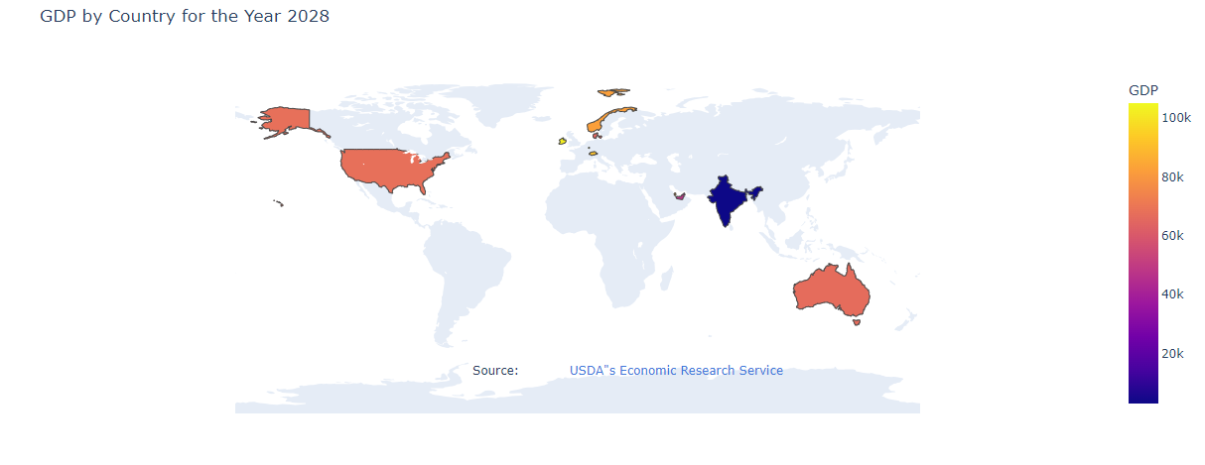**Graph 5:** World map to represent top 10 countries and India.

**Conclusion**

From both data set top 3 countries are same but there is difference in ranking from rank 4th to 10th.

Singapore ranked 10 in analysis of data set 1 but it not included in top 10 countries of dataset 2.

Similarly for countries like Macau, Australia and United Arab Emirates not included in top 10 countries by data set 1.

Correlation among both data sets:

Negative correlation from year 1980 to 1993 from 1994 to 2028 correlation ranges from 0.02 to 0.05 which represent data are moderately corelated.

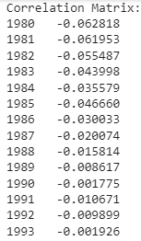

Final per capita GDP of top 10 countries ranges from 4.067816e+06 USD to 1964935.558USD

Overall GDP distribution in 2028 ranges from 919.2k to 154.41k USD according to analysis of International monetary funds dataset and 290.7USD to 109.5k USD according to USDA’s Economic Research Service dataset.