Name: Nidhi Uday Mehendale

PRN: 250240520049

SDM LAB EXAM
Q1) Selenium Practical
Ans:
// Generated by Selenium IDE
import org.junit.Test;
import org.junit.Before;
import org.junit.After;
import static org.junit.Assert.*;
import static org.hamcrest.CoreMatchers.is;
import static org.hamcrest.core.IsNot.not;
import org.openqa.selenium.By;
import org.openqa.selenium.WebDriver;
import org.openqa.selenium.firefox.FirefoxDriver;
import org.openqa.selenium.chrome.ChromeDriver;
import org.openqa.selenium.remote.RemoteWebDriver;
import org.openqa.selenium.remote.DesiredCapabilities;
import org.openqa.selenium.Dimension;
import org.openqa.selenium.WebElement;
import org.openqa.selenium.interactions.Actions;
import org.openqa.selenium.support.ui.ExpectedConditions;
import org.openqa.selenium.support.ui.WebDriverWait;
import org.openqa.selenium.JavascriptExecutor;
import org.openqa.selenium.Alert;
import org.openqa.selenium.Keys;
import java.util.*;
import java.net.MalformedURLException;
import java.net.URL;
public class SDMExamTestTest {
private WebDriver driver;
private Map<String, Object> vars;
JavascriptExecutor js;
@Before
public void setUp() {
driver = new FirefoxDriver();
js = (JavascriptExecutor) driver;
vars = new HashMap<String, Object>();
}
@After
public void tearDown() {
driver.quit();
}
@Test
public void sDMExamTest() {
driver.get("https://demoqa.com/automation-practice-form");
driver.manage().window().setSize(new Dimension(1254, 699));
{
WebElement element = driver.findElement(By.cssSelector("header img"));
Actions builder = new Actions(driver);
builder.moveToElement(element).perform();
}
driver.findElement(By.id("firstName")).click();
driver.findElement(By.id("firstName")).sendKeys("Nidhi");
driver.findElement(By.id("lastName")).click();
driver.findElement(By.id("lastName")).sendKeys("m");
driver.findElement(By.id("userEmail")).click();
driver.findElement(By.id("userEmail")).click();
driver.findElement(By.id("userEmail")).sendKeys("n@gmail.com");
driver.findElement(By.cssSelector(".custom-radio:nth-child(2) > .custom-control-label")).click();
driver.findElement(By.id("userNumber")).click();
driver.findElement(By.id("userNumber")).sendKeys("9643455678");
driver.findElement(By.id("dateOfBirthInput")).click();
driver.findElement(By.cssSelector(".react-datepicker__year-select")).click();
{
WebElement dropdown = driver.findElement(By.cssSelector(".react-datepicker__year-select"));
dropdown.findElement(By.xpath("//option[. = '2000']")).click();
}
driver.findElement(By.cssSelector("option:nth-child(101)")).click();
driver.findElement(By.cssSelector(".react-datepicker__day--004:nth-child(3)")).click();
driver.findElement(By.cssSelector(".subjects-auto-complete__value-container")).click();
driver.findElement(By.id("subjectsInput")).sendKeys("sdm");
driver.findElement(By.cssSelector(".custom-checkbox:nth-child(3) > .custom-control-label")).click();
driver.findElement(By.id("uploadPicture")).click();
driver.findElement(By.id("uploadPicture")).sendKeys("C:\\fakepath\\nidhi.png");
driver.findElement(By.id("currentAddress")).click();
driver.findElement(By.id("currentAddress")).sendKeys("mumbai");
driver.findElement(By.cssSelector(".css-1pahdxg-control .css-1wa3eu0-placeholder")).click();
driver.findElement(By.id("react-select-3-option-0")).click();
driver.findElement(By.cssSelector(".css-1gtu0rj-indicatorContainer > .css-19bqh2r")).click();
driver.findElement(By.id("react-select-4-option-0")).click();
driver.findElement(By.id("submit")).click();
}
}

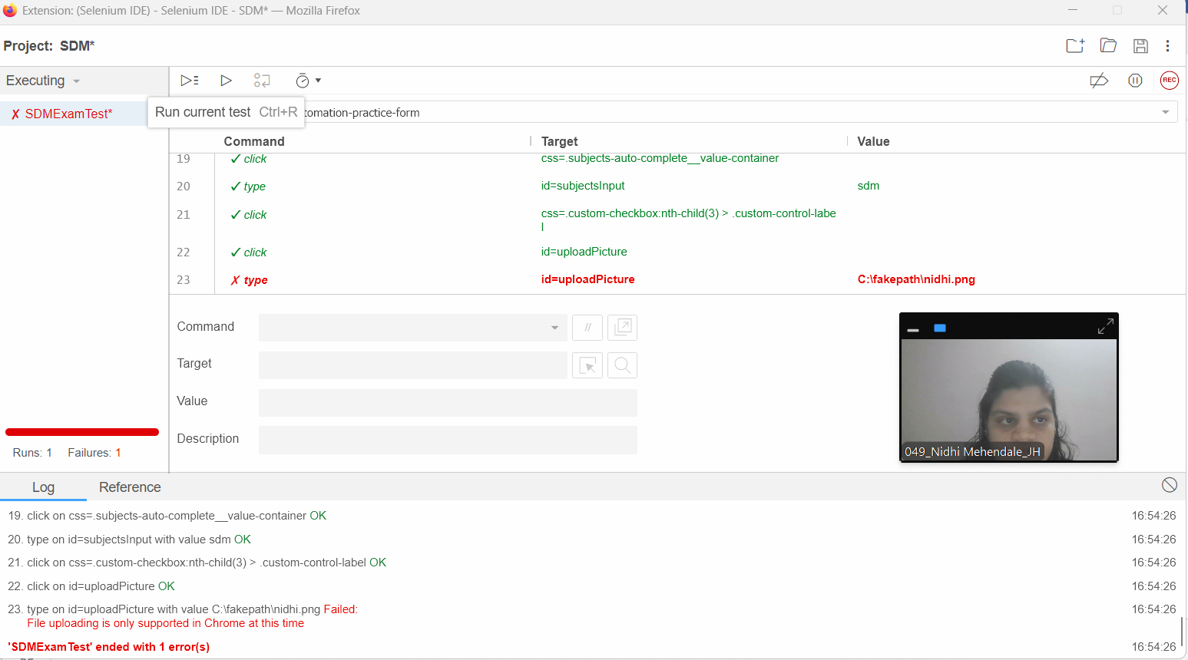

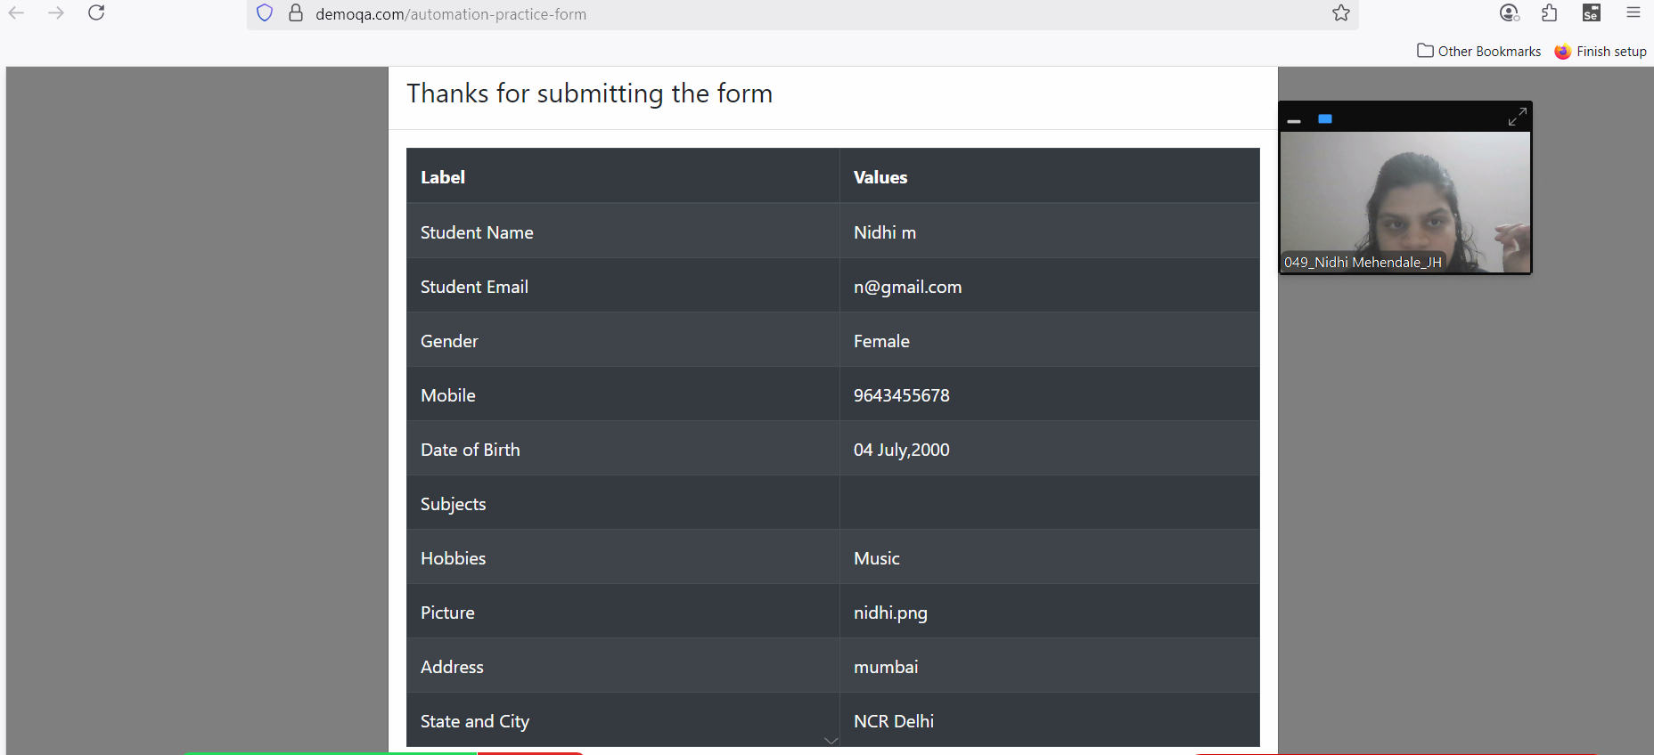

Q3) Docker Practical
Ans:
HelloDocker.java
public class HelloDocker {
public static void main(String[] args){
System.out.println("Hello from Docker!");
}
}
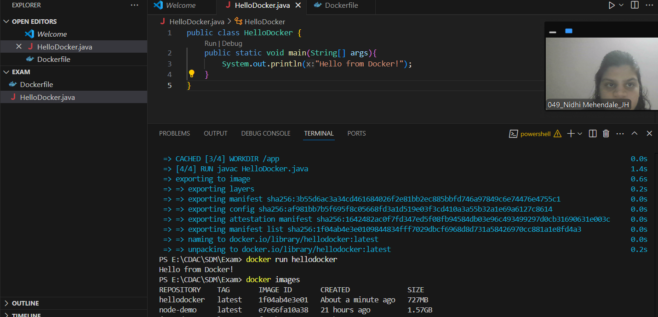

- Dockerfile
FROM openjdk:17
COPY HelloDocker.java /app/
WORKDIR /app
RUN javac HelloDocker.java
CMD ["java","HelloDocker"]
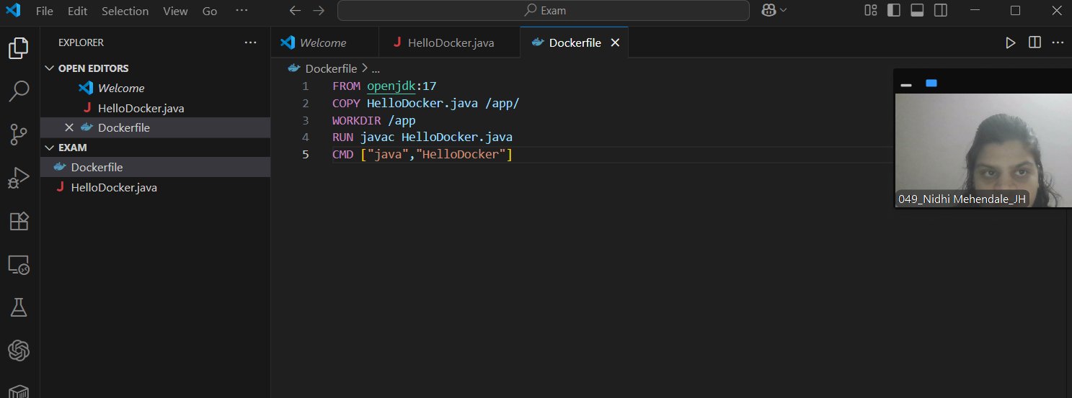

b)
i) Build the docker image
docker build -t hellodocker .
docker run hellodocker
docker images

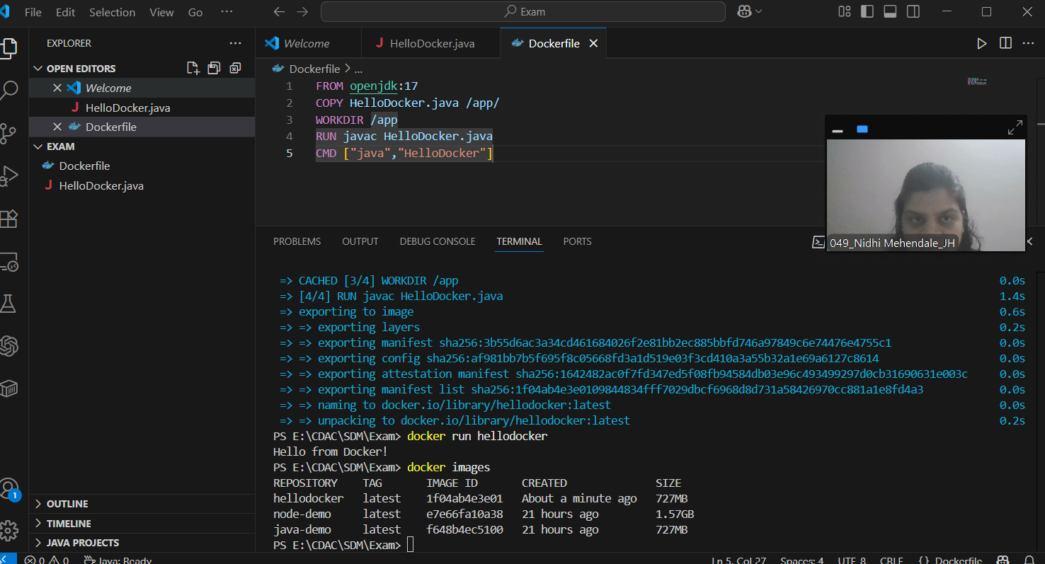

ii)Run the container and print the output

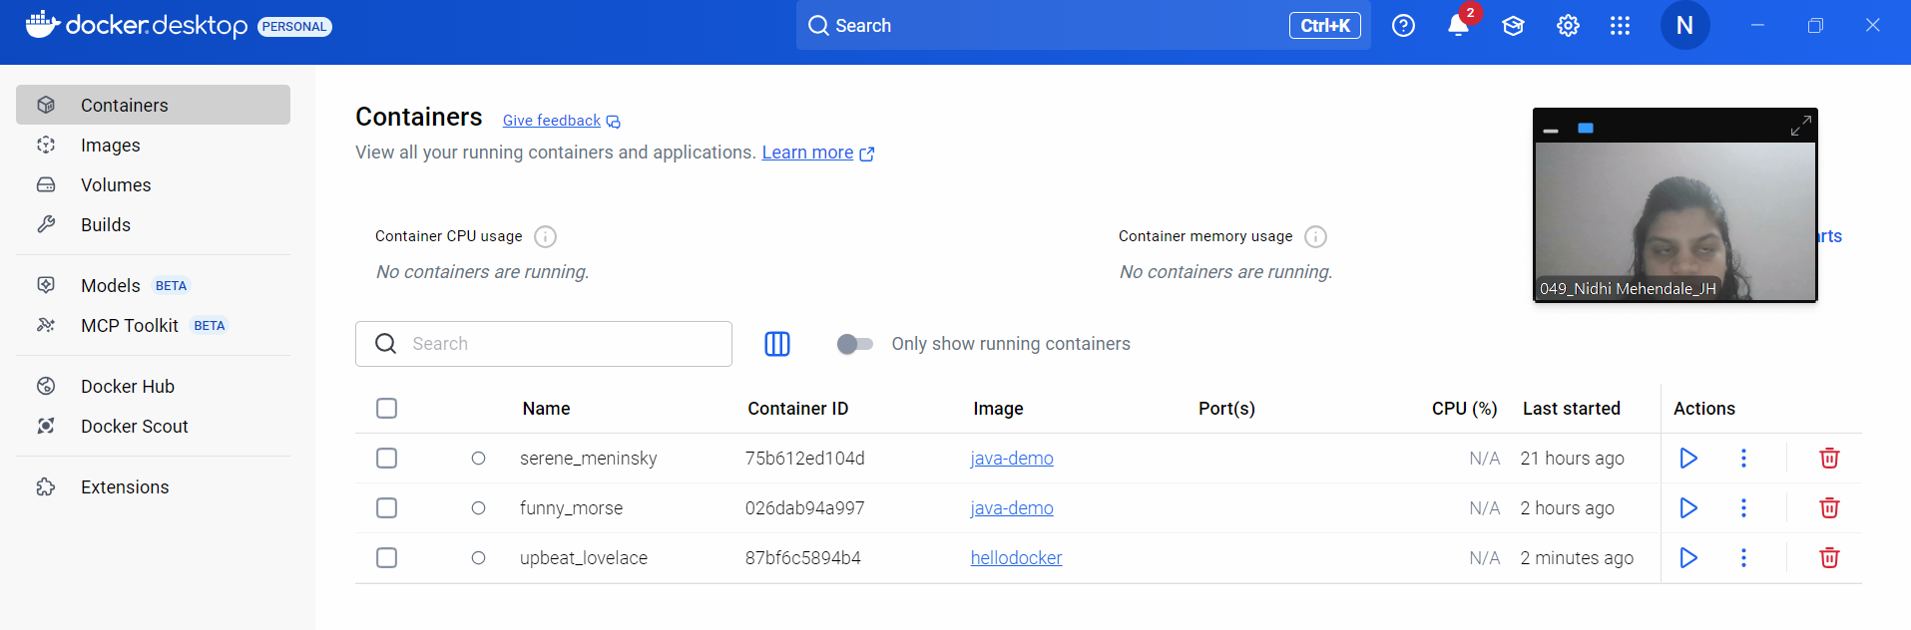

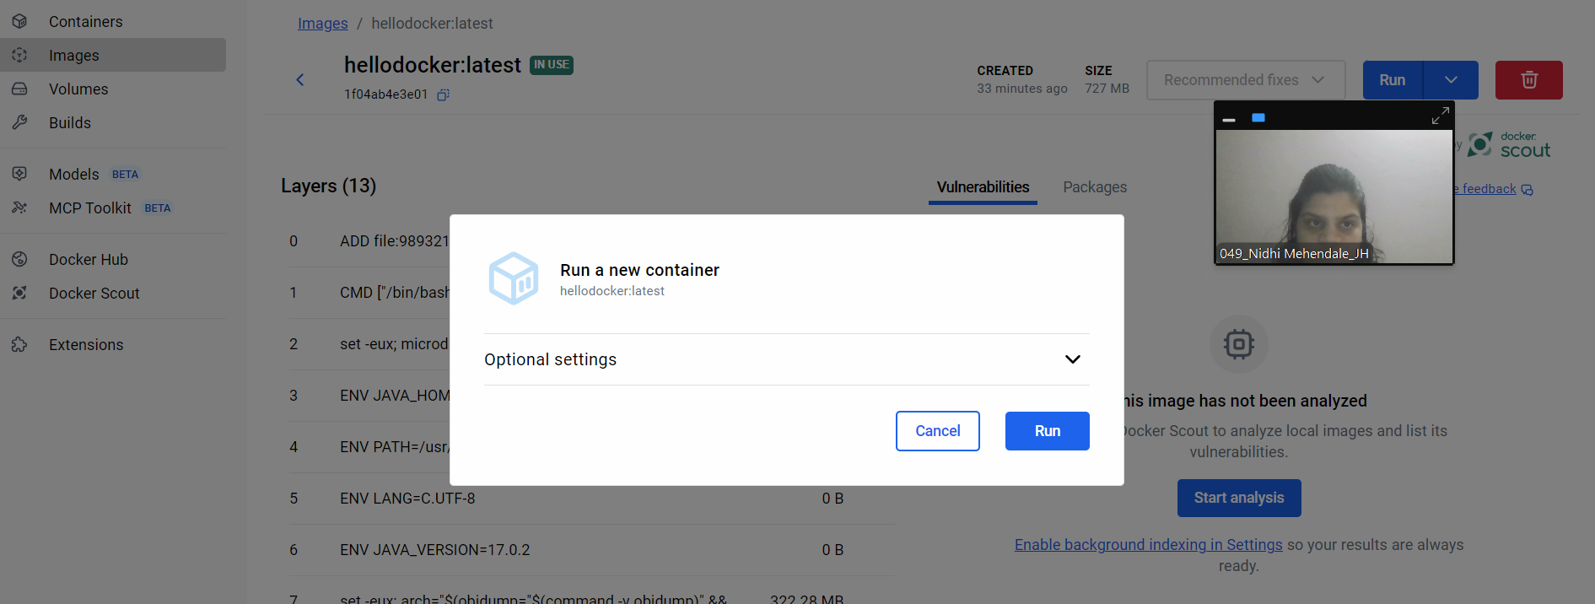

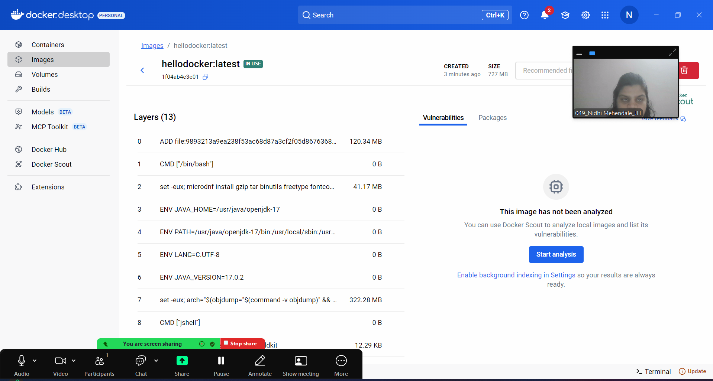

c)output
