1) Install Github Desktop for Windows

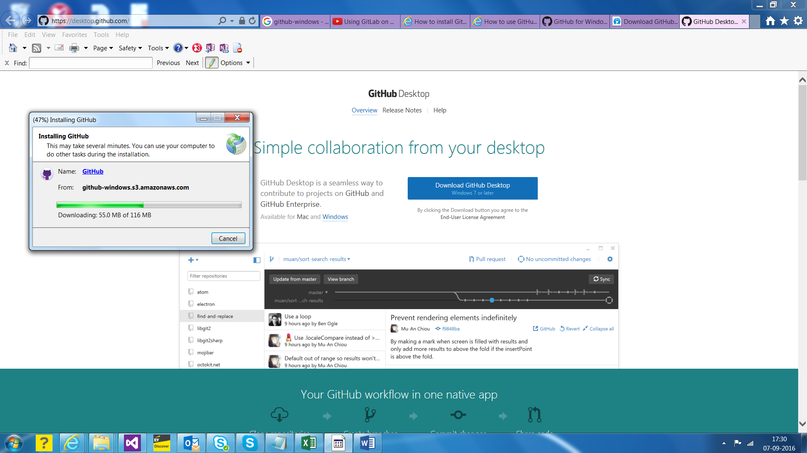

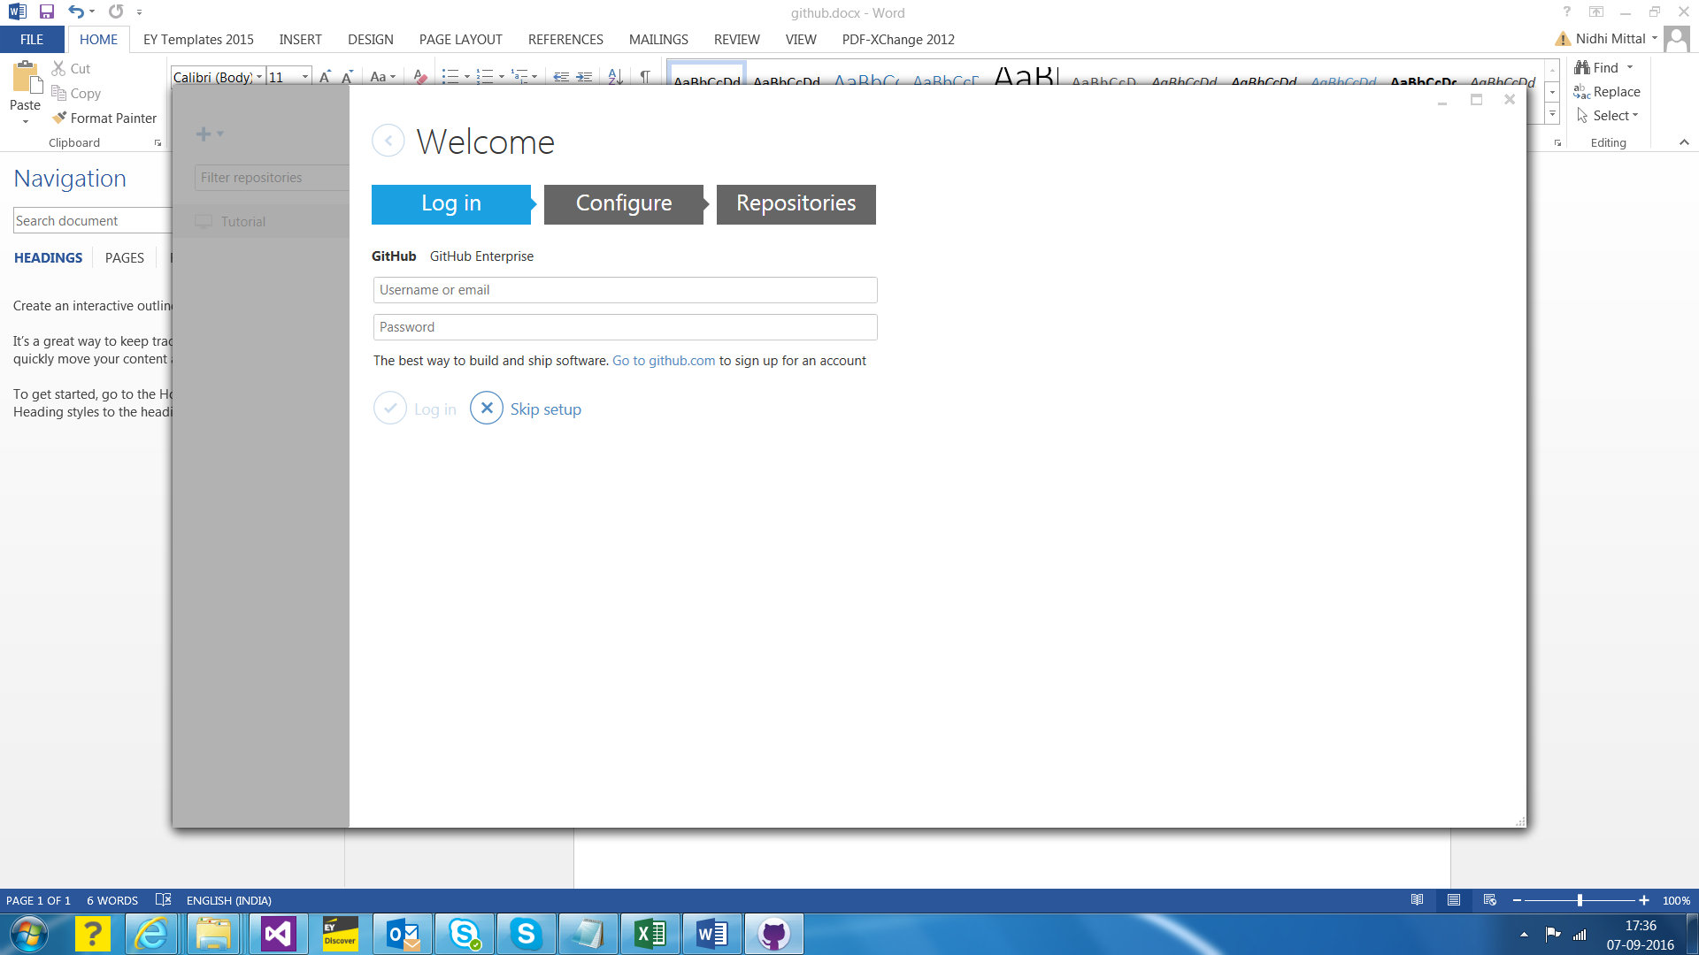

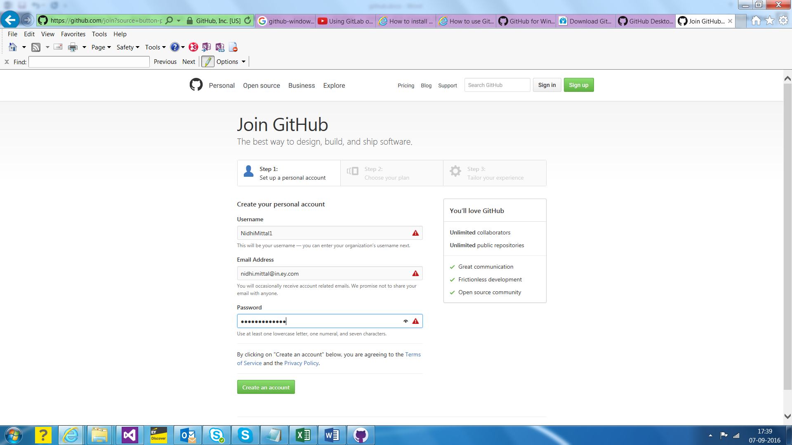

Ctrlshift_010

Exploring git features as a source control…….

1. Download The Visual Studio Tools for Git is an extension for Team Explorer that provides source control integration for Git. Go to -

<https://visualstudiogallery.msdn.microsoft.com/abafc7d6-dcaa-40f4-8a5e-d6724bdb980c>

I also did Visual Studio Update 4, because of pre-requisite before doing above step.

1. When we open Team Explorer, we’ll see option to connect to Git Repositories; Map your local projects to a Git Repository.
2. Track local changes and commit them using the Changes page.
3. Manage incoming and outgoing commits with fetch, pull, and push operations on the Commits page
4. Create, merge, and publish branches on the Branches page; there is a default branch called “master”, you can create new…

**Other features**

* Compare files using the integrated diff tool
* Resolve merge conflicts using the integrated 3-way merge tool
* View file and branch history (log)
* View details for commits

1. [GitLab](https://www.gitlab.com/) is a github like service that organizations can use to provide internal management of git repositories; probably it provides features security