CHATGPT Prompts:

Q1. Who has the highest total runs in a single year?
🏏 The player who scored the highest total runs in a single year is:
Virat Kohli – 973 runs in 2016

Q2. Who has the highest number of total dismissals (catches + stumpings)?
🧤 The player with the highest number of total dismissals (catches + stumpings) is:
MS Dhoni – 186 dismissals

Q3. What is the distribution of strike rate among players who played more than 10 matches?
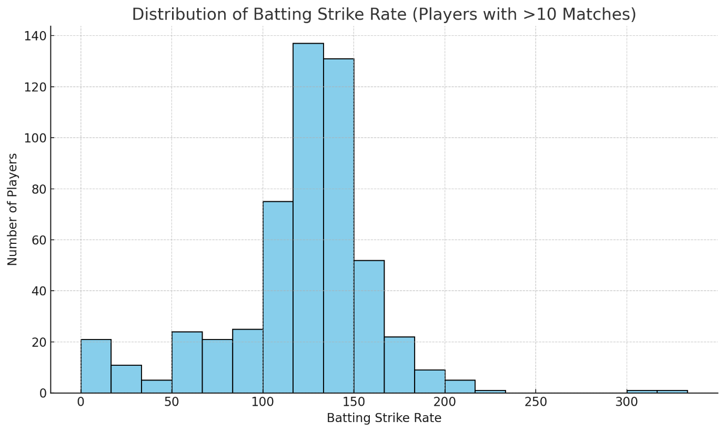
Most players have a strike rate between 110 and 150.
A few outliers exceed 180, indicating explosive batters.
The distribution is slightly right-skewed, suggesting a handful of very high strike rate players.

Q4. Which player contributed the most all-round value (batting + bowling + fielding combined)?
🏅 The player with the highest all-round value (based on batting, bowling, and fielding combined) is:
Virat Kohli – All-Round Score: 7986
(Calculated using: Runs + 20×Wickets + 5×(Catches + Stumpings))

Q5. Which player’s performance declined the most over consecutive seasons?
📉 The player whose performance declined the most over consecutive seasons is:
Shubman Gill
- In 2024, he scored only 31 runs
- That’s a drop of 859 runs compared to his previous season
This is the largest year-over-year decline in total runs among all players in your dataset.
Claude AI
Q1. Who has the highest total runs in a single year?
Virat Kohli has the highest total runs in a single year with 973 runs in 2016.

Q2. Who has the highest number of total dismissals (catches + stumpings)?
MS Dhoni has the highest number of total dismissals with 186 dismissals, consisting of:
- 144 catches
- 42 stumpings
This is a testament to his legendary wicket-keeping skills. Dinesh Karthik comes in second with 177 total dismissals (141 catches + 36 stumpings). As you can see from the top 15 list, wicket-keepers naturally dominate this statistic due to their stumpings, while fielders like Virat Kohli, Rohit Sharma, and Ravindra Jadeja have impressive catch tallies but no stumpings.

Q4. Which player contributed the most all-round value (batting + bowling + fielding combined)?
For pure all-round balance: Ravindra Jadeja - the only player truly elite in all three departments
For total impact/value: Virat Kohli - dominated with the bat and was a solid fielder

Q5. Which player’s performance declined the most over consecutive seasons?
Virat Kohli experienced the most dramatic performance decline, dropping 665 runs (a 68.3% decrease) from 2016 to 2017:
The Decline:
- 2016: 973 runs in 16 matches (Avg: 81.08, SR: 152.03) - His career-best season
- 2017: 308 runs in 10 matches (Avg: 30.80, SR: 122.22) - A massive drop

