**Name: Nidhi Pednekar**

**Class: D15B / 47**

**ADV DEVOPS PRAC 5**

**AIM: Installation and Configuration of Terraform in Windows**

**THEORY:**

Terraform is an infrastructure as code (IaC) tool that allows you to build, change, and version infrastructure safely and efficiently. This includes low-level components such as compute instances, storage, and networking, as well as high level components such as DNS entries, SaaS features, etc.

Terraform can manage infrastructure on multiple cloud platforms. Terraform's state allows you to track resource changes throughout your deployments. You can commit your configurations to version control to safely collaborate on infrastructure. Terraform plugins called providers let Terraform interact with cloud platform and other services via their application programming interfaces (APIs).

**Step 1:** Download terraform

To install Terraform, First Download the Terraform Cli Utility for windows

from terraforms official website

website:<https://www.terraform.io/downloads.html>

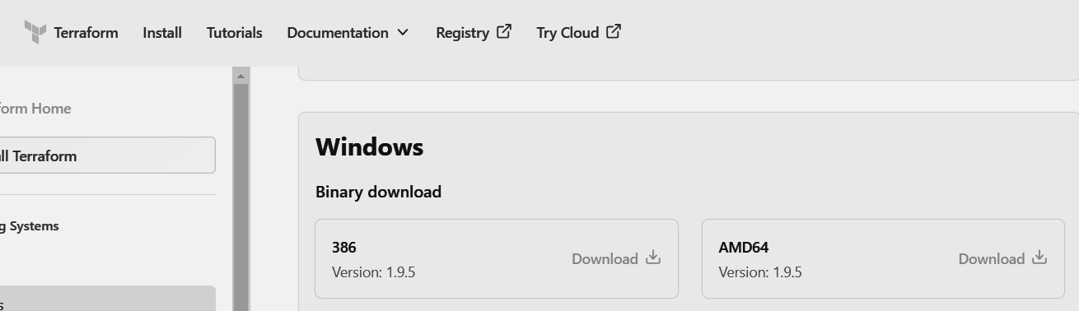

**Step 2:** Extract the downloaded setup file Terraform.exe in C:\Terraform

Directory

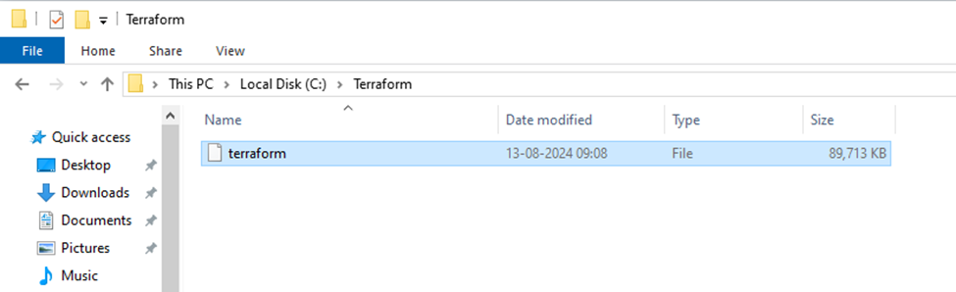

**Step 3:** Set the System path for Terraform in Environment Variables

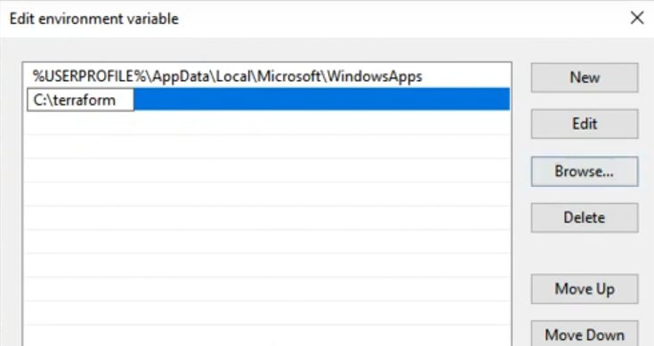

**Step 4 :** Open Terraform in Command Prompt and check its functionality

