**Name: Nidhi Pednekar**

**Class: D15B / 47**

**ADVDEVOPS PRAC 8**

**AIM: Integrating Jenkins with SonarQube.**

Open up Jenkins Dashboard on localhost, port 8080

Run SonarQube in a Docker container using this command -

**$ docker run -d --name sonarqube -e SONAR_ES_BOOTSTRAP_CHECKS_DISABLE=true -p 9000:9000 sonarqube:latest**



**sonarqube**

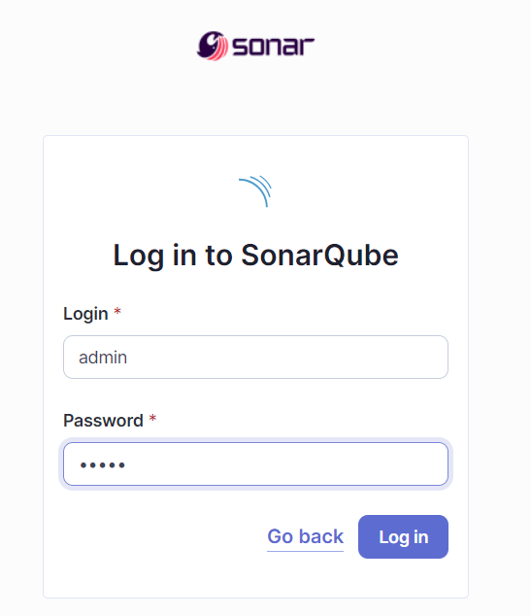

**Create project manually**

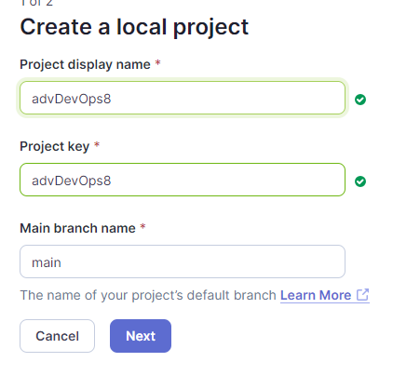

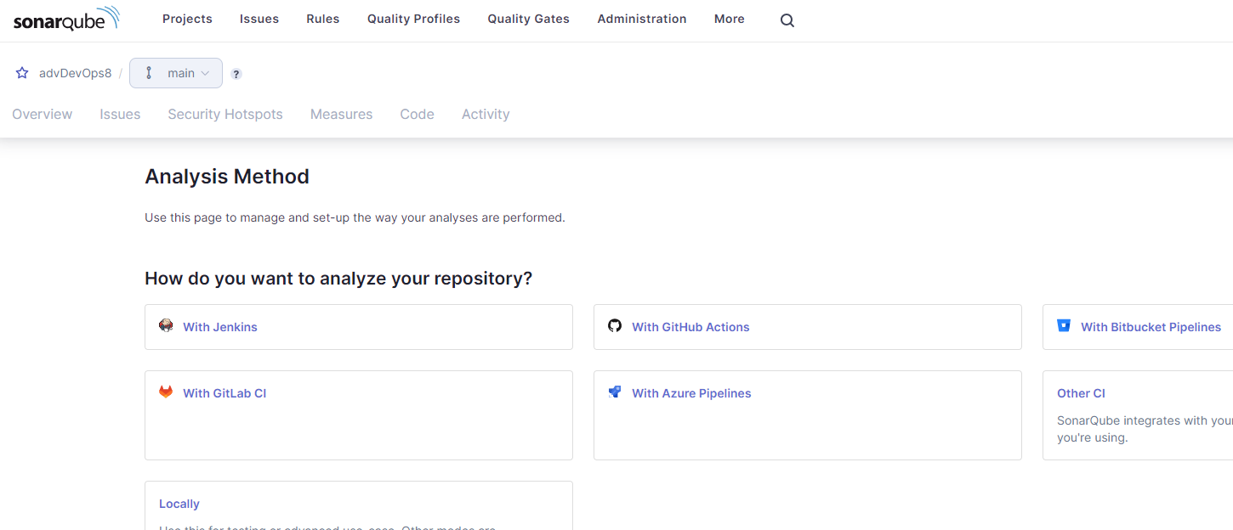

In Jenkins create a pipeline here named “SonarQube”

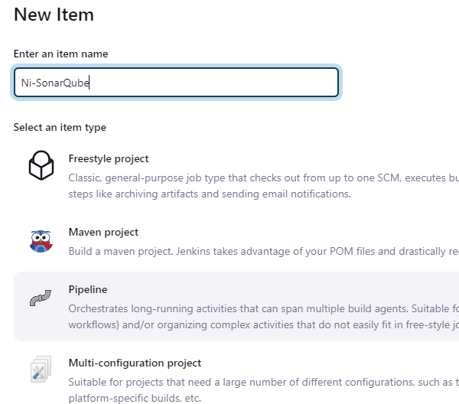

Enter the following in pipeline script:

node {

stage('Cloning the GitHub Repo') {

git 'https://github.com/PrajaktaUpadhye6/MSBuild_firstproject.git'

}

stage('SonarQube analysis') {

withSonarQubeEnv('sonarqube') {

bat "D:/sonar-scanner-cli-5.0.1.3006-windows/sonar-scanner-5.0.1.3006-windows/bin/sonar-scanner.bat \

-D sonar.login=admin \

-D sonar.password=abc \

-D sonar.projectKey=AdDevops \

-D sonar.exclusions=vendor/**,resources/**,**/*.java \

-D sonar.host.url=http://127.0.0.1:9000/"

}

}

}

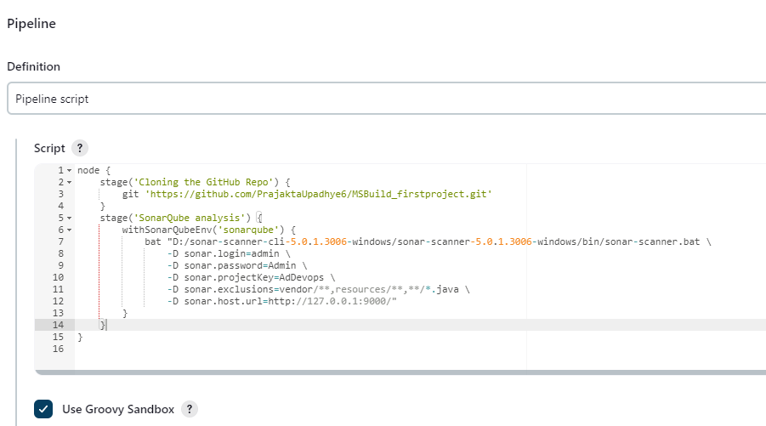

It is a java sample project which has a lot of repetitions and issues that will be detected by

SonarQube.

Build and run:

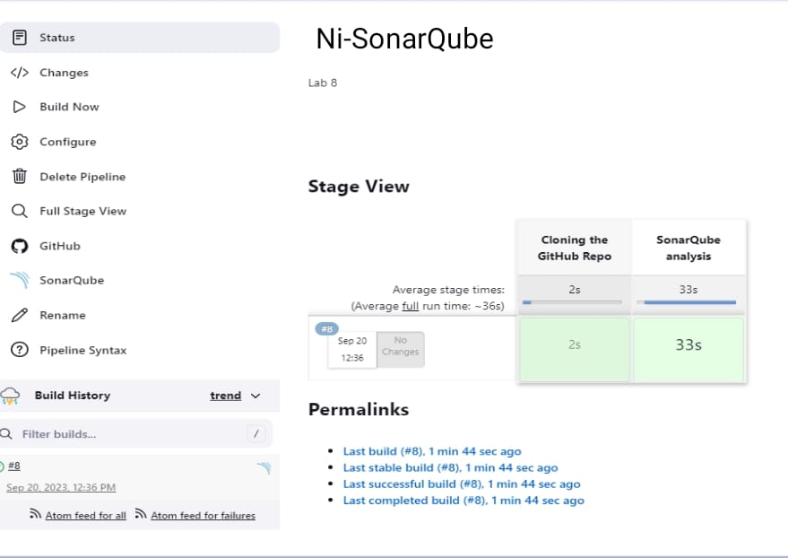

Console output:

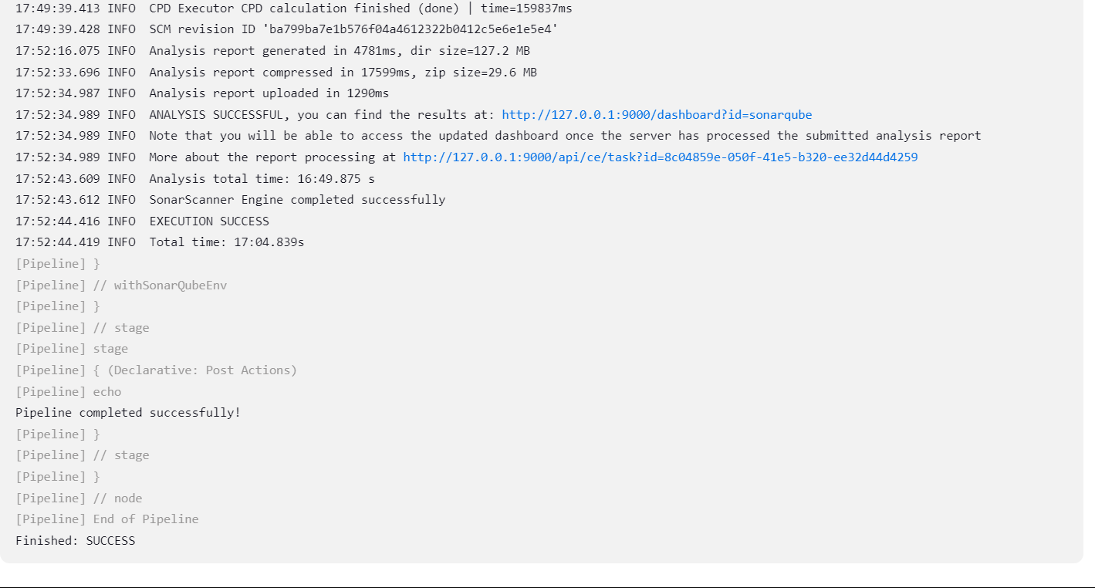

sonarqube:

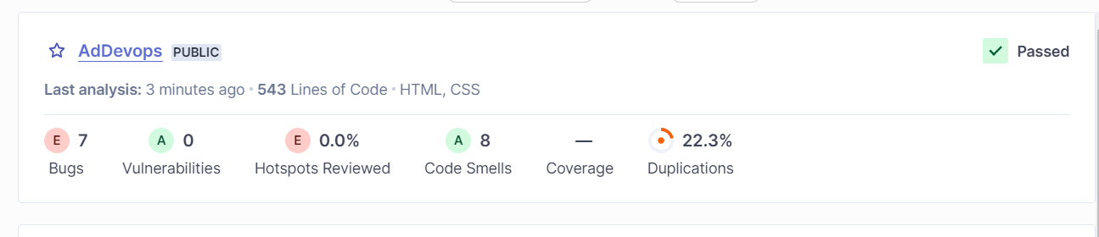

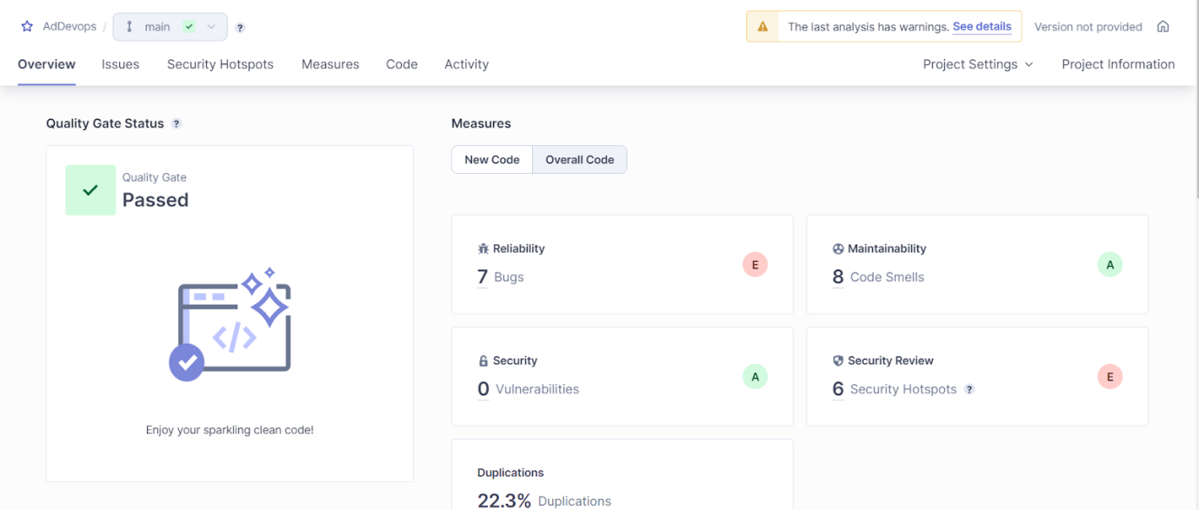

**Reliability:**

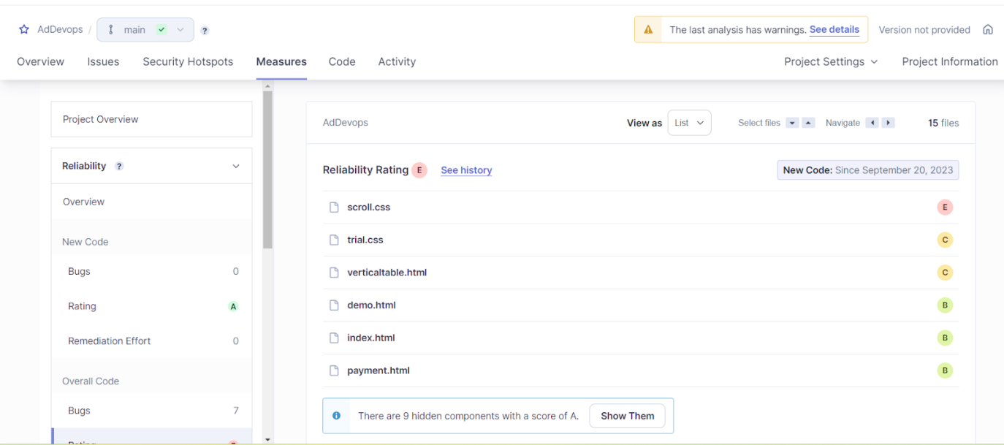

**Bugs:**

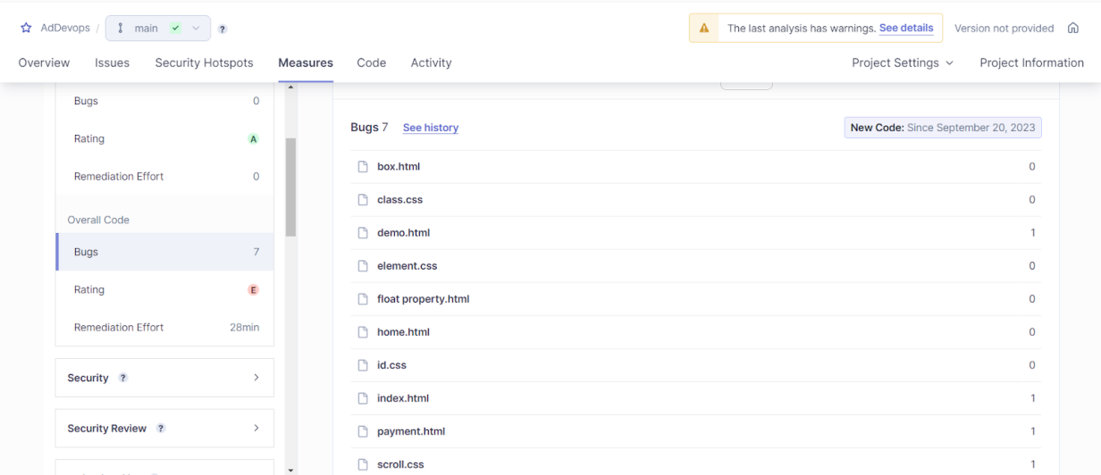

**Maintainaibility:**

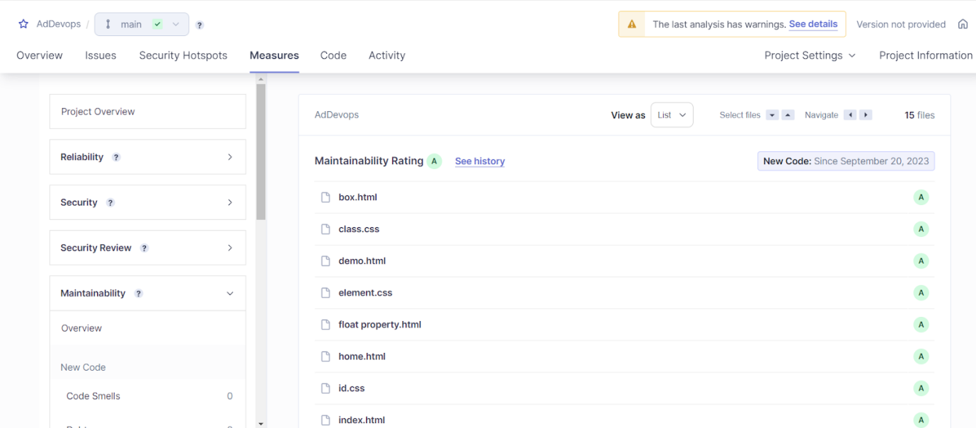

Security:

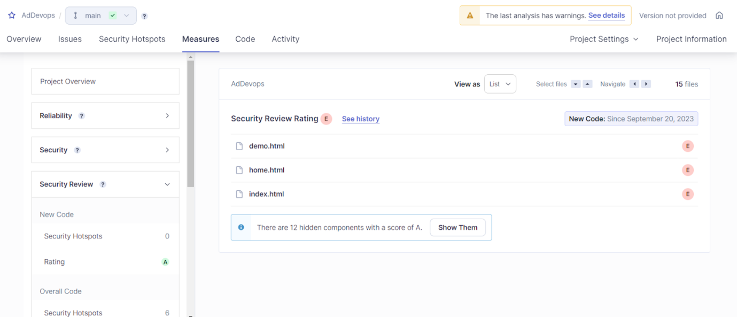

Duplications:

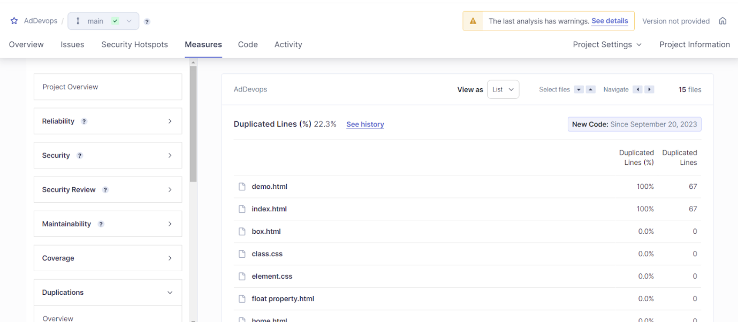

Cyclomatic complexity:

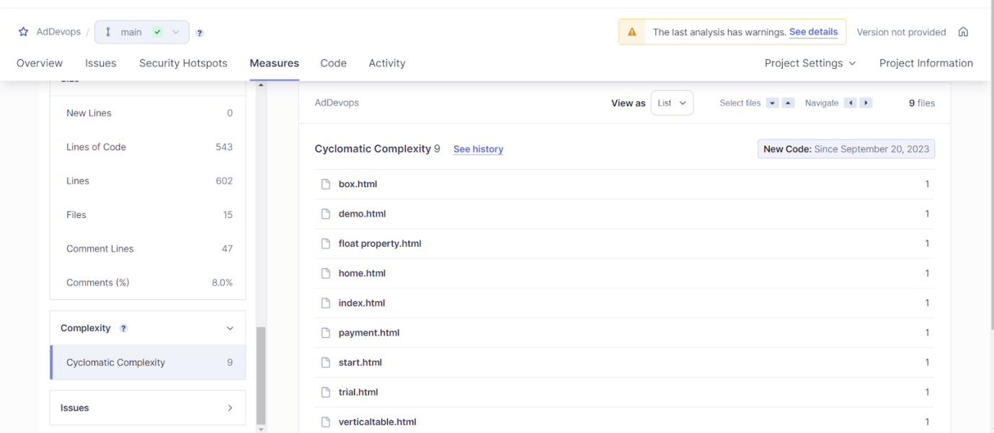

**Conclusion:** Thus, we have successfully integrated Jenkins with SonarQube.